LearningSpoonsR_lifeCountry

Geon Seung Lee

2019뀈 1썡 14씪

Table of Contents

## **각 대륙별 GDP 및 기대수명에 대한 박스플롯을 만들어보세요.**

library(dplyr)  
library(ggplot2)  
dataset <- read.csv("lifeCountry.csv", stringsAsFactors = FALSE)

**박스플롯에서 아웃라이러를 제외한 최대/상위25/중간값/하위25/최소 데이터값만 표기하고 싶습니다.**

### Step 1. 기본 박스 플랏 그리기

a <- ggplot(dataset, aes(x=Continent, y=GDP_per_Capita)) + geom_boxplot()   
a

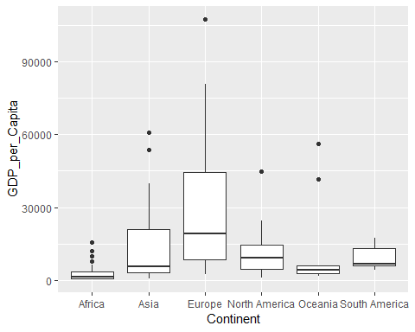

### Step 2. geom_text로 통계량 추가하기

##### Step 2-1. 먼저 통계량을 모아놓은 GDP_stats라는 데이터 프레임을 만듭니다.

summary(dataset$GDP_per_Capita)

## Min. 1st Qu. Median Mean 3rd Qu. Max.   
## 221 2039 5599 13541 16443 107708

GDP_stats <- dataset %>%   
 group_by(Continent) %>%  
 summarise(Min = summary(GDP_per_Capita)[1],  
 Q1 = summary(GDP_per_Capita)[2],  
 Median = summary(GDP_per_Capita)[3],  
 Q3 = summary(GDP_per_Capita)[5],  
 Max = summary(GDP_per_Capita)[6])  
GDP_stats[,-1] <- round(GDP_stats[,-1])  
GDP_stats

## # A tibble: 6 x 6  
## Continent Min Q1 Median Q3 Max   
## <chr> <S3: table> <S3: table> <S3: table> <S3: table> <S3: table>  
## 1 Africa 221 702 1206 3429 15658   
## 2 Asia 572 2886 5677 20957 60811   
## 3 Europe 2458 8420 19282 44561 107708   
## 4 North America 761 4500 9249 14596 44773   
## 5 Oceania 1625 2689 4176 5761 56135   
## 6 South America 4138 5966 6506 13050 17252

##### Step 2-2. geom_text를 이용해서 label을 추가합니다.

a +   
 geom_text(data = GDP_stats, aes(x=Continent, y=Min, label=Min), size = 3) +   
 geom_text(data = GDP_stats, aes(x=Continent, y=Q1, label=Q1), size = 3) +   
 geom_text(data = GDP_stats, aes(x=Continent, y=Median, label=Median), size = 3) +   
 geom_text(data = GDP_stats, aes(x=Continent, y=Q3, label=Q3), size = 3) +  
 geom_text(data = GDP_stats, aes(x=Continent, y=Max, label=Max), size = 3)

## Don't know how to automatically pick scale for object of type table. Defaulting to continuous.  
## Don't know how to automatically pick scale for object of type table. Defaulting to continuous.  
## Don't know how to automatically pick scale for object of type table. Defaulting to continuous.  
## Don't know how to automatically pick scale for object of type table. Defaulting to continuous.  
## Don't know how to automatically pick scale for object of type table. Defaulting to continuous.

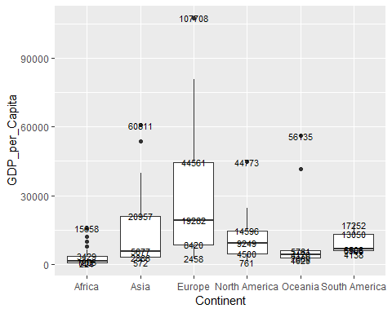

##### Step 2-3. 텍스트가 선이랑 겹쳐서 잘 보이지 않네요?

* 박스플랏의 크기가 촘촘하여 텍스트를 넣을 자리가 별로 없습니다. 이런 경우에는 박스 플랏을 더 크게 만드는 것이 좋아보입니다.
* Chunk control 부분에 {r, fig.height = 10}를 추가하였습니다. (코드 확인해주세요)
* Rstudio내에서 보면 사이즈가 그대로입니다. 하지만 rendering된 html에는 크기가 커진 것을 확인할 있습니다.

a <- ggplot(dataset, aes(x=Continent, y=GDP_per_Capita)) + geom_boxplot()   
a +  
 geom_text(data = GDP_stats, aes(x=Continent, y=Min, label=Min), size = 3) +   
 geom_text(data = GDP_stats, aes(x=Continent, y=Q1, label=Q1), size = 3) +   
 geom_text(data = GDP_stats, aes(x=Continent, y=Median, label=Median), size = 3) +   
 geom_text(data = GDP_stats, aes(x=Continent, y=Q3, label=Q3), size = 3) +  
 geom_text(data = GDP_stats, aes(x=Continent, y=Max, label=Max), size = 3)

## Don't know how to automatically pick scale for object of type table. Defaulting to continuous.  
## Don't know how to automatically pick scale for object of type table. Defaulting to continuous.  
## Don't know how to automatically pick scale for object of type table. Defaulting to continuous.  
## Don't know how to automatically pick scale for object of type table. Defaulting to continuous.  
## Don't know how to automatically pick scale for object of type table. Defaulting to continuous.

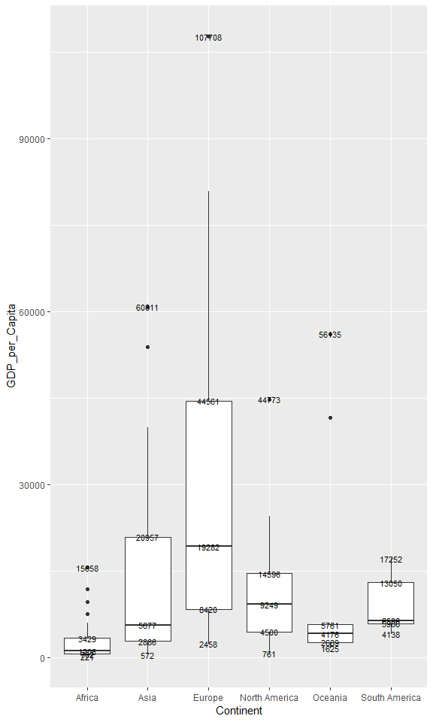

##### Step 2-4. 조금 나아지긴 했지만 여전히 겹쳐네요. 텍스트 위치를 조금 옮겨 보겠습니다.

h_shift = -0.1 # horizontal shift  
v_shift = -0.5 # vertical shift   
a +  
 geom_text(data = GDP_stats,   
 aes(x=Continent, y=Min, label=Min, hjust=h_shift, vjust=v_shift),   
 size = 3) +   
 geom_text(data = GDP_stats,   
 aes(x=Continent, y=Q1, label=Q1, hjust=h_shift, vjust=v_shift),   
 size = 3) +   
 geom_text(data = GDP_stats,   
 aes(x=Continent, y=Median, label=Median, hjust=h_shift, vjust=v_shift),   
 size = 3) +   
 geom_text(data = GDP_stats,   
 aes(x=Continent, y=Q3, label=Q3, hjust=h_shift, vjust=v_shift),   
 size = 3) +  
 geom_text(data = GDP_stats,   
 aes(x=Continent, y=Max, label=Max, hjust=h_shift, vjust=v_shift),   
 size = 3)

## Don't know how to automatically pick scale for object of type table. Defaulting to continuous.  
## Don't know how to automatically pick scale for object of type table. Defaulting to continuous.  
## Don't know how to automatically pick scale for object of type table. Defaulting to continuous.  
## Don't know how to automatically pick scale for object of type table. Defaulting to continuous.  
## Don't know how to automatically pick scale for object of type table. Defaulting to continuous.

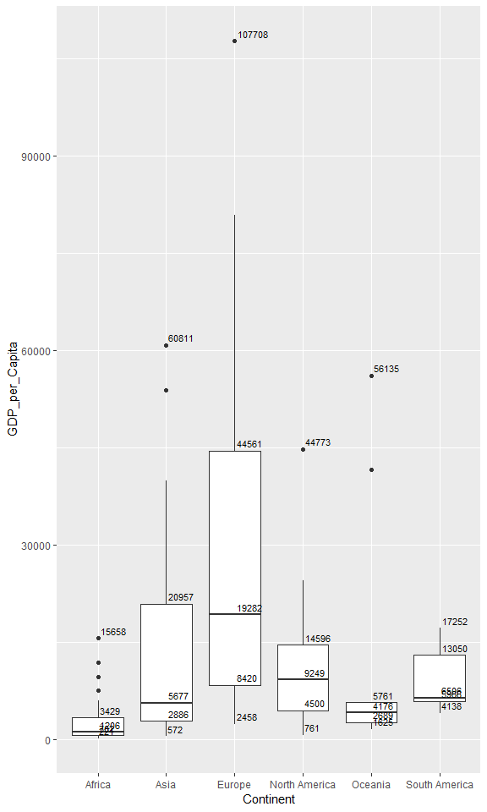

* Africa 같은 대륙은 Q1, Median, Q3가 촘촘하여 text를 넣을 공간이 없습니다.
* 위의 코드에서 Q1과 Q3에는 hjust값을 양수로 넣어준다면 Q1과 Q3는 왼쪽으로 배열할 수 있습니다.

h_shift = -0.1   
h_shift2 = 1.1  
v_shift = -0.5   
a +  
 geom_text(data = GDP_stats,   
 aes(x=Continent, y=Min, label=Min, hjust=h_shift, vjust=v_shift),   
 size = 3) +   
 geom_text(data = GDP_stats,   
 aes(x=Continent, y=Q1, label=Q1, hjust=h_shift2, vjust=v_shift),   
 size = 3) +   
 geom_text(data = GDP_stats,   
 aes(x=Continent, y=Median, label=Median, hjust=h_shift, vjust=v_shift),   
 size = 3) +   
 geom_text(data = GDP_stats,   
 aes(x=Continent, y=Q3, label=Q3, hjust=h_shift2, vjust=v_shift),   
 size = 3) +  
 geom_text(data = GDP_stats,   
 aes(x=Continent, y=Max, label=Max, hjust=h_shift, vjust=v_shift),   
 size = 3)

## Don't know how to automatically pick scale for object of type table. Defaulting to continuous.  
## Don't know how to automatically pick scale for object of type table. Defaulting to continuous.  
## Don't know how to automatically pick scale for object of type table. Defaulting to continuous.  
## Don't know how to automatically pick scale for object of type table. Defaulting to continuous.  
## Don't know how to automatically pick scale for object of type table. Defaulting to continuous.

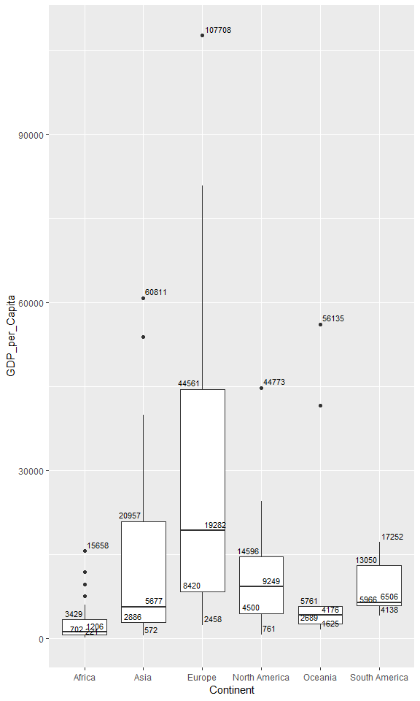

이런 식으로 text의 위치를 조금씩 조정한다면 원하는 모양에 가까워 질 것 같습니다.