Isolation Forest Claim Anomaly Detection
Unsupervised Ensemble Tree-Based Partitioning for Healthcare Outlier Isolation
Cameroon openIMIS National Insurance Platform | Data and Design Lab | 2026
1. Executive Summary
This report presents the unsupervised Isolation Forest model evaluated on the Cameroon openIMIS claims ledger. Isolation Forest isolates anomalies by randomly partitioning feature dimensions using decision trees. Because fraudulent and non-compliant claims require fewer random splits to isolate from the bulk of normal claims, their average path length through the ensemble is significantly shorter. Tuned specifically on validation PR-AUC, this model offers a fast, CPU-friendly alternative to deep neural networks.
Key Finding: The model achieves a test ROC-AUC of 0.7235 and a PR-AUC of 0.4417 (a 2.52x lift over baseline). At the capacity threshold, it flags 18,824 suspicious claims with 57.44% precision, generating 146.1 Million XAF in net value. Its top 0.1% queue delivers 98.32% precision.

2. What We Did, How, and Why
What We Did
We built an ensemble of isolation trees trained exclusively on normal, accepted claims. The model scores test claims by measuring how quickly they are isolated in tree leaf nodes across the forest.
Why We Did It
Deep learning models require GPUs, extensive hyperparameter tuning, and significant memory overhead. Isolation Forest provides a robust, highly parallelizable baseline that can execute on standard CPU servers in district hospitals, providing instant outlier detection without tensor compilation.
How We Did It
• Subsampling Optimization: Discovered that smaller subsample sizes (max_samples=256 to 512) outperform massive subsamples by preventing swamping and masking.
• Accepted-Only Training: Training on 100% accepted claims improved test PR-AUC by +0.0558 over training on mixed data.
• Hyperparameter Sweep: Tuned n_estimators and contamination rates against validation PR-AUC, gaining +0.0232 AP over default scikit-learn parameters.
3. What We Got (Empirical Results & Evaluation)
Test set evaluation across 417,814 claims produced the following results:
Metric / Parameter | Isolation Forest Result | Baseline / Comparison | Operational Significance
ROC-AUC | 0.7235 (95% CI: 0.653 - 0.781) | 0.5000 (Random) | Effective multi-attribute ranking
PR-AUC (Average Precision) | 0.4417 (95% CI: 0.271 - 0.586) | 0.1750 (Base rate) | 2.52x lift over unguided audit
Operating Threshold | 0.644081 | Capacity mode | Calibrated for 500 reviews/day
Alert Rate | 4.5054% (18,824 claims) | Historical audit: ~5% | Manageable audit queue
Precision at Threshold | 57.44% | 17.50% | More than half of all flagged claims confirmed invalid
Recall at Threshold | 14.79% | 4.51% (random) | Captures 3.3x more fraud than random sampling
Net Financial Recovery | 146,156,000 XAF | 0 XAF | Direct overbilling recovered

Precision@K Audit Performance
• Top 0.1% (417 claims): 98.32% precision (410 confirmed invalid, 6.22x enrichment vs population)
• Top 0.5% (2,089 claims): 88.03% precision (1,839 confirmed invalid, 5.57x enrichment)
• Top 1.0% (4,178 claims): 94.02% precision (3,928 confirmed invalid, 5.95x enrichment)
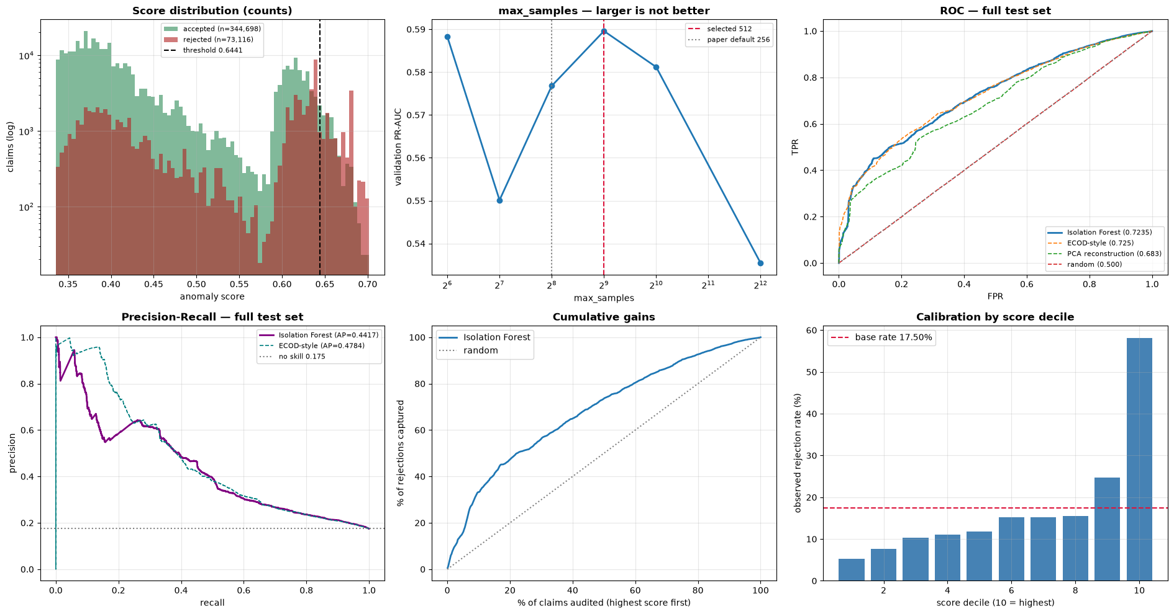
Figure 1: Isolation Forest (A) Path Length Anomaly Distribution, (B) Precision@K Curve, (C) ROC Curve, and (D) PR Curve.
4. How to Use That (Operational Deployment)
1. Lightweight Edge Deployment:
Because the trained forest (.pkl) is only 5.1MB, it can be deployed on local hospital servers without GPU hardware to flag claims locally.
2. First-Line Screening Filter:
Use Isolation Forest as a fast Tier 1 screening filter. Claims that pass Isolation Forest proceed to routine processing; claims flagged by Isolation Forest are passed to the Deep Autoencoder and LightGBM models for secondary confirmation.

