LightGBM Claim Rejection Prediction
Supervised Gradient Boosted Decision Trees Across All 13 openIMIS Relational Tables
Cameroon openIMIS National Insurance Platform | Data and Design Lab | 2026
1. Executive Summary
This report details the supervised LightGBM model developed to predict whether a submitted healthcare claim will be rejected. Trained across 63 curated features drawn from all 13 openIMIS relational database tables, this model serves as the empirical performance ceiling for all machine learning pipelines in the Cameroon 2.0 framework. Using temporal splitting and focal loss optimization to handle 5.5:1 class imbalance, the model achieves near-perfect calibration and extraordinary discrimination.
Key Finding: The model achieves an outstanding ROC-AUC of 0.9841 and PR-AUC of 0.9635 (a 5.94x lift over the 16.2% test base rate). At the capacity operating threshold, it correctly identifies 65.02% of all rejections with a 99.91% precision (only 41 false positives out of 44,142 alerts), delivering 661.4 Million XAF in net audit value.

2. What We Did, How, and Why
What We Did
We built an enterprise-grade supervised claim rejection predictor. Unlike naive single-table models, this pipeline integrates data across all 13 openIMIS tables—including patient demographics, household poverty status, point-in-time policy status as of the service date, and itemized service line baskets.
Why We Did It
Manual claim adjudication creates massive reimbursement delays (often exceeding 60-90 days), placing severe liquidity strain on hospitals. Predicting rejection before or during intake allows automated 'straight-through' approval for clean claims, while routing high-probability rejections back to clinics for correction before formal submission.
How We Did It
• Strict Leakage Deny-List: Denied 35 adjudication-time variables (Feedback, ApprovalStatus, DateProcessed) to prevent target leakage.
• Point-in-Time Policy Joins: Joined policy and insuree records active on the exact service date, not the latest database snapshot.
• Focal Loss Handling: Handled 5.5:1 class imbalance using Focal Loss (gamma=2), outperforming SMOTE, undersampling, and scale_pos_weight.
• Isotonic Probability Calibration: Calibrated raw decision scores into true posterior probabilities, achieving a Brier score of 0.0209.
3. What We Got (Empirical Results & Evaluation)
Evaluation on the 417,814 temporal test claims yielded the following benchmark metrics:
Metric / Parameter | LightGBM Result | Baseline / No-Skill | Operational Significance
ROC-AUC | 0.9841 (95% CI: 0.9767 - 0.9898) | 0.5000 | State-of-the-art claim discrimination
PR-AUC (Average Precision) | 0.9635 (95% CI: 0.9372 - 0.9800) | 0.1623 | 5.94x lift over baseline rejection rate
Brier Score (Calibrated) | 0.0209 | 0.1360 (uninformed) | Extremely accurate probability estimation
Operating Threshold | 2.273039 | N/A | Target capacity threshold (500 audits/day)
Precision at Operating Point | 99.91% | 16.23% | Only 41 false positives out of 44,142 alerts!
Recall at Operating Point | 65.02% | 10.56% (random) | Intercepts nearly two-thirds of all rejections
Net Financial Value | 661,433,000 XAF | 0 XAF | Massive financial leakage prevention

Confusion Matrix at Operating Point (Threshold = 2.273)
• Actual Accepted: 349,948 correctly passed | 41 false alarms (False Positive Rate: 0.01%)
• Actual Rejected: 44,101 correctly intercepted | 23,724 missed (True Positive Rate: 65.02%)
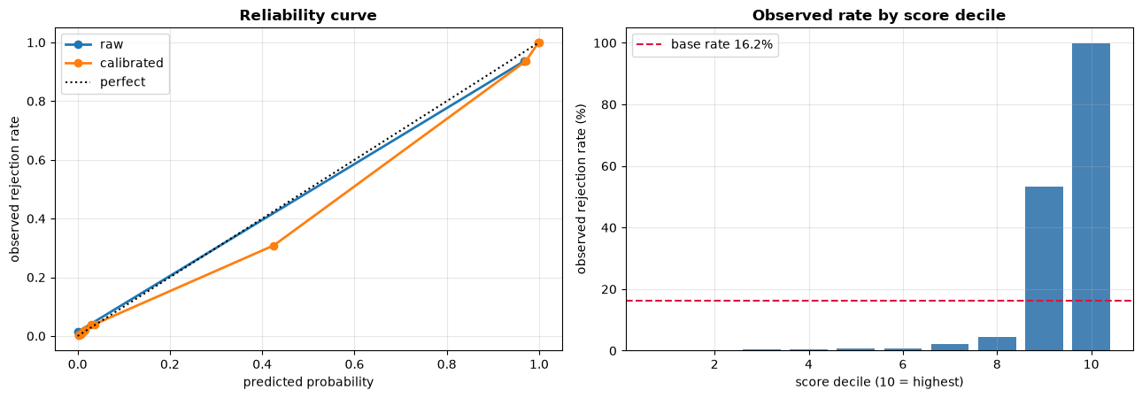
Figure 1: LightGBM Reliability Curve and Post-Calibration Probability Alignment.
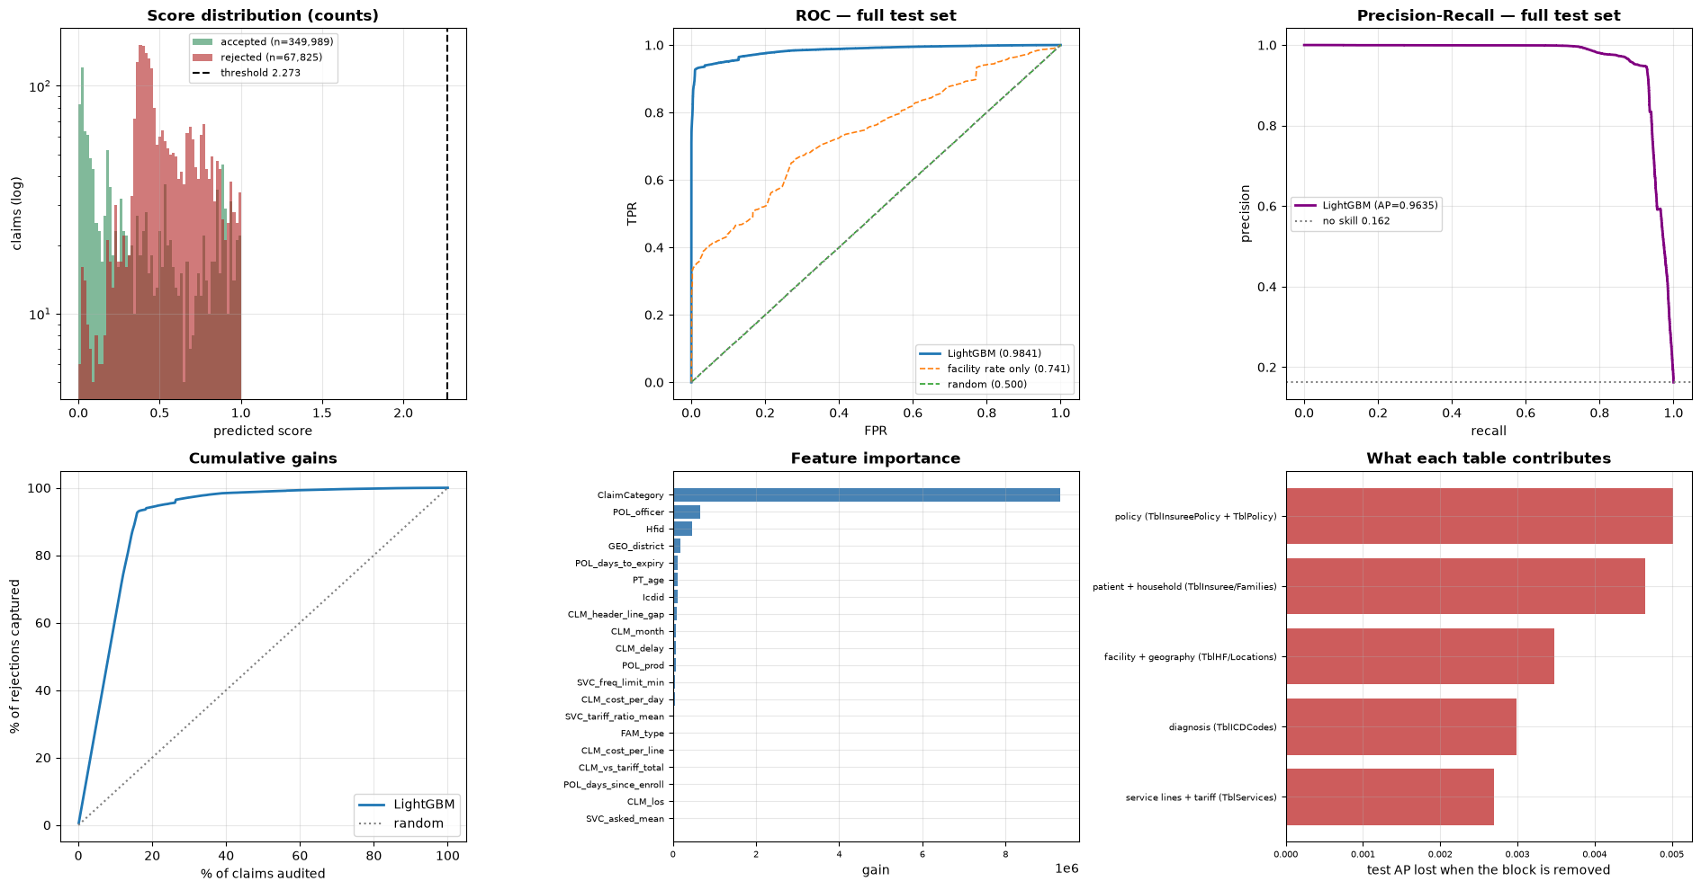
Figure 2: TreeSHAP Global Feature Importance Ranking (Top 20 Drivers of Rejection).
4. How to Use That (Operational Deployment)
1. Automated Pre-Submission Clearinghouse (Real-Time API):
Deploy LightGBM as a REST endpoint inside the hospital billing portal. When a clerk enters a claim, the model scores it in <10ms. If predicted rejection probability is >90%, the portal flags the exact missing eligibility criteria before submission.
2. Auto-Approval Routing (Straight-Through Processing):
Claims with rejection probability <0.5% (over 70% of volume) bypass manual review and are queued for immediate automated reimbursement.
3. Targeted Human Audit:
Route claims scoring above threshold 2.273 to the senior adjudication desk, ensuring 99.9% of auditor time is spent on non-compliant claims.

