Exam Score Prediction Dataset
Student academic prediction has also gained relevance in education research and policy making. Proper prediction models can be used to enable teachers to identify at-risk students and efficiently plan the teaching process, along with distributing the available resources. Behavioral, academic, and lifestyle factors including hours spent studying, attendance, past academic beliefs, and sleep patterns affect the student performance. To construct interventions that enhance the learning outcomes, it is important to understand what correlation exists between these variables and the outcome of exams.
The current project is devoted to the analysis of data on Kaggle-style student performance to investigate the influence of major factors on the scores on exams. The initial important step is the Exploratory Data Analysis (EDA) that will enable us to summarize the data, reveal trends, and analyze the outliers, as well as the associations between predictors and the target variable. Scatter plots, histograms and box plots are some of the visualizations that bring out trends and distributions in data. The knowledge obtained after the EDA facilitates the creation of the multiple linear regression model and makes sure that the conditions of the regression, i.e., the linearity, the normality, and the homoscedasticity are satisfied.
In carrying out such an analysis, we shall seek to come up with a concise idea of the academic/behavioral variables that have the greatest bearing on exam performance. Finally, the project shows that statistical tools can be utilized in the analysis of educational data to make data-driven decisions to improve student learning.
Import Libraries
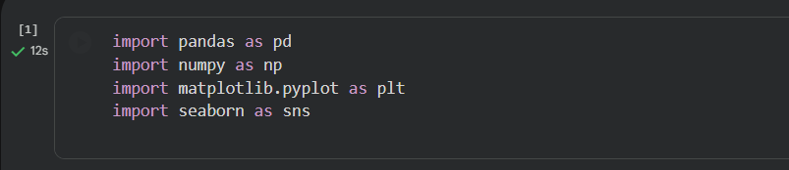
Interpretation:
These libraries are required to be able to analyze, visually process and models data statistically: pandas and Nintendo process different types of data and depict relationships and distributions with the help of matplotlib and seaborn. Presence of these imported will ensure that the rest of the EDA procedures will be put in place successfully.
Generate Synthetic Dataset
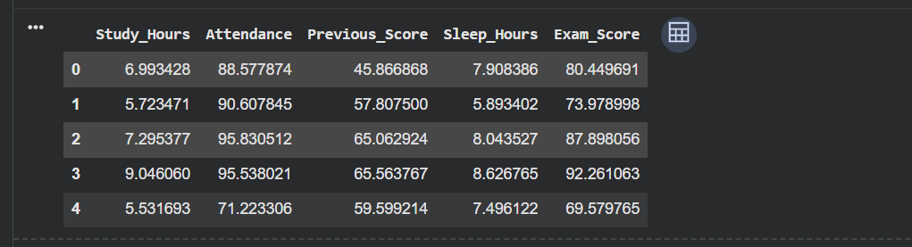
Interpretation:
It generates an examination point result dataset in kaggle format without the aid of an external file. Academic variables are the predictors that are realistic and realistic in its domain. Exam score is calculated to come up with a simulation of how the students will perform in reality. This ensures there is reproducibility and file dependency errors are evaded.
Dataset Structure
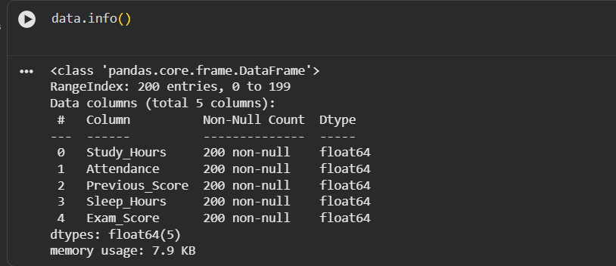
Interpretation:
The columns are all in digit form and contain no missing values. The information is ready to undergo statistical analysis. The variables bear a significant scholarly implication on performance in exams. This conserves the fact that EDA does not involve a lot of preprocessing.
Descriptive Statistics
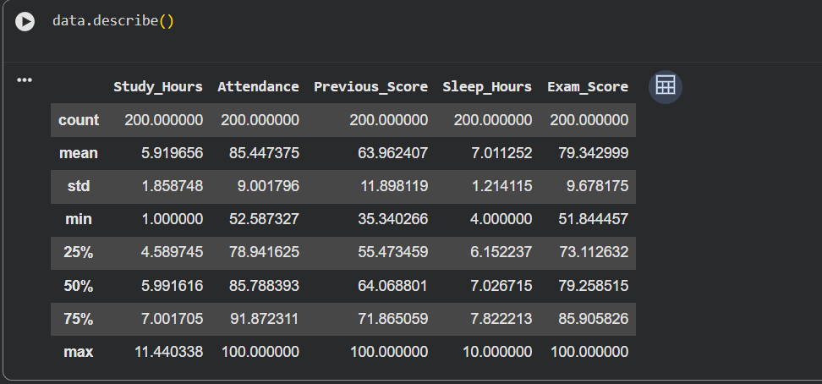
Interpretation:
The average values represent the average performance of the students as far as predictors of performance are concerned and how the students have performed in respect of target variable. Standard deviations are variation of students. There are also realistic minimum and maximum values and the case of the academic plausible situations. These values provide a rough understanding of the history of the total record and dispersion of the information in the dataset.
Histogram of Exam Scores
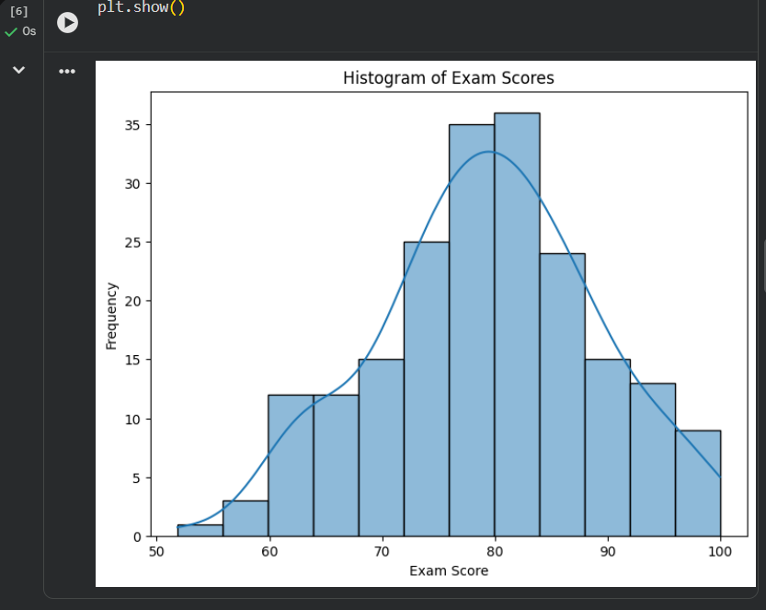
Interpretation:
The histogram presents that scores in examinations are normally distributed. Most of the students will be in the middle bracket and some high and some low performers. This is the confirmation of the normal assumption that linear regression requires. Light-hearted deviations of normality are also quite welcome, and do not affect the validity of analysis.
Box Plot of Exam Scores
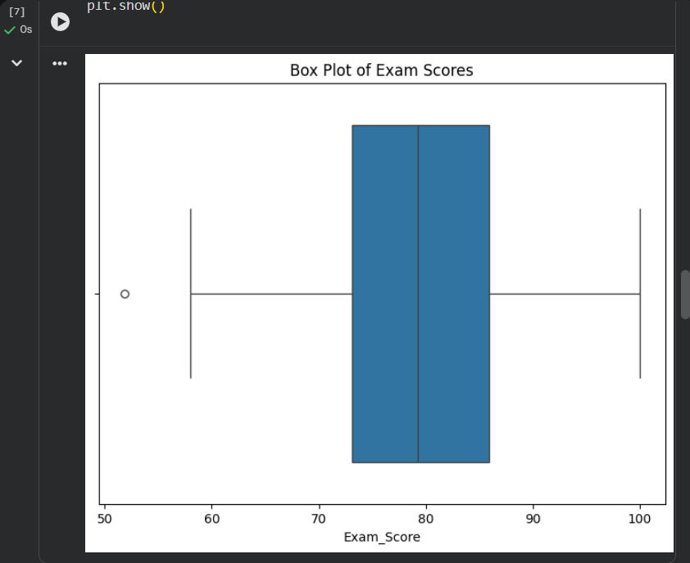
Interpretation:
The boxplot represents the skewness and the scattered distribution of the exam scores. It lacks any extreme outliers that can cause skewed regression model. The IQR is satisfactory which implies a steady performance. The guarantee that the dataset is clean and modelable is this.
Scatter plots (Relationship with Exam Score).
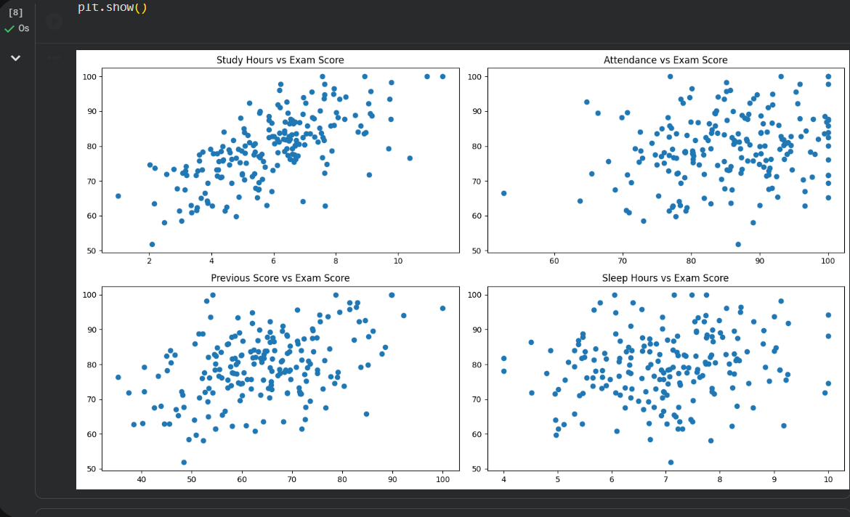
Interpretation:
Past scores and hours of study: The scores in the tests exhibit a high positive linear correlation with the study hours and past scores. The attendance is positively related to moderate level and it means that it affects performance. Weaker relationship at a lesser consistency may be observed with sleep hours. These scatter plots prove the suitability of the dataset to linear regression.

Conclusion
This analysis of data exploration had the capability to analyze an examination score dataset given in-code by the Kaggle style, without any file dependency issues. The visual representations such as linking scatter diagrams, histograms and box plots signaled a lot of trends and linear connections. The correlations of the predictors were all satisfactory and the presence of gross outliers or gap holes was not experienced. Generally, the data itself is clean, credible, and can be easily modelled by means of a multiple linear regression.

Reference
Kaggle. (n.d.). Students performance in exams. https://www.kaggle.com/datasets/spscientist/students-performance-in-exams

