Exploratory Data Analysis (EDA) and Preprocessing Results

The Three Musketeers
Westcliff University
DATA 200: Applied Statistical Analytics
Professor Regmi
February 1, 2026

Exploratory Data Analysis (EDA) and Preprocessing Results
For this week’s report, we have performed some basic Exploratory Data Analysis (EDA) on the dataset that we have selected which is the “Diabetes Prediction Dataset”. What we are trying to do is learn how our data is structured in this dataset, check if there are any errors or inconsistencies, and find out which of the health factor that is present in our dataset has the has the strongest relationship with diabetes. Doing this is really important because successfully doing so tells us that this data is ready for running tests and for our models that we will be doing later in the future. By doing these and seeing the data actually, we can be sure that the model we will be building is based on a real reading rather than just guesswork.
Data Preprocessing and Cleaning
Before running any codes for building visualizations, what we have done is checked the data for any quality issues to make sure that future model will be accurate. So, The very first thing that we did was check the dataset for any duplicate entries, because this was a patient’s data, having same rows probably meant that there were some errors while entering the data rather than having unique patients with the same exact metrics. We thoroughly checked and removed any of the duplicate rows to prevent our models from analyzing repeated data.
After this we scoured through the data set to see if there were any null or missing values. We seemed to be quite fortunate as this datasets quality was good and didn’t really have any null or missing values in critical columns, such as age, BMI. Or glucose levels, meaning that we didn’t really have to do anything here. Having completed all that, we checked if there were any formatting errors in the column where there were texts stored in a numerical column, making sure that we are ready to run tests using this dataset.
Descriptive Statistics
We made some use of descriptive statistics to take a better look at the overview of our patient demographics. The patients that are in this dataset range quite significantly in age, from children to seniors up to 80 years of age, having an average age of about 42 years. This wide range of ages tell us that this model will be applicable to the general population instead of specifically focusing on only one age group. As we can see in Figure 1, the dataset seems to be a bit imbalanced. There is a really less amount of patients that are diagnosed with diabetes than the ones without. This seems to be happening quite commonly in medical datasets because majority of the population is generally healthy, but we still have to keep this in mind because it might later come handy when we will be testing our models accuracy.
Figure 1
Count of Non-Diabetic (0) vs. Diabetic (1) Patients.
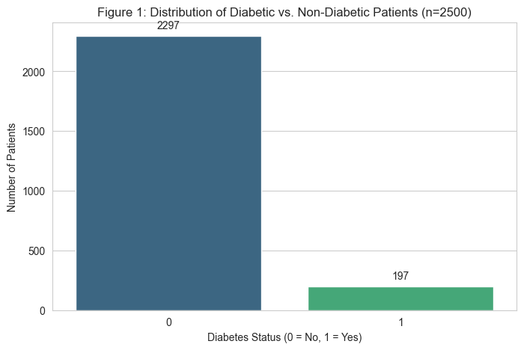

Key Visualizations and Relationships
To see what is the main thing that increases the chances of diabetes, we tested the relationships between the different variables we had using a correlation matrix that we can also see in Figure 2. Looking at the heatmap we can see that the blood_glucose_level and HbA1c_level have the strongest relationships when having diabetes as the target variable. This actually makes sense, in medical terms too, as diabetes is generally known by elevated blood sugar. We also saw that age and BMI showed some positive correlations but they weren’t as strong as the blood markers were. So, what we can understand from this is that those that are of old age and those that have high body weight are mainly at risk, but still blood sugar levels still is the main indicator.
Figure 2
Correlation heatmap showing relationships between health factors.
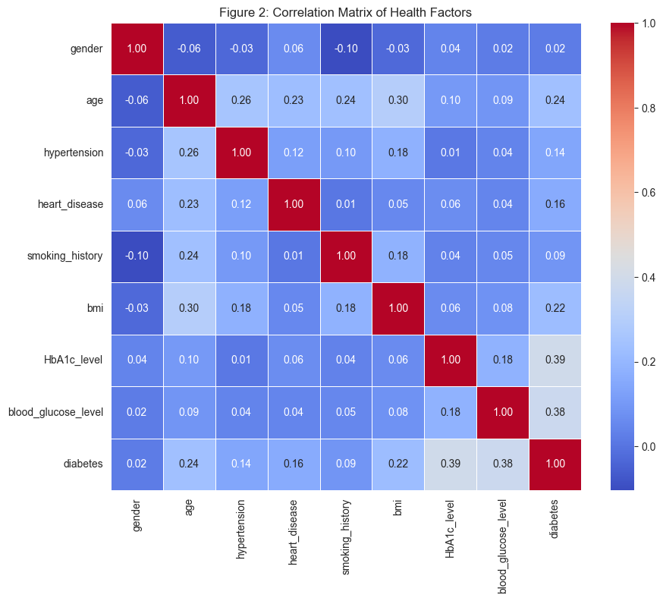
Now since the correlation matrix indicates that blood sugar levels and HbA1c levels are significant factors in predicting diabetes, we can use these data to compare them to healthy patients’ data and compare their box plots. In Figure 3 and 4 we can see the separation between the two types of patients where patients with diabetes have higher blood glucose levels (above 126 mg/dl – and a higher HbA1c levels compared to healthy patients records. Since this variable allow for us to get such separations among patients that do and do not have diabetes, we can take these “features” to be important in training our logistic regression model.
Figure 3
Comparison of Blood Glucose Levels between groups.
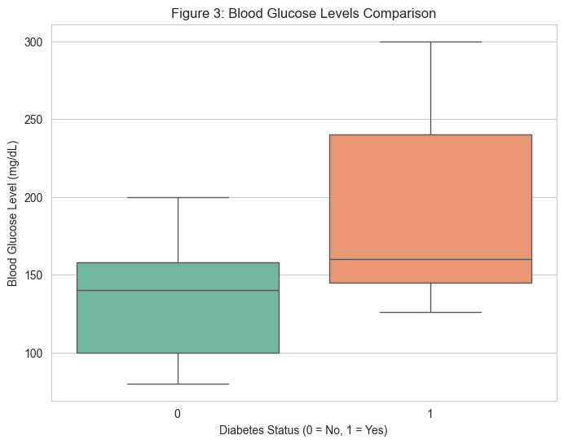
Figure 4
Comparison of HbA1c Levels between groups.
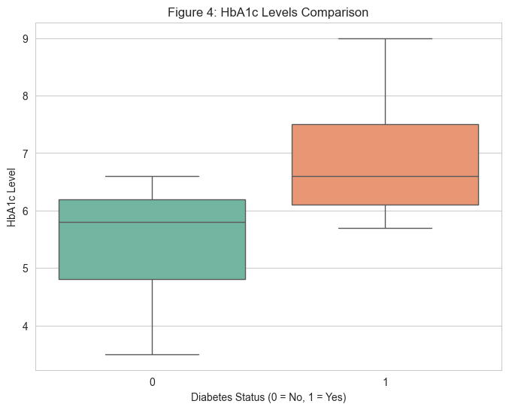
Conclusion
The Exploratory Data Analysis was successful and provided us key insights into the project. We performed data cleaning, decreased the number of missing values and duplicates to get cleaner results. We focus on important factors that act as strong predictors in predicting diabetes in the dataset like Blood Glucose and HbA1c levels while we have Age and BMI to act as secondary roles. Moving ahead, steps like data preparation make our data suitable for processing, building confidence in which variables we need to focus on in modeling and building a diabetes prediction tool.

