Diabetes Prediction: Predicting Risk Using Patient Healthcare Data

Sushant Ale Magar, Rojan Tamang, Bikram Timalsina
Westcliff University
DATA 200: Applied Statistical Analytics
Professor Regmi
February 15, 2026

Diabetes Prediction: Predicting Risk Using Patient Healthcare Data
Diabetes is quickly becoming one of the most important health issues in the world. Because it doesn’t usually present any noticeable symptoms in its early stages, many people find out they are at risk when it is too late to avoid severe health outcomes. As a result, there is an important need for the condition to be more easily predictable. In the past five or so years, researchers have begun to take on this problem using machine learning and data mining techniques. By inputting health data about patients, including their age, body mass index (BMI), and blood glucose levels, a computer program can now accurately predict if a patient will develop diabetes. We are also trying to make the same kind of prediction tool. We will be analyzing a big set of healthcare dataset and put it in statistical modeling to see and find out most of the risk factors that are very critical and also make prediction whether the patient is diabetic or not.
Literature Review
One of the biggest controversies in this area of research is which computer model to use to best anticipate diabetes? There are plenty of different algorithms, and each has its own pros and cons. In a research study conducted by authors Sisodia and Sisodia (2018), the study authors decided to explore three of the most commonly used algorithms: Decision Trees, Naïve Bayes, and Support Vector Machines (SVM). The authors decided to put these models into a standard healthcare database to see how productive these models could be when faced with a diabetic classification challenge. The results from their experiment showed us that all three models were fairly productive. The most effective model was the Naïve Bayes Algorithm, which got an accuracy score of 76%. But, the research team also found out that the success of the algorithm often relies on the input data. It shows that there aren’t any quite complicated algorithms that need to be used so that it results in being an effective model, as even simple models can be effective with accurate data input.
Just choosing an algorithm is not a complete work but also looking at which health factors (features) that might actually be beneficial and hold significance in our research and data processing. Not every piece of feature is important and holds a significance in the finals result. According to Zou et al. (2018), in his conducted study, there is a detailed study on how feature selection affects prediction accuracy. Just because a feature exists does not mean it is compatible with what we are planning to do. Their research also showed us that fasting blood glucose, BMI, and age are constantly some of the strongest predictors of diabetes.
They reduced less relevant data focusing on more significant indicators, their models (specifically Random Forest and Decision Trees) that performed better for predictions. This also aligns with our project in datasets that might contain relevant data like Blood Glucose, BMI, Age, etc like Zou did in his studies. This literature teaches us to choose the right variables for finals predictions and involving too much irrelevant data can act as noise that disrupt the results or make the analysis more difficult that can confuse the model, so we can focus on these specific biological markers to make initial choice of features easier.
Also the common theme across all the literature we chose are also data preparations. Simply searching for a dataset and running it though a model immediately is easy. Sarwar et al. (2018) discusses the whole process in predicting diabetes in healthcare, focusing on steps before even the modeling. They indicate healthcare data can often be messy and might have null values, and different scales for numbers (like age can be 45 a small number while glucose number can reach 140). In their proposed system, Sarwal includes step that help clean the data and normalize it to properly scale data and how to handle missing information to achieve higher accuracy with the help of algorithms like (K-Nearest Neighbours and SVM). As research done by Lai et al. (2019) also showed that predictive model that are using these kinds of techniques can really help to improve the early detection rates than using the traditional medical scoring systems. This supports our groups methodology heading in to the final project as our initial steps include data cleaning and normalization.
Methodology and Data Selection
For this project, we have selected the "Diabetes Prediction Dataset" from Kaggle. We selected this dataset because it was quite large and had simple easily understandable variables and also have really important clinical variables like the HbA1c level and blood glucose level that’s really important for our model.
We have decided to go with Logistic Regression as our main statistical technique because what we are trying to get is just a Yes or No outcome, either they are diabetic or not-diabetic. Logistic regression gives us a probability score from between 0 and 1, which makes it really easy to interpret as well for medical risk assessment, unlike the Linear Regression, which just predicts continuous number. And to make sure that our result are accurate, we will also be performing classification methods like the Random Forest and Decision Tree as bench markers.
We did some feature selection using the medical literature and our data analysis. We found out that Blood Glucose Level and HbA1c Level are the most effective predictors while Age and BMI were secondary valuable predictors. And at last we lowered our analysis to these four variables so that we will avoid any overfitting and make our model more efficient.
Exploratory Data Analysis (EDA)
In this stage of our project, EDA helps us with cleaning data for a better understanding on our data. We start by cleaning our data and since these are patient’s data, we have higher chances of identical rows being data entry errors, as opposed to unique patients with specific same data. We clean the data by removing duplicate rows so that our model does not memorize repeated data. Finally, there seems to be no missing values in the crucial columns in the dataset.
We then analyze the statistical outline of the data and found the patients to be both newborns and the old aged up to 80 years with average age of 42 years old. As shown in the Figure 1, there is an imbalance with much fewer patients diagnosed with diabetes as compared to the non-diagnosed.
Figure 1
Count of Non-Diabetic (0) vs. Diabetic (1) Patients.
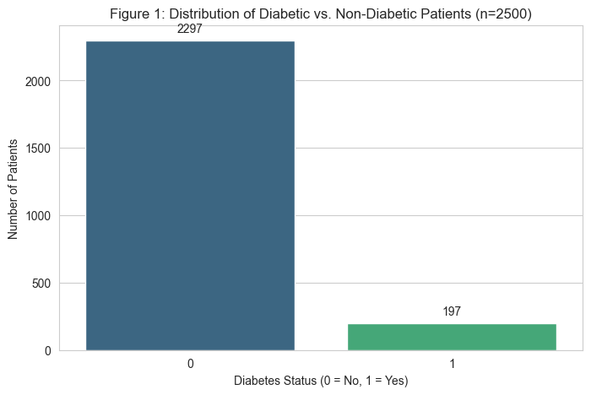
To determine the specific relationships among the variables that impact the risk of diabetes, we apply correlation matrix to analyze the relationship between those different variables. This analysis shows that variables of diabetes target variable are strongly correlated with Blood Glucose Level and HbA1c levels. We also have Age and BMI as secondary variables since those variables have weaker but still positive correlation than the initial ones.
Figure 2
Correlation heatmap showing relationships between health factors.
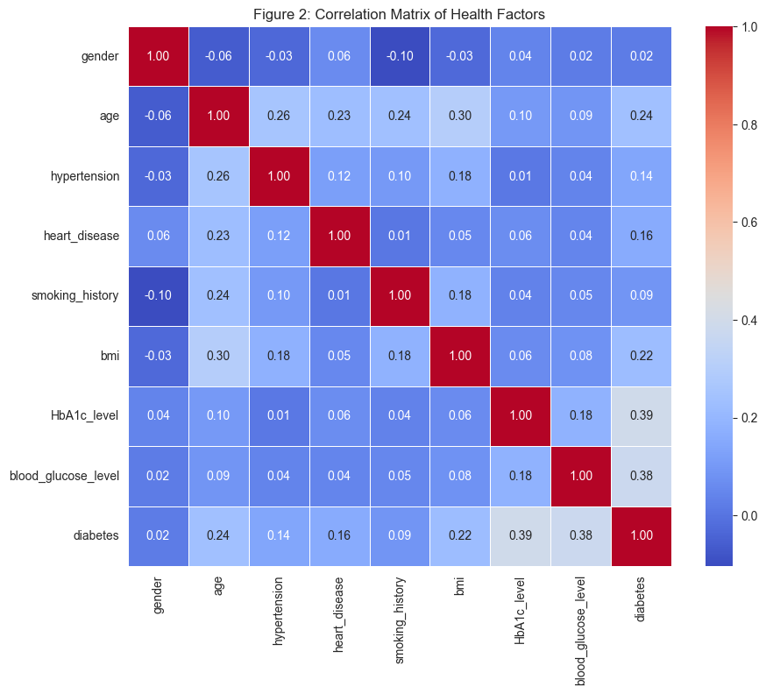
Since the correlation table further identifies Blood Sugar Level and HbA1c, we plotted them in box plots specifically. The two groups are completely separated as observed in figure 3. Diabetic patients always show a elevated Blood Glucose Level – mostly over 126mg/dL and elevated HbA1c levels that are the non-diabetic group.
Figure 3
Comparison of Blood Glucose Levels between groups.
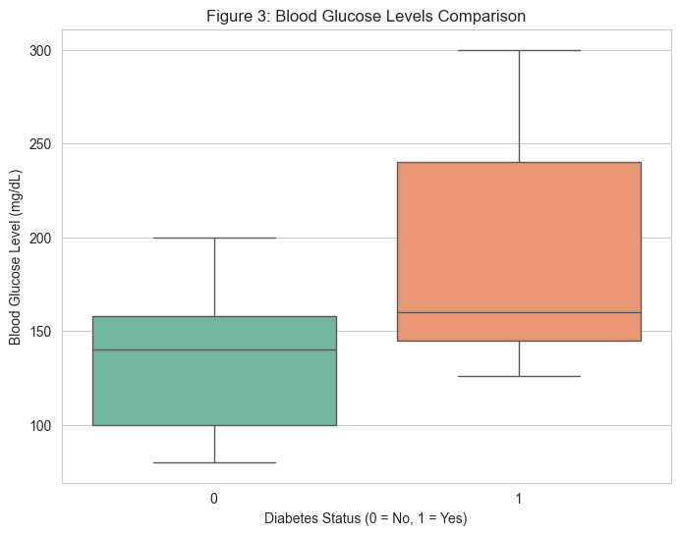
Statistical Analysis and Results
To scientifically test our model, we formulate statistical hypotheses as follows:
- The Null Hypothesis (H₀): There is no significant correlation between chosen variables (Glucose, HbA1c, Age, BMI) and the risk of diabetes.
- The Alternative Hypothesis (H₁): These particular metric of health are statistically significant predictors of risk of diabetes.
We analyzed our P-values after training our Logistic Regression model with the help of statsmodel in Python. The outcome of the analysis provides us with P-values of 0.000 of both Glucose and HbA1c which is significantly lower than 0.05 standard alpha level. Hence, we reject the null hypothesis to statistically prove there is absolute relationship between diabetes and these predictors.
We divide our data into 80/20 percent training and testing sets respectively in terms of predictive power. We benchmark the three models, Random Forest model being the most accurate with 96.57 percent, and Logistic Regression with 95.77 percent and Decision Tree with 95.12 percent with least predictive power. But why we chose our own model is for the benefit that we can interpret the results by how we want to learn the risk of diabetes with increase in blood sugar levels in a linear fashion.
Discussion
Finally, our results are closely congruent with the study we were doing during our literature review. Similarly to Zou et al. (2018) purposed, we were successful because of feature selection. Data preparation was a important part in our model having better results and concentrating on the four important variables. This means we have a high accuracy from our model without excessive complication in the model. Close relation between positive diagnosis and Hb1Ac levels is the reason to keep the medical standards.
Nonetheless, our analysis identifies another problem, the imbalance in classes. Due to the significantly lower number of diabetic patients in the data compared to healthy patients, our model necessarily had a higher predictive power on the healthy patients opposed to diabetic ones. Which could pose and issue because of the false negative rate that requires attention.

Conclusion
We were able to show how machine learning models have the potential to identify the diabetes risks with just regular healthcare records quite accurately. We have achieved our goal of choosing the appropriate dataset, cleaning the dataset through EDA and developing a prediction model to test our hypothesis. The next step we have in the future is to create a user interface that doctors can use early and add these four metrics to get a risk probability of patients in real time.

References
Lai, H., Huang, H., Keshavjee, K., Guergachi, A., & Gao, X. (2019). Predictive models for diabetes mellitus using machine learning techniques. BMC Endocrine Disorders, 19(1), 101. https://doi.org/10.1186/s12902-019-0436-6
Sarwar, M. A., Kamal, N., Hamid, W., & Shah, M. A. (2018). Prediction of diabetes using machine learning algorithms in healthcare. 2018 24th International Conference on Automation and Computing (ICAC), 1–6. https://doi.org/10.23919/IConAC.2018.8748992
Sisodia, D., & Sisodia, D. S. (2018). Prediction of diabetes using classification algorithms. Procedia Computer Science, 132, 1578–1585. https://doi.org/10.1016/j.procs.2018.05.122
Zou, Q., Qu, K., Luo, Y., Yin, D., Ju, Y., & Tang, H. (2018). Predicting diabetes mellitus with machine learning techniques. Frontiers in Genetics, 9, 515. https://doi.org/10.3389/fgene.2018.00515

