Sun Haven: More Mana

Phung Tran

2024-11-30

# Introduction

Sun Haven is a farming rpg similar to more popular titles such as Stardew Valley and Harvest Moon. Players must balance there time between farming, crafting, and exploration to improve their farm and player stats. By permanently boosting your stats, such as mana, players can optimize there gameplay.

To permanently boost your mana stat, there are many events or random objects that the player can find. However, the most mainline way to do this would be to eat. Whether it be foragables or cooked foods, eating is the most basic way to raise mana, making it important to manage your resources. Specifically because having more mana let’s you cast spells that make farming/combat and traveling more efficient.

Whether its after the first year of game play or beginning of the game, having this information will save resources for making more storage containers and saves space in your home. Just like other games in this genre, you need supplies and space to create the storage. While the game might give you three homes/farms to travel through, those same resources can be used for other crafts such as weapons/armor and furnace materials.

It can be hard to keep track of what foods are the most ideal to constantly stack up on. This also means you have to mine more ore and wood, with wood specifically needing more time to regrow. By looking through the charts presented, we can get useful knowledge about how to proceed with resource management to increase mana to optimize game play

# Loading libraires used  
  
library(tidyverse) # Loads R packages for data manipulation and visualization  
library(ggplot2) # Used to create graphs/charts  
library(janitor) # Used to help clean data   
library(wesanderson) # Color palettes from Wes Anderson movies   
library(extrafont) # Loaded in more fonts   
library(gridExtra) # Create a 2x2 grid for plots  
library(grid) # Used to change font for gridExtra  
library(cowplot) # Clean

# Loading in data that will be used  
  
cooked_food <- read.csv('Sun Haven Cooked Food.csv') # All cooked meals in Sun Haven game  
  
animal_product <- read.csv('Sun Haven Farm Animal.csv') # Ranch animals  
  
fish <- read.csv("Sun Haven Fish.csv") # All fish in game  
  
foragables <- read.csv('Sun Haven Foragables.csv') # All foragables in game  
  
crops <- read.csv('Sun Haven Crops.csv') # All crops in game

# Data Collection

I collected my own data for this project, making data clean up an important part of this project. Information was complied from two wikis

<https://sun-haven.fandom.com/wiki/Sun_Haven_Wiki> <https://sunhaven.wiki.gg/wiki/Sun_Haven_Wiki>

as well as my own save file

The game is still fairly new, with updates still being pushed. Numeric columns in the cleaned data were updated in micropatches but wikis had not been.

While using “csv_” is the best choice, I had first created it with “csv.”. By doing so, the code to clean up is a bit more bloated than necessary. Different versions of “NA” has been appropiateky replaced for future codes to be handeled correctly. Not all files were used in the end, however, they were still kept in to show the amount of consideration that I had to put in collecting and scraping the data.

# Data Analysis

By looking at crops grown in the starting town, Sun Haven, that can only be grown in the Spring and any season, for first play through of the game, players can figure out which crops will be more cost efficient. Items that were categorized as trees and flowers were filtered out. The reason being, flowers are not used in any recipes and fruits from trees can be found everywhere for free around town while crops have tp be grown by the player. While this plot can be used to find crops to grow to maximize profits, we want to looks at the cheapest seeds we can buy as a new player, and then, crops that would be best to grow after first year gameplay.

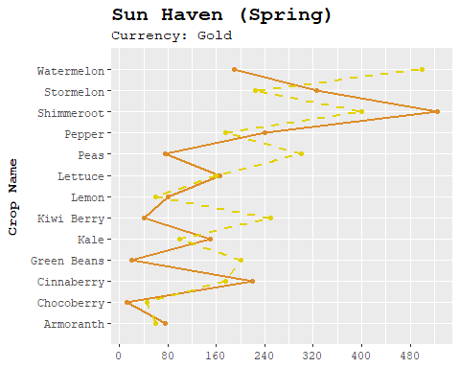

## town category name season growth_time yield currency sell_price  
## 1 Sun Haven Crop Chocoberry Spring 6 3 Gold 12  
## 2 Sun Haven Crop Green Beans Spring 12 1 Gold 20  
## 3 Sun Haven Crop Kiwi Berry Spring 8 1 Gold 40  
## seed_price max_harvest profit_per_day x x_1 x_2  
## 1 45 1 -1.50 <NA> <NA>   
## 2 200 16 4.44 <NA> <NA> All crop proces minus 10  
## 3 250 10 5.77 <NA> <NA>

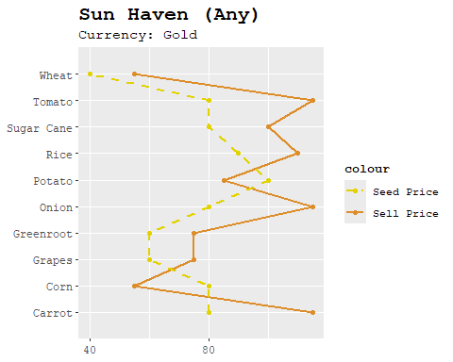

For spring/any seaosn during first time gameplay, the top 3 cheapest crops are going to be Chocoberry (45 Gold) , Green Beans (200 Gold) , and Kiwi Berry (250 Gold).

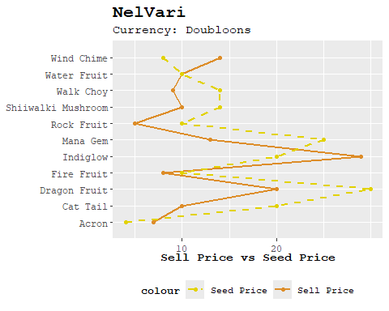

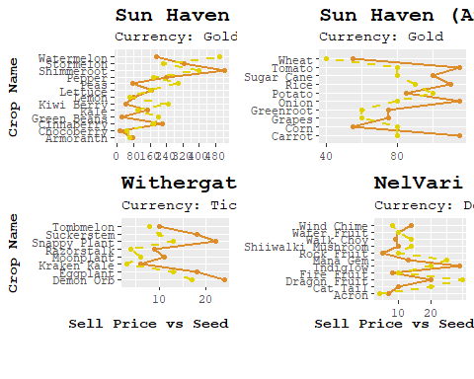

After first year gameplay, players can choose crops from all the towns in the game, which includes Withergate and Nel’Vari, as well as consider some of the pricier crops available to them from Sun Haven alone shown in the table below.

## town category name season growth_time yield currency  
## 1 Sun Haven Crop Pumpkin Fall 18 1 Gold  
## 2 Sun Haven Crop Shimmeroot Spring 14 1 Gold  
## 3 Sun Haven Crop Pythagorean Berry Winter 13 1 Gold  
## sell_price seed_price max_harvest profit_per_day x x_1 x_2  
## 1 575 300 1 15.28 <NA> <NA>   
## 2 525 400 1 8.93 <NA> <NA>   
## 3 512 345 1 12.85 <NA> <NA>

Notice the currency for the two other towns are different from the starter town. Later on, we will be using this information to filter down the cooked food items we want to focus on.

Next, we can look at all the stations that is used to cook food.

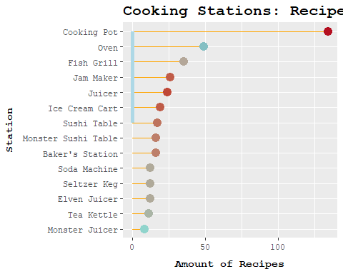

From Sushi table to cooking pot is all the stations available to you in the starting town. You can tell that one of the starting station, cooking pot, has the most cooked food that are available to players at the beginning of the game.

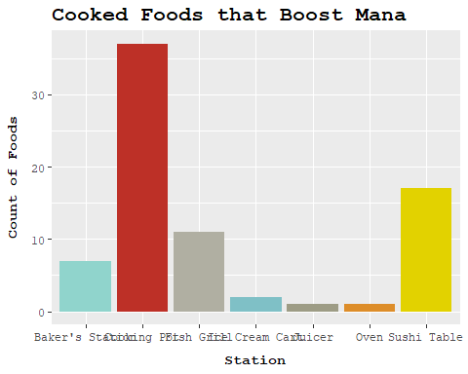

By narrowing it down to only looking at recipes that permanently boost players mana, it can be seen that the cooking pot still has the most options available to players. Meaning that whether or not players are doing their first gameplay, growing crops from Sun Haven is going to be beneficial in boosting the mana.stat permanently.

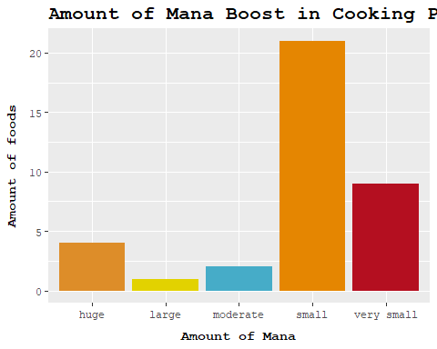

The Cooking Pot has a clear bias towards small stat boosts, which could indicate that it is designed to provide incremental boosts to players for first year playthrough. However, there is a noticeable amount of recipes that offer huge permanent stat boosts, which is geared towards after first year playthrough.

## # A tibble: 4 × 8  
## station item currency stat stat_boost ingredient_1 ingredient_2 ingredient_3  
## <chr> <chr> <chr> <chr> <chr> <chr> <chr> <chr>   
## 1 Cookin… Gold… Mana Orb Mana huge Golden Fire… Noodles Greenspice   
## 2 Cookin… Gold… Mana Orb Mana huge Golden Fath… Mushroom Seaweed   
## 3 Cookin… Gold… Mana Orb Mana huge Golden Mush… Bread Tomato   
## 4 Cookin… Gold… Mana Orb Mana huge Golden Brin… Golden Tren… Golden Naut…

These “huge” mana stat boost items contain “Golden” in the name as well as ingredients listed that are not possible to obtain early on. With the currency being “Mana Orb”, the town Nel’Vari would have to be available to the player. It can be implied, when “Golden” is excluded from the search, it becomes clear that there are no beginner-friendly recipes for huge mana stat boosts in the Cooking Pot at the start of the game.

By filtering the search down further, to include only crops from Spring or Any season players can look at more early game accessible items that are easier to obtain. This will help significantly with boosting mana stat efficiently early on so players do not overstock on multiple items and clutter their farm layout.

The filtered data set shows the top 10 recipes for mana boosts that include Spring crops as ingredients. It has also been filtered down by removing any crop whose currency is anything other “Gold”, as it’s going to be the first currency available for players to use for awhile.

## # A tibble: 10 × 7  
## station item currency stat_boost ingredient_1 ingredient_2 ingredient_3  
## <chr> <chr> <chr> <chr> <chr> <chr> <chr>   
## 1 Cooking Pot Blueb… Gold small Blueberry Lettuce <NA>   
## 2 Cooking Pot Pickl… Gold small Lettuce Tomato Greenspice   
## 3 Cooking Pot Sesam… Gold small Rice Seaweed <NA>   
## 4 Cooking Pot Mochi Gold small Rice Sugar <NA>   
## 5 Cooking Pot Lasag… Gold moderate Noodles Tomato Cheese   
## 6 Cooking Pot Apple… Gold small Apple Sugar Cinnaberry   
## 7 Cooking Pot Cinna… Gold small Cinnaberry Apple Sugar   
## 8 Cooking Pot BLT Gold small Bread Lettuce Tomato   
## 9 Cooking Pot Poke … Gold small Salmon Tuna Rice   
## 10 Cooking Pot Churr… Gold very small Cinnaberry Flour Sugar

For new players starting in Sun Haven, filtering recipes by the Sun Haven (starting town) and Spring season gives players insight into what is accessible to them to permanently increase their mana stat. With a more filtered and focused data, this helps players manage resources better and help stat progression, while also optimizing their gameplay

As players get pass their first year, a more generalized search of recipes can help them optimize resource management. By considering all available recipes, players can find the data useful towards long term goals and make better decisions in how they would like to use their time and resources.

In both scenarios, players can use the information to better organize their farm and storage layouts. This strategic planning allows for a more efficient gameplay, allowing players to use their increased permanent mana to cast spells to maximize their crops to recipe yield, as well as profits and usage of attack spells to get through the fighting aspects of the game.