External Function Documentation
Contents
License 1
Compatibility and Configuring 2
Cohort Overview 3
COHORT CONTROL(level, time in group, inflow at 0, elmcount, want cum) 4
COHORT SHIFT 5
Initial Population 6
Population Pyramids and other things 7
COHORT COUNT(level, from time, to time) 7
COHORT CONTROL Function Variations 10
COHORT CONTROL INFLOW(level, time in group, inflow everywhere, inflow at 0, elmcount, want cum) 10
COHORT CONTROL TRANSFER(level, time in group, inflow everywhere, source level, inflow at 0, elmcount, want cum) 10
COHORT_CONTROL_INIT(level, time in group, init level, init time in group, inflow at 0, elmcount, want cum) 11
Prevalence computations 11
COHORT SS PREVALENCE COMP(target, on_pop ,incidence_rate, remission_rate, mortality_rate, grouplen , elmcount) 12
COHORT SSMC PREVALENCE COMP(target, on_pop ,incidence_rate, remission_rate, progression_rate, mortality_rate, grouplen ) 13
COMPUTE COPREVALENCE(count, dependence, total pop, x at 25, x at 75) 13
COMPUTE COPREV 2(prevalence, dependence) 14
LIFE EXPECTANCY(mortality, time_in_group, elmcount) 14
LPBASED INCIDENCE (maxval ,prevalence,intercept ,age_slope, dependence_matrix ,age) 14
Source Code Notes 15

License
Copyright (c) 2012 Duke-NUS Graduate Medical School
Permission is hereby granted, free of charge, to any person obtaining a copy of this software and associated documentation files (the "Software"), to deal in the Software without restriction, including without limitation the rights to use, copy, modify, merge, publish, distribute, sublicense, and/or sell copies of the Software, and to permit persons to whom the Software is furnished to do so, subject to the following conditions:
The above copyright notice and this permission notice shall be included in all copies or substantial portions of the Software.
THE SOFTWARE IS PROVIDED "AS IS", WITHOUT WARRANTY OF ANY KIND, EXPRESS OR IMPLIED, INCLUDING BUT NOT LIMITED TO THE WARRANTIES OF MERCHANTABILITY, FITNESS FOR A PARTICULAR PURPOSE AND NONINFRINGEMENT. IN NO EVENT SHALL THE AUTHORS OR COPYRIGHT HOLDERS BE LIABLE FOR ANY CLAIM, DAMAGES OR OTHER LIABILITY, WHETHER IN AN ACTION OF CONTRACT, TORT OR OTHERWISE, ARISING FROM, OUT OF OR IN CONNECTION WITH THE SOFTWARE OR THE USE OR OTHER DEALINGS IN THE SOFTWARE.

Compatibility and Configuring
The external functions documented here were written to work with Vensim DSS version 5.10e 5.11, 5.11a or 6.0. They may work with later versions of Vensim and could also be made to work with earlier versions of Vensim by recompiling with the appropriate vensim.h file.
To make use of them with other software will probably require significant modification as the data structures are likely to be substantially different. The core algorithms should, however, be transferable and are explicitly delineated in the source code (see notes at end).
To use the functions you must first extract cohort_control06.dll (or cohort_control06dp.dll if you are using the double precision version of Vensim DSS) from its archive and place it in an easy to remember location. A good choice would be \Users\Public\Vensim – this folder should exist if Vensim is installed. Then in Vensim select Tools>Options and click on the Startup tab.

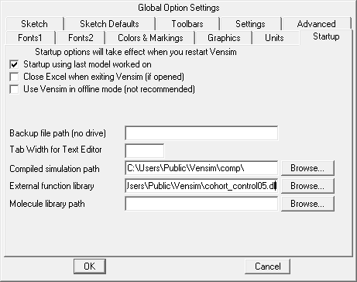
Click the browse button to the right of “External function library” and select cohort_control06.dll (05 shown in screenshot) from the location you have placed it. Click OK.
Now you should be able to use a model that was created using external functions.

Cohort Overview
The cohorting functions are implemented as external functions in Vensim which means you first need to point Vensim at the external function library. This file is called cohort_control02.dll (02 is the version number). It is in the same directory as this document. To use it go to Tools>Options in the Vensim menu, click on Startup, then the Browse… button to the right of “External Function Library” and select the files.

These functions are used very much like the way the SHIFT IF TRUE function is used, but the shifting is continuous. We start with a model like

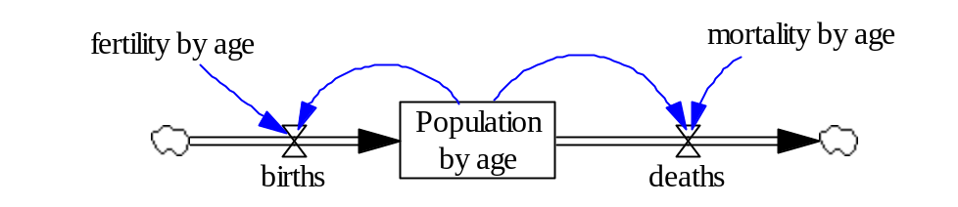
This is a perfectly ordinary model and is suited to be completed as an ageing chain, by using the SHIFT IF TRUE function or by using the COHORT_CONTROL function. To make it more interesting lets set the age subscript up as
Age: AgeUnder1,Age1To14,Age15To44,Age45To67,Age68AndOver (1)
Because these age groups are of different sizes, the option of using SHIFT IF TRUE is no longer available. We can either go for the ageing chain (an exercise for the reader if you are so inclined) or use the COHORT CONTROL function. To set up for the COHORT CONTROL function we first make sure that births flow into only the AgeUnder1 cohort and that all cohorts have deaths. We define
AgeOlder : Age1To14,Age15To44,Age45To67,Age68AndOver (2)
Note that in the model we actually define AgeOlder as above then define Age as AgeUnder1,AgeOlder. This gives the same results as equation 1 but makes it slightly easier to change the grouping.
Now for AgeUnder1 we have
Population by age[AgeUnder1] = INTEG(births-deaths[AgeUnder1], initial population[AgeUnder1]) (3)
While for the remaining ages we use
Population by age[AgeOlder] = INTEG(-deaths[AgeOlder],initial population[AgeOlder]) (4)
This is the same as the method when using a SHIFT IF TRUE function.
Except for initialization (which we will return to) the remaining equations are the obvious ones. If we were to do nothing else then all the age groups except AgeUnder1 would simply diminish to 0. So, we need to add in our COHORT CONTROL function which is always paired with a COHORT SHIFT function.

COHORT CONTROL(level, time in group, inflow at 0, elmcount, want cum)
level is the model level and it must be subscripted with the last subscript being age (so that you would use gender,age if the model is divided by gender).
time in group is a model Constant or Initial variable that contains the number of time periods each subscript element represents. In or example it will be 1,14,30,23 and an arbitrary number since the A68Over do not ever leave except through mortality. The final subscript on this variable must be the same as the final subscript on level.
inflow at 0 represents the flow into the level. This can be a variable or an expression (if there are multiple inflows). This is only the inflow into the first cohort. If there are additional inflows into and outflows from other cohorts these are not referenced here. For example we might have immigration and emigration and these would be included in the equations for population, but not in the COHORT CONTROL function.
elmcount is the number of cohort groups. This is normally just ELMCOUNT(subscript).
want cum should almost always be 1. It may be possible to use 0 when tracking attributes rather than populations, but I haven’t made sure this works as yet.
What the cohort control function does is take level which is already divided into cohorts (5 in our example) and create sub cohorts from those where each sub cohort is the same length as TIME STEP. In our example using a time step of 1/8 this would mean 8 sub cohorts for AgeUnder1, 112 for Age2To14 and so on. We don’t ever need to deal with these sub cohorts – the function takes care of them for us.
NOTE This must be paired with:
COHORT SHIFT(level)
level is the same model variable used in the COHORT CONTROL function.
Function pairing is required to control computational sequence. The COHORT SHIFT function is always called first and changes the levels. The COHORT CONTROL function then records information for the next shift. This doubling up is an artifact of the way Vensim implements external functions that can change the values of their arguments (it would not be necessary in a native implementation of the function).
When the model is initialized, the COHORT CONTROL function sets up the sub cohorts so that the transition from one cohort to the next is relatively smooth. This is done by trying to make the sub cohorts adjacent to the next cohort group equal to the average value of the two cohorts.
Then, as time moves forward, the flows Vensim computes for the cohorts are distributed across the sub cohorts. If there is a net outflow it is made proportional to the content of the sub cohorts. If there is a net inflow it is allocated evenly across the sub cohorts. The COHORT CONTROL INFLOW function allows you to split out an inflow to change this computation.

To implement the COHORT CONTROL function the model becomes

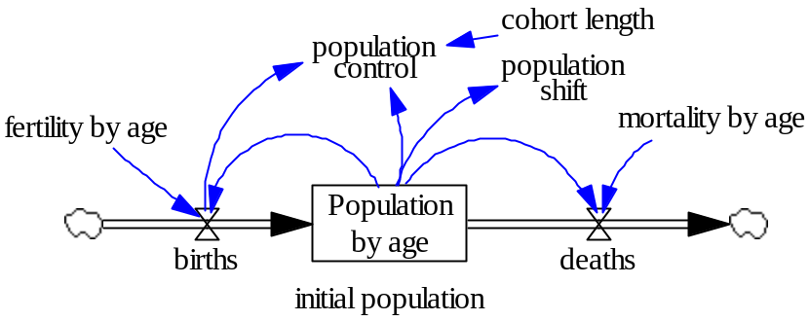
The population control equation is:
population control=COHORT CONTROL(Population by age[AgeUnder1],
cohort length[AgeUnder1], births, ELMCOUNT(age), 1) (5a)
The population shift equation is:
population shift=COHORT SHIFT(Population by age[AgeUnder1) (5b )

and the cohort lengths are set at 1,14,30,23,1. The final 1 is a convention I use. The actual value of the last cohort length does not matter since there is no subdivision of the final cohort. Note that both of these functions are called without any subscript on the left and with the first element of the subscript on the right. In general these equations will have one less subscript then the level being acted upon.

Initial Population
I have set the fertility at 0.25 for the 15 to 44 year olds and 0 for everyone else. With mortality of 0.1,0.01,0.03,0.1 and 0.4 this gives a population growing at about 5%. Clearly it is not possible to start the model in equilibrium given these assumptions. However, we can start the model so that the relative share of each of the population groups is the same. Thus I set initial population to: 0.0705,0.6082,0.3061,0.0151,0.000157. These numbers come from simulating the model and observing. I leave it as an exercise to come up with an analytical expression.
If we simulate the model and look at population by age we get
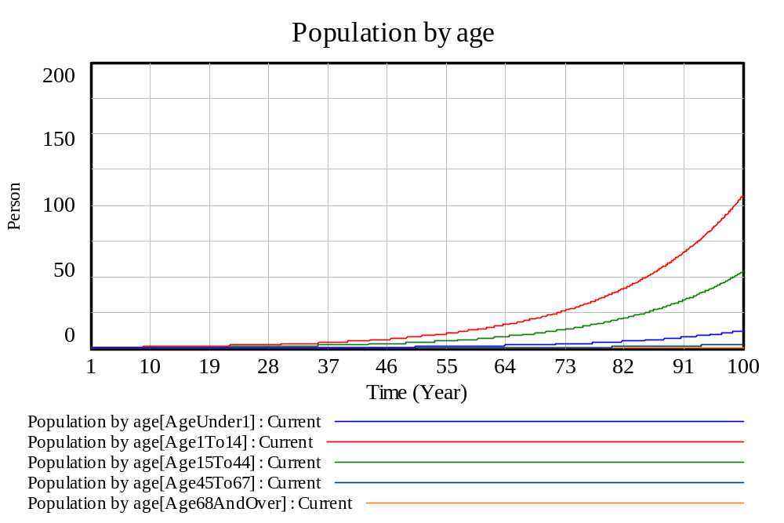
And bar graphs at 0 and 62.5 gives
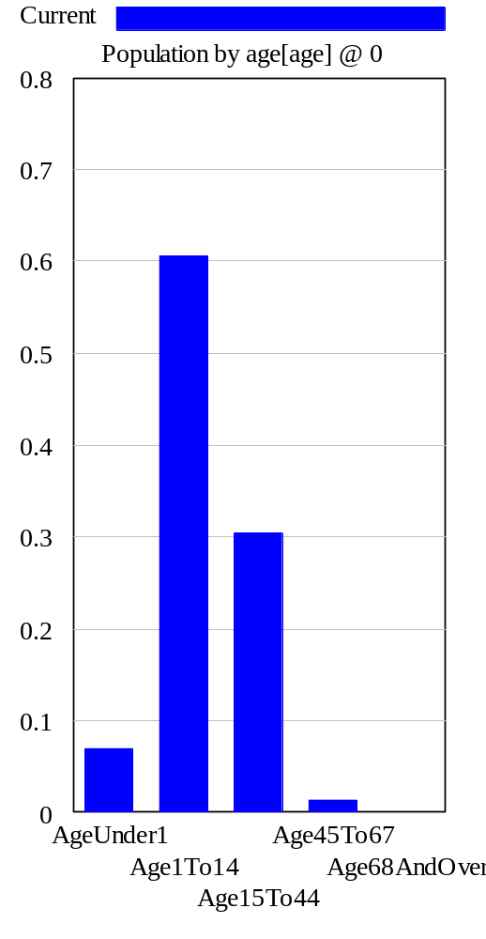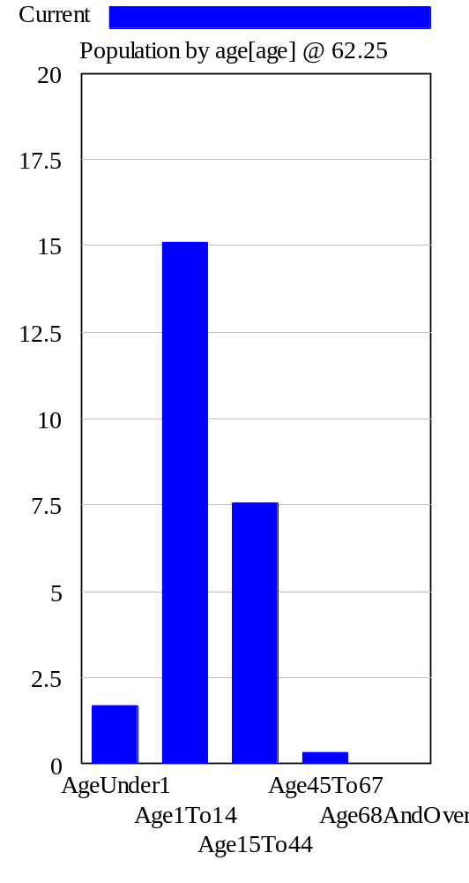
Which are identical except for the scaling.

Population Pyramids and other things
What about a population pyramid? One of the advantages of the annual cohorts is that they allow things like population pyramids. Even though we are using very granular cohorts, we actually do have this annual breakdown available via a function called COHORT COUNT.

COHORT COUNT(level, from time, to time)
level is the level that is used as the first argument to a COHORT CONTROL function.
from time is the starting point to count membership
to time is the ending point to count membership
Using COHORT COUNT(population[AgeUnder1],13,14) will count all the people between 13 and 14. (Actually the function will do [13,14) skipping the actual 14.0 entry so that by putting in successive intervals you get the expected non-overlapping results.)
Since we can get the annual breakdown, we can do a population pyramid. Defining
PAge : PA68,PA67,PA66,….PA2,PA1,PA0 (6)
we use
population for pyramid[PAge]= COHORT COUNT(
Population by age[AgeUnder1], ELMCOUNT(PAge)-PAge ,
ELMCOUNT(PAge)-PAge+1) (7)
Giving the population pyramid
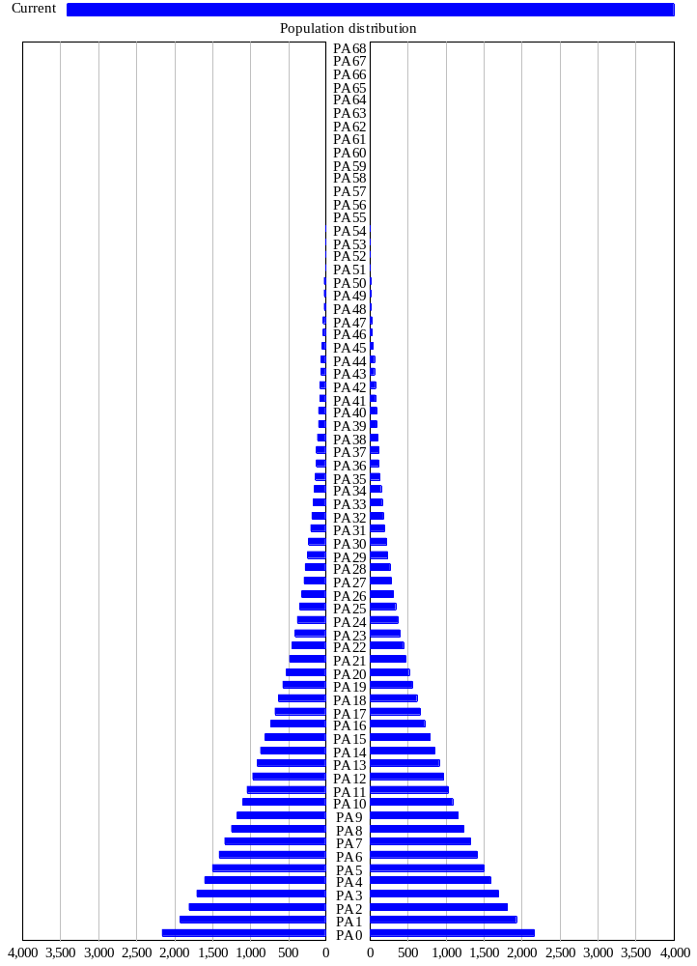
Note that this is no longer inverted. By defining the PAge subscript to count down and then grabbing the sections in reverse order we can get the upward aging pyramid. The only drawbacks are that all the entries for PAge have to be entered and the COUNT equation is a little bit confusing.
This computation, along with a couple of other things is stored in cohort_control_counting.mdl.

COHORT CONTROL Function Variations

COHORT CONTROL INFLOW(level, time in group, inflow everywhere, inflow at 0, elmcount, want cum)
inflow everywhere is a variable (not an expression) with the same final subscript as level. The remaining change, normally a net outflow, is subtracted from the sub cohort members proportional to their values. Then the inflow everywhere values (assumed positive) are distributed evenly across the sub cohorts.
The difference between this and the basic function are likely to be subtle, but might be important. A good example would be
Population shift = COHORT CONTROL INFLOW(Resident Population[AG0To4],
cohort lengths[AG0To4], immigrating by age[AG0To4],births,
ELMCOUNT(AgeGrouped),1 ) (8)

Here we allow both immigration and emigration and this will force both emigration and deaths to pull out proportionately from the population group. With annual cohorts this is unlikely to matter, but if there are 5 year groupings (or longer) of people it may be important.
Note: Must be paired with COHORT SHIFT.

COHORT CONTROL TRANSFER(level, time in group, inflow everywhere, source level, inflow at 0, elmcount, want cum)
source level is a variable (not an expression) with the same final subscript as inflow everywhere. source level must also be used in a COHORT CONTROL function. When inflow everywhere is distributed, it will be done by referring back to source level and doing so proportionally to the values therein. For example:
mild d pop shift=
COHORT CONTROL TRANSFER( mild dementia population[AG60To64] ,
cohort lengths[AG60To64],mild onset[AG60To64] ,
incipient dementia population[AG60To64] ,
0, ELMCOUNT(elderly), 1) (9)
Here the milld dementia population is being increased as the result of an outflow from the incipient dementia population. The people age 68 to 68.2499 from the incipient population will add to people age 68 to 68.2499 in the mild population. This is potentially significant with dementia because of the steepness with which prevalence rises with age.

COHORT_CONTROL_INIT(level, time in group, init level, init time in group, inflow at 0, elmcount, want cum)
init level is the initialization level with a subscript that is more granular than the regular cohort groupings. For example we might use annual cohorts to initialize a model with 5 year or variable length cohorts.
init time in group is the amount of time in each of the more refined cohorts. This must have the same final subscript as init level. In addition init time in group must divide evenly into the time in group values. If time in group were all 5 then a value of init time in group of 2 would not work. On the other hand, if time in group were 3,4 then init time in group of 1,1,1,2,2 would work. Most likely, though, init time in group will be uniformly 1.

Note: Must be paired with COHORT SHIFT.

Prevalence computations
Prevalence is the number of individuals within a population that have a given attribute or condition. The computation of prevalence is very similar to the classic coflow, except that the outflow from the number of people with a condition may not be strictly proportional to the number of people flowing out of the population (dying or emigrating). Most typically there is excess mortality associated with a condition. Care needs to be taken to ensure that any excess drawdown from a particular condition is reflected in the draw down from the general population.
Initializing the number of people with a condition is tricky when working with the COHORT CONTROL functions because the distribution of people having a condition will reflect the history of when they developed that condition. Simply initializing the level of people with a condition, and letting the COHORT CONTROL function manage the distribution within the sub cohorts is likely to yield unsatisfactory results.
To get around this there is an external function that initializes the sub cohorts in such a way that, given the value for incidence and mortality at the time of initialization, they will be in equilibrium. This equilibrium assumption, while not really appropriate for achanging population, prevents the emergence of unstable behavior that can easily emerge (and persist as populations are shifted in time) when using a less granular initialization. These functions are definitely the recommended approach to initializing any model using COHORT CONTROL for which a secondary population is being shifted in parallel with the primary population.

The other function related to prevalence is COMPUTE COPREVALENCE which computes the co-prevalence index. This is a fairly simple function, but not quite doable in regular equations.

COHORT SS PREVALENCE COMP(target, on_pop ,incidence_rate, remission_rate, mortality_rate, grouplen , elmcount)
Initializes target so that the number of people in that variable relative to the total population will be consistent with a steady state number of people given the incidence, remission and mortality rates specified. The variable returns the total number of people, but its function is actually to change the initial value for the target.
NOTE/WARNING COHORT SS PREVALENCE COMP should only ever be used in an INITIAL function. Use in any other equation type will result in unpredictable behavior.
target is the level variable that is to be initialized. It must have at least one subscript on age which must be the final subscript (typically this would be subscripted by gender, condition and age). The left hand side variable in the equation should have 1 subscript fewer (ie not the last one) than target (typically gender and condition). target must be used in a COHORT CONTROL function.
on_pop is the population from which the target is being drawn. This must have the same last subscript (ie age) as target and must also be computed using a COHORT CONTROL function.
incidence_rate is the rate for movement from on_pop into target. The initial value of the rate is used in the computation.
remission_rate is the rate of remission in the disease. This may be 0, but must be a named variable with the same subscripts as target
mortality_rate is the excess mortality rate relative to mortality for the entire population. Using 0 for this is often a reasonable approximation. With multiple conditions by definition some of the values for this must be smaller than 0 and others larger than 0. Like remission, it must be a named variable. remission and mortality are used in exactly the same way by the function.
grouplen is the list of lengths for each age cohort subscripted by age.
elmcount is the number of elements in the age subscript. This is typically something like ELMCOUNT(AgeGroup) though it is possible to use the COHORT SS PREVALENCE COMP function on a contiguous subrange of a variable.
It is possible to cascade calls to COHORT SS PREVALENCE COMP. This can be done (for example) if the values for the number of people with one condition might influence the incidence of another condition. If this is done the first call must be used on the right hand side of the equation for the second call (again +0* is a good way to do this) to assure the correct computational order.
NOTE You may have to use the LHS variable from the COHORT CONTROL function for population inside of the equation to prevent simulation errors. To do this just add it after the function multiplied by 0. This will insure that the sub cohorts of the population are all initialized before COHORT SS PREVALENCE COMP is called.
NOTE – you may need to rename the shift variable on the population to precede the cohort control variable so that the COHORT SHIFT function is called before COHORT CONTROL.
NOTE Use only in an INITIAL function. target and on_pop must be used in COHORT CONTROL functions.

COHORT SSMC PREVALENCE COMP(target, on_pop ,incidence_rate, remission_rate, progression_rate, mortality_rate, grouplen )
This function is very similar to COHORT SS PREVALENCE COMP but allows for conditions that progress from one stage to another. For example, a model might have mild, moderate and sever dementia or no, 1-2, 3-5 and >5 ADL limitations.
Most of the description is the same as for the previous functions. Only changes for each argument are noted.
target must have at least two subscripts with the last two being the condition and age in that order.
on_pop no change.
incidence_rate last two subscripts same as target. If incidence_rate is 0 for all ages referencing a specific condition then that condition is treated as progressive. For a progressive condition all people with the condition come from progression through the prior stage (only the first stage has incidence).
remission_rate last two subscripts same as target.
progression_rate the fraction per time unit of people moving from a condition to the next condition in the sequence. For conditions that are not in sequence this is 0 for all ages. For conditions that are in sequence this is typically nonzero for all but the last condition in sequence. Note that for initialization this is ignored for a condition if, for any age, incidence_rate is nonzero. progression_rate must have the same subscripts as target.
mortality_rate must have the same subscripts as target.
grouplen no change.

The function works by checking for 0 incidence_rate across all subscripts. If this is found then the previous condition is used to populate the values for the current condition, and the values for the previous condition are adjusted downward accordingly.

COMPUTE COPREVALENCE(count, dependence, total pop, x at 25, x at 75)
Computes an average co prevalence (extent of overlapping conditions) for the population by using a logistic curve to select between the maximum possible coprevalence that could occur given the count of people with different conditions and the minimum coprevalence (usually 1) that could occur with these counts.
count is the number of people with each condition. It must be a subscripted variable with the condition as the last subscript
dependence is a vector that describes the type and relationship of sequential conditions. The type of 0 is used to denote risk factors that should not be treated as conditions for the purpose of computing coprevalence (such conditions might also have no mortality specific to them though this is not necessary).A value of 2 is used to denote a condition that is part of a sequence with the next condition. A value of 1 marks that last condition in a sequence, or a singular condition. dependence must have the same final subscript as count.
total pop is the total population against which the counts are being measured (no subscript or one less than count).
x at 25, x at 75 specifiy the points at which a 25% weight and 75% weight will be given to the maximum coprevalence. This allows adjustment of sensitivity to penetration into the population.

COMPUTE COPREV 2(prevalence, dependence)
Computes average co prevalence (extent of overlapping conditions) for the population by assuming independence among the individual prevalence values. This is simple than COMPUTE COPREVALENCE and returns very similar results. It simply enumerates all possible combinations of conditions to determine an average value.
prevalence is the prevalence of each condition. It must be a subscripted variable with the condition as the last subscript
dependence is a vector that describes the type and relationship of sequential conditions. The type of 0 is used to denote risk factors that should not be treated as conditions for the purpose of computing coprevalence (such conditions might also have no mortality specific to them though this is not necessary). A value of 2 is used to denote a condition that is part of a sequence with the next condition. A value of 1 marks that last condition in a sequence, or a singular condition. dependence must have the same final subscript as prevalence.

LIFE EXPECTANCY(mortality, time_in_group, elmcount)
Computes the remaining life expectancy given the mortality rates for populations grouped with any cohort. The life expectancy is computed as the expected time to death with age for each time unit selected at the 0.5 point and the terminal contribution as 1/mortality at the terminal age (not + 0.5). This can all be computed directly in equations but requires the addition of a fractional survivorship variable which makes it cumbersome.

To compute the life expectancy at a given age just use that age as the first subscript. For example
life expectancy at birth[gender]=LIFE EXPECTANCY(mortality rate[gender,AGInfant],
cohort lengths[AGInfant],ELMCOUNT(AgeGroup))
life expectancy at 45[gender]= LIFE EXPECTANCY(mortality rate[gender,AG45To49],
cohort lengths[AG45To49],ELMCOUNT(AgeGroup)+1-AG45To49)

LPBASED INCIDENCE (maxval ,prevalence,intercept ,age_slope, dependence_matrix ,age)
Computes the Logit Prevalence based incidence of risk factors and conditions given the current prevalence of risk factors and conditions along with age. This is an instantiation of the formula
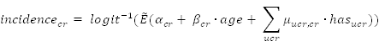
Where alpha is the intercept, beta the age_slope and mu the dependence_matrix. This function computed incidence for all value of a vector and that means the last subscript on the left hand side variable needs to be the condition/risk factor subscript (hereafter CCRF) and that this also needs to be the last subscript for prevalence, intercept and age_slope. The variable dependence_matrix needs to have CCRF as its last two subscripts. The first of these is the upstream or cause condition, the second the downstream or effect condition.
Basically this needs to be used in the form:
underlying incidence[AgeGroup,CCRF]=LPBASED INCIDENCE(
ui maxval[CCRF],prevalence[AgeGroup,CCRF], ui intercept[CCRF],
ui age alpha[CCRF], ui condition alpha[CCRF,CCRF], age[AgeGroup])
where any additional subscripts are added before CCRF. Note that ui condition alpha[CCRF,CCRF] appears with repeated CCRF subscripts. This is a convention in Vensim for functions that are called self looping. What is passed to the external is actually the first element of CCRF and then the remaining elements are determined inside the external function.

**************************************************************
**************************************************************

Source Code Notes
The source code is call cohort_control.c. There is a MSVC version 6 project that can be used to build the DLL that Vensim will access and it is called venext.dsp. This can be built with any modernish C compiler but requires the supporting files that ship with Vensim DSS to be compiled.

