Analytics

Open report:
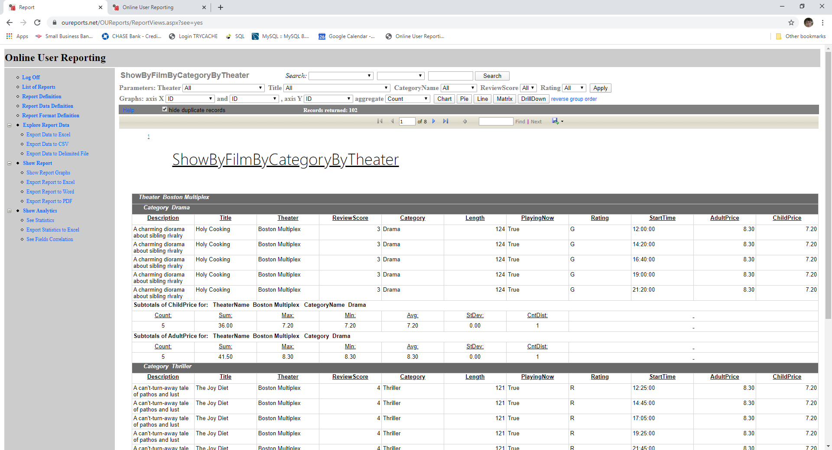

Click Show Analytics from the left menu and see links to matrix, graphs, and drilldown reports:
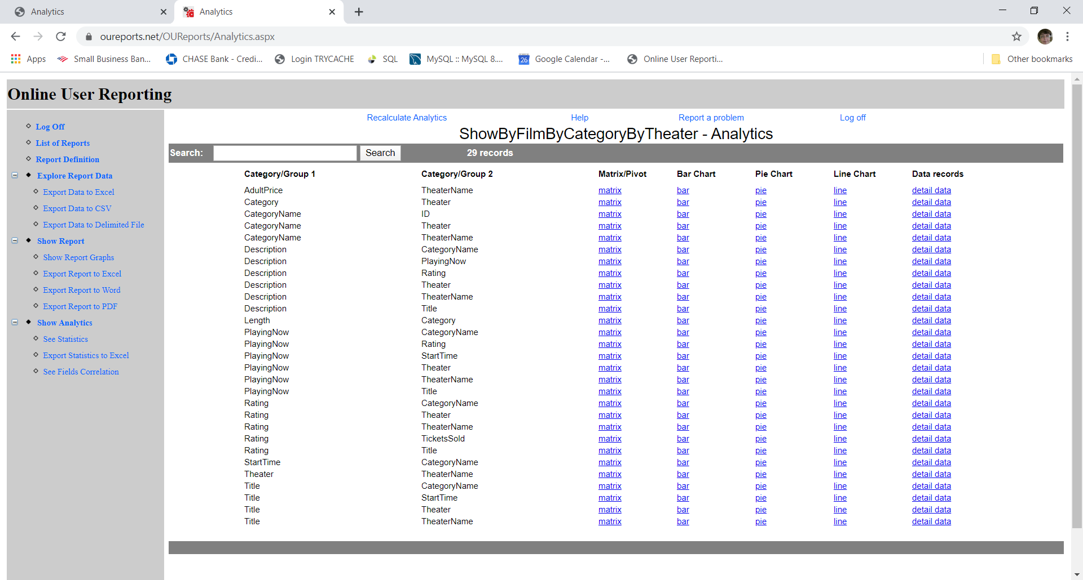

Clicking some drilldown link will open drilldown report with grouping by selected Group1 and Group2:
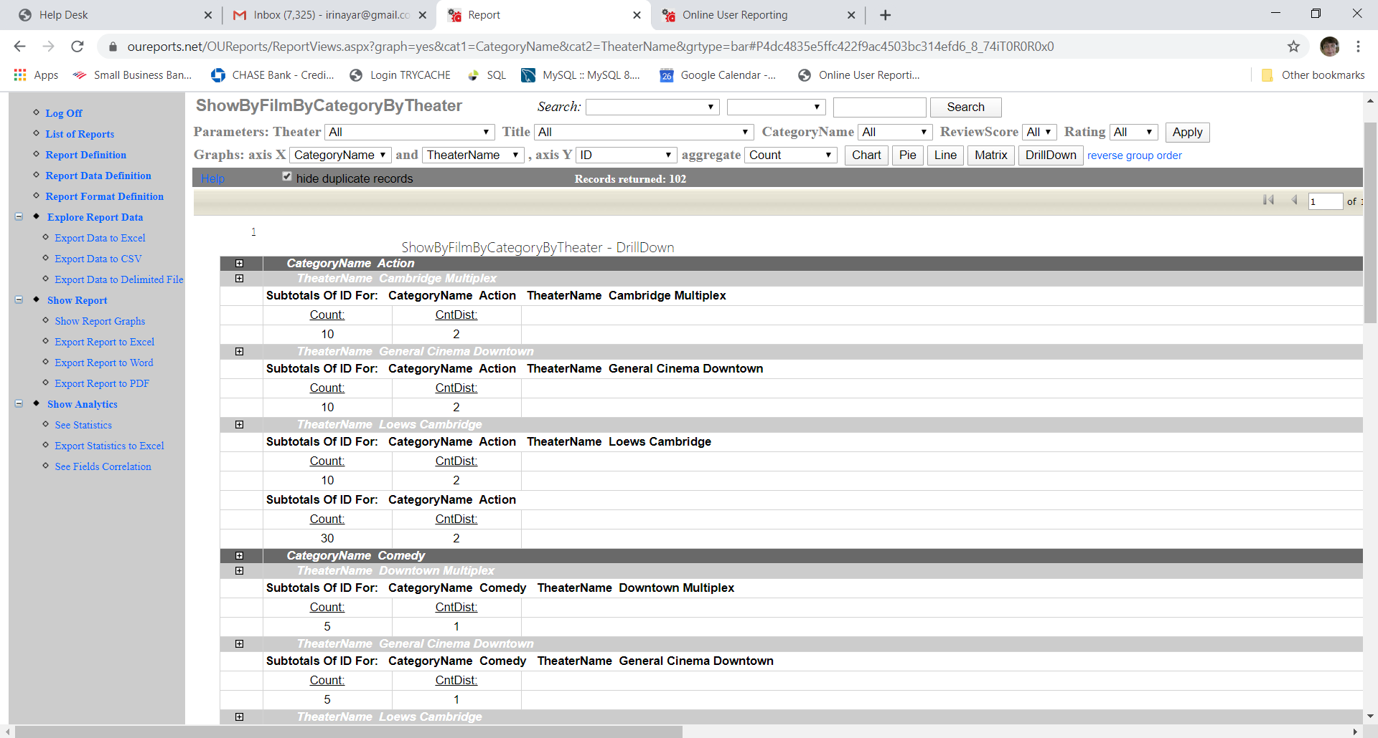
Expand by clicking “+” sign:
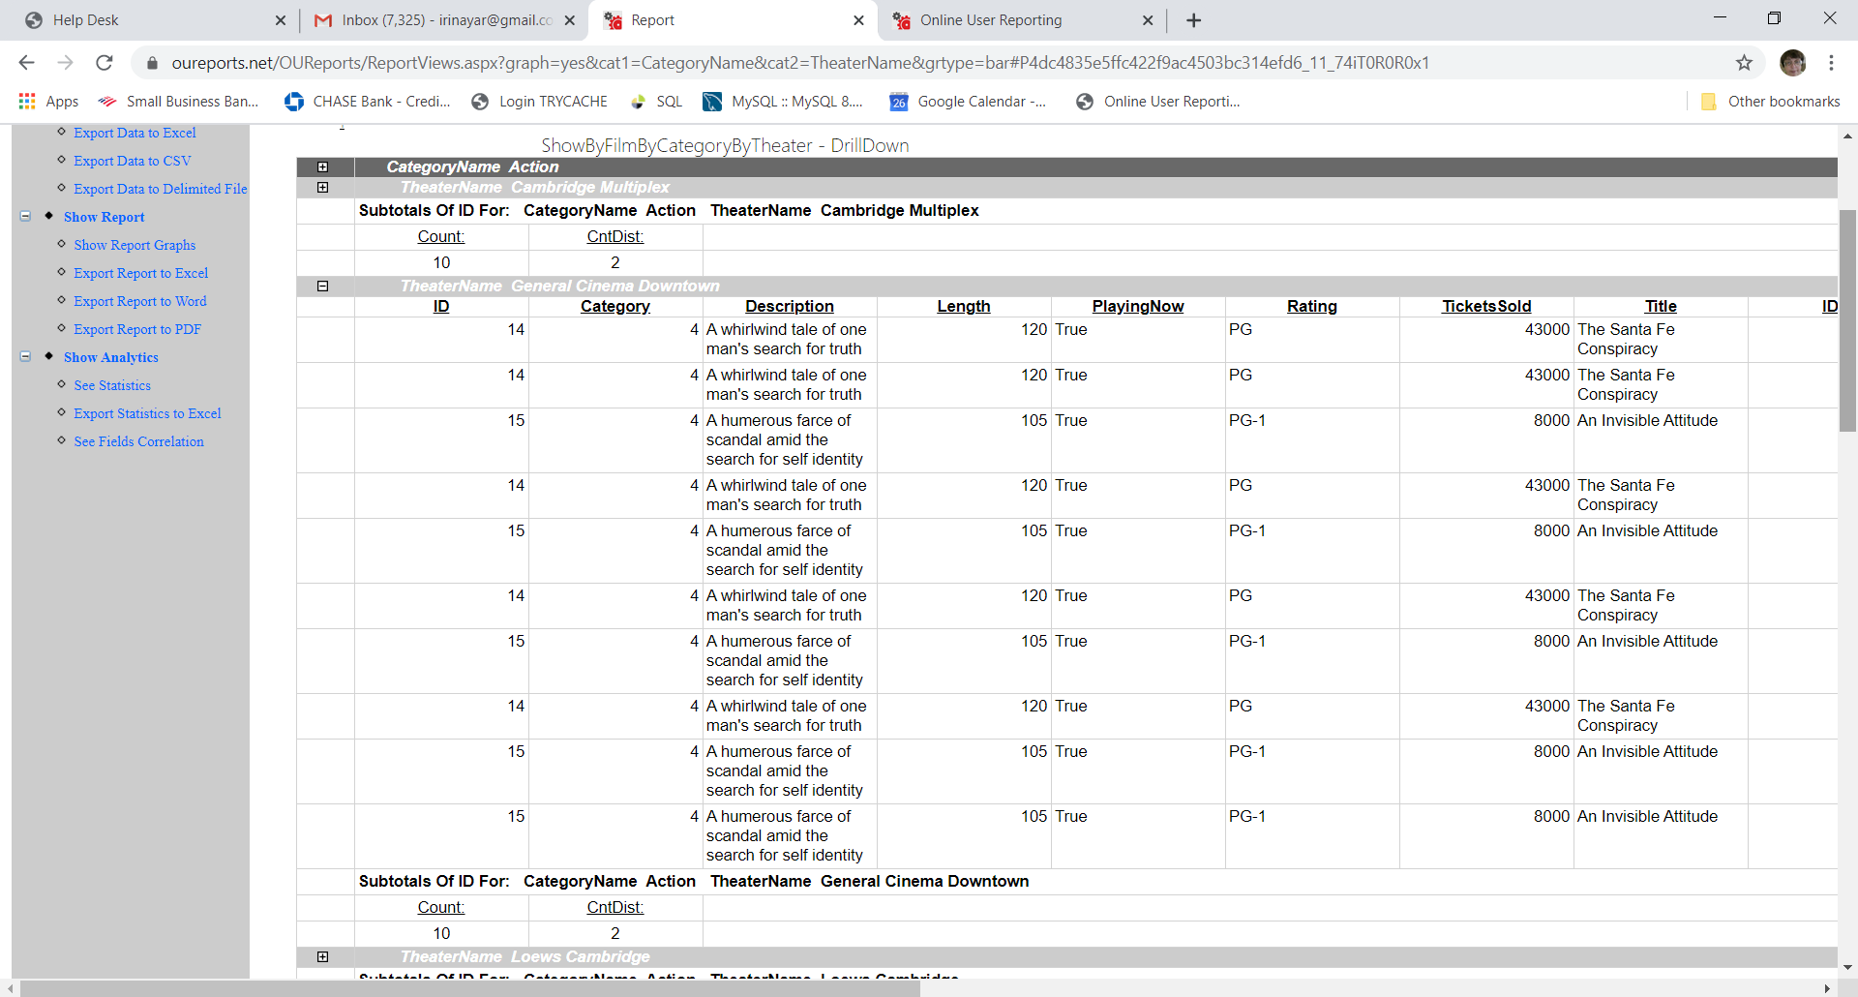

Clicking some matrix link will open matrix report with links to drilldown reports in each cell:
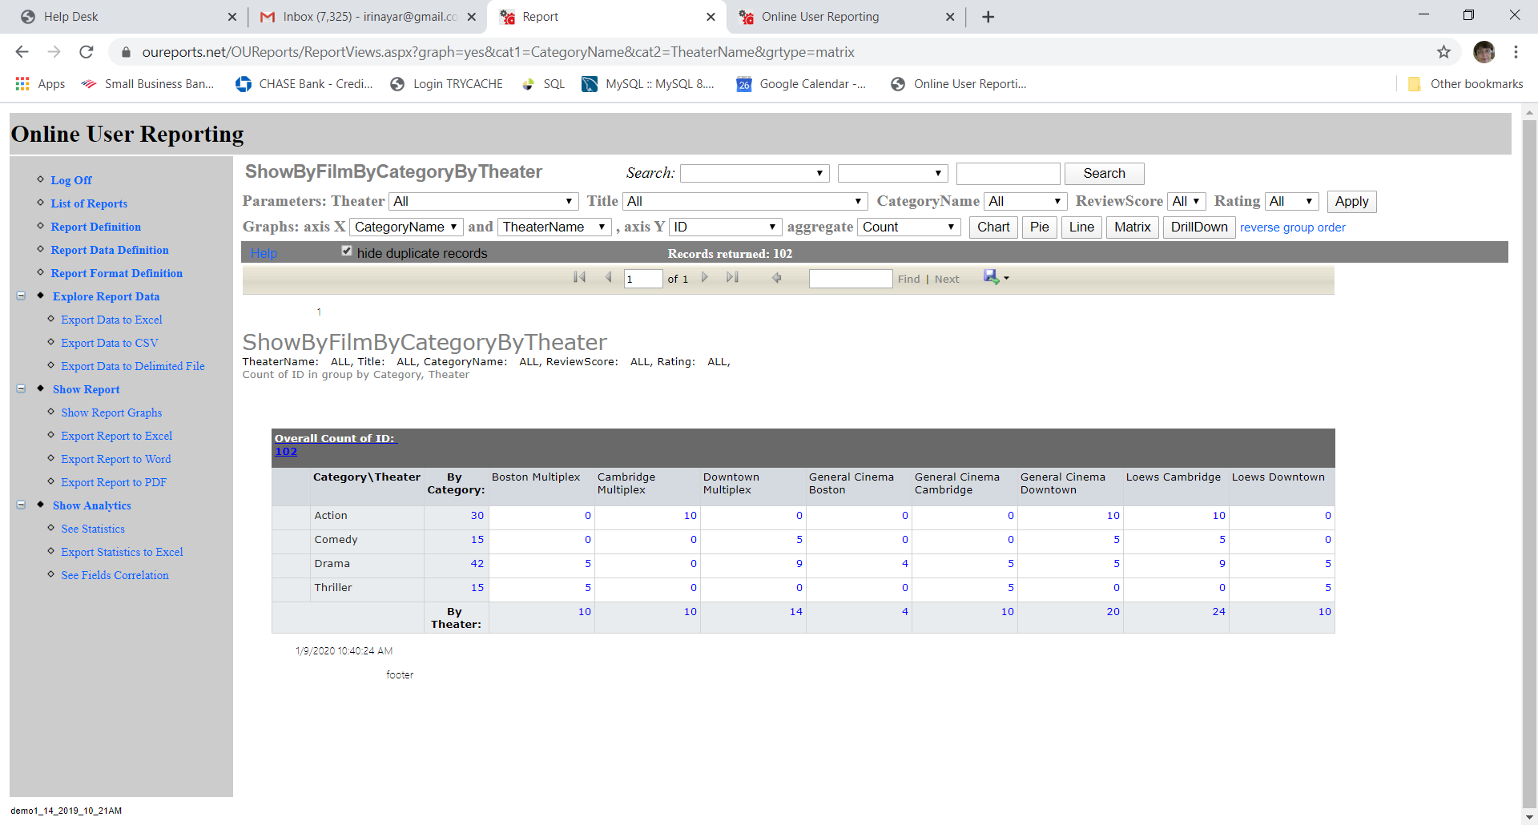

Click the “bar” button from this page or link from matrix report:
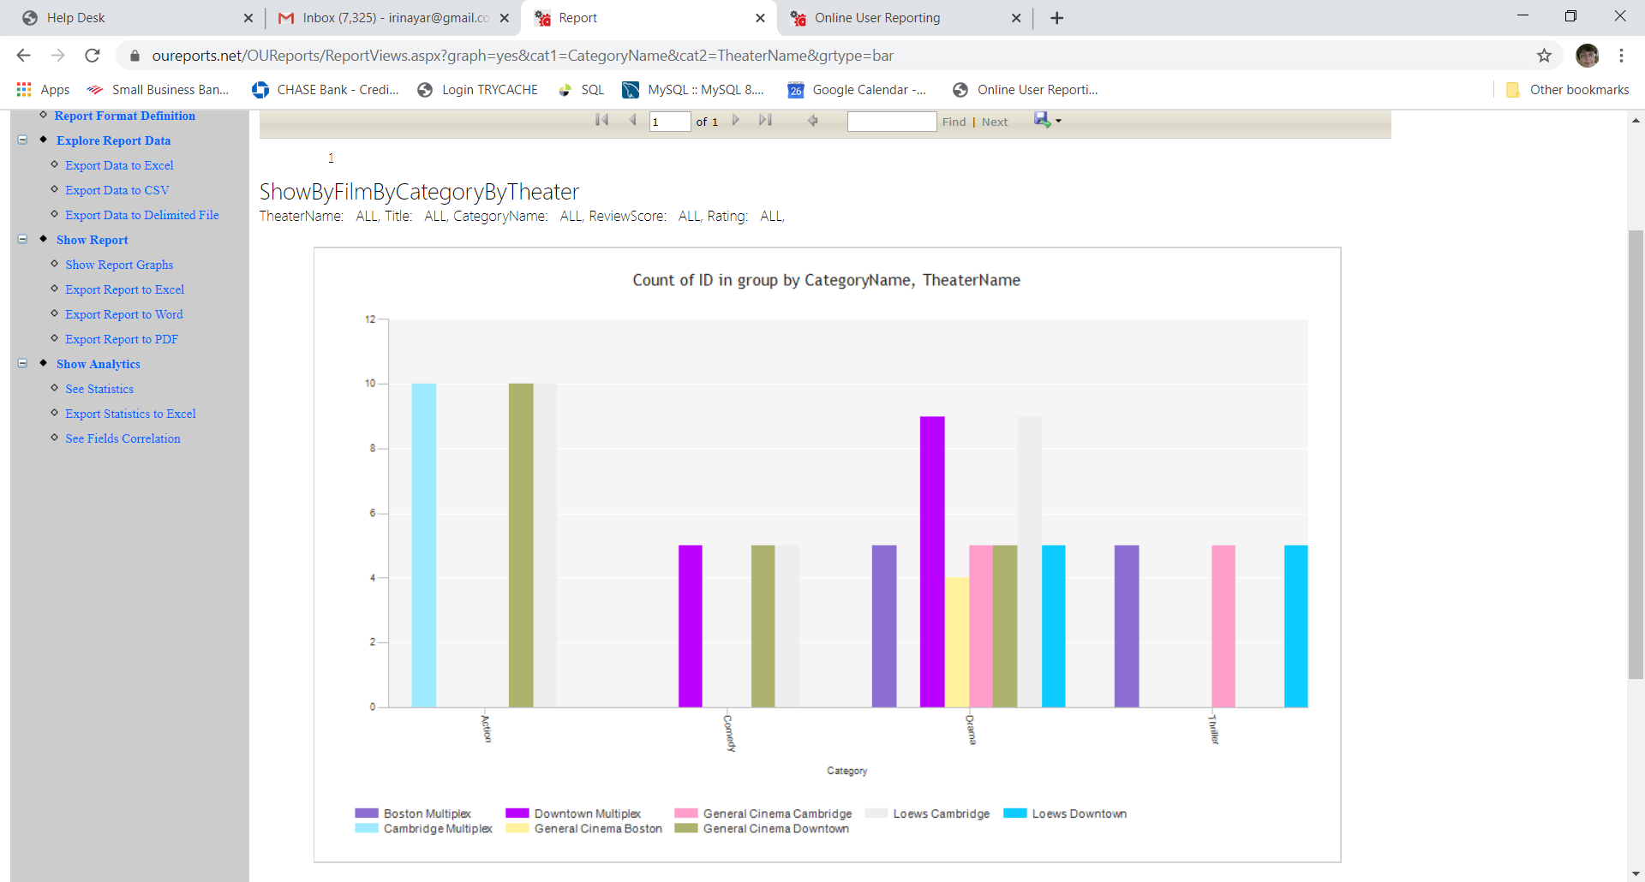
Click “reverse group order” link:
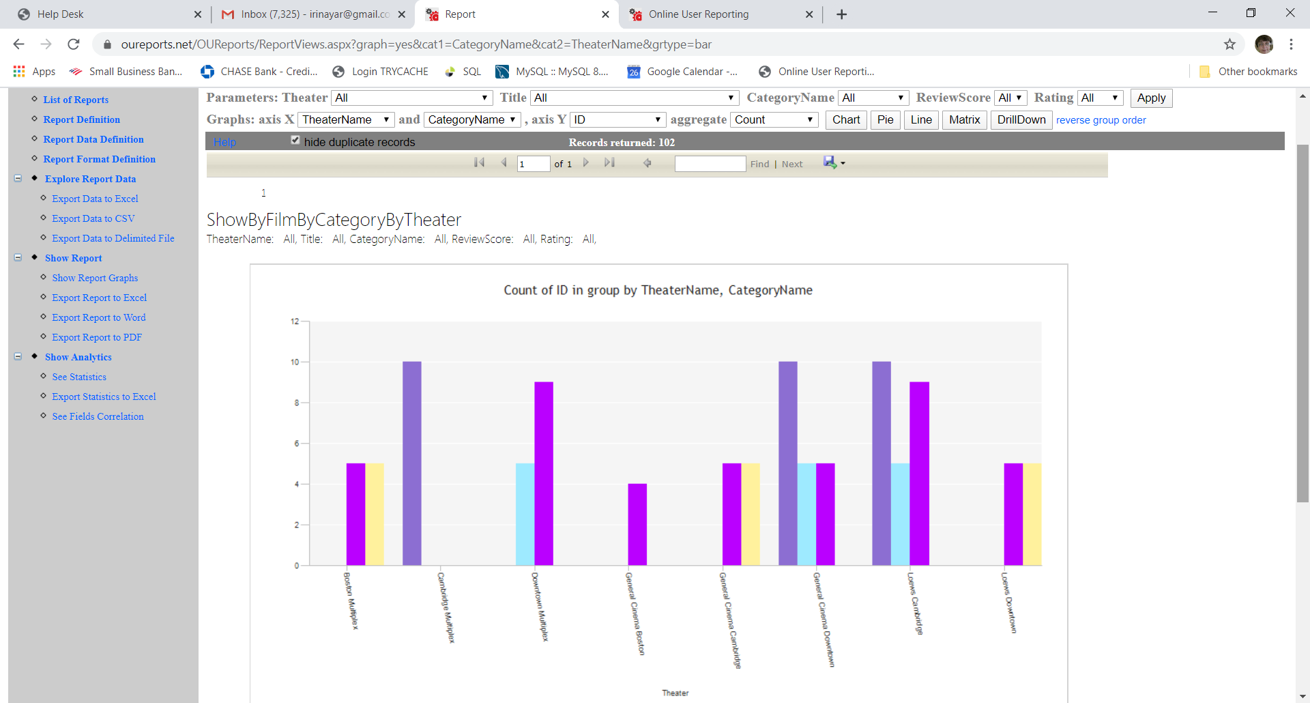Click the “pie” button from this page or link from matrix report: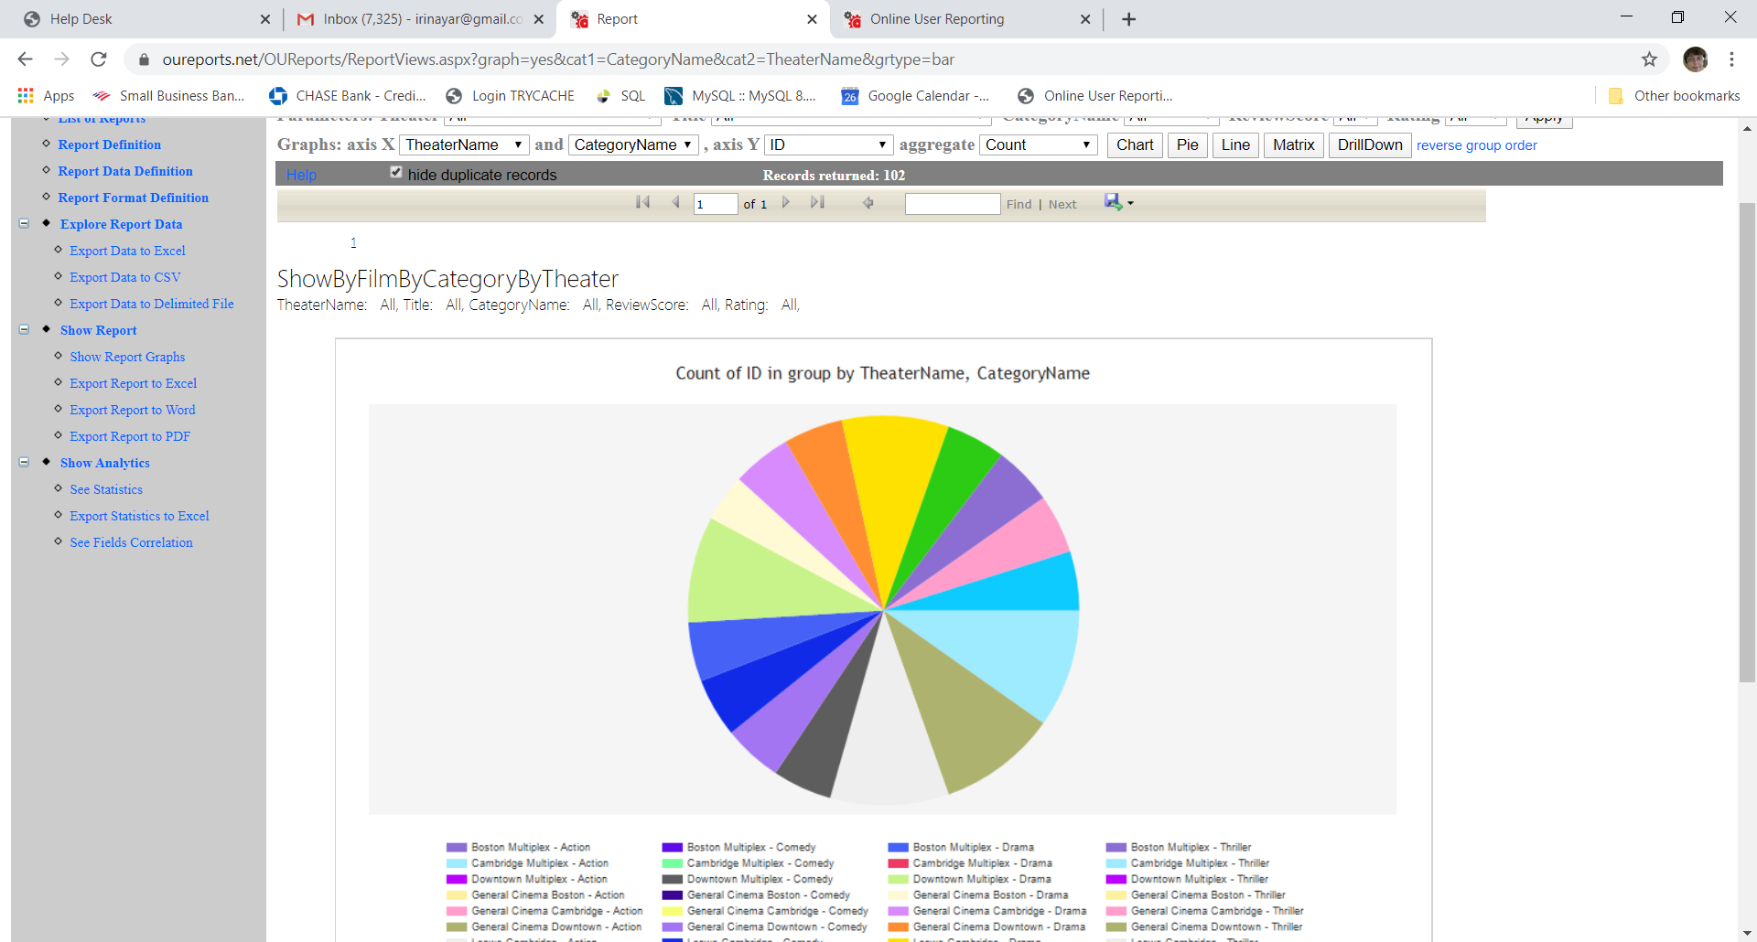

Click the “line” button from this page or link from matrix report:
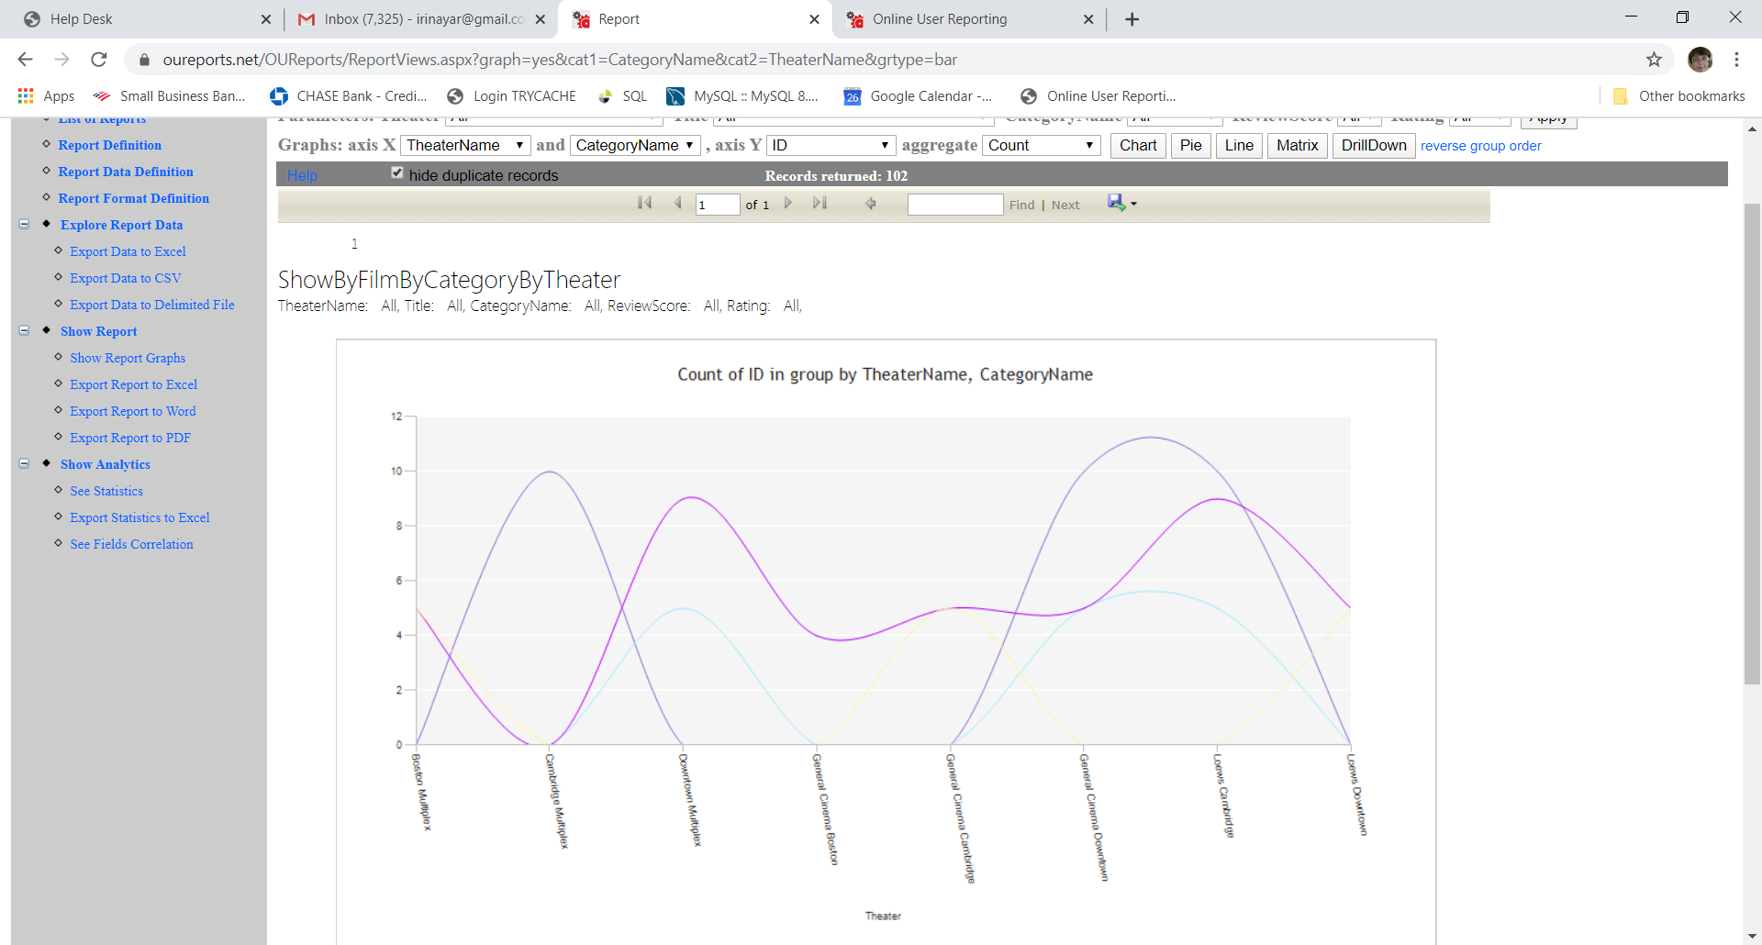
Reverse group order:
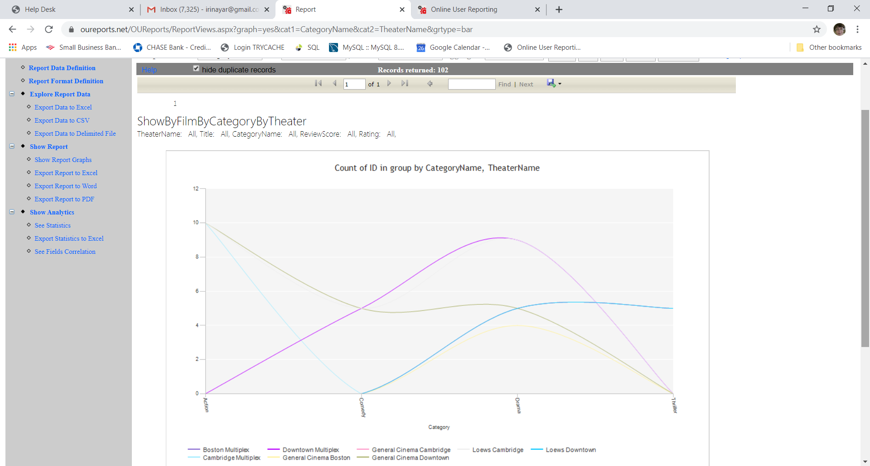

Click Correlation from the left menu to see Correlation Coefficients and graph reports:
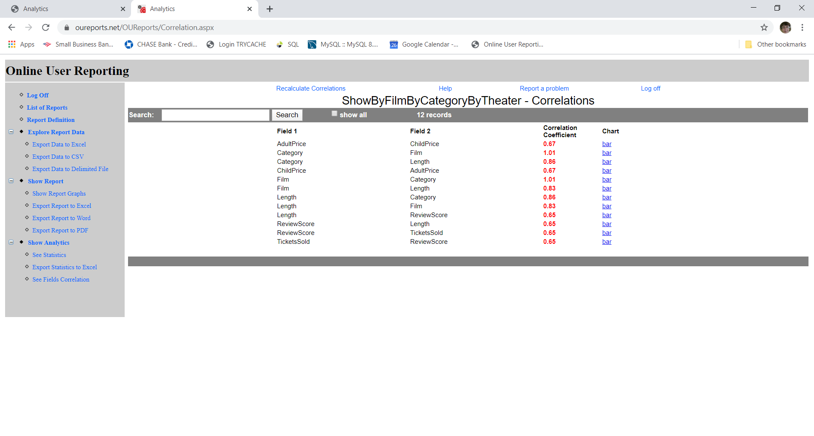

Click See Statistics from the left menu:
