**PMS (Performance Management System)**

1. **Admin Panel**

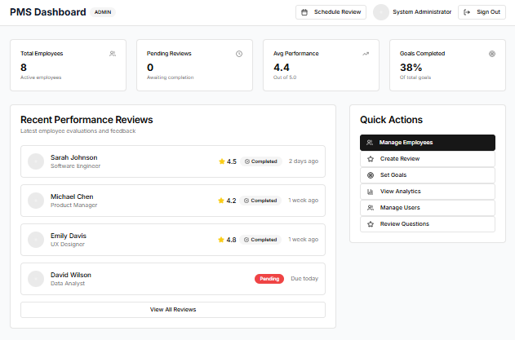

* Above screenshot is **admin panel’s** dashboard providing facility of viewing “Total Employees”, “Pending Reviews”, “Average Performance” and “Goals Completed”.

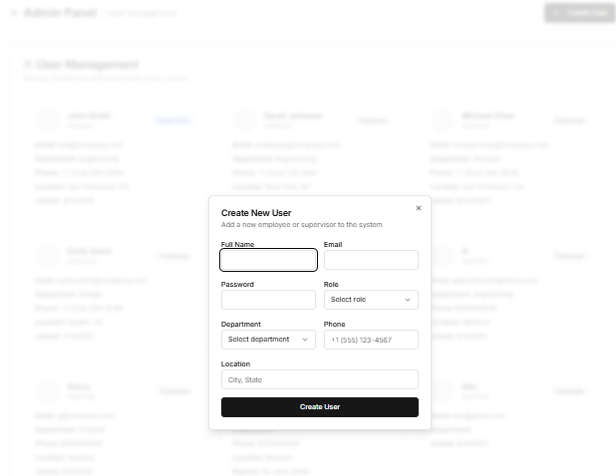

* Navigate to **“Manage Users”** to create new users (Employee and HOD) that can be created by clicking on **“Create User”** button through admin panel as shown in above images.

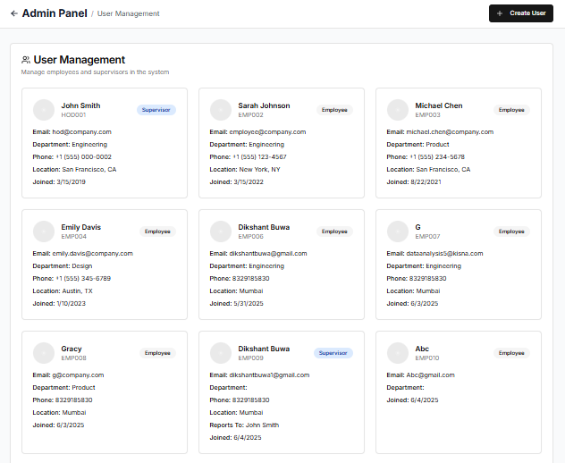

* All the user’s that are created will be visible in this section.

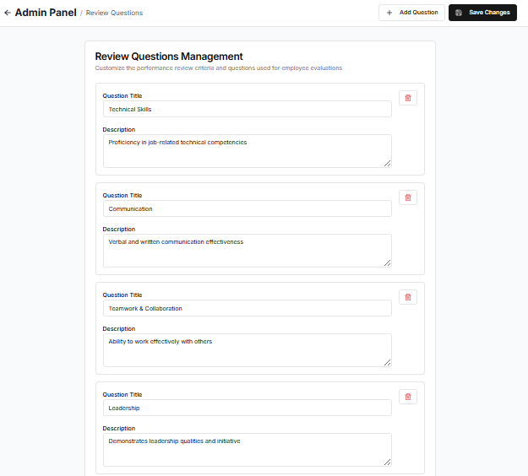

* The review questions can be edited by navigating to **“Review Questions”** in **“Quick Actions”**.

1. **HOD / Supervisor Panel**

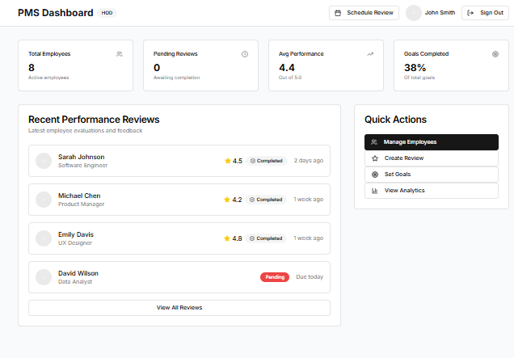

* The above image shows **HOD/Supervisor panel**, it has similar functionalities to that of the admin panel.
* This would be used by respected HOD’s to review or set goals, and update them, for their employees.
* On the above page, we see all the recent reviews submitted.

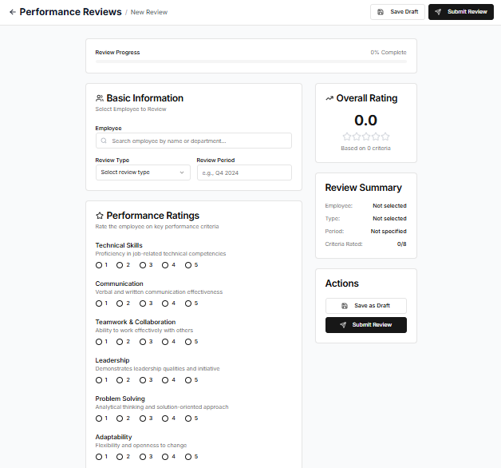

* This page opens when clicked on “create review”, to submit employee review, the star rating would be updated according to the average. It works the same way as that on admin panel.

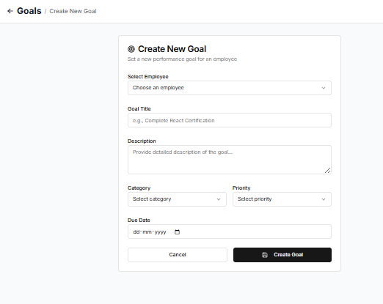

* This is for creating new goals, for each employee.
* The goal created will be displayed on the employee side, and its update would be done by the supervisor or admin.

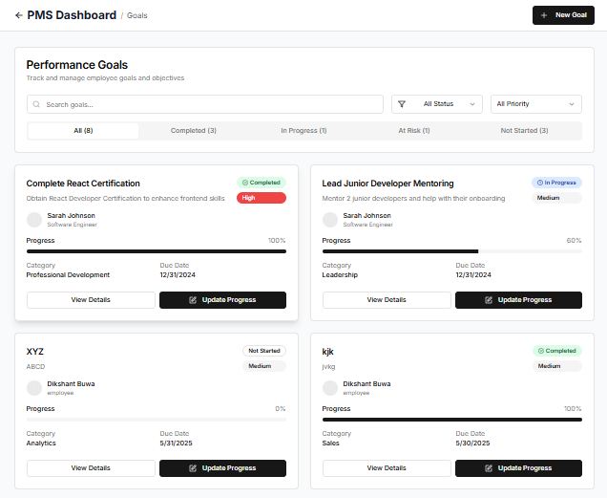

* This page opens when clicked on “create goals”, we can see the existing goals, and their progress, we can view details, and update progress by clicking their buttons respectively.
* This is same as that on the admin side.

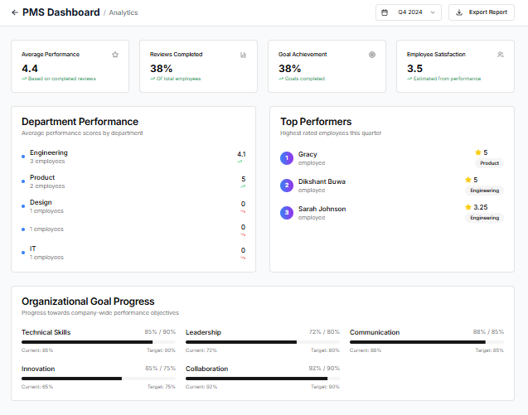

* This page opens when clicked on “view analytics”.
* It calculates and shows the Average Performance of all employees, the percent of total review completed, percent of total goals achieved and employee satisfaction.
* It displays the top performers based on their star rating, which they achieve after review is submitted.
* Similarly, we can see department performance.
* Below it, we can see the goal progress, which will show stats of all the goals assigned.

1. **Employee Panel**

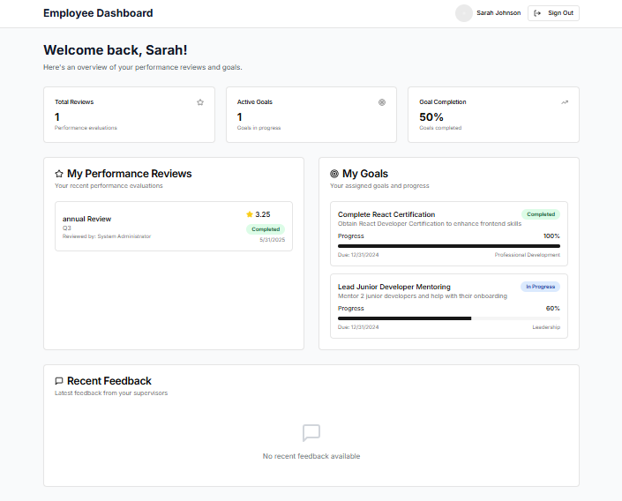

* All the employees can view their **“Performance Reviews”** given by there respective HOD.
* In addition, they could also see the Goal / Target set for them.