  DATABASE PROJECT  Hospital Management System Database | Abstract  This project presents the design and implementation of a Hospital Management System database in PostgreSQL. The database models patient admissions, diagnoses, clinical notes, radiology examinations, surgical procedures, and discharge records. Sample data was generated and imported to test the system, and twenty SQL queries were developed to verify that the database satisfies the project requirements.  Freddy Mvemba: StudentID: 25745616, Laurent StudentID: Mohammad StudentID, Juan Student ID, Zachari StudentID  Database Systems

Contents
Introduction 2
System Overview 2
Entity-Relationship Diagram 3
Relational Schema 4
Data Population 6
Reproduction Steps 7
Conclusion 7
Appendix A — Individual Query Screenshots 8
Table of Figures 28
Bibliography 28

SOEN 363 — Project Phase 1 Report

Introduction
For this project, our team was tasked with building a Hospital Management System (HMS) database from the ground up. We split the work into three main phases: first, designing an Entity-Relationship (ER) model that maps out how hospital data connects; second, translating that design into actual SQL code using PostgreSQL; and third, populating the database with realistic sample data. To make the data useful for testing, we wrote a Python script to automatically generate a large, consistent dataset. The final deliverables for this phase include the ER diagram, the table schemas, the data population scripts, and a set of 20 analytical SQL queries that we wrote to test the database's capabilities.

System Overview
Our database covers the main operations you would expect in a hospital setting. It tracks patients from the moment they are admitted, including their initial triage vitals, any diagnoses they receive (using ICD-9 codes), and their discharge records. It also handles the staff side of things, linking physicians and nurses to specific admissions, notes, and procedures. We also included tables for more complex workflows, such as radiology orders, ICU stays, and surgical procedures.
When designing the schema, our main priority was keeping the data clean. We normalized the tables to Third Normal Form (3NF) to prevent redundant data, and we set up foreign keys to make sure that, for example, a diagnosis couldn't be entered for an admission that doesn't exist. We also made sure our data generation script produced a consistent dataset so that anyone could re-run it and get the exact same results.

Entity-Relationship Diagram

Figure 1: ER Diagram
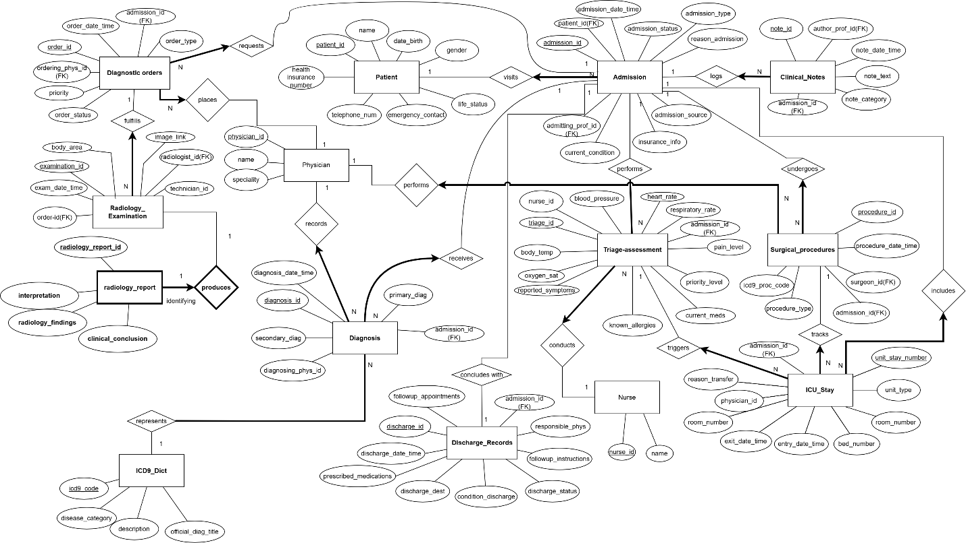
Figure 1 shows our ER diagram. We modelled the patient journey as a chain: a patient has many admissions; each admission is linked to one triage_assessment, one or more diagnosis records (with exactly one marked as primary), optional icu_stay and surgical_procedure records, and one discharge_record. Staff are modelled separately: physician and nurse connect to admissions through the tables where they act (e.g., admitting_prof_id on admission, nurse_id on triage). Diagnostic work follows a strict path — diagnostic_order → radiology_examination → radiology_report — because one order can produce one exam, and each exam has one report. We made icu_stay a separate entity (rather than a column on admission) because a patient can move between units (ICU, CCU, MICU, SICU) during a single stay, and Q15/Q16 requires counting those transfers. Cardinality and participation constraints are marked on the diagram: for example, a patient may have zero admissions, but every admission must belong to exactly one patient.

Relational Schema
The database schema was designed according to Third Normal Form (3NF). Each table represents a specific entity in the hospital system, which helps reduce data duplication and maintain consistency.
Primary keys uniquely identify records in each table, while foreign keys define relationships between tables. For example, each admission is linked to a patient, and diagnoses are linked to both admissions and physicians.
The database consists of 14 tables that work together to model hospital operations and support the required project queries.
Below is the formal relational schema mapping for the 14 operational tables:

- icd9_dict (icd9_code, disease_category, description, official_diag_title)
- physician (physician_id, name, specialization)
- nurse (nurse_id, name)
- patient (patient_id, name, date_birth, gender, address, telephone_number, emergency_contact, life_status)
- admission (admission_id, patient_id, admission_date_time, admission_type, reason_admission, admission_source, insurance_info, current_condition, admitting_prof_id)
  - Foreign Keys: patient_id references patient(patient_id), admitting_prof_id references physician(physician_id)
- triage_assessment (triage_id, admission_id, nurse_id, blood_pressure, heart_rate, respiratory_rate, body_temp, oxygen_sat, pain_level, priority_level, reported_symptoms, known_allergies, current_meds)
  - Foreign Key: admission_id references admission(admission_id), nurse_id references nurse(nurse_id)
- diagnosis (diagnosis_id, admission_id, icd9_code, diagnosing_phys_id, diagnosis_date_time, primary_diag, secondary_diag)
  - Foreign Keys: admission_id references admission(admission_id), icd9_code references icd9_dict(icd9_code), diagnosing_phys_id references physician(physician_id)
- icu_stay (unit_stay_number, admission_id, unit_type, room_number, bed_number, entry_date_time, exit_date_time, physician_id, reason_transfer)
  - Foreign Keys: admission_id references admission(admission_id), physician_id references physician(physician_id)
- clinical_note (note_id, admission_id, author_prof_id, note_date_time, note_text, note_category)
  - Foreign Keys: admission_id references admission(admission_id)
- diagnostic_order (order_id, admission_id, ordering_phys_id, order_date_time, order_type, order_status)
  - Foreign Keys: admission_id references admission(admission_id), ordering_phys_id references physician(physician_id)
- radiology_examination (examination_id, order_id, exam_date_time, modality, technician_id, radiologist_id)
  - Foreign Keys: order_id references diagnostic_order(order_id), radiologist_id references physician(physician_id)
- surgical_procedure (procedure_id, admission_id, surgeon_id, icd9_proc_code, procedure_date_time, phone_number)
  - Foreign Keys: admission_id references admission(admission_id), surgeon_id references physician(physician_id)
- discharge_record (discharge_id, admission_id, discharge_date_time, discharge_dest, condition_discharge, discharge_status, followup_instructions, responsible_phys)
  - Foreign Keys: admission_id references admission(admission_id), responsible_phys references physician(physician_id)

Data Population
The database was populated using a Python script that generated synthetic hospital data. No real patient information was used in this project.
The generated dataset contains records for patients, physicians, nurses, admissions, diagnoses, clinical notes, ICU stays, radiology examinations, and surgical procedures. The goal was to create enough data to properly test the database structure and all required SQL queries.
The script produces an SQL file containing INSERT statements that can be executed directly in PostgreSQL to populate the database.
A detailed description of the dataset generation process, AI usage, prompts, transformation steps, validation procedures, and import methodology is provided in Comprehensive_Data_Population_Report. All database records were synthetically generated for educational purposes and no real patient data was used.
The generate_data.py script creates populate_all_hospital.sql, which contains the sample-data INSERT statements.
The generated dataset includes:
4 ICD-9 codes, 15 physicians, 10 nurses, and 45 patients.
51 admissions, 50 triage assessments, 68 diagnoses, 15 ICU stays, and 50 clinical notes.
22 diagnostic orders, 23 radiology examinations, and radiology reports.
50 discharge records and 18 surgical procedures.

Figure 2: Database Statistics
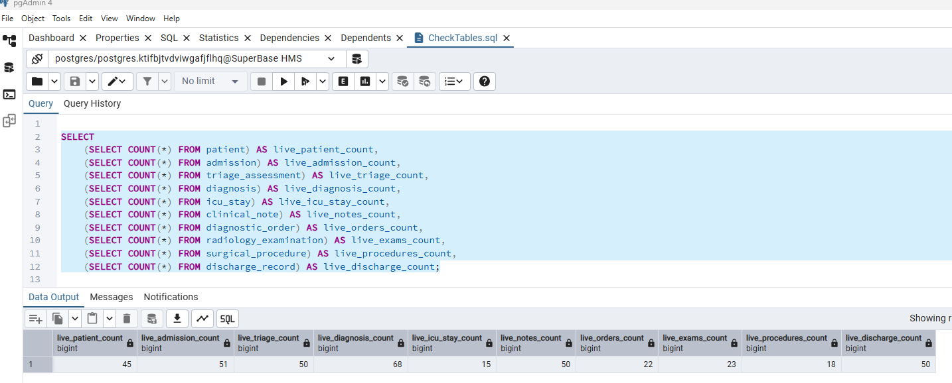
See Appendix A — Individual Query Screenshots for a list of Queries.

Reproduction Steps
1. Create an empty PostgreSQL database named Superbase HMS.
2. Run TablesCreation.sql to create the database schema.
3. Run populate_all_hospital.sql to load the sample data.
4. Run CheckTables.sql and verify the expected row counts.
5. Run Q1 through Q20 from FirstPart.sql.

Conclusion
Looking back, we successfully completed all the main goals for Phase 1. We ended up with a fully normalized, 14-table database in PostgreSQL that handles everything from patient admissions to surgical procedures. By sticking to 3NF, we avoided data duplication and used foreign keys to keep the relationships between tables strict and reliable.
Generating the test data was one of the more challenging parts, but the Python script worked well in the end, giving us a consistent dataset of 45 patients and 51 admissions to work with. Finally, writing the 20 queries was a good way to see if our design actually held up. By using complex joins and subqueries to answer realistic questions—like tracking ICU transfers or finding patients with multiple diagnoses—we were able to confirm that the database is structured correctly and can handle real analytical tasks.

Appendix A — Individual Query Screenshots
Q1: [Zachary]
List the names and admission dates of all patients who were classified as high-priority
emergency patients during triage.

Query:

Figure 3: Query 1
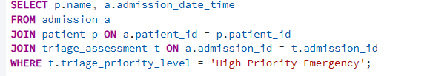
Output:
Figure 4: Output Query 1
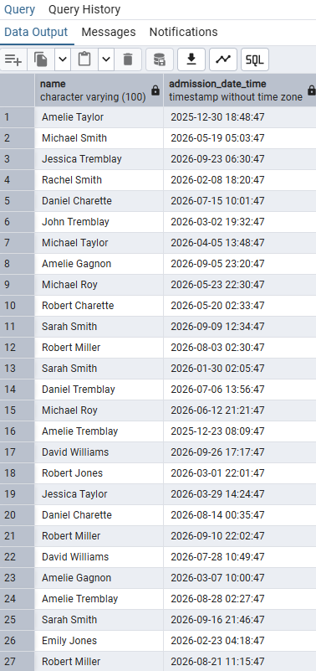
Logic: The logic of this query is we first select the name and admission date time which we want to show. They are from 2 different tables, so we need to create patient p and admission a. We use from to indicate that we are selecting from that table and then join to find the patient that has the same id as the admission that we are selecting. We then select these patients and use them to find the names. Then, same logic but for the triage assessment. We find the triage assessment that has the same id as the admission/patient and then, as a condition we are selecting only those that have their triage priority level to high-priority emergency. We are putting the triage in SELECT since we only want to show the name and admission date/time.
Q2: [Zachary]
Find all patients who had more than three hospital admissions. Display the
patient identifier, patient name, and total number of admissions.

Figure 5: Query 2
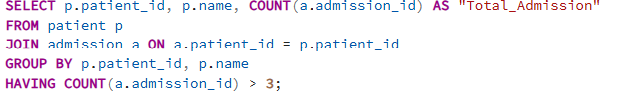

Output:

Figure 6: Output Query 2
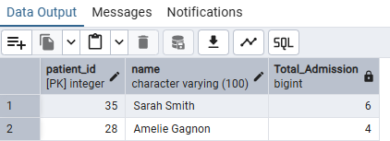

Logic: The logic of this query is that we first select the patient id and the name of a patient p. Then we want to calculate the total number of admissions. For that we use count on the admission id from the patient p and we display is as total_admissions. Then we use join to only show the admission where the patient id’s are the same. And finally, we use group to merge all the rows with the same patient id into one row that displays the total number of admissions. The having will then be the condition for the query. (more than 3 admissions)

Q3: [Zachary]
Retrieve the names, admission dates, and discharge dates of patients who were dis-
charged without undergoing any surgical procedure during admission.

Query:

Figure 7: Query 3
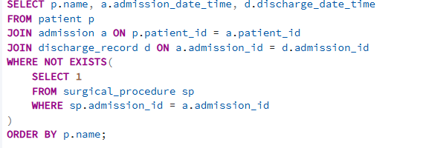
Output:
Figure 8: Output Query 3
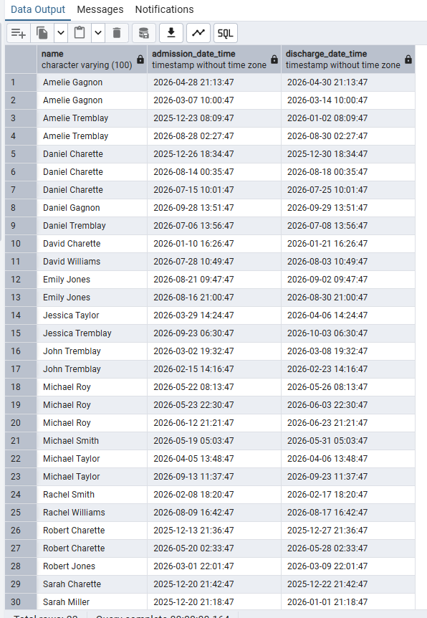

Logic: The main logic of this query is that we need to find what link exists between a patient, the admission and the surgical procedure. Between the patient and the admission, it is the patient id, we can then use that to find a patient with certain condition from the admission and patient table. The surgical procedure table is also based on the admission id, so we can do the same thing using join. The final step is to check if the discharge date time is not null because we want patients who were discharged only.

Q4: [Zachary]
List all patients who had both a radiology examination and a surgical procedure
during the same admission.

Query:

Figure 9: Query 4
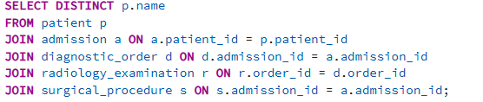

Output
Figure 10: Output Query 4
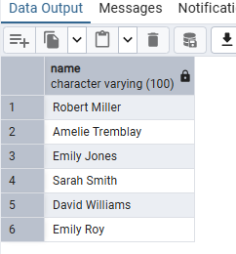

Logic: First, we need to select distinct since a single patient can have multiple admissions that satisfy the requirements, so to prevent that, we use the distinct keyword. After that, like in query 4, we need to find a link between every table. For patients and admissions, it’s the patient id. After that, for the diagnostic order, its the admissions id. Th
Q5: [Juan]
Find all ICU or CCU unit stays that lasted more than seven days. Display the patient name, unit type, unit entry time, unit exit time, and calculated length of stay.
Query:
Figure 11: Query 5
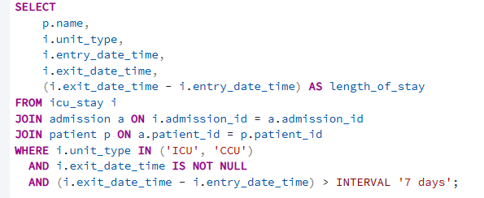
Output:
Figure 12: Output Query 5
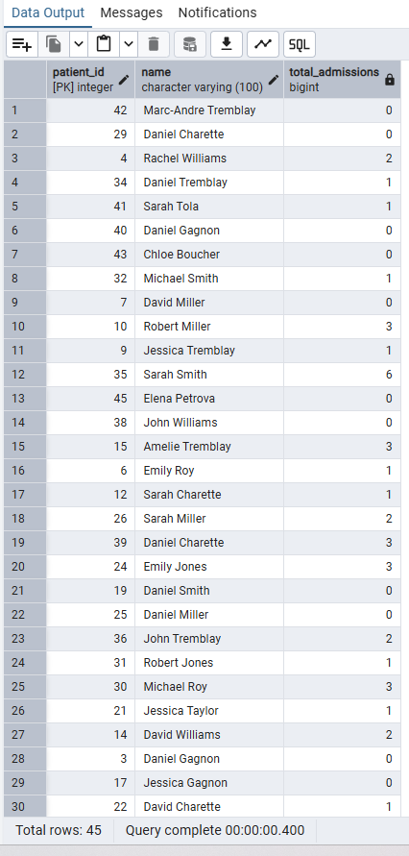
Logic:

Q6: [JuanMa]
Count the total number of hospital admissions for each patient. Include patients
who have no recorded admissions.
Query:
Figure 13: Query 6
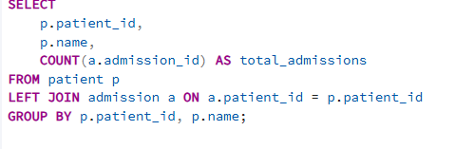
Output:
Figure 14: Output Query 6
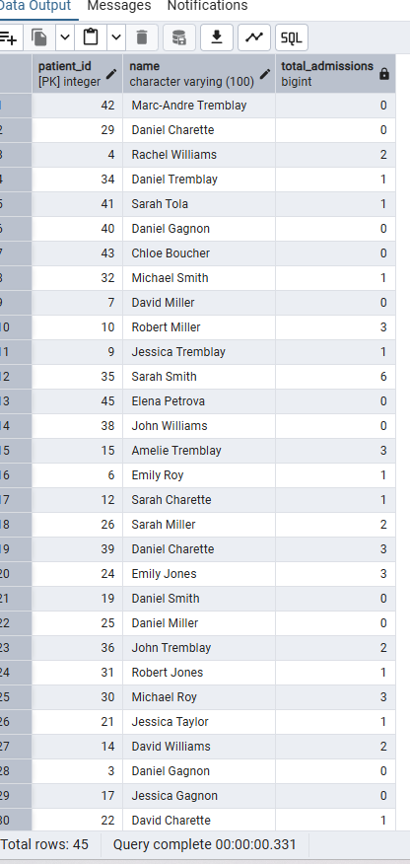
Logic:

Q7 : [JuanMa]
Q7: List all patients who entered the hospital through the Emergency Department and were later transferred to an ICU or CCU during the same admission.
Query:
Figure 15: Query 7
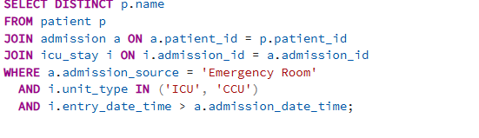
Output:
Figure 16: Output Query 7
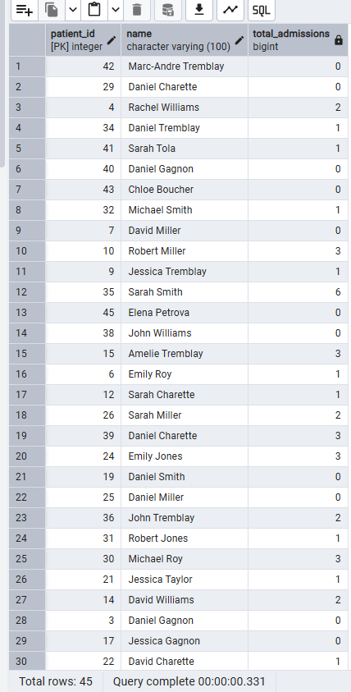
Logic:

Q8: [JuanMa]

Q9: [Mohammad]
Calculate the average length of stay for each critical care unit type, such as MICU,
SICU, ICU, and CCU. Display the unit type and its average length of stay.
Query:
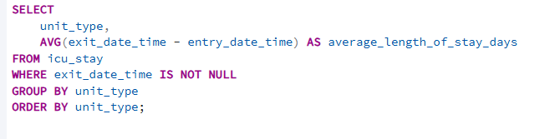
Output:
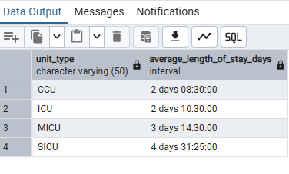
Logic: The query calculates each completed critical care stay by subtracting the entry timestamp from the exit timestamp. It groups the stays by unit type and uses AVG to calculate the average length of stay for each unit. Stays without an exit time are excluded because they are not completed.

Q10: [Mohammad]
List all patients who underwent a surgical procedure before entering an ICU or
CCU during the same admission. Display the patient’s name, procedure date and time, critical care unit type, and unit entry time.

Query:

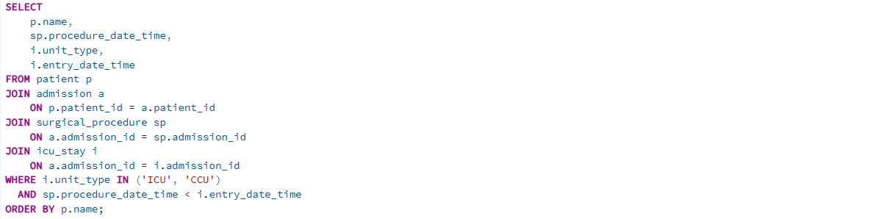

Output:

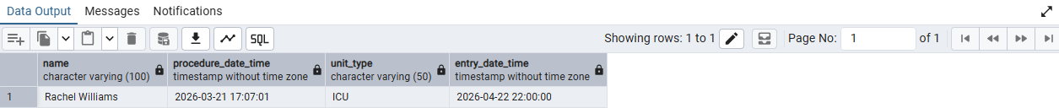

Logic: The query joins patients with their admissions, surgical procedures, and critical care stays. It keeps only ICU or CCU stays and checks that the surgical procedure occurred before the unit entry time during the same admission. The result displays the patient, procedure time, unit type, and ICU/CCU entry time.

Q11: [Mohammad]
Retrieve the name of each patient and the total number of radiology examinations
received across all admissions. Including patients who have not received any radiology examinations and display zero for their examination count.

Query:
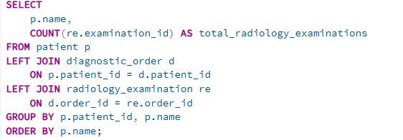
Output:
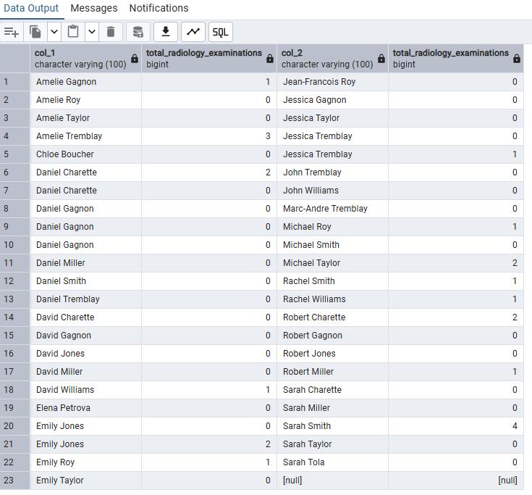
Logic: The query starts with all patients and uses LEFT JOIN to connect them to their admissions, diagnostic orders, and radiology examinations. It groups the results by patients and counts the examinations for each patient. The LEFT JOIN ensures that patients with no radiology examinations are still included with a count of zero.
Q12: [Mohammad]
Find all patients whose discharge-summary clinical note contains the keyword
“recovery”. The search should be case-insensitive.
Query:
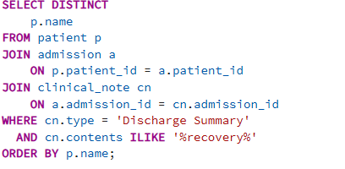
Output:
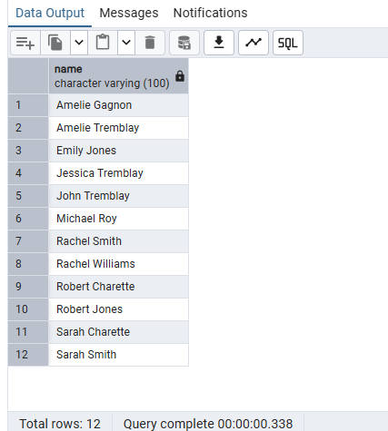
Logic: The query joins patients with their admissions and clinical notes, then keeps only discharge summary notes. LOWER converts the note contents to lowercase and LIKE '%recovery%' searches for the word “recovery” regardless of capitalization. DISTINCT ensures that each patient appears only once in the result.

Q13: [Laurent]
List all admissions in which the patient had at least one radiology examination but
had no recorded ICU or CCU stay.
Query:
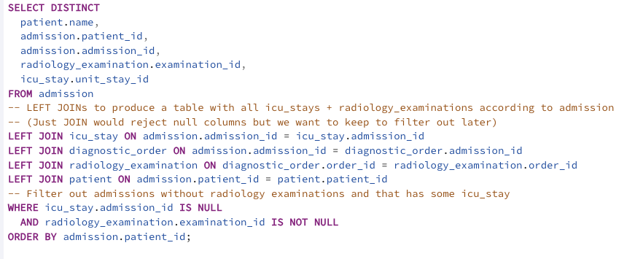
Output
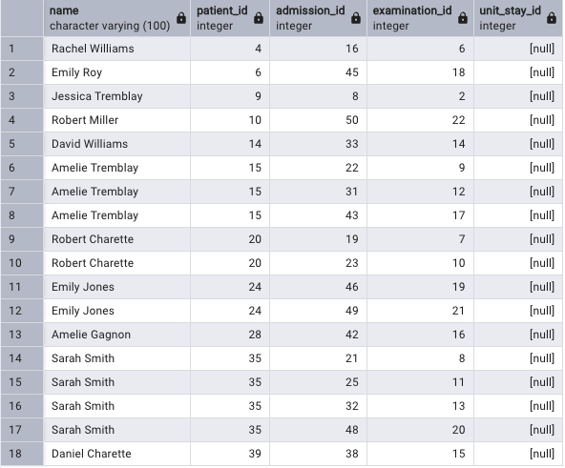
Explanation: Logic explanation in the query comments

Q14: [Laurent]
Retrieve the patient or patients with the longest completed hospital stay, calculated from admission time to discharge time. If multiple patients have the same
maximum length of stay, display all of them.

Query:

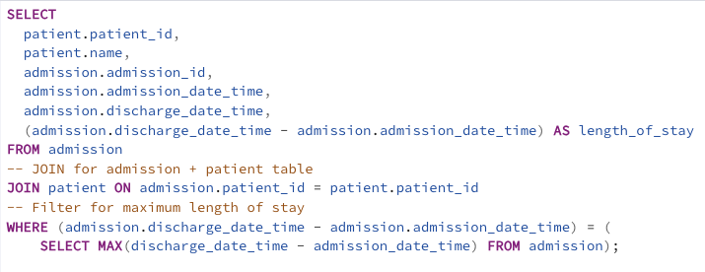

Output:

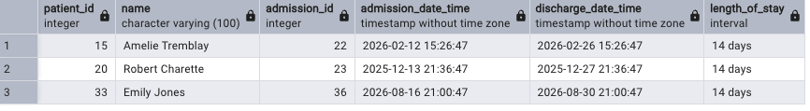

Explanation: Logic explanation in the query comments

Q15: [Laurent]
Count the total number of transfers between hospital units for each patient. The
patient’s first placement is not considered a transfer; each subsequent unit stay
within the same admission represents one transfer.

Query:

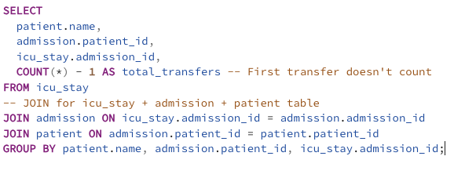

Output

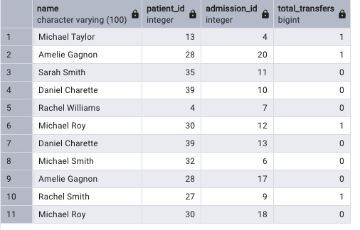

Explanation: Logic explanation in the query comments
Q16: [Laurent]
List all patients who stayed in more than one type of critical care unit during
the same admission. For example, a patient may have been transferred from an ICU
to a CCU.
Query:

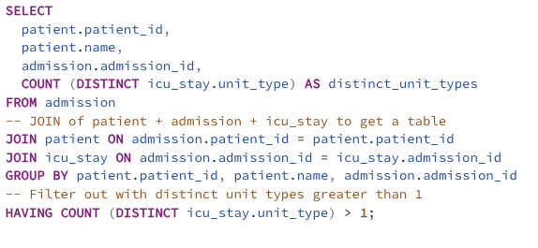

Output:

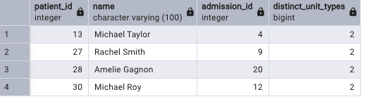

Explanation: Logic explanation in the query comments

Q17: [Freddy Mvemba]
Find all admissions during which the patient received more than one distinct ICD-
9 diagnosis. Display the patient’s name, admission identifier, and number of distinct
ICD-9 codes.
Query:
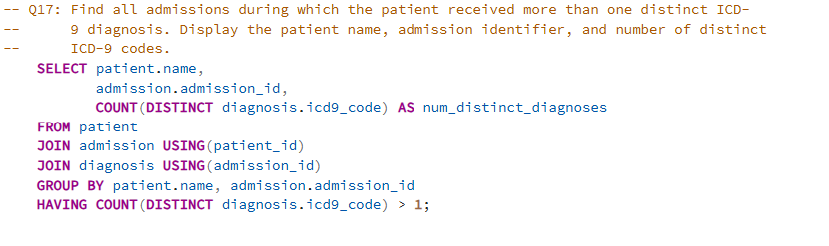
Output
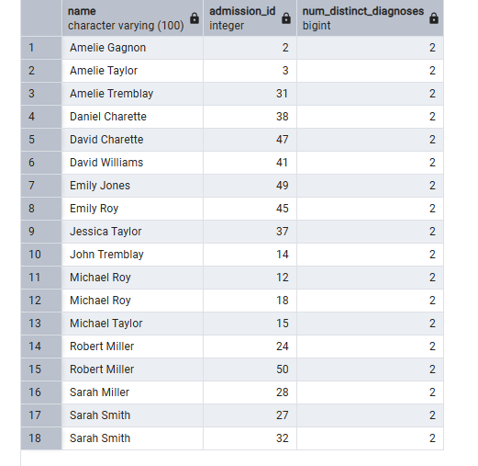
Logic: Group every admission's diagnoses together, count how many distinct ICD-9 codes appear, and keep only the admissions where that count exceeds 1.

Q18 – [Freddy Mvemba]
Retrieve the latest clinical note for each patient. Display the patient’s name, note
type, note creation date and time, and note contents.
Query:
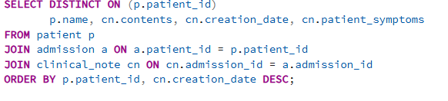
Output:
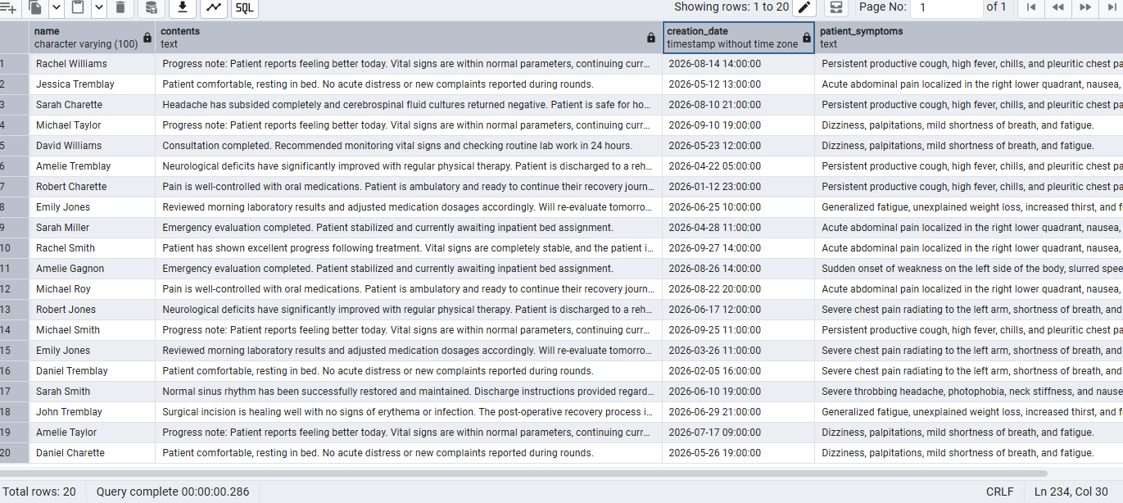
Main logic: A patient can have different notes across multiple hospital stays. To pull the latest notes, we link patient, admission and clinical_note together. We used DISTINCT on (patient_id) and ORDER BY statement sorting the creation dates is descending(DESC) order.

Q19 – [Freddy Mvemba]
List all admissions where the patient’s discharge status or discharge condition indicates that the patient died during the hospital stay. Display the patient’s name, admission date, recorded date of death, and associated primary ICD-9 diagnosis.
Query:

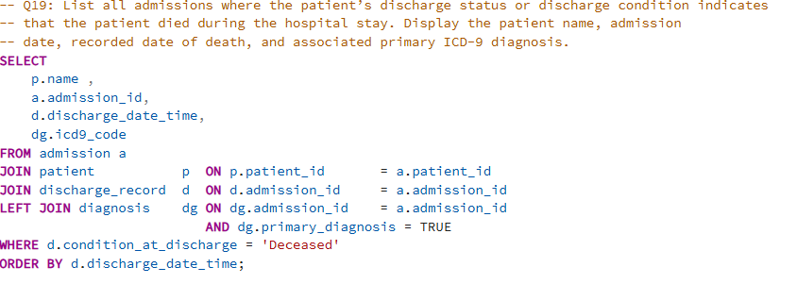

Output

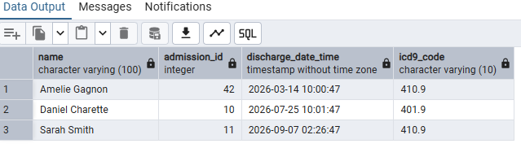
Main logic: we listed any hospital admissions where the discharge records show that the patient passed away. Where statement is used to filter data matching the ‘deceased ‘condition. We used normal joint to link patient details to their discharge data and left join for the diagnosis table so that ICD9_code can be attached.

Q20 – [Freddy Mvemba]
Find all patients who underwent a surgical procedure and a radiology examination on the same calendar day during the same admission. Display the patient’s name, admission identifier, procedure type, radiology examination type, and the common date.
Query:
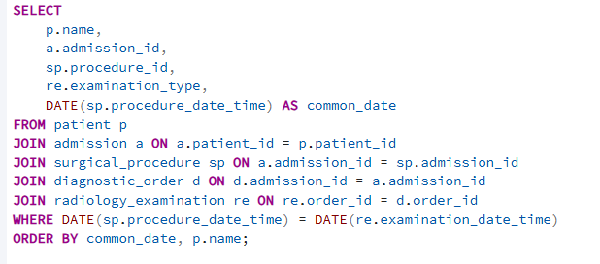

Output:
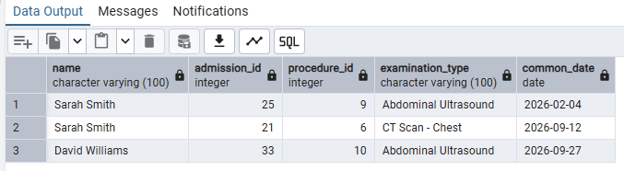

Logic:
So, we have to chain our joints from patient to admission, down to surgical_procedure, and then out to diagnostic_order and radiology_examination. To find procedures happening on the exact same day, we wrapped the timestamps in a DATE() function inside our WHERE clause. This strips away the hours and minutes so we can check if the calendar days match up perfectly.

Table of Figures
Figure 1: ER Diagram 3
Figure 2: Database Statistics 6
Figure 3: Query 1 8
Figure 4: Output Query 1 8
Figure 5: Query 2 9
Figure 6: Output Query 2 9
Figure 7: Query 3 10
Figure 8: Output Query 3 10
Figure 9: Query 4 11
Figure 10: Output Query 4 11
Figure 11: Query 5 12
Figure 12: Output Query 5 12
Figure 13: Query 6 13
Figure 14: Output Query 6 13
Figure 15: Query 7 14
Figure 16: Output Query 7 14

Bibliography
There are no sources in the current document.

