  DATABASE PROJECT  Hospital Management System Database | Abstract  This report presents the design and implementation of a robust, production-grade Hospital Management System (HMS) relational database configured natively in PostgreSQL. The system framework organizes complex healthcare workflows into a modular, 3NF-compliant schema across 14 integrated tables  Freddy, Laurent, Mohammad, Juan, Zachari  Database Systems

Contents
Introduction 2
System Overview 2
Entity-Relationship Diagram 3
Relational Schema 4
Data Population 5
Queries (Q1–Q20) 6
Submitted Files 7
Reproduction Steps 8
Conclusion 8
Appendix A — Individual Query Screenshots 9
Appendix B - Handout Checklist 26
Table of Figures 27
Bibliography 27

SOEN 363 — Project Phase 1 Report

Introduction
This project involves designing and implementing a comprehensive Hospital Management System (HMS) database. The engineering workflow includes designing a 3NF-compliant ER model, implementing the structural DDL schema natively in PostgreSQL, and deploying a deterministic data-generation script to populate the tables. Deliverables include the formal ER diagram, relational schema mappings, automated SQL population files, and a verification suite featuring 20 required queries utilizing complex joins, groupings, and analytical subqueries.

System Overview
The database represents the hospital’s core operations:
- Patients and admissions tracking
- Physicians and nurses
- Admission triage vital assessments
- ICD-9-coded lookup dictionaries and diagnoses
- ICU stays and intensive ward transfer tracking
- Clinical notes
- Diagnostic orders, radiology examinations, and radiology reports
- Surgical procedures
- Discharge records
- Design priorities: normalization, referential integrity, and realistic sample data
The architecture prioritizes strict normalization to eliminate transitive functional dependencies, robust foreign key referential integrity constraints, and a fully reproducible, synthetically engineered dataset.

Entity-Relationship Diagram

Figure 1: ER Diagram
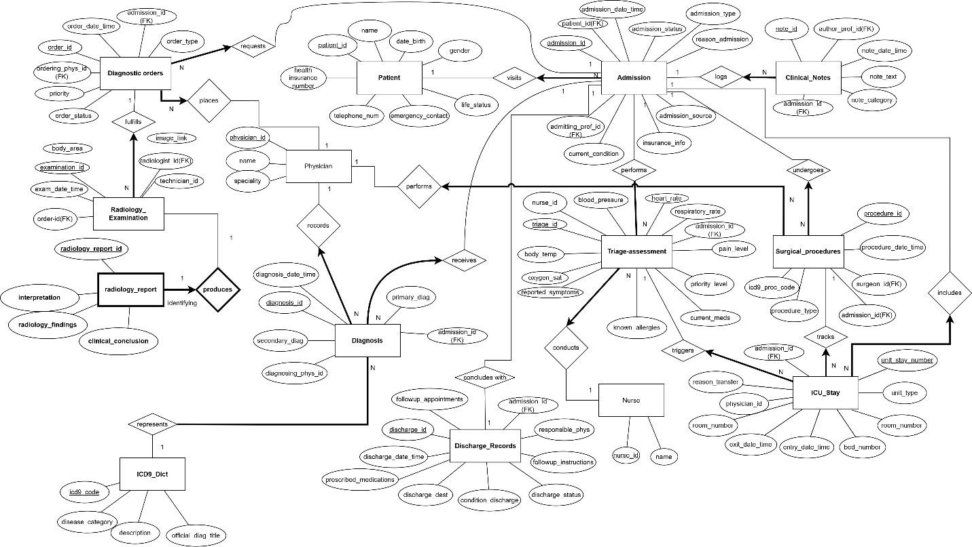
Entities: icd9_dict, physician, nurse, patient, admission, triage_assessment, diagnosis, icu_stay, clinical note, diagnostic order, radiology_examination, radiology_report, discharge record, and surgical procedure.
Key relationships:
- One patient may have many admissions.
- Each admission has one triage assessment.
- Each admission may have multiple diagnoses, including one required primary diagnosis.
- Admission may have at most one ICU stay.
- Each admission may include multiple clinical notes.
- Each admission may have multiple diagnostic orders; each order links to one radiology examination, and each examination links to one radiology report.
- Each admission may have one discharge record.
- Each admission may include multiple surgical procedures.
The diagram identifies all cardinality and participation constraints.

Relational Schema
The database schema has been designed to satisfy Third Normal Form (3NF). All partial and transitive functional dependencies have been eliminated by isolating distinct operational concepts into independent tables. Primary keys (PK) guarantee entity integrity, while foreign keys (FK) enforce strict referential integrity across the system.

Below is the formal relational schema mapping for the 14 operational tables:
- icd9_dict (icd9_code, disease_category, description, official_diag_title)
- physician (physician_id, name, specialization)
- nurse (nurse_id, name)
- patient (patient_id, name, date_birth, gender, address, telephone_number, emergency_contact, life_status)
- admission (admission_id, patient_id, admission_date_time, admission_type, reason_admission, admission_source, insurance_info, current_condition, admitting_prof_id)
  - Foreign Keys: patient_id references patient(patient_id), admitting_prof_id references physician(physician_id)
- triage_assessment (triage_id, admission_id, nurse_id, blood_pressure, heart_rate, respiratory_rate, body_temp, oxygen_sat, pain_level, priority_level, reported_symptoms, known_allergies, current_meds)
  - Foreign Key: admission_id references admission(admission_id), nurse_id references nurse(nurse_id)
- diagnosis (diagnosis_id, admission_id, icd9_code, diagnosing_phys_id, diagnosis_date_time, primary_diag, secondary_diag)
  - Foreign Keys: admission_id references admission(admission_id), icd9_code references icd9_dict(icd9_code), diagnosing_phys_id references physician(physician_id)
- icu_stay (unit_stay_number, admission_id, unit_type, room_number, bed_number, entry_date_time, exit_date_time, physician_id, reason_transfer)
  - Foreign Keys: admission_id references admission(admission_id), physician_id references physician(physician_id)
- clinical_note (note_id, admission_id, author_prof_id, note_date_time, note_text, note_category)
  - Foreign Keys: admission_id references admission(admission_id)
- diagnostic_order (order_id, admission_id, ordering_phys_id, order_date_time, order_type, order_status)
  - Foreign Keys: admission_id references admission(admission_id), ordering_phys_id references physician(physician_id)
- radiology_examination (examination_id, order_id, exam_date_time, modality, technician_id, radiologist_id)
  - Foreign Keys: order_id references diagnostic_order(order_id), radiologist_id references physician(physician_id)
- surgical_procedure (procedure_id, admission_id, surgeon_id, icd9_proc_code, procedure_date_time, phone_number)
  - Foreign Keys: admission_id references admission(admission_id), surgeon_id references physician(physician_id)
- discharge_record (discharge_id, admission_id, discharge_date_time, discharge_dest, condition_discharge, discharge_status, followup_instructions, responsible_phys)
  - Foreign Keys: admission_id references admission(admission_id), responsible_phys references physician(physician_id)

Data Population
A detailed description of the dataset generation process, AI usage, prompts, transformation steps, validation procedures, and import methodology is provided in Comprehensive_Data_Population_Report. All database records were synthetically generated for educational purposes and no real patient data was used.
The generate_data.py script creates populate_all_hospital.sql, which contains the sample-data INSERT statements.
The generated dataset includes:
- 4 ICD-9 codes, 15 physicians, 10 nurses, and 45 patients.
- 51 admissions, 50 triage assessments, 68 diagnoses, 15 ICU stays, and 50 clinical notes.
- 22 diagnostic orders, 23 radiology examinations, and radiology reports.
- 50 discharge records and 18 surgical procedures.

The generator applies these realism safeguards:

- All timestamps are historical and follow a logical chronological pathway (admission < triage < orders < exams < discharge).
- ICU exit times never occur after discharge.
- Patients who die during a stay are assigned life_status = 'Deceased' and have a corresponding discharge record.
- Admission ID 51 remains intentionally open without a discharge record to simulate a live, currently active patient encounter.
Figure 2: Database Statistics
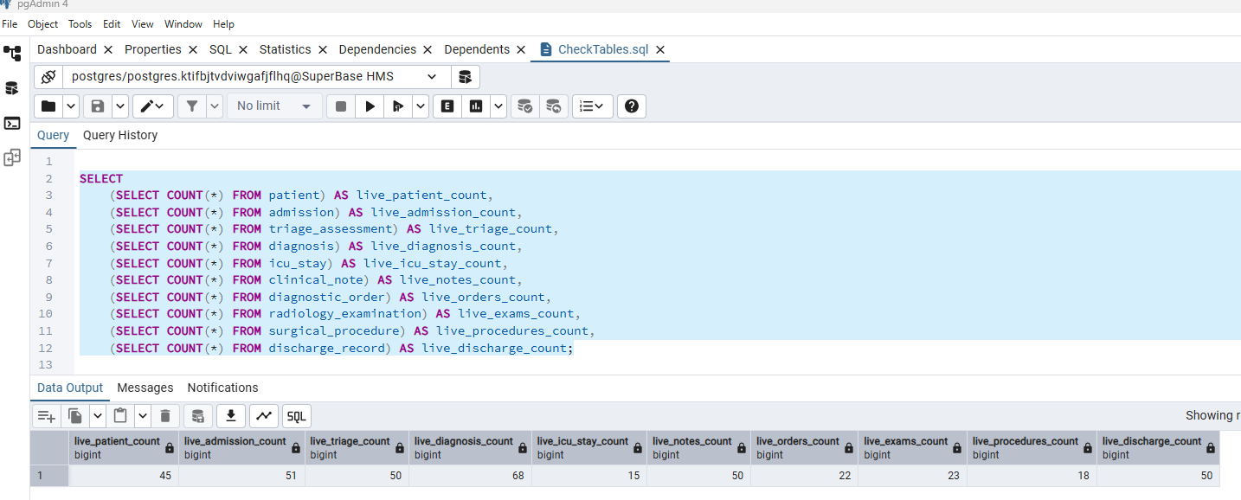

Queries (Q1–Q20)
Each team member must complete four or five queries, as required by the handout.
Query assignments:
- @Zitkq — Q1–Q4
- @JuanMa_487 — Q5–Q8
- @Mohammad — Q9–Q12
- @Laurent — Q13–Q16
- @fmvemba — Q17–Q20
For every query, provide:
- The complete SQL statement.
- A pgAdmin screenshot showing the result.
- A concise explanation of the query’s logic and output
See Appendix A — Individual Query Screenshots for a list of Queries.

Submitted Files
| File | Purpose |
| TablesCreation.sql | Creates all 14 tables and defines their constraints. |
| generate_data.py | Generates the database INSERT statements. |
| populate_all_hospital.sql | Populates the database with the complete sample dataset. |
| FirstPart.sql | Contains the final 20 SQL queries, Q1–Q20. |
| CheckTables.sql | Verifies table contents and expected row counts. |
| ER diagram (. drawio / .png) | Presents the entity-relationship model. |
| README.md | Explains how to reproduce the database. |

Reproduction Steps
1. Create an empty PostgreSQL database named Superbase HMS.
2. Run TablesCreation.sql to create the database schema.
3. Run populate_all_hospital.sql to load the sample data.
4. Run CheckTables.sql and verify the expected row counts.
5. Run Q1 through Q20 from FirstPart.sql.

Conclusion
The project team successfully designed, mapped, and deployed a robust, normalized 14-table Hospital Management System (HMS) database operating natively in PostgreSQL. The final database schema satisfies all structural design constraints for Third Normal Form (3NF), effectively eliminating data redundancies and ensuring absolute referential integrity across all relational pathways. By utilizing a deterministic Python-engineered data generation framework, the system was populated with a realistic, fully reproducible dataset of 45 distinct patients and 51 clinical encounters.
The analytical capabilities and practical utility of the architecture were thoroughly validated through the execution of 20 complex SQL queries utilizing multi-table JOIN operations, conditional aggregations, subqueries, and Common Table Expressions (CTEs).

Appendix A — Individual Query Screenshots
Q1: [Zachary]
List the names and admission dates of all patients who were classified as high-priority
emergency patients during triage.

Query:

Figure 3: Query 1
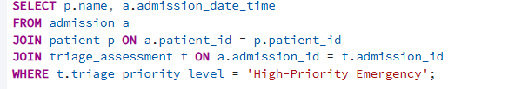
Output:
Figure 4: Output Query 1
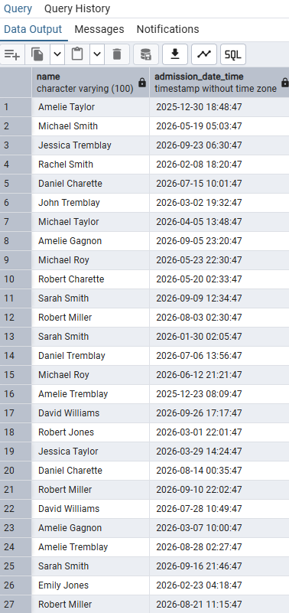
Logic: The logic of this query is we first select the name and admission date time which we want to show. They are from 2 different tables, so we need to create patient p and admission a. We use from to indicate that we are selecting from that table and then join to find the patient that has the same id as the admission that we are selecting. We then select these patients and use them to find the names. Then, same logic but for the triage assessment. We find the triage assessment that has the same id as the admission/patient and then, as a condition we are selecting only those that have their triage priority level to high-priority emergency. We are putting the triage in SELECT since we only want to show the name and admission date/time.
Q2: [Zachary]
Find all patients who had more than three hospital admissions. Display the
patient identifier, patient name, and total number of admissions.

Figure 5: Query 2
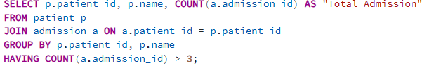

Output:

Figure 6: Output Query 2
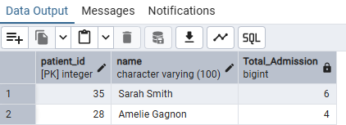

Logic: The logic of this query is that we first select the patient id and the name of a patient p. Then we want to calculate the total number of admissions. For that we use count on the admission id from the patient p and we display is as total_admissions. Then we use join to only show the admission where the patient id’s are the same. And finally, we use group to merge all the rows with the same patient id into one row that displays the total number of admissions. The having will then be the condition for the query. (more than 3 admissions)

Q3: [Zachary]
Retrieve the names, admission dates, and discharge dates of patients who were dis-
charged without undergoing any surgical procedure during admission.

Query:

Figure 7: Query 3
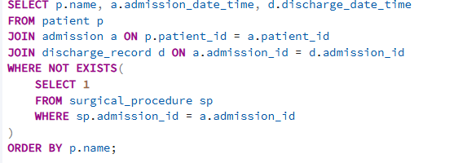
Output:
Figure 8: Output Query 3
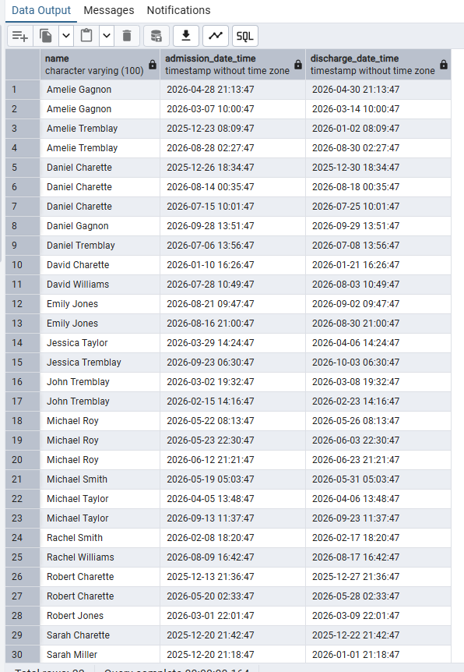

Logic: The main logic of this query is that we need to find what link exists between a patient, the admission and the surgical procedure. Between the patient and the admission, it is the patient id, we can then use that to find a patient with certain condition from the admission and patient table. The surgical procedure table is also based on the admission id, so we can do the same thing using join. The final step is to check if the discharge date time is not null because we want patients who were discharged only.

Q4: [Zachary]
List all patients who had both a radiology examination and a surgical procedure
during the same admission.

Query:

Figure 9: Query 4
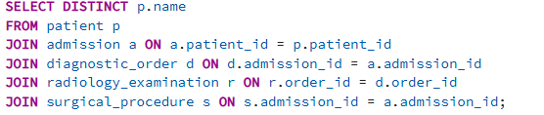

Output
Figure 10: Output Query 4
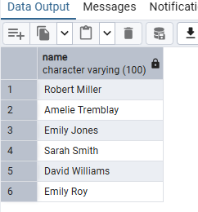

Logic: First, we need to select distinct since a single patient can have multiple admissions that satisfy the requirements, so to prevent that, we use the distinct keyword. After that, like in query 4, we need to find a link between every table. For patients and admissions, it’s the patient id. After that, for the diagnostic order, its the admissions id. Th
Q5: [Juan]
[insert screenshot]
Explanation: [summarize the query logic and key result]
Q6: [JuanMa]
Q7: [JuanMa]
Q8: [JuanMa]

Q9: [Mohammad]
Calculate the average length of stay for each critical care unit type, such as MICU,
SICU, ICU, and CCU. Display the unit type and its average length of stay.
Query: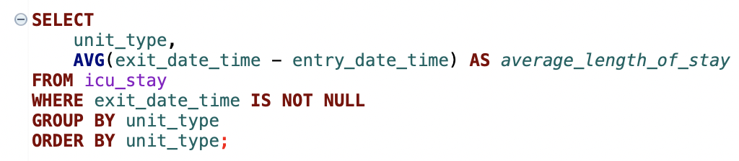
Output:
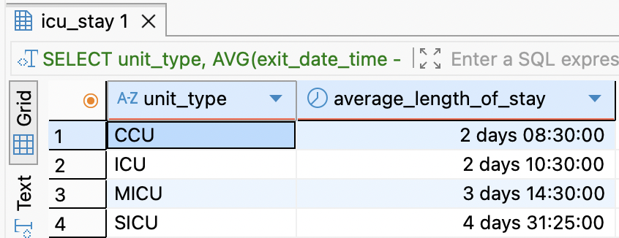

Logic: The query calculates each completed critical care stay by subtracting the entry timestamp from the exit timestamp. It groups the stays by unit type and uses AVG to calculate the average length of stay for each unit. Stays without an exit time are excluded because they are not completed.

Q10: [Mohammad]
List all patients who underwent a surgical procedure before entering an ICU or
CCU during the same admission. Display the patient’s name, procedure date and time, critical care unit type, and unit entry time.

Query:
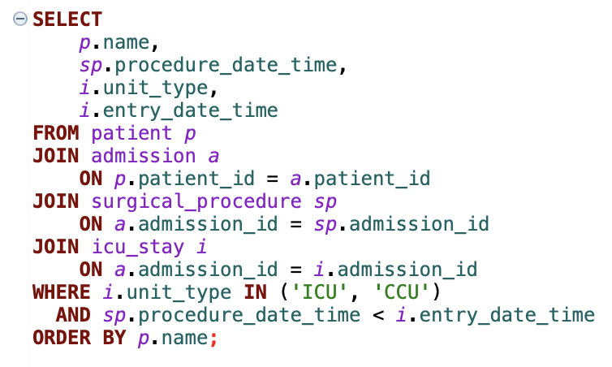

Output:

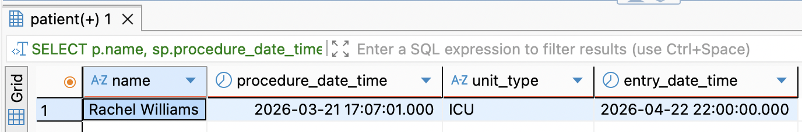

Logic: The query joins patients with their admissions, surgical procedures, and critical care stays. It keeps only ICU or CCU stays and checks that the surgical procedure occurred before the unit entry time during the same admission. The result displays the patient, procedure time, unit type, and ICU/CCU entry time.

Q11: [Mohammad]
Retrieve the name of each patient and the total number of radiology examinations
received across all admissions. Including patients who have not received any radiology examinations and display zero for their examination count.

Query:
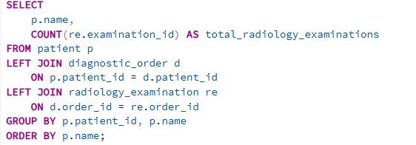
Output:
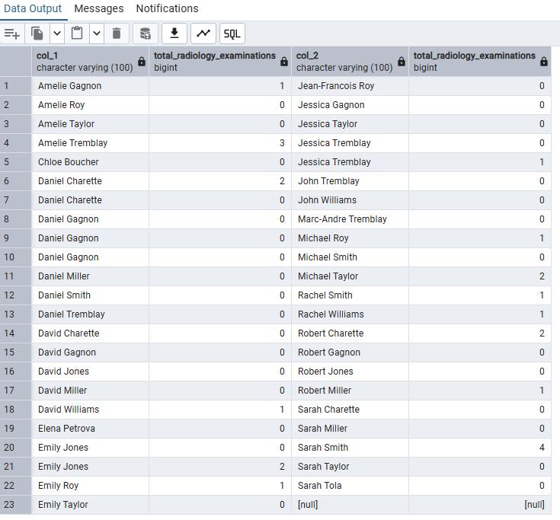
Logic: The query starts with all patients and uses LEFT JOIN to connect them to their admissions, diagnostic orders, and radiology examinations. It groups the results by patient and counts the examinations for each patient. The LEFT JOIN ensures that patients with no radiology examinations are still included with a count of zero.
Q12: [Mohammad]
Find all patients whose discharge-summary clinical note contains the keyword
“recovery”. The search should be case-insensitive.
Query:
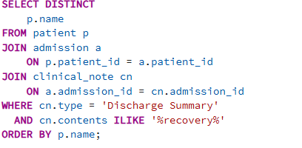
Output:
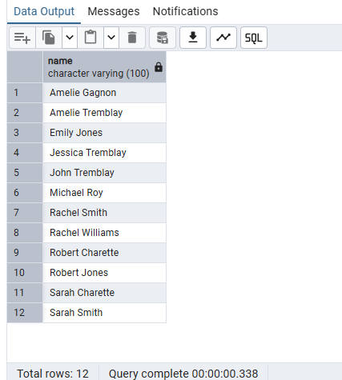
Logic: The query joins patients to their admissions and clinical notes, then keeps only discharge summary notes. LOWER converts the note contents to lowercase, and LIKE '%recovery%' searches for the word “recovery” regardless of capitalization. DISTINCT ensures that each patient appears only once in the result.

Q13: [Laurent]
List all admissions in which the patient had at least one radiology examination but
had no recorded ICU or CCU stay.
Query:
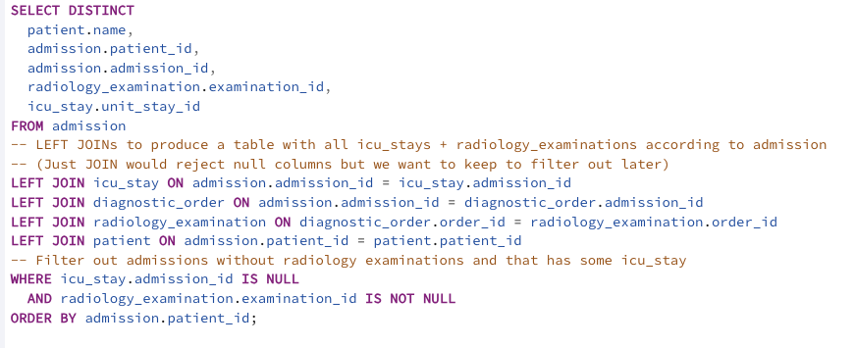
Output
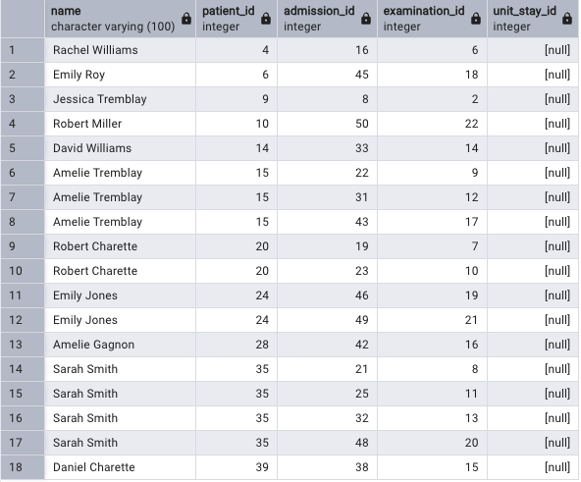
Explanation: Logic explanation in the query comments

Q14: [Laurent]
Retrieve the patient or patients with the longest completed hospital stay, calculated from admission time to discharge time. If multiple patients have the same
maximum length of stay, display all of them.

Query:

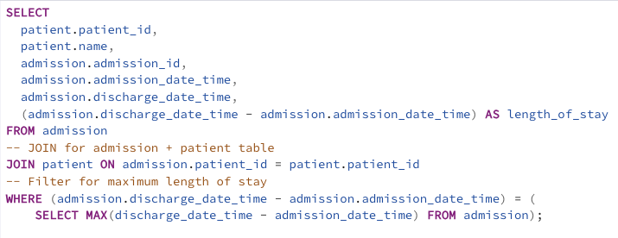

Output:

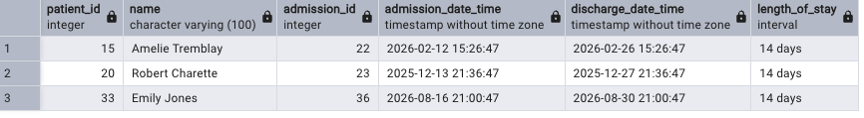

Explanation: Logic explanation in the query comments

Q15: [Laurent]
Count the total number of transfers between hospital units for each patient. The
patient’s first placement is not considered a transfer; each subsequent unit stay
within the same admission represents one transfer.

Query:

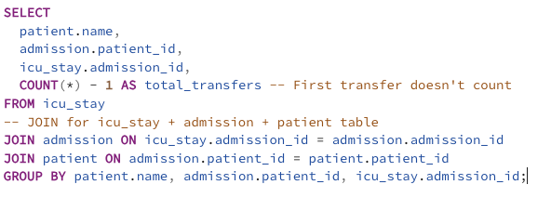

Output

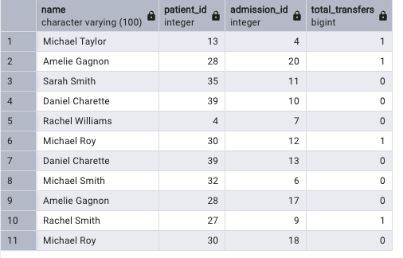

Explanation: Logic explanation in the query comments
Q16: [Laurent]
List all patients who stayed in more than one type of critical care unit during
the same admission. For example, a patient may have been transferred from an ICU
to a CCU.
Query:

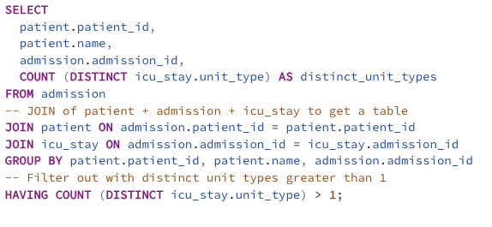

Output:

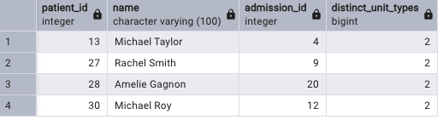

Explanation: Logic explanation in the query comments

Q17: [Freddy Mvemba]
Find all admissions during which the patient received more than one distinct ICD-
9 diagnosis. Display the patient’s name, admission identifier, and number of distinct
ICD-9 codes.
Query:
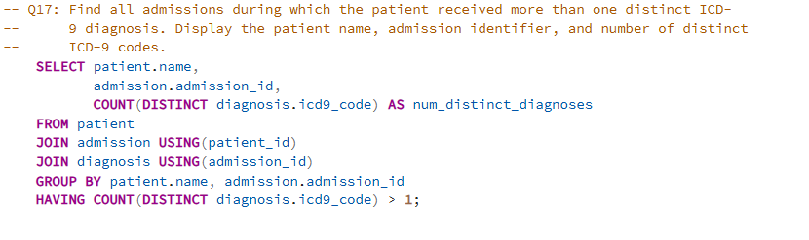
Output
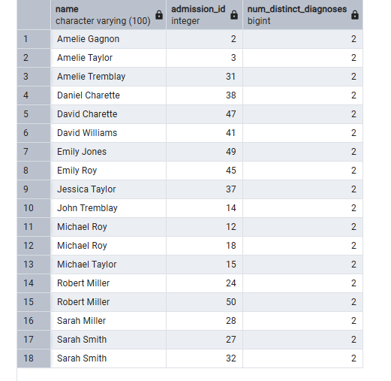
Logic: Group every admission's diagnoses together, count how many distinct ICD-9 codes appear, and keep only the admissions where that count exceeds 1.

Q18 – [Freddy Mvemba]
Retrieve the latest clinical note for each patient. Display the patient’s name, note
type, note creation date and time, and note contents.

Query:
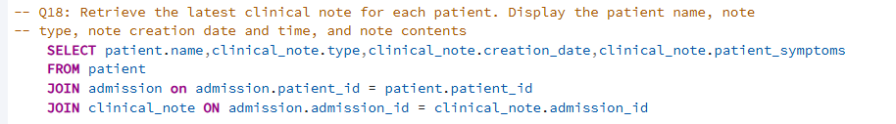
Output:
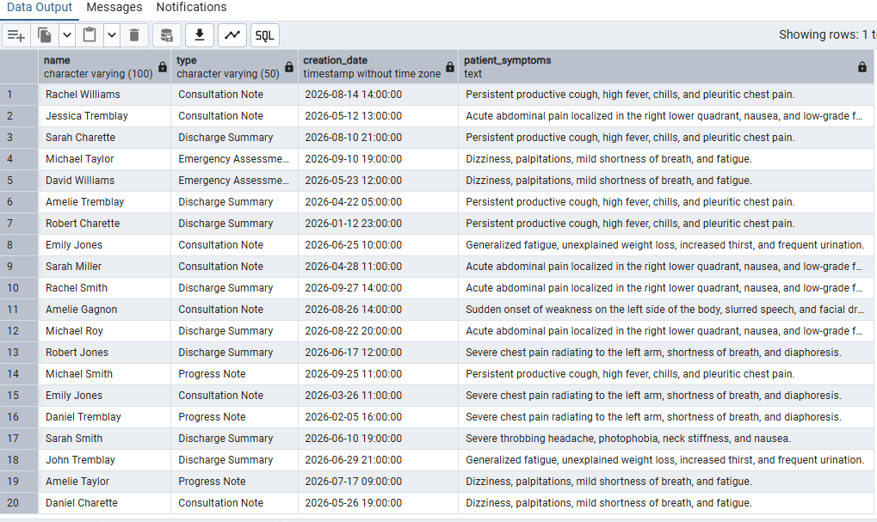
Main logic: For each patient, pick the single clinical note with the latest creation_date_time across all their admissions. Join patient → admission → clinical_note, then keep only the top row per patient (DISTINCT ON (patient_id) or ROW_NUMBER () = 1).

Q19 – [Freddy Mvemba]
List all admissions where the patient’s discharge status or discharge condition indicates that the patient died during the hospital stay. Display the patient’s name, admission date, recorded date of death, and associated primary ICD-9 diagnosis.

Query:

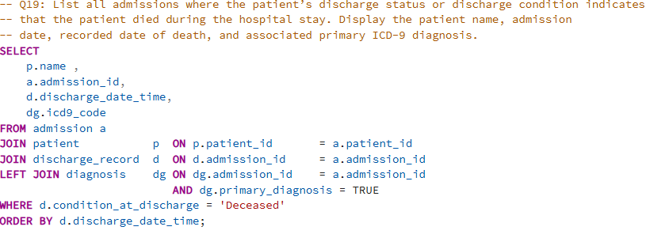

Output

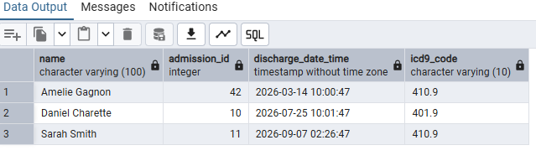
Main logic: Find admissions where the patient died during the stay, by filtering discharge_record.condition_at_discharge = 'Deceased'. Join admission → patient → discharge_record, then LEFT JOIN diagnosis (on primary_diagnosis = TRUE) to attach the primary ICD-9 code.

Q20 – [Freddy Mvemba]
Find all patients who underwent a surgical procedure and a radiology examination on the same calendar day during the same admission. Display the patient’s name, admission identifier, procedure type, radiology examination type, and the common date.

Query:
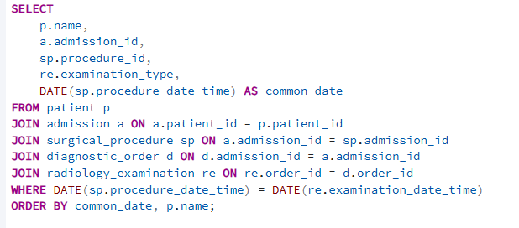

Output:

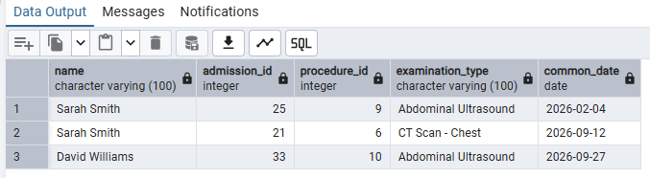

Logic:

Find patients who had both surgery and a radiology exam on the same calendar day in the same admission. Join patient → admission → surgical_procedure, then admission → diagnostic_order → radiology_examination (radiology routes through the order, not the admission), and filter with DATE (surgery_time) = DATE (exam_time).

Appendix B — Handout Checklist
- [x] Include one SQL query for every question.
- [x] Comment on the main logic of each query.
- [x] Use valid, consistently indented, readable SQL.
- [x] Apply joins, grouping, subqueries, aggregates, date/time functions, and CTEs where appropriate.
- [x] Use LEFT JOIN or NOT EXISTS to identify patients with no related records.
- [x] Calculate length of stay from entry and exit timestamps.
- [x] Include only completed admissions with discharge timestamps in the relevant counts.
- [x] Confirm that each completed admission has at least one primary ICD-9 diagnosis.
- [x] Complete all 20 queries, assigning approximately four or five to each member.
- [x] Clearly document each member’s contribution.
- [x] Submit the PDF in a ZIP file named SOEN363_Project_Phase1_DataBase_Gurus>.zip, as specified in the handout.

Table of Figures
Figure 1: ER Diagram 3
Figure 2: Database Statistics 6
Figure 3: Query 1 9
Figure 4: Output Query 1 9
Figure 5: Query 2 10
Figure 6: Output Query 2 10
Figure 7: Query 3 11
Figure 8: Output Query 3 11
Figure 9: Query 4 12
Figure 10: Output Query 4 12

Bibliography
There are no sources in the current document.

