
database project
PHASE1

October 7, 2026
DATABASE GURU
CONCORDIA UNIVERSITY

Contents
Introduction 1
System Overview 2
Entity-Relationship Diagram 2
Relational Schema 3
Data Population 3
Queries (Q1–Q20) 4
Submitted Files 4
Reproduction Steps 4
Conclusion 5
Appendix A — Individual Query Screenshots 6
Appendix B — Handout Checklist 6
Table of Figures 7
Bibliography 7

SOEN 363 — Project Phase 1 Report
Team Name: Database Guru
Members: Laurent, Mohammad, Juan, Zachari, Freddy
Date:10/7/2026

Introduction
This project involves designing and implementing a Hospital Management System (HMS) database. The work includes creating an ER model, implementing the schema in PostgreSQL, and using AI to generate realistic sample data. Deliverables include the ER diagram, relational schema, SQL DDL, populated dataset, and 20 required queries, each with a brief explanation of its purpose.

System Overview
The database represents the hospital’s core operations:
- Patients and admissions
- Physicians and nurses
- Admission triage assessments
- ICD-9-coded diagnoses
- ICU stays
- Clinical notes
- Diagnostic orders, radiology examinations, and reports
- Surgical procedures
- Discharge records
- Design priorities: normalization, referential integrity, and realistic sample data

Entity-Relationship Diagram
Figure 1:ER Diagram
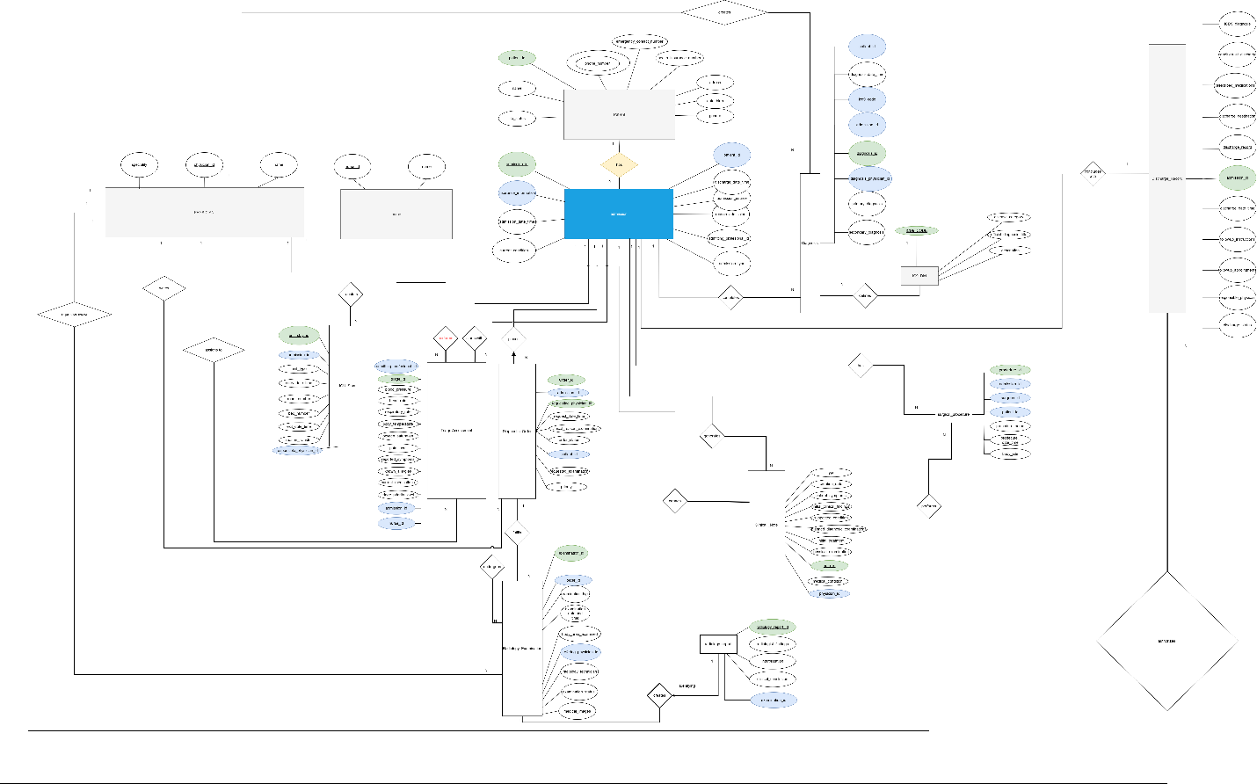
Entities: icd9_dict, physician, nurse, patient, admission, triage_assessment, diagnosis, icu_stay, clinical note, diagnostic order, radiology_examination, radiology_report, discharge record, and surgical procedure.
Key relationships:
- One patient may have many admissions.
- Each admission has one triage assessment.
- Each admission may have multiple diagnoses, including one required primary diagnosis.
- Admission may have at most one ICU stay.
- Each admission may include multiple clinical notes.
- Each admission may have multiple diagnostic orders; each order links to one radiology examination, and each examination links to one radiology report.
- Each admission may have one discharge record.
- Each admission may include multiple surgical procedures.
The diagram identifies all cardinality and participation constraints

Relational Schema
All tables satisfy third normal form (3NF), eliminating partial and transitive dependencies

Data Population
The generate_data.py script creates populate_all_hospital.sql, which contains the sample-data INSERT statements.
The generated dataset includes:
- 4 ICD-9 codes, 15 physicians, 10 nurses, and 40 patients.
- 50 admissions, 50 triage assessments, about 75 diagnoses, about 25 ICU stays, and 50 clinical notes.
- About 25 diagnostic orders, radiology examinations, and radiology reports.
- 50 discharge records and about 15–20 surgical procedures.
- The generator applies these realism safeguards:
- All timestamps are historical.
- ICU exit times never occur after discharge.
- Patients who die during a stay are assigned life_status = 'Deceased' and have a corresponding discharge record.
For reproducibility, random. seed(42) produces the same dataset on every run.

Queries (Q1–Q20)
Each team member must complete four or five queries, as required by the handout.
Query assignments:
- @Zitkq — Q1–Q4
- @JuanMa_487 — Q5–Q8
- @Mohammad — Q9–Q12
- @Laurent — Q13–Q16
- @fmvemba — Q17–Q20
For every query, provide:
- The complete SQL statement.
- A pgAdmin screenshot showing the result.
- A concise explanation of the query’s logic and output

Submitted Files
| File | Purpose |
| TablesCreation.sql | Creates all 14 tables and defines their constraints. |
| generate_data.py | Generates the database INSERT statements. |
| populate_all_hospital.sql | Populates the database with the complete sample dataset. |
| FirstPart.sql | Contains the final 20 SQL queries, Q1–Q20. |
| CheckTables.sql | Verifies table contents and expected row counts. |
| ER diagram (.drawio / .png) | Presents the entity-relationship model. |
| README.md | Explains how to reproduce the database. |

Reproduction Steps
1. Create an empty PostgreSQL database named Superbase HMS.
2. Run TablesCreation.sql to create the database schema.
3. Run populate_all_hospital.sql to load the sample data.
4. Run CheckTables.sql and verify the expected row counts.
5. Run Q1 through Q20 from FirstPart.sql.

Conclusion
The team designed a normalized 14-table HMS database, populated it with realistic sample data, and completed 20 SQL queries using joints, aggregates, subqueries, and CTEs.
The project deepened the team’s understanding of schema design, constraint enforcement, and reproducible data generation.

Appendix A — Individual Query Screenshots

- Q1 — [author]
[insert screenshot]
Explanation: [summarize the query logic and key result]
- Q2 — [author]
Repeat this format for Q3 through Q20.

Appendix B — Handout Checklist

- [x] Include one SQL query for every question.
- [x] Comment the main logic of each query.
- [x] Use valid, consistently indented, readable SQL.
- [x] Apply joins, grouping, subqueries, aggregates, date/time functions, and CTEs where appropriate.
- [x] Use LEFT JOIN or NOT EXISTS to identify patients with no related records.
- [x] Calculate length of stay from entry and exit timestamps.
- [x] Include only completed admissions with discharge timestamps in the relevant counts.
- [x] Confirm that each completed admission has at least one primary ICD-9 diagnosis.
- [x] Complete all 20 queries, assigning approximately four or five to each member.
- [x] Clearly document each member’s contribution.
- [x] Submit the PDF in a ZIP file named SOEN363_Project_Phase1_<TeamName>.zip, as specified in the handout.

Table of Figures
Figure 1:ER Diagram 2

Bibliography
There are no sources in the current document.

