Math Adventures — AI-Powered Adaptive Learning Prototype

Adaptive Learning Assignment Submission

Contents
- 1. Objective
2. Problem Overview
3. System Components
4. Adaptive Logic
5. Puzzle Generation Decision Tables
6. Expected Time and Confidence Formula
7. Data Pipeline & Storage
8. Repo Structure & Sample Code
9. Work Flow
10. Evaluation of model

1. Objective
Build a minimal adaptive math learning prototype that adjusts puzzle difficulty based on user performance using either a rule-based logic or a lightweight ML model. The aim is to demonstrate how AI can keep learners in the optimal challenge zone.

2. Problem Overview
Target users: Children aged 5–10 practicing basic math (addition, subtraction, multiplication, division). Prototype requirements:
• Generate simple math puzzles.
• Track performance (correctness, response time).
• Automatically adjust next puzzle difficulty.
• Display end-of-session performance summary.

3. System Components
Component | Description
Puzzle Generator | Creates math problems dynamically for Easy, Medium, Hard levels. Ensures clean division for / operations. Create expected time.
Model Preparation | Create/check a model (Random Forest Classifier.
Adaptive Engine | Recommending the next level using model(pickle file)
Tracker | Get the progress, calculating confidence stores session records.
logger | monitor, debug, and analyze the behavior

4. Adaptive Logic
Two approaches (choose one for implementation):
- A. Rule-based (recommended for simplicity):
• If correctness over last N questions ≥ 80% and average response time ≤ expected_time → increase difficulty.
• If correctness ≤ 50% or response time much higher than expected → decrease difficulty.
• Else keep difficulty same. Use streak to moderate changes (require streak ≥ 3 to increase).
B. Lightweight ML: Train a RandomForestClassifier on simulated/collected features: difficulty, correct, avg_response_time, streak, confidence → predict next_level.

5. Puzzle Generation Decision Tables
Control variables: level (Easy/Medium/Hard), confidence (0–100), streak (int).

Confidence-Based Overrides
Confidence Range | Effect on Puzzle | Allowed Ops | Number Range | Notes
≥ 80 (High) | Increase Puzzle Difficulty | Easy → +,-,* ; Medium/Hard → +,-,*,/ | Larger ranges | Push student upward faster
≤ 50 (Low) | Reduce Puzzle Difficulty | Easy → +,- ; Medium/Hard → +,-,* | Smaller ranges | Helps recovery
50–80 (Normal) | Use streak logic | Depends on streak | Depends on level | Balanced progression

Easy / Medium / Hard Decision Tables
Easy Level Logic
Condition | Operations | Number Range (num1, num2) | Behaviour
Confidence ≥ 80 | +, -, * | 10–25, 5–15 | Harder Easy
Confidence ≤ 50 | +, - | 1–12, 1–10 | Easier Easy
Streak ≤ 5 | +, - | 1–15, 1–10 | Beginner Easy
6 ≤ Streak ≤ 8 | +, - | 10–30, 5–15 | Moderate Easy
Streak > 8 | *, / | 5–20, 2–10 | Advanced Easy

Medium Level Logic
Condition | Operations | Number Range | Behaviour
Confidence ≥ 80 | All (+,-,*,/) | 30–70, 10–30 | Medium becomes Hard-like
Confidence ≤ 50 | +, -, * | 10–40, 5–20 | Easier Medium
Streak ≤ 5 | +, -, * | 10–40, 5–20 | Entry Medium
6–10 Streak | +, -, *, / | 20–60, 5–25 | Balanced Medium
Streak > 10 | +,-,*,/ | 30–80, 10–30 | Hard-level Medium

Hard Level Logic
Condition | Operations | Number Range | Behaviour
Confidence ≥ 80 | All ops | 80–200, 10–40 | Ultra Hard
Confidence ≤ 50 | +, -, * | 20–80, 5–25 | Easier Hard
Streak ≤ 5 | All ops | 20–80, 5–25 | Entry Hard
6–10 Streak | All ops | 50–120, 10–30 | Intermediate Hard
Streak > 10 | All ops | 80–200, 10–40 | Expert Hard

6. Expected Time & Confidence Formula
Base times per operation:
+ : 5s
- : 6s
* : 8s
/ : 10s
Expected time formula:
expected_time = base_time + (difficulty - 1) * 1.5
(Difficulty mapping: Easy=1, Medium=2, Hard=3)
Confidence calculation (example):
base = 50
+ correctness impact (±20)
+ streak bonus (up to +40)
+ time impact (−15 to +15)
+ difficulty reward (+3/+6/+9 if correct)
Clamped between 0 and 100.

7. Data Pipeline & Storage
Training Data Features:
- difficulty
- response_time
- correct
- streak
- confidence
- next_level (label)

Runtime Storage: progress.db (SQLite) schema example:
Field | Type | Description
session_id | TEXT | UUID for session
timestamp | DATETIME | Time of attempt
difficulty | TEXT | Easy/Medium/Hard
correct | BOOLEAN | 1 or 0
response_time | FLOAT | Seconds
streak | INTEGER | Current streak after attempt
confidence | FLOAT | Calculated confidence score

8. Repo Structure & Sample Code
Recommended repository layout:
MATH_ADVENTURES/
├─ README.md
├─ requirements.txt
├─ src/
├─ main.py
├─ puzzle_generator.py
├─ tracker.py
└─ adaptive_engine.py
├─ logger.py
├─ main.py
└─ exception.py

9. Work-Flow:
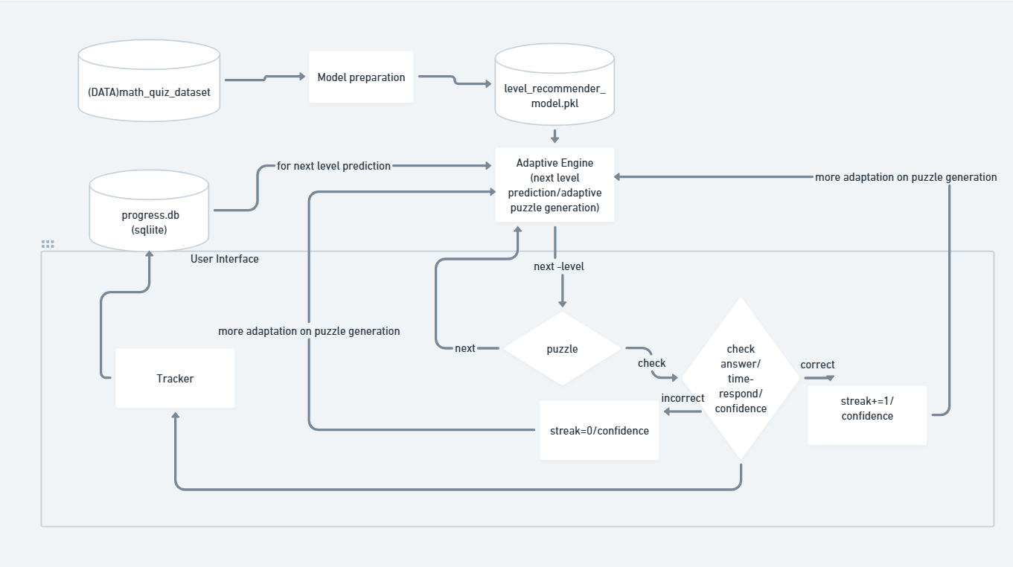

System Architecture Components
Component | Description
math_quiz_dataset | Dataset used for training the ML model containing difficulty, time, correctness, streak, and confidence.
Model Preparation | Feature engineering, preprocessing, training and saving the ML model.(RandomForestClassifier)
level_recommender_model.pkl | Saved ML model responsible for predicting next difficulty level.
progress.db (SQLite) | Runtime database storing user actions, accuracy, time, streak and confidence.
Adaptive Engine | Logic engine that combines model predictions and heuristic rules.
Puzzle Generator | Creates context-aware questions based on level, streak, and confidence.
Tracker | Tracks every user action, logs metrics, and updates the runtime database.
User Interface (Streamlit) | Interactive UI where user solves questions and sees feedback.

10. Evaluation of model : (Random Forest Classifier)

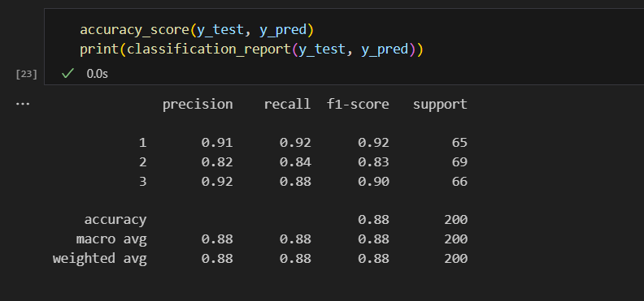

Class | Precision | Recall | F1-Score | Support | Interpretation
1 | 0.91 | 0.92 | 0.92 | 65 | Highly accurate, very few misses
2 | 0.82 | 0.84 | 0.83 | 69 | Lower than others → model struggles more on this class
3 | 0.92 | 0.88 | 0.90 | 66 | Good performance, occasionally misses a few

• High Precision → few false positives
• Strong Recall → captures most positives
• Balanced F1-Scores → overall strong classification capability

