Behavioural Clustering and Model Evaluation

The behavioural clustering analysis was carried out using the 12 GA4 behavioural features prepared for the project. The original GA4 data available was limited, with only 28 rows or users, so it was not sufficient for meaningful behavioural analysis and clustering. To address this, we asked Data Engineering (DE) team to generate a larger synthetic dataset based on the available information. The synthetic dataset was then used for the modelling and segmentation analysis.
Using this dataset, K-means was tested with different values of k and the elbow method as well as silhouette score was used to decide the most suitable number of clusters. Based on the results, K=4 was selected, with a silhouette score of approximately 0.484. The four clusters contained 300, 525, 300 and 375 users.
Looking at the cluster profiles, we could see some clear differences in how the users interacted with DiscountMate. Cluster 0 showed higher engagement time, category browsing and product-detail activity. Cluster 1 had higher comparison and specials activity, along with more varied browsing behaviour. Cluster 2 showed much lower activity across most of the features. Cluster 3 had higher overall activity, particularly in My Lists, sessions, pages visited and browsing behaviour.
We also used PCA to visualise the four clusters. The first two components explained around 67.9% of the variation in the data, and the plot showed that the four clusters are clearly separated into distinct groups. A heatmap was also created to make the differences in behaviour across the clusters easier to compare.
DBSCAN was tested as another clustering approach. However, with the selected settings, it produced only one main cluster containing 293 users, while 1,207 users were classified as noise. This did not give us a useful segmentation, so K-means was considered more suitable for the current dataset.
Overall, the K=4 K-means solution provides a useful starting point for the next stage of the project. The cluster profiles and behavioural differences can now be used for the persona interpretation stage and compared with the existing T1 personas.

Now, let’s go through the main modelling outputs step by step, explaining what each result shows and how it informed the decisions.
- Selecting the number of clusters
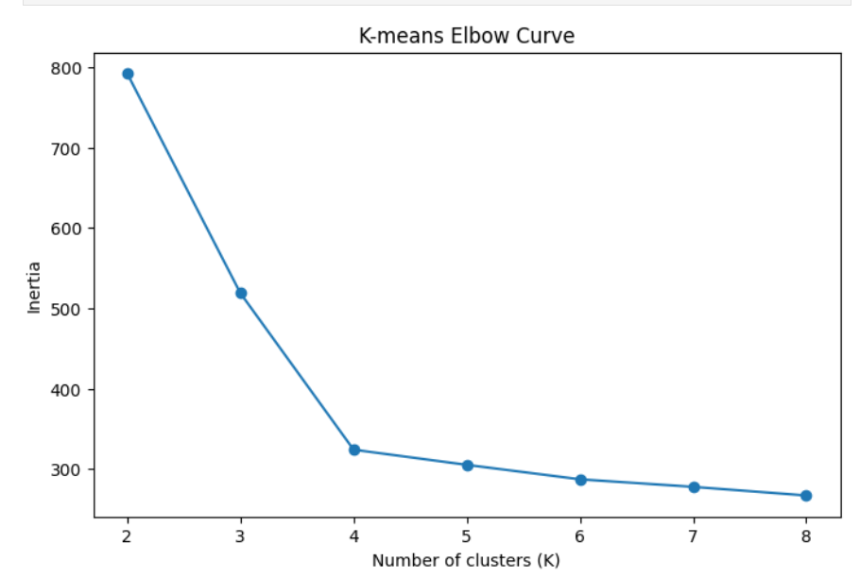

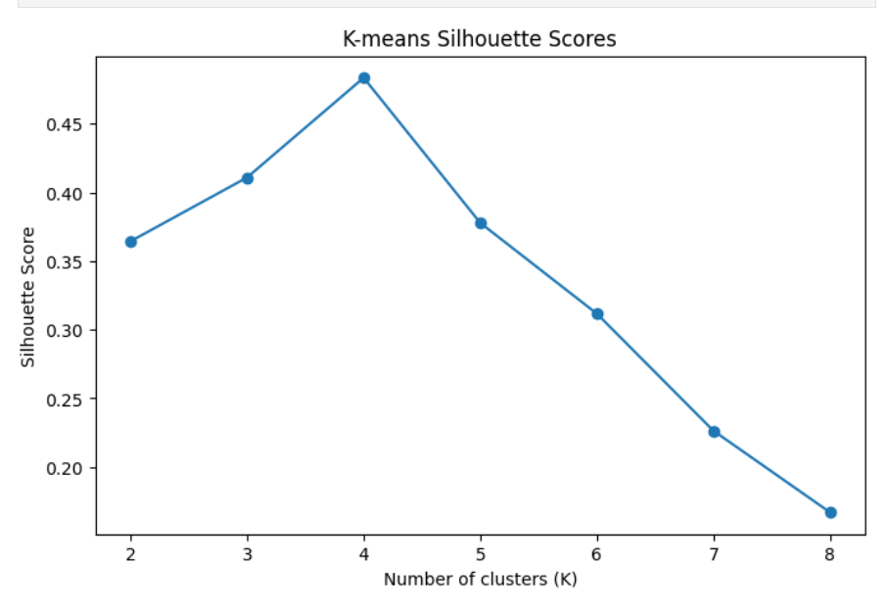

Different number of clusters were tested to determine which value of K would be most suitable. The silhouette score was highest at K=4, with a score of 0.484. The elbow plot also showed that the improvement started to level off around this point. Based on these results, K=4 was selected for the final K-means model.

- Final K-means clustering

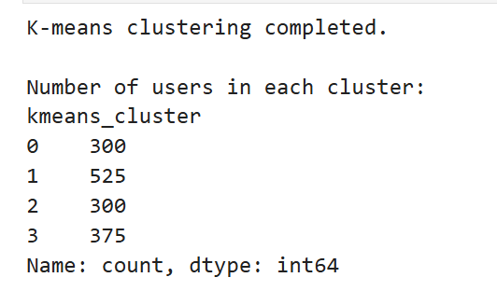

After selecting K=4, the K-means model was run on the full dataset. The users were divided into four groups, with 300, 525, 300 and 375 users in each cluster. This also showed that all four clusters had a reasonable number of users.

- Cluster profiles
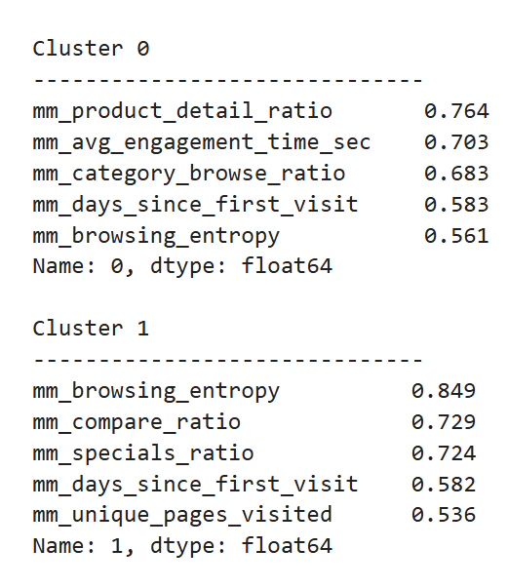

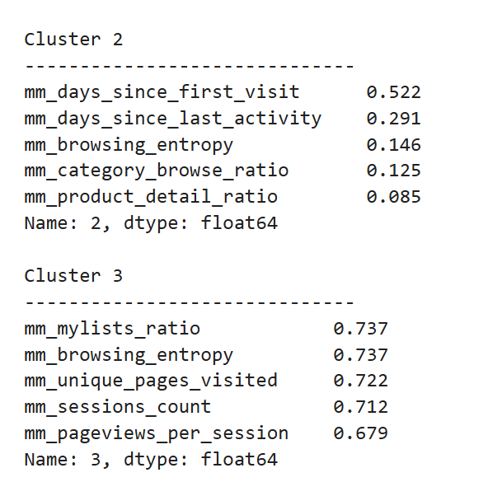

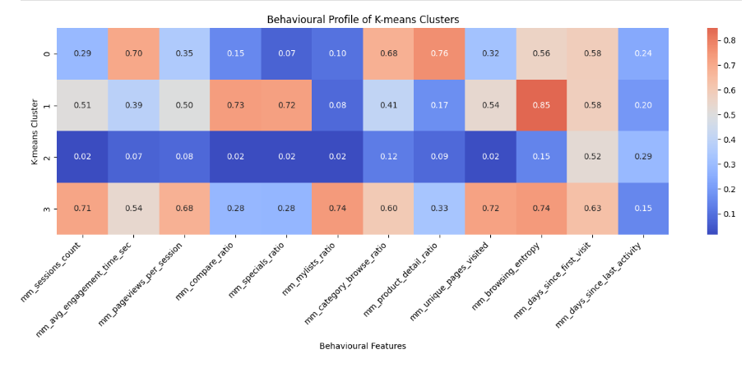

The average behavioural features across the four clusters were compared to understand how the groups differed. Cluster 0 showed stronger product-detail and category-browsing behaviour, Cluster 1 showed higher comparison and specials activity, Cluster 2 had relatively low activity across most features, and Cluster 3 showed higher overall engagement, particularly through sessions, page views and My Lists.

- PCA visualisation

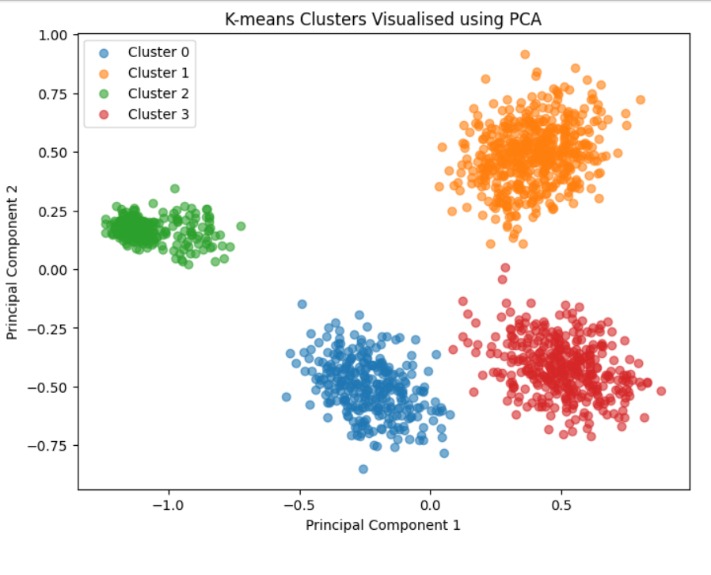

PCA was used to visualise the four clusters in two dimensions. The first two components explained around 67.9% of the variation in the data and the clusters were clearly separated into distinct groups. This provided an additional visual check of the K=4 solution.

- DBSCAN results

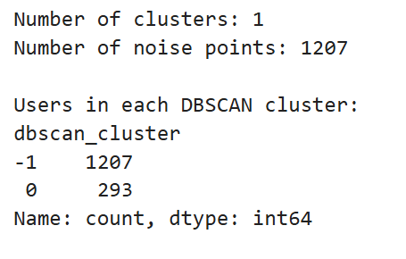

DBSCAN as an alternative clustering method was tested. However, most users were classified as noise and only one main cluster was identified. So, this did not provide a useful segmentation of the users and K-means was considered more suitable for our dataset.

