Week 8 Progress Summary
- This week I focused on software architecture tasks and completed non-disruptive technical contributions in the active project path.
- I implemented a backend health endpoint (GET /health) in newBackend/BackendCode/app.js to improve service reliability and operational visibility.
- I created backend smoke tests in newBackend/tests/api.smoke.test.js to validate core routes (/, /health, /api/stream-names) and invalid payload handling for /api/filter-streams.
- I fixed backend path resolution in newBackend/BackendCode/repositories/mockRepository.js so dataset loading is more stable across run contexts.
- I updated architecture documentation by expanding docs/LLD.md and validating HLD visuals/diagram pack in docs/diagrams.
- I linked technical work to evidence artifacts through docs/evidence/worklog.md, docs/evidence/evidence_index.md, and docs/evidence/code_snippets_showcase.md.
- I also added project governance traceability using Planner mapping in docs/evidence/PLANNER_TRACEABILITY.md.
- I mapped this week’s technical outputs to SFIA-aligned professional skills (Data analytics, Information security, Functional testing, Systems integration, Knowledge management) in docs/sfia/sfia_skill_mapping.md.
- To support engagement and demonstration, I prepared structured walkthrough scripts and video evidence logging format.
- Overall, my Week 8 progress demonstrates architecture-led integration of Data Science contributions with test-backed outcomes.

SFIA Alignment (Week 8)
- Data analytics (DAAN): correlation behavior analysis and data flow interpretation.
- Information security (SCTY): reliability and validation controls via health checks and safe request handling.
- Functional testing (TEST): smoke-test suite proving endpoint stability.
- Systems integration and build (SINT): architecture mapping across frontend, backend, and analytics paths.
- Knowledge management (KNOW): evidence index, planner traceability, and structured documentation.

Reliability Evidence Infographic
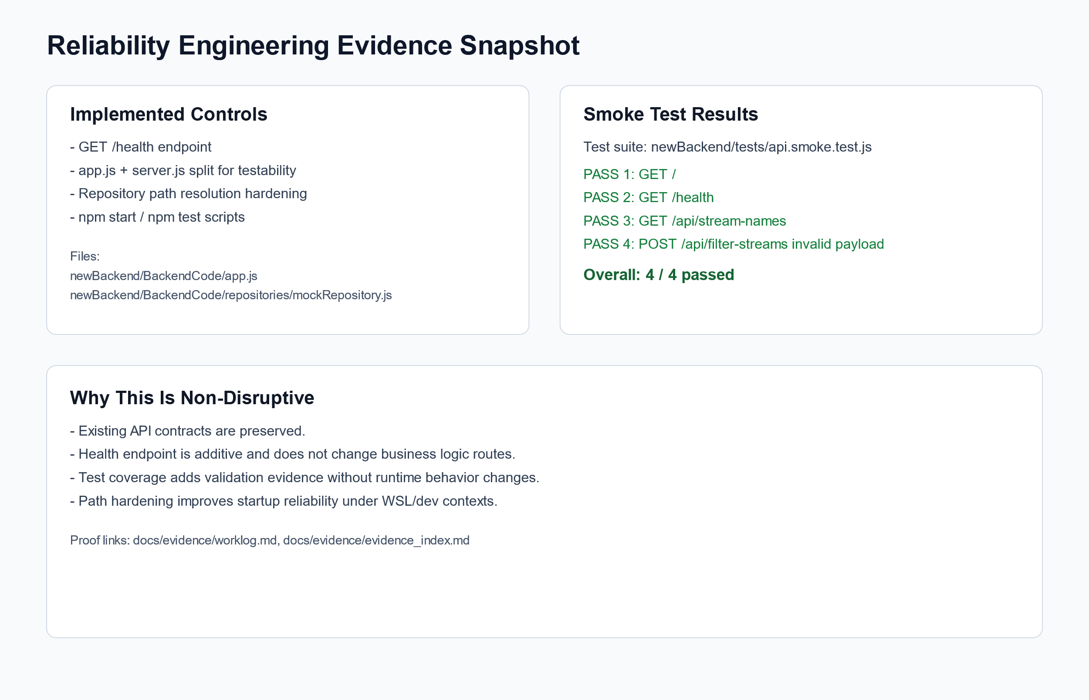
Reliability Engineering Evidence

Week 8 Technical Snippets

Technical Contribution Evidence (Code Snippets)

1) Reliability Endpoint (Non-Disruptive Additive Control)
Source: newBackend/BackendCode/app.js
app.get('/health', (req, res) => {
res.status(200).json({
status: 'ok',
timestamp: new Date().toISOString(),
uptimeSeconds: process.uptime()
});
});

2) Automated Smoke Test Verification
Source: newBackend/tests/api.smoke.test.js
test('GET /health returns service health payload', async () => {
const response = await fetch(`${baseUrl}/health`);
const body = await response.json();
assert.equal(response.status, 200);
assert.equal(body.status, 'ok');
assert.equal(typeof body.timestamp, 'string');
assert.equal(typeof body.uptimeSeconds, 'number');
});

3) Path Resolution Hardening
Source: newBackend/BackendCode/repositories/mockRepository.js
const configuredPath = process.env.PROCESSED_DATA_PATH;
if (!configuredPath) {
throw new Error('PROCESSED_DATA_PATH is not configured');
}
this.filePath = path.isAbsolute(configuredPath)
? configuredPath
: path.resolve(__dirname, '..', configuredPath);

4) Correlation Logic (Data Science Alignment)
Source: new-frontend/frontend/src/utils/correlationUtils.js
const numerator = x.reduce((sum, xi, i) => sum + (xi - avgX) * (y[i] - avgY), 0);
const denominator = Math.sqrt(
x.reduce((sum, xi) => sum + (xi - avgX) ** 2, 0) *
y.reduce((sum, yi) => sum + (yi - avgY) ** 2, 0)
);
return numerator / denominator;

5) Variance Guard for Insight Quality
Source: new-frontend/frontend/src/utils/varianceUtils.js
export const hasVariance = (data, key) => {
const values = data.map(d => parseFloat(d[key])).filter(v => !isNaN(v));
const unique = new Set(values);
return unique.size > 1;
};

6) Python Correlation-Outlier Logic
Source: data_science/algorithms/correlation_based.py
corr_matrix = df_period.corr()
avg_corr = {}
for stream in streams:
other_corr = corr_matrix.loc[stream, streams].drop(stream)
avg_corr[stream] = other_corr.mean()
if threshold is None:
threshold = avg_corr_series.mean() - avg_corr_series.std()

Git Evidences
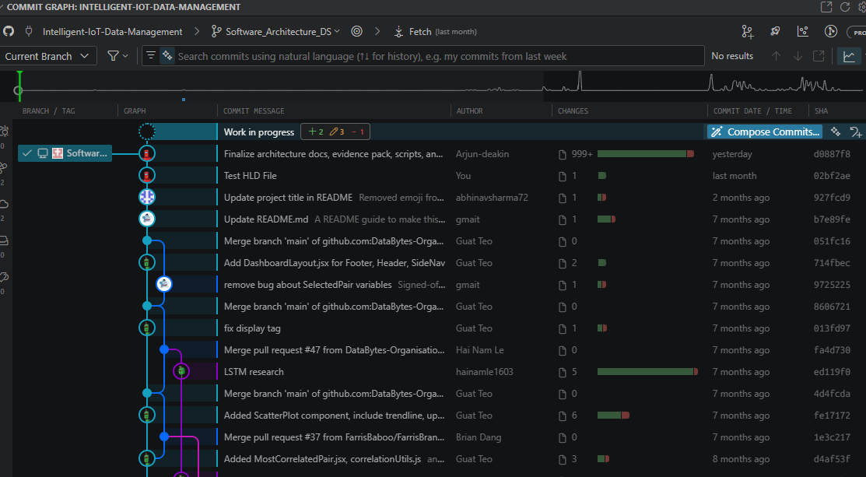

Video Evidence
Recap: Call with RACHIT GOYAL Saturday, | Meeting | Microsoft Teams
Code Walkthrough https://deakin.au.panopto.com/Panopto/Pages/Viewer.aspx?id=11af56f7-8287-4475-8278-b43f006d6395

Planner Governance Evidence (Software Architecture Bucket)
Planner board used for architecture task planning and progress traceability:
- https://planner.cloud.microsoft/webui/plan/Zx8AozAXI0qGNjreoURensgADRuX/view/board?tid=d02378ec-1688-46d5-8540-1c28b5f470f6

Planner Snippets
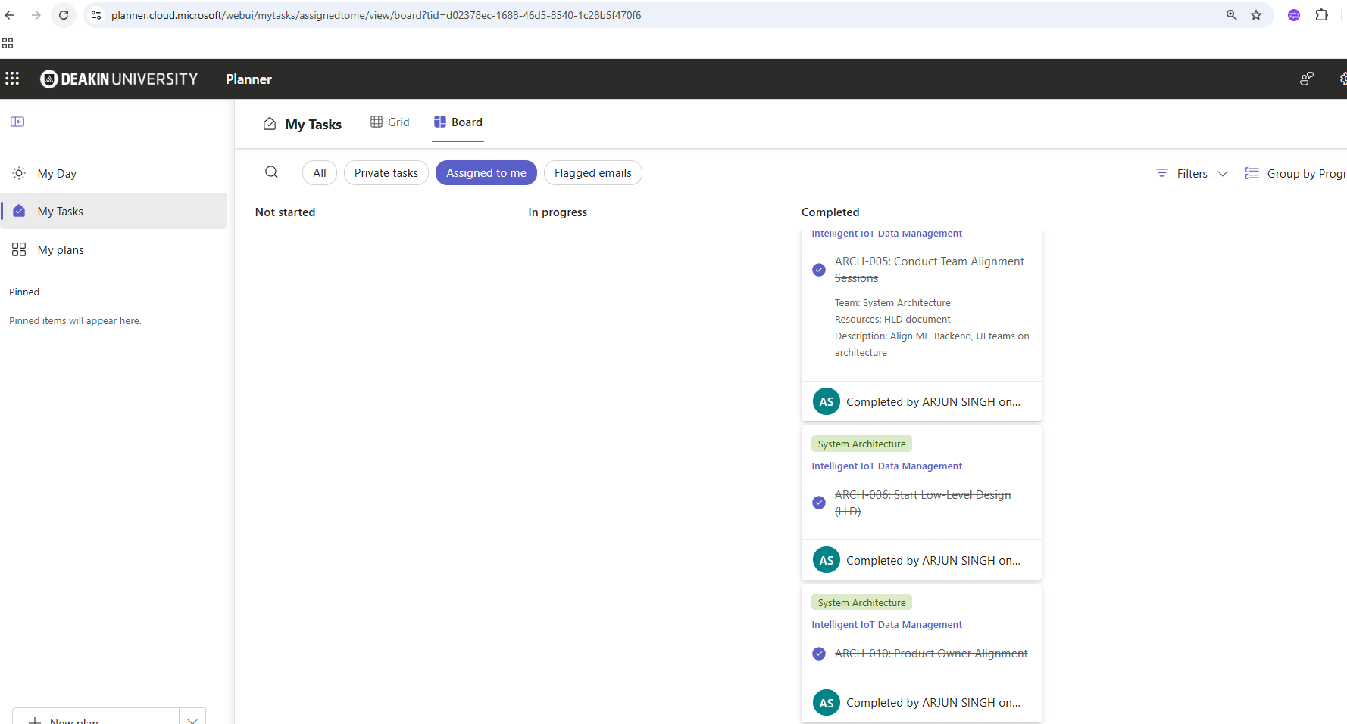

Chat With Team Member Snippet

RACHIT GOYAL
started transcription
RG

RACHIT GOYAL
0 30:03
RACHIT GOYAL 0 minutes 3 seconds
The recording has started now.
AS

ARJUN SINGH
0 50:05
ARJUN SINGH 0 minutes 5 seconds
Yeah, yeah, just I got the notification. Yeah, hi, Rachit, how are you? Good. Yeah, yeah, yeah. So, you know, like it's been quite a time. We have been discussing about all the software architecture part. And so last week we...
RG

RACHIT GOYAL
0 100:10
RACHIT GOYAL 0 minutes 10 seconds
Go ahead, Arjun, yourself?
RACHIT GOYAL 0 minutes 19 seconds
Yep.
RACHIT GOYAL 0 minutes 22 seconds
So I was a bit actually confused in the HLD document that we were discussing about. Is it all right if we can just take it from there? And then, yep, I've made some diagrams based on the HLD document. So I'll show you those. But first I would really appreciate if we can go through the document.
AS

ARJUN SINGH
0 250:25
ARJUN SINGH 0 minutes 25 seconds
MQHUM.
ARJUN SINGH 0 minutes 27 seconds
MQHUM.
ARJUN SINGH 0 minutes 29 seconds
Correct.
ARJUN SINGH 0 minutes 32 seconds
Definitely, definitely.
ARJUN SINGH 0 minutes 37 seconds
Mhm, mhm.
ARJUN SINGH 1 minute 42 seconds
Okay.
ARJUN SINGH 1 minute 44 seconds
MQHUM.
ARJUN SINGH 1 minute 46 seconds
Okay, so yeah, okay. So architecture driver, so what is your take on it? So I must ask you, so like whenever you see that particular sections, what is your take? How you see it so that I can correct you or maybe if you have some concerns or the queries regarding it.
ARJUN SINGH 2 minutes 4 seconds
I'll take you through there from actually where we wanted to take it up. So tell me, like, so you have a functional driver issue or non-functional driver or constrained drivers? Or you want me to explain each and every one?
RG

RACHIT GOYAL
2 minutes 11 seconds2:11
RACHIT GOYAL 2 minutes 11 seconds
Yeah.
RACHIT GOYAL 2 minutes 13 seconds
Mhm.
RACHIT GOYAL 2 minutes 15 seconds
Help.
RACHIT GOYAL 2 minutes 18 seconds
Yep, actually, I'm new to the architecture segment. So basically, I was trying to go through all of them. I did understand a little bit about each of them, but I would appreciate if you could just take me through the constraint driver and the non-functional drivers.
AS

ARJUN SINGH
2 minutes 22 seconds2:22
ARJUN SINGH 2 minutes 22 seconds
Okay.
ARJUN SINGH 2 minutes 25 seconds
MQHUM.
ARJUN SINGH 2 minutes 28 seconds
MQHUM.
ARJUN SINGH 2 minutes 33 seconds
MQHUM.
ARJUN SINGH 2 minutes 35 seconds
Okay, great. So if you are good with the functional driver, then our life is quite easy in context to it. Okay, so non-functional. So Rachit, like functionality is our core essence of application. So you know, I was keep reiterating this thing in our last meeting with the Sarah.
RG

RACHIT GOYAL
2 minutes 41 seconds2:41
RACHIT GOYAL 2 minutes 41 seconds
Yeah.
RACHIT GOYAL 2 minutes 43 seconds
Yeah.
RACHIT GOYAL 2 minutes 50 seconds
MQHUM.
AS

ARJUN SINGH
2 minutes 55 seconds2:55
ARJUN SINGH 2 minutes 55 seconds
On all the folks, so yeah, you remember that, right? The functionality is what currently we opt or not opt, basically, the currently whatever the functionality is in the project, so the functional driver is a core engine which drives which can take you to a different level of.
RG

RACHIT GOYAL
2 minutes 56 seconds2:56
RACHIT GOYAL 2 minutes 56 seconds
Yeah, I remember.
RACHIT GOYAL 2 minutes 59 seconds
Yeah.
RACHIT GOYAL 3 minutes 12 seconds
MQHUM.
AS

ARJUN SINGH
3 minutes 15 seconds3:15
ARJUN SINGH 3 minutes 15 seconds
You know the steps where you can actually process the data and get the results, and you can publish it on a, you know, other dashboard, basically the front end, but so that is quite interesting part. You know, the non-functional driver is all about the health monitoring.
RG

RACHIT GOYAL
3 minutes 32 seconds3:32
RACHIT GOYAL 3 minutes 32 seconds
MQHUM.
AS
ARJUN SINGH
3 minutes 34 seconds3:34
ARJUN SINGH 3 minutes 34 seconds
health monitoring, process monitoring, and the reliability of that particular, you know, application, how it works. Because you know, whenever you are publishing a new sensor or whenever your existing application is running, feeding so much data from back end to front end, so the reliability is the most important thing.
RG
RACHIT GOYAL
3 minutes 35 seconds3:35
RACHIT GOYAL 3 minutes 35 seconds
Ohh.
RACHIT GOYAL 3 minutes 39 seconds
MQHUM.
RACHIT GOYAL 3 minutes 41 seconds
MQHUM.
RACHIT GOYAL 3 minutes 51 seconds
MQHUM.
AS
ARJUN SINGH
3 minutes 56 seconds3:56
ARJUN SINGH 3 minutes 56 seconds
So in non-functional driver, we are capturing it. You know what we do, we will be predicting the endpoint behavior. So whether the endpoint behaviour is consistent or not, understood?
RG
RACHIT GOYAL
3 minutes 56 seconds3:56
RACHIT GOYAL 3 minutes 56 seconds
Okay.
RACHIT GOYAL 4 minutes
MQHUM.
RACHIT GOYAL 4 minutes 4 seconds
Ohh.
RACHIT GOYAL 4 minutes 8 seconds
Okay, that makes sense.
AS
ARJUN SINGH
4 minutes 10 seconds4:10
ARJUN SINGH 4 minutes 10 seconds
Okay, so other thing is, you know, the maintainability of the code. You know, right now everyone is using Git and all. So most of the process has been sorted out because, you know, other folks are taking care of the ownership of whenever you are pushing the code, whenever you are changing something, it should not break the existing one.
RG
RACHIT GOYAL
4 minutes 15 seconds4:15
RACHIT GOYAL 4 minutes 15 seconds
MQHUM.
RACHIT GOYAL 4 minutes 17 seconds
Yep.
RACHIT GOYAL 4 minutes 21 seconds
MQHUM.
RACHIT GOYAL 4 minutes 26 seconds
MQHUM.
AS
ARJUN SINGH
4 minutes 30 seconds4:30
ARJUN SINGH 4 minutes 30 seconds
So, you know how you are maintaining it, basically the version revisioning and the versioning of that particular code. Now, you know, not even a single code is, you know, perfect, so you'll see so many bugs, you will see small enhancements, you can see so many, you know.
RG
RACHIT GOYAL
4 minutes 30 seconds4:30
RACHIT GOYAL 4 minutes 30 seconds
MQHUM.
RACHIT GOYAL 4 minutes 34 seconds
Yep.
RACHIT GOYAL 4 minutes 38 seconds
Or.
RACHIT GOYAL 4 minutes 44 seconds
It.
RACHIT GOYAL 4 minutes 51 seconds
MQHUM.
AS
ARJUN SINGH
4 minutes 51 seconds4:51
ARJUN SINGH 4 minutes 51 seconds
A customer's arcs on a last moment, so that is where we want a reproducibility of that particular piece. So, if suppose you are doing some testing and you wanted to evaluate this particular section of a code, maybe your front end, maybe back end, or...

Research References Used
- ISO/IEC/IEEE 42010 (Architecture Description Standard)
https://www.iso.org/standard/74393.html
- SEI Carnegie Mellon - Software Architecture
https://www.sei.cmu.edu/our-work/software-architecture/
- Microsoft Azure Architecture Center
https://learn.microsoft.com/en-us/azure/architecture/
- Google Cloud Architecture Framework
https://cloud.google.com/architecture/framework
- Deakin AI and Literature Review Guide
https://deakin.libguides.com/ai-literature-review

