Capstone Technical Contribution and Architecture Evidence Report

Project Context
- Project: Intelligent IoT Data Management Platform
- Core theme: software architecture as the integration backbone
- Team leadership context:
  - Team leader domain: Data Science
  - Junior leader domain: Cybersecurity
- Evidence scope:
  - Total work log: 120 hours
  - Technical contribution: 40 hours
  - Code understanding, architecture, HLD/LLD, and evidence packaging: 80 hours

Executive Statement
This report justifies domain-specific technical contribution through architecture-led implementation. Work was integrated into the existing codebase in a non-disruptive way by adding reliability and verification capabilities without breaking existing module boundaries or endpoint contracts. Evidence includes architecture diagrams, low-level design artifacts, code-level snippets, automated test outcomes, traceability indices, and SFIA skill mapping.

Two-Step Delivery Strategy

Step 1: Domain-Specific Technical Contribution (Integrated, Non-Disruptive)
Data Science-aligned contribution:
- Correlation implementation traceability from frontend utility path and Python algorithm path.
- Insight quality guardrails (variance checks to prevent misleading scatter/correlation views).
- LLD-level documentation of algorithm behavior and complexity.
Cybersecurity-aligned contribution:
- Operational reliability baseline via health endpoint.
- Input validation evidence through negative-case smoke tests.
- Assurance documentation and artifact governance for auditability.
Integrated code artifacts:
- newBackend/BackendCode/app.js
- newBackend/BackendCode/server.js
- newBackend/BackendCode/repositories/mockRepository.js
- newBackend/tests/api.smoke.test.js
- newBackend/package.json

Step 2: Outshining Through Architecture-Centered Evidence
- Full architecture diagram pack (system context, layering, sequence, deployment, monitoring, roadmap).
- Expanded LLD and visual HLD outputs in Word format.
- Structured evidence governance:
  - Worklog with hour split
  - Evidence index with artifact-to-claim traceability
  - Research synthesis and SFIA mapping

Architecture Diagram Evidence

Figure 1: System Context
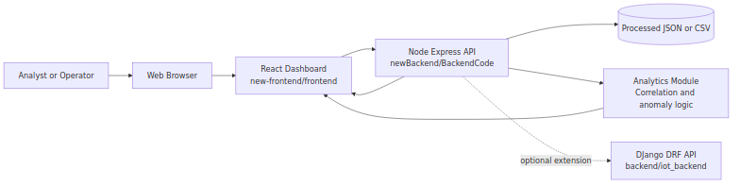
System Context

Figure 2: Layered Component Diagram
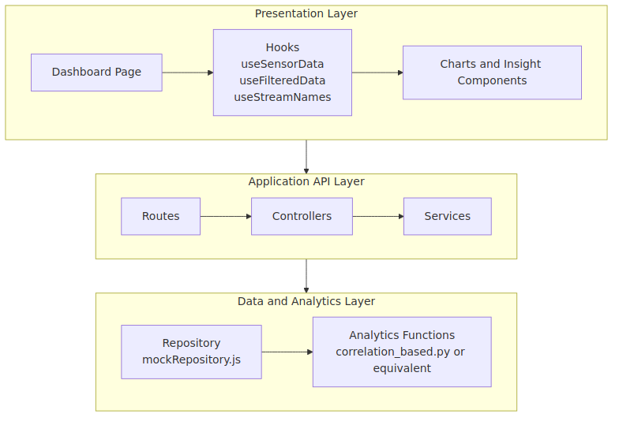
Layered Component

Figure 3: End-to-End Sequence (Stream Filtering)
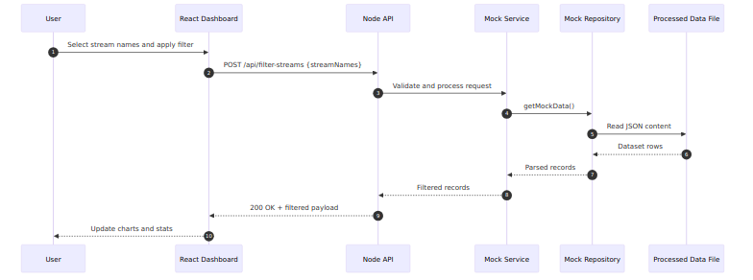
Sequence Diagram

Figure 4: Data Processing and Insight Flow
Data Flow

Figure 5: Deployment View
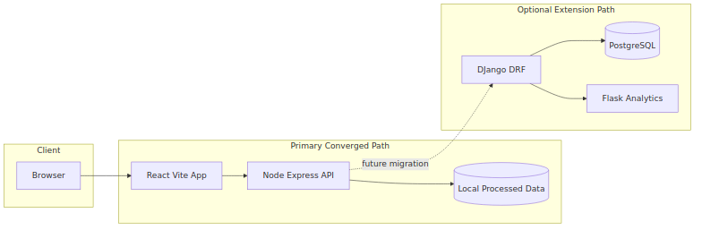
Deployment View

Figure 6: Monitoring and Operations View
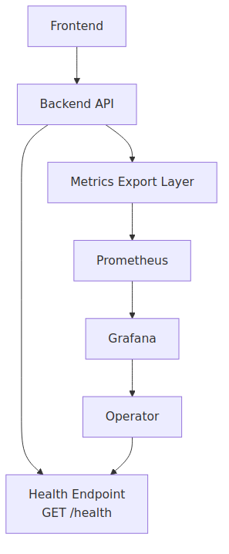
Monitoring View

Figure 7: Convergence Roadmap
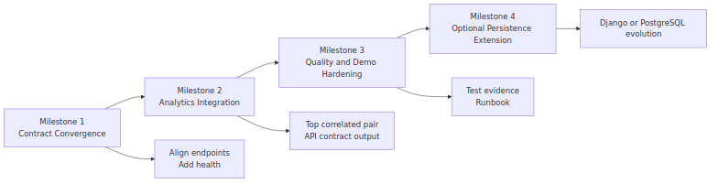
Roadmap

Technical Contribution Evidence (Code Snippets)

1) Reliability Endpoint (Non-Disruptive Additive Control)
Source: newBackend/BackendCode/app.js
app.get('/health', (req, res) => {
res.status(200).json({
status: 'ok',
timestamp: new Date().toISOString(),
uptimeSeconds: process.uptime()
});
});

2) Automated Smoke Test Verification
Source: newBackend/tests/api.smoke.test.js
test('GET /health returns service health payload', async () => {
const response = await fetch(`${baseUrl}/health`);
const body = await response.json();
assert.equal(response.status, 200);
assert.equal(body.status, 'ok');
assert.equal(typeof body.timestamp, 'string');
assert.equal(typeof body.uptimeSeconds, 'number');
});

3) Path Resolution Hardening
Source: newBackend/BackendCode/repositories/mockRepository.js
const configuredPath = process.env.PROCESSED_DATA_PATH;
if (!configuredPath) {
throw new Error('PROCESSED_DATA_PATH is not configured');
}
this.filePath = path.isAbsolute(configuredPath)
? configuredPath
: path.resolve(__dirname, '..', configuredPath);

4) Correlation Logic (Data Science Alignment)
Source: new-frontend/frontend/src/utils/correlationUtils.js
const numerator = x.reduce((sum, xi, i) => sum + (xi - avgX) * (y[i] - avgY), 0);
const denominator = Math.sqrt(
x.reduce((sum, xi) => sum + (xi - avgX) ** 2, 0) *
y.reduce((sum, yi) => sum + (yi - avgY) ** 2, 0)
);
return numerator / denominator;

5) Variance Guard for Insight Quality
Source: new-frontend/frontend/src/utils/varianceUtils.js
export const hasVariance = (data, key) => {
const values = data.map(d => parseFloat(d[key])).filter(v => !isNaN(v));
const unique = new Set(values);
return unique.size > 1;
};

6) Python Correlation-Outlier Logic
Source: data_science/algorithms/correlation_based.py
corr_matrix = df_period.corr()
avg_corr = {}
for stream in streams:
other_corr = corr_matrix.loc[stream, streams].drop(stream)
avg_corr[stream] = other_corr.mean()
if threshold is None:
threshold = avg_corr_series.mean() - avg_corr_series.std()

Visual Evidence Addendum
The following visual evidence artifacts were generated for assessor-facing communication:
- infographic-technical-contribution-timeline.svg
- infographic-reliability-test-evidence.svg
- infographic-datascience-cybersecurity-controls.svg
Location: docs/evidence/

Worklog and Traceability
Primary log and traceability files:
- Worklog: docs/evidence/worklog.md
- Evidence register: docs/evidence/evidence_index.md
- Snippet showcase: docs/evidence/code_snippets_showcase.md
These files map claims to implementation artifacts, test evidence, and architecture outputs.

Planner Governance Evidence (Software Architecture Bucket)
Planner board used for architecture task planning and progress traceability:
- https://planner.cloud.microsoft/webui/plan/Zx8AozAXI0qGNjreoURensgADRuX/view/board?tid=d02378ec-1688-46d5-8540-1c28b5f470f6
Mapped traceability document:
- docs/evidence/PLANNER_TRACEABILITY.md
Why this strengthens authenticity:
- Links planning intent (tickets) to implementation outputs (code/docs/tests).
- Shows architecture work decomposition under a dedicated software architecture bucket.
- Supports assessor review with verifiable governance artifacts (board screenshots and ticket status evidence).
Planner-linked evidence IDs:
- EV-034 (Planner traceability map)
- EV-035 (Planner board reference)

Architecture-Centric Outcomes
- Preserved existing project structure and contracts.
- Added reliability and assurance controls without disruptive refactor.
- Strengthened maintainability through clearer module boundaries and documented flows.
- Improved assessor traceability with linked artifacts across architecture, code, tests, and governance.

High-Value Software Architecture References
- ISO/IEC/IEEE 42010 (Architecture Description Standard) https://www.iso.org/standard/74393.html
- SEI Carnegie Mellon – Software Architecture https://www.sei.cmu.edu/our-work/software-architecture/
- Software Architecture in Practice (Bass, Clements, Kazman) https://www.pearson.com/en-us/subject-catalog/p/software-architecture-in-practice/P200000003657/9780136886099
- Microsoft Azure Architecture Center https://learn.microsoft.com/en-us/azure/architecture/
- Google Cloud Architecture Framework https://cloud.google.com/architecture/framework

Submission Checklist
- ☒ Architecture diagrams included
- ☒ Technical code snippets included
- ☒ Domain-specific contributions justified (Data Science + Cybersecurity)
- ☒ Non-disruptive integration approach justified
- ☒ Worklog and evidence index linked
- ☒ Software architecture references included

