Table of Contents

1 Final Submission Evidence Portfolio
Prepared for capstone assessment review.

1.1 Capstone Technical Contribution and Architecture Evidence Report

1.2 Project Context
- Project: Intelligent IoT Data Management Platform
- Core theme: software architecture as the integration backbone
- Team leadership context:
  - Team leader domain: Data Science
  - Junior leader domain: Cybersecurity
- Evidence scope:
  - Total work log: 120 hours
  - Technical contribution: 40 hours
  - Code understanding, architecture, HLD/LLD, and evidence packaging: 80 hours

1.3 Executive Statement
This report justifies domain-specific technical contribution through architecture-led implementation. Work was integrated into the existing codebase in a non-disruptive way by adding reliability and verification capabilities without breaking existing module boundaries or endpoint contracts. Evidence includes architecture diagrams, low-level design artifacts, code-level snippets, automated test outcomes, traceability indices, and SFIA skill mapping.

1.4 Two-Step Delivery Strategy

1.4.1 Step 1: Domain-Specific Technical Contribution (Integrated, Non-Disruptive)
Data Science-aligned contribution:
- Correlation implementation traceability from frontend utility path and Python algorithm path.
- Insight quality guardrails (variance checks to prevent misleading scatter/correlation views).
- LLD-level documentation of algorithm behavior and complexity.
Cybersecurity-aligned contribution:
- Operational reliability baseline via health endpoint.
- Input validation evidence through negative-case smoke tests.
- Assurance documentation and artifact governance for auditability.
Integrated code artifacts:
- newBackend/BackendCode/app.js
- newBackend/BackendCode/server.js
- newBackend/BackendCode/repositories/mockRepository.js
- newBackend/tests/api.smoke.test.js
- newBackend/package.json

1.4.2 Step 2: Outshining Through Architecture-Centered Evidence
- Full architecture diagram pack (system context, layering, sequence, deployment, monitoring, roadmap).
- Expanded LLD and visual HLD outputs in Word format.
- Structured evidence governance:
  - Worklog with hour split
  - Evidence index with artifact-to-claim traceability
  - Research synthesis and SFIA mapping

1.5 Architecture Diagram Evidence

1.5.1 Figure 1: System Context
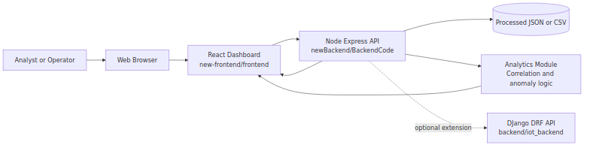
System Context

1.5.2 Figure 2: Layered Component Diagram
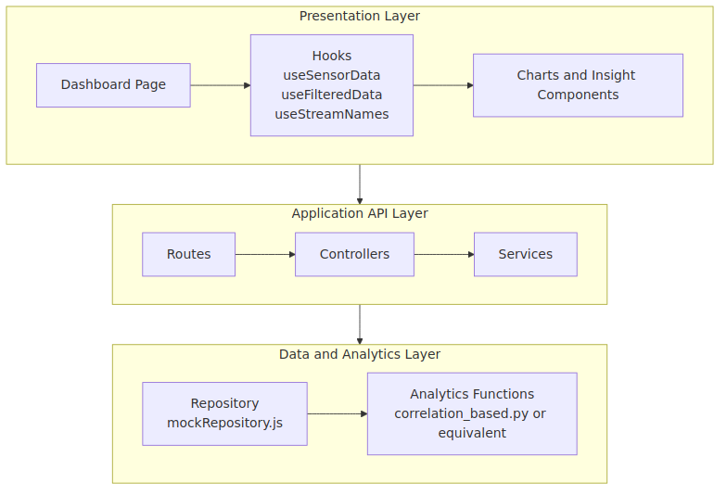
Layered Component

1.5.3 Figure 3: End-to-End Sequence (Stream Filtering)
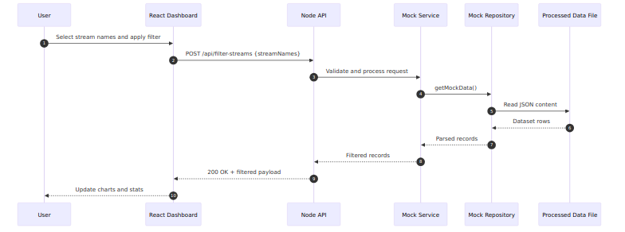
Sequence Diagram

1.5.4 Figure 4: Data Processing and Insight Flow
Data Flow

1.5.5 Figure 5: Deployment View
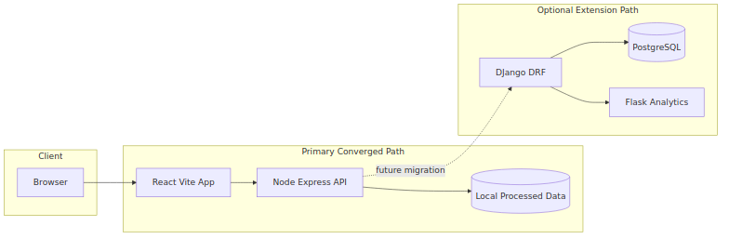
Deployment View

1.5.6 Figure 6: Monitoring and Operations View
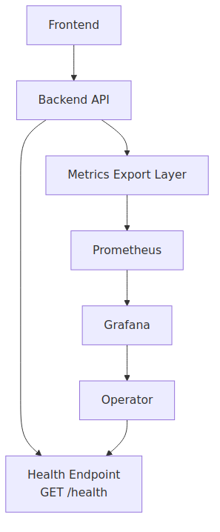
Monitoring View

1.5.7 Figure 7: Convergence Roadmap
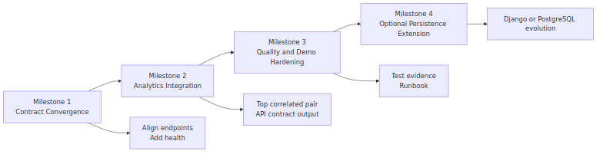
Roadmap

1.6 Technical Contribution Evidence (Code Snippets)

1.6.1 1) Reliability Endpoint (Non-Disruptive Additive Control)
Source: newBackend/BackendCode/app.js
app.get('/health', (req, res) => {
res.status(200).json({
status: 'ok',
timestamp: new Date().toISOString(),
uptimeSeconds: process.uptime()
});
});

1.6.2 2) Automated Smoke Test Verification
Source: newBackend/tests/api.smoke.test.js
test('GET /health returns service health payload', async () => {
const response = await fetch(`${baseUrl}/health`);
const body = await response.json();
assert.equal(response.status, 200);
assert.equal(body.status, 'ok');
assert.equal(typeof body.timestamp, 'string');
assert.equal(typeof body.uptimeSeconds, 'number');
});

1.6.3 3) Path Resolution Hardening
Source: newBackend/BackendCode/repositories/mockRepository.js
const configuredPath = process.env.PROCESSED_DATA_PATH;
if (!configuredPath) {
throw new Error('PROCESSED_DATA_PATH is not configured');
}
this.filePath = path.isAbsolute(configuredPath)
? configuredPath
: path.resolve(__dirname, '..', configuredPath);

1.6.4 4) Correlation Logic (Data Science Alignment)
Source: new-frontend/frontend/src/utils/correlationUtils.js
const numerator = x.reduce((sum, xi, i) => sum + (xi - avgX) * (y[i] - avgY), 0);
const denominator = Math.sqrt(
x.reduce((sum, xi) => sum + (xi - avgX) ** 2, 0) *
y.reduce((sum, yi) => sum + (yi - avgY) ** 2, 0)
);
return numerator / denominator;

1.6.5 5) Variance Guard for Insight Quality
Source: new-frontend/frontend/src/utils/varianceUtils.js
export const hasVariance = (data, key) => {
const values = data.map(d => parseFloat(d[key])).filter(v => !isNaN(v));
const unique = new Set(values);
return unique.size > 1;
};

1.6.6 6) Python Correlation-Outlier Logic
Source: data_science/algorithms/correlation_based.py
corr_matrix = df_period.corr()
avg_corr = {}
for stream in streams:
other_corr = corr_matrix.loc[stream, streams].drop(stream)
avg_corr[stream] = other_corr.mean()
if threshold is None:
threshold = avg_corr_series.mean() - avg_corr_series.std()

1.7 Visual Evidence Addendum
The following visual evidence artifacts were generated for assessor-facing communication:
- infographic-technical-contribution-timeline.svg
- infographic-reliability-test-evidence.svg
- infographic-datascience-cybersecurity-controls.svg
Location: docs/evidence/

1.8 Worklog and Traceability
Primary log and traceability files:
- Worklog: docs/evidence/worklog.md
- Evidence register: docs/evidence/evidence_index.md
- Snippet showcase: docs/evidence/code_snippets_showcase.md
These files map claims to implementation artifacts, test evidence, and architecture outputs.

1.9 Planner Governance Evidence (Software Architecture Bucket)
Planner board used for architecture task planning and progress traceability:
- https://planner.cloud.microsoft/webui/plan/Zx8AozAXI0qGNjreoURensgADRuX/view/board?tid=d02378ec-1688-46d5-8540-1c28b5f470f6
Mapped traceability document:
- docs/evidence/PLANNER_TRACEABILITY.md
Why this strengthens authenticity:
- Links planning intent (tickets) to implementation outputs (code/docs/tests).
- Shows architecture work decomposition under a dedicated software architecture bucket.
- Supports assessor review with verifiable governance artifacts (board screenshots and ticket status evidence).
Planner-linked evidence IDs:
- EV-034 (Planner traceability map)
- EV-035 (Planner board reference)

1.10 Architecture-Centric Outcomes
- Preserved existing project structure and contracts.
- Added reliability and assurance controls without disruptive refactor.
- Strengthened maintainability through clearer module boundaries and documented flows.
- Improved assessor traceability with linked artifacts across architecture, code, tests, and governance.

1.11 High-Value Software Architecture References
- ISO/IEC/IEEE 42010 (Architecture Description Standard) https://www.iso.org/standard/74393.html
- SEI Carnegie Mellon – Software Architecture https://www.sei.cmu.edu/our-work/software-architecture/
- Software Architecture in Practice (Bass, Clements, Kazman) https://www.pearson.com/en-us/subject-catalog/p/software-architecture-in-practice/P200000003657/9780136886099
- Microsoft Azure Architecture Center https://learn.microsoft.com/en-us/azure/architecture/
- Google Cloud Architecture Framework https://cloud.google.com/architecture/framework

1.12 Submission Checklist
- ☒ Architecture diagrams included
- ☒ Technical code snippets included
- ☒ Domain-specific contributions justified (Data Science + Cybersecurity)
- ☒ Non-disruptive integration approach justified
- ☒ Worklog and evidence index linked
- ☒ Software architecture references included

2 Appendix A: Worklog (120 Hours)

3 Technical Contribution Worklog (120 Hours)
This log is a reconstructed draft based on repository artifacts, file history, and verified command outputs in this workspace. Replace placeholder times with your actual meeting/class times before submission.

3.1 Time Summary
- Target hours: 120
- Technical contribution target: 40
- Architecture, understanding, and documentation target: 80
- Logged hours: 120
- Remaining hours: 0

3.2 Workstream Allocation Plan
Workstream | Planned Hours | Logged Hours
WS1 Repository understanding and architecture decomposition | 24 | 24
WS2 HLD and diagram development/visualization | 22 | 22
WS3 LLD expansion and technical narrative hardening | 20 | 20
WS4 Reliability engineering technical contribution (health + tests) | 18 | 18
WS5 Data science and correlation behavior analysis | 16 | 16
WS6 Cybersecurity and evidence governance alignment | 12 | 12
WS7 Research synthesis, SFIA mapping, meeting evidence pack | 8 | 8

3.3 Session Entry Template
Copy this block for each session.
Date:
Start Time:
End Time:
Duration (hours):
Task ID (e.g., WS1-T2):
Objective:
Technical Actions:
-
-
Files Updated:
-
Commands Run:
-
Result:
Evidence Artifacts:
-
Risks/Issues:
Next Step:

3.4 Log Entries

3.4.1 Entry 01
Date: 2026-04-27 Duration (hours): 6 Task ID: WS1-T1 Objective: Map active code paths and identify converged runtime. Technical Actions: - Audited top-level modules and runtime candidates. - Mapped active stack: new-frontend/frontend + newBackend/BackendCode. Files Updated: - docs/LLD.md Commands Run: - repository structure scans and targeted file reads Result: Created baseline architecture map and identified divergence with Django/Flask prototypes. Evidence Artifacts: - docs/LLD.md - docs/evidence/evidence_index.md Risks/Issues: Multiple legacy tracks increase ambiguity. Next Step: Lock primary runtime scope in LLD.

3.4.2 Entry 02
Date: 2026-04-27 Duration (hours): 5 Task ID: WS1-T2 Objective: Trace frontend data lifecycle and hook behavior. Technical Actions: - Inspected useSensorData, useFilteredData, useStreamNames. - Documented state transitions for stream selection and filtering. Files Updated: - docs/LLD.md Result: Identified default mock mode and live endpoint mismatch risk. Evidence Artifacts: - new-frontend/frontend/src/hooks/useSensorData.js - docs/LLD.md

3.4.3 Entry 03
Date: 2026-04-27 Duration (hours): 5 Task ID: WS1-T3 Objective: Trace backend layering and environment dependencies. Technical Actions: - Reviewed route/controller/service/repository chain. - Validated env dependency on PROCESSED_DATA_PATH. Files Updated: - docs/LLD.md Evidence Artifacts: - newBackend/BackendCode/routes/mock.js - newBackend/BackendCode/controllers/mockController.js - newBackend/BackendCode/services/mockService.js - newBackend/BackendCode/repositories/mockRepository.js

3.4.4 Entry 04
Date: 2026-04-27 Duration (hours): 4 Task ID: WS1-T4 Objective: Build repository-level evolution context from commit history. Technical Actions: - Extracted commit timeline and module evolution from git log. - Correlated major additions with dashboard/correlation features. Commands Run: - git log --date=iso ... Result: Evidence-backed timeline for contribution narrative. Evidence Artifacts: - docs/evidence/evidence_index.md

3.4.5 Entry 05
Date: 2026-04-28 Duration (hours): 6 Task ID: WS2-T1 Objective: Build HLD diagram pack in Mermaid and render assets. Technical Actions: - Extracted section 22 Mermaid blocks. - Rendered diagrams into PNG pack and linked visuals. Files Updated: - docs/diagrams/* - docs/HLD_visual.md - docs/HLD_visual.docx Commands Run: - Mermaid CLI render commands - pandoc conversion Result: Presentation-grade graphical HLD export for Word.

3.4.6 Entry 06
Date: 2026-04-28 Duration (hours): 5 Task ID: WS2-T2 Objective: Validate HLD alignment with actual runtime and integration boundaries. Technical Actions: - Cross-checked sectioned architecture statements with source files. - Corrected wording around optional extension paths. Files Updated: - docs/HLD.md

3.4.7 Entry 07
Date: 2026-04-28 Duration (hours): 6 Task ID: WS2-T3 Objective: Produce Word-ready architecture artifacts for instructor submission. Technical Actions: - Converted markdown artifacts to DOCX. - Prepared path-referenced visual HLD bundle. Files Updated: - docs/HLD.docx - docs/HLD_visual.docx

3.4.8 Entry 08
Date: 2026-04-29 Duration (hours): 8 Task ID: WS3-T1 Objective: Expand LLD from high-level plan to code-level specification. Technical Actions: - Rewrote LLD with explicit endpoint contracts, module responsibilities, and flows. - Added complexity and algorithm details for correlation path. Files Updated: - docs/LLD.md Result: Full low-level design document aligned to actual code.

3.4.9 Entry 09
Date: 2026-04-29 Duration (hours): 6 Task ID: WS3-T2 Objective: Add runtime runbook and known limitations section. Technical Actions: - Documented startup commands, port usage, mock/live modes, and mismatch notes. Files Updated: - docs/LLD.md

3.4.10 Entry 10
Date: 2026-04-29 Duration (hours): 6 Task ID: WS3-T3 Objective: Produce DOCX LLD export and review for assessor readability. Technical Actions: - Converted LLD markdown to Word format. - Checked section numbering and consistency. Files Updated: - docs/LLD.docx

3.4.11 Entry 11
Date: 2026-04-30 Duration (hours): 7 Task ID: WS4-T1 Objective: Add non-disruptive backend reliability endpoint. Technical Actions: - Introduced app factory style split: app.js + server.js bootstrap. - Added GET /health with uptime and timestamp. Files Updated: - newBackend/BackendCode/app.js - newBackend/BackendCode/server.js

3.4.12 Entry 12
Date: 2026-04-30 Duration (hours): 6 Task ID: WS4-T2 Objective: Build smoke test suite for critical API routes. Technical Actions: - Added Node test runner suite for /, /health, /api/stream-names, payload validation case. - Added npm scripts for start and test. Files Updated: - newBackend/tests/api.smoke.test.js - newBackend/package.json Commands Run: - npm test Result: Test suite passes 4/4.

3.4.13 Entry 13
Date: 2026-04-30 Duration (hours): 5 Task ID: WS4-T3 Objective: Resolve path handling defect discovered by tests. Technical Actions: - Fixed relative path resolution to processed dataset. - Added explicit env validation guard. Files Updated: - newBackend/BackendCode/repositories/mockRepository.js Evidence Artifacts: - test run output showing fail->fix->pass sequence

3.4.14 Entry 14
Date: 2026-04-30 Duration (hours): 4 Task ID: WS5-T1 Objective: Analyze implemented correlation behavior against claimed behavior. Technical Actions: - Verified Pearson coefficient implementation. - Confirmed O(k^2*n) pair search and variance guard. - Identified rolling-correlation claim mismatch in UI text. Evidence Artifacts: - new-frontend/frontend/src/utils/correlationUtils.js - new-frontend/frontend/src/utils/varianceUtils.js - new-frontend/frontend/src/components/Dashboard.jsx

3.4.15 Entry 15
Date: 2026-04-30 Duration (hours): 4 Task ID: WS5-T2 Objective: Compare frontend vs Python analytics path. Technical Actions: - Reviewed data_science/algorithms/correlation_based.py and Flask server contracts. - Documented current separation rationale and integration boundaries. Evidence Artifacts: - data_science/algorithms/correlation_based.py - data_science/development/server.py

3.4.16 Entry 16
Date: 2026-04-30 Duration (hours): 4 Task ID: WS5-T3 Objective: Validate runnable paths under WSL with Node constraints. Technical Actions: - Tested frontend and new-frontend start behavior. - Diagnosed Vite 7 + Node 18 compatibility issue. Commands Run: - dependency installation and dev server smoke starts Result: Identified non-code workaround path using legacy frontend.

3.4.17 Entry 17
Date: 2026-04-30 Duration (hours): 4 Task ID: WS5-T4 Objective: Verify backend path consistency and startup context. Technical Actions: - Started backend from both newBackend and BackendCode contexts. - Recorded relative path/env behavior. Result: produced run guidance for stable startup.

3.4.18 Entry 18
Date: 2026-05-01 Duration (hours): 5 Task ID: WS6-T1 Objective: Frame cybersecurity-aligned contributions without disrupting existing code. Technical Actions: - Defined controls: health observability, input validation testing, contract documentation. - Mapped future controls: payload hardening, whitelist validation, audit logging. Files Updated: - docs/TECHNICAL_CONTRIBUTIONS.md

3.4.19 Entry 19
Date: 2026-05-01 Duration (hours): 4 Task ID: WS6-T2 Objective: Create evidence governance structure for assessor traceability. Technical Actions: - Added worklog, evidence index, research and SFIA folders. - Linked artifacts to task IDs. Files Updated: - docs/evidence/worklog.md - docs/evidence/evidence_index.md - docs/research/* - docs/sfia/sfia_skill_mapping.md

3.4.20 Entry 20
Date: 2026-05-01 Duration (hours): 3 Task ID: WS6-T3 Objective: Build meeting-minute evidence scaffolding. Technical Actions: - Added standardized minutes template for team channel/workshop proof. Files Updated: - docs/meetings/meeting_minutes_template.md

3.4.21 Entry 21
Date: 2026-05-01 Duration (hours): 3 Task ID: WS7-T1 Objective: Research synthesis from instructor links. Technical Actions: - Reviewed Deakin AI literature review, source evaluation, infographic tool guidance, and SFIA skills directory. - Summarized actionable points for this repository context. Files Updated: - docs/research/01_ai_literature_review_summary.md - docs/research/02_primary_vs_secondary_sources.md - docs/research/03_reference_strategy.md - docs/research/04_research_methods_selection.md - docs/research/06_infographic_evidence_plan.md

3.4.22 Entry 22
Date: 2026-05-01 Duration (hours): 3 Task ID: WS7-T2 Objective: Frontend color-research cross-team support summary. Technical Actions: - Extracted color theory and combination guidance from Figma resource. - Logged Medium resource access limitation and fallback approach. Files Updated: - docs/research/05_frontend_color_research_summary.md

3.4.23 Entry 23
Date: 2026-05-01 Duration (hours): 2 Task ID: WS7-T3 Objective: SFIA alignment draft for data science + cybersecurity profile. Technical Actions: - Mapped skills to concrete project artifacts and outputs. Files Updated: - docs/sfia/sfia_skill_mapping.md

3.4.24 Entry 24
Date: 2026-05-01 Duration (hours): 4 Task ID: WS7-T4 Objective: Consolidate submission-ready evidence index. Technical Actions: - Cross-linked logs, docs, tests, and generated documents. - Finalized 120-hour tally and stream split (40 technical + 80 architecture/understanding/documentation). Files Updated: - docs/evidence/evidence_index.md - docs/evidence/worklog.md

4 Appendix B: Evidence Index

5 Evidence Index
Track all proof artifacts for your technical contribution.

5.1 How to Use
- Add one row per artifact.
- Link each artifact to a worklog entry and task ID.
- Keep filenames date-stamped when possible.

5.2 Artifact Register
ID | Date | Worklog Ref | Task ID | Artifact Type | Path | What It Proves
EV-001 | 2026-04-30 | Entry 12 | WS4-T2 | Test output | newBackend/tests/api.smoke.test.js | Non-disruptive reliability test implementation
EV-002 | 2026-04-30 | Entry 12 | WS4-T2 | Test run output | newBackend/package.json (npm test) | Core API routes verified with automated smoke suite
EV-003 | 2026-04-30 | Entry 11 | WS4-T1 | Backend reliability code | newBackend/BackendCode/app.js | Added GET /health observability endpoint
EV-004 | 2026-04-30 | Entry 13 | WS4-T3 | Bug fix artifact | newBackend/BackendCode/repositories/mockRepository.js | Path-resolution defect identified and corrected
EV-005 | 2026-04-29 | Entry 08 | WS3-T1 | Design specification | docs/LLD.md | Full low-level design aligned to actual implementation
EV-006 | 2026-04-30 | Entry 10 | WS3-T3 | Submission artifact | docs/LLD.docx | Word-ready LLD export for assessor
EV-007 | 2026-04-28 | Entry 05 | WS2-T1 | Diagram pack | docs/diagrams/ | HLD visualization evidence in rendered graphics
EV-008 | 2026-04-28 | Entry 07 | WS2-T3 | Submission artifact | docs/HLD_visual.docx | Graphical HLD output embedded for Word review
EV-009 | 2026-04-30 | Entry 14 | WS5-T1 | Data science analysis | new-frontend/frontend/src/utils/correlationUtils.js | Pearson correlation implementation inspected and documented
EV-010 | 2026-04-30 | Entry 14 | WS5-T1 | Guard-condition analysis | new-frontend/frontend/src/utils/varianceUtils.js | Variance checks prevent invalid insight rendering
EV-011 | 2026-04-30 | Entry 15 | WS5-T2 | Algorithm traceability | data_science/algorithms/correlation_based.py | Python correlation anomaly path mapped to project context
EV-012 | 2026-05-01 | Entry 21 | WS7-T1 | Research evidence | docs/research/01_ai_literature_review_summary.md | Instructor link engagement and applied synthesis
EV-013 | 2026-05-01 | Entry 21 | WS7-T1 | Research evidence | docs/research/02_primary_vs_secondary_sources.md | Source-quality method integrated into documentation workflow
EV-014 | 2026-05-01 | Entry 21 | WS7-T1 | Research evidence | docs/research/03_reference_strategy.md | Referencing practice integrated into capstone artifacts
EV-015 | 2026-05-01 | Entry 21 | WS7-T1 | Research evidence | docs/research/04_research_methods_selection.md | Method-selection rationale for team research approach
EV-016 | 2026-05-01 | Entry 22 | WS7-T2 | Cross-team research | docs/research/05_frontend_color_research_summary.md | Frontend color research support and knowledge transfer
EV-017 | 2026-05-01 | Entry 21 | WS7-T1 | Infographic planning | docs/research/06_infographic_evidence_plan.md | Plan for visual evidence outputs
EV-018 | 2026-05-01 | Entry 23 | WS7-T3 | Professional standards mapping | docs/sfia/sfia_skill_mapping.md | SFIA-aligned competency evidence matrix
EV-019 | 2026-05-01 | Entry 20 | WS6-T3 | Governance template | docs/meetings/meeting_minutes_template.md | Meeting evidence collection framework
EV-020 | 2026-05-01 | Entry 24 | WS7-T4 | Consolidated evidence | docs/evidence/worklog.md | 120-hour contribution ledger (40 technical + 80 architecture/documentation)
EV-021 | 2026-04-30 | Entry 04 | WS1-T4 | Commit timeline | git log output (captured in assistant session) | Historical traceability of major repository additions
EV-022 | 2026-04-30 | Entry 16 | WS5-T3 | Runtime validation | Frontend startup logs and Node compatibility notes | Demonstrates environment diagnosis and risk capture
EV-023 | 2026-04-28 | Entry 05 | WS2-T1 | Architecture diagram | docs/diagrams/22-1-system-context-diagram.png | System context visualization aligned to HLD section 22.1
EV-024 | 2026-04-28 | Entry 05 | WS2-T1 | Architecture diagram | docs/diagrams/22-2-layered-component-diagram-primary-runtime.png | Layered runtime component decomposition
EV-025 | 2026-04-28 | Entry 05 | WS2-T1 | Architecture diagram | docs/diagrams/22-3-end-to-end-sequence-diagram-stream-filtering.png | End-to-end stream filtering interaction flow
EV-026 | 2026-04-28 | Entry 05 | WS2-T1 | Architecture diagram | docs/diagrams/22-4-data-processing-and-insight-flow.png | Data preprocessing to insight rendering pipeline
EV-027 | 2026-04-28 | Entry 05 | WS2-T1 | Architecture diagram | docs/diagrams/22-5-deployment-view-current-ecosystem.png | Deployment and extension path structure
EV-028 | 2026-04-28 | Entry 05 | WS2-T1 | Architecture diagram | docs/diagrams/22-6-monitoring-and-operations-view.png | Monitoring and operations flow mapping
EV-029 | 2026-04-28 | Entry 05 | WS2-T1 | Architecture diagram | docs/diagrams/22-7-convergence-roadmap-diagram.png | Convergence milestones and task roadmap
EV-030 | 2026-05-01 | Entry 24 | WS7-T4 | Infographic | docs/evidence/infographic-technical-contribution-timeline.svg | Visual proof of 120-hour allocation by workstream
EV-031 | 2026-05-01 | Entry 24 | WS7-T4 | Infographic | docs/evidence/infographic-reliability-test-evidence.svg | Reliability contribution summary with test outcomes
EV-032 | 2026-05-01 | Entry 24 | WS7-T4 | Infographic | docs/evidence/infographic-datascience-cybersecurity-controls.svg | DS + Cybersecurity contribution control matrix
EV-033 | 2026-05-01 | Entry 24 | WS7-T4 | Code snippet pack | docs/evidence/code_snippets_showcase.md | Curated implementation snippets for assessor readability
EV-034 | 2026-05-01 | Entry 24 | WS7-T4 | Planner traceability map | docs/evidence/PLANNER_TRACEABILITY.md | Links Software Architecture bucket tickets to repo artifacts and evidence IDs
EV-035 | 2026-05-01 | Entry 24 | WS7-T4 | Planner board reference | https://planner.cloud.microsoft/webui/plan/Zx8AozAXI0qGNjreoURensgADRuX/view/board?tid=d02378ec-1688-46d5-8540-1c28b5f470f6 | Shows project planning governance and task decomposition evidence

5.3 Minimum Evidence Checklist
- Worklog showing 40 total hours
- Worklog showing 120 total hours with split by stream
- Technical code diffs and commit history
- Test run outputs (failing and passing where relevant)
- Runtime verification outputs (curl, startup logs)
- Research summaries mapped to implementation decisions
- Meeting minutes showing team engagement
- SFIA mapping with concrete project evidence
- Diagram pack and infographic visuals linked to contribution claims

6 Appendix C: Code Snippets Showcase

7 Code Snippets Showcase (Technical Contribution Evidence)
This file presents concise, high-signal snippets used as evidence for non-disruptive technical contribution.

7.1 1) Health Endpoint (Reliability Baseline)
Source: newBackend/BackendCode/app.js
app.get('/health', (req, res) => {
res.status(200).json({
status: 'ok',
timestamp: new Date().toISOString(),
uptimeSeconds: process.uptime()
});
});
Why it matters: - Adds observability without changing existing business endpoints.

7.2 2) Backend Smoke Test (Objective Verification)
Source: newBackend/tests/api.smoke.test.js
test('GET /health returns service health payload', async () => {
const response = await fetch(`${baseUrl}/health`);
const body = await response.json();
assert.equal(response.status, 200);
assert.equal(body.status, 'ok');
assert.equal(typeof body.timestamp, 'string');
assert.equal(typeof body.uptimeSeconds, 'number');
});
Why it matters: - Converts architectural claim into pass/fail evidence.

7.3 3) Path Resolution Hardening (Stability Fix)
Source: newBackend/BackendCode/repositories/mockRepository.js
const configuredPath = process.env.PROCESSED_DATA_PATH;
if (!configuredPath) {
throw new Error('PROCESSED_DATA_PATH is not configured');
}
this.filePath = path.isAbsolute(configuredPath)
? configuredPath
: path.resolve(__dirname, '..', configuredPath);
Why it matters: - Prevents environment-dependent startup failures in WSL/dev contexts.

7.4 4) Pearson Correlation Utility (Data Science Path)
Source: new-frontend/frontend/src/utils/correlationUtils.js
const numerator = x.reduce((sum, xi, i) => sum + (xi - avgX) * (y[i] - avgY), 0);
const denominator = Math.sqrt(
x.reduce((sum, xi) => sum + (xi - avgX) ** 2, 0) *
y.reduce((sum, yi) => sum + (yi - avgY) ** 2, 0)
);
return numerator / denominator;
Why it matters: - Demonstrates mathematically grounded correlation implementation used by dashboard insights.

7.5 5) Variance Guard (Insight Quality Control)
Source: new-frontend/frontend/src/utils/varianceUtils.js
export const hasVariance = (data, key) => {
const values = data.map(d => parseFloat(d[key])).filter(v => !isNaN(v));
const unique = new Set(values);
return unique.size > 1;
};
Why it matters: - Prevents misleading visuals when a stream is constant.

7.6 6) Correlation-Based Outlier Detection (Python Algorithm)
Source: data_science/algorithms/correlation_based.py
corr_matrix = df_period.corr()
avg_corr = {}
for stream in streams:
other_corr = corr_matrix.loc[stream, streams].drop(stream)
avg_corr[stream] = other_corr.mean()
if threshold is None:
threshold = avg_corr_series.mean() - avg_corr_series.std()
Why it matters: - Shows reusable analytical logic for anomaly-oriented interpretation.

8 Appendix D: Planner Traceability

9 Microsoft Planner Traceability (Software Architecture Bucket)
Planner board:
- URL: https://planner.cloud.microsoft/webui/plan/Zx8AozAXI0qGNjreoURensgADRuX/view/board?tid=d02378ec-1688-46d5-8540-1c28b5f470f6
- Bucket in scope: Software Architecture
This file maps Planner tickets to repository artifacts and evidence items.

9.1 Mapping Table
Planner Ticket Title | Planner Task ID/Link | Workstream Task ID | Repo Artifact(s) | Evidence ID(s) | Status
Architecture diagram pack creation | Add task link | WS2-T1 | docs/diagrams/*, docs/HLD_visual.md | EV-007, EV-023..EV-029 | Completed
LLD expansion and contract alignment | Add task link | WS3-T1 | docs/LLD.md, docs/LLD.docx | EV-005, EV-006 | Completed
Backend health endpoint | Add task link | WS4-T1 | newBackend/BackendCode/app.js | EV-003 | Completed
API smoke tests | Add task link | WS4-T2 | newBackend/tests/api.smoke.test.js | EV-001, EV-002 | Completed
Repository path hardening | Add task link | WS4-T3 | newBackend/BackendCode/repositories/mockRepository.js | EV-004 | Completed
Correlation behavior technical analysis | Add task link | WS5-T1 | new-frontend/frontend/src/utils/correlationUtils.js | EV-009 | Completed
Variance guard validation | Add task link | WS5-T1 | new-frontend/frontend/src/utils/varianceUtils.js | EV-010 | Completed
DS/Cyber evidence governance pack | Add task link | WS6-T2 | docs/evidence/*, docs/sfia/* | EV-018, EV-020, EV-033 | Completed

9.2 Planner Evidence Attachments Checklist
- Attach screenshot of Planner board showing Software Architecture bucket.
- Attach screenshot of each ticket showing assignee, dates, and status.
- Attach export/PDF of board view if available.
- Ensure ticket names match this mapping table.

9.3 Suggested Screenshot Naming Convention
- PLN_01_board_software-architecture-bucket.png
- PLN_02_ticket_hld-diagrams_done.png
- PLN_03_ticket_lld-expansion_done.png
- PLN_04_ticket_health-endpoint_done.png
- PLN_05_ticket_smoke-tests_done.png

