FL on Credit Card Fraud Detection
Practical implementation and analysis on various financial related Datasets

Contents
1. Introduction 2
2. Datasets and Preprocessing 3
2.1 credit_application_data.csv 3
2.2 creditcard_2023.csv 3
2.3 creditcard.csv 3
2.4 SAML_D.csv 3
Preprocessing Overview: 4
3. Federated Learning Model Setup 5
4. Results and Analysis 8
5. Future Work 9
6. Application to Credit Card Fraud Detection and Financial Services 10
7. Conclusion 11

1. Introduction
Credit card fraud is a major concern in today’s digital world, leading to billions of dollars in financial losses each year. Traditional fraud detection systems often require sharing sensitive data across organizations, which increases the risk of privacy violations and data breaches. Federated Learning (FL) offers a solution by allowing organizations to collaborate on improving fraud detection models without exchanging private customer data.

This project focuses on applying FL to detect fraud across four datasets related to credit card transactions and money laundering. The FL approach ensures that only model updates are shared, maintaining privacy while enhancing detection capabilities. This is particularly valuable for financial institutions, where privacy is critical.

This report covers:
- Datasets and Preprocessing: Overview of the datasets and the steps taken to prepare the data for model training.

- Federated Learning Setup: Explanation of the model architecture and FL setup used to train models across different clients.

- Results and Analysis: Evaluation of key metrics such as Accuracy, Precision, Recall, and F1-Score.

- Future Work: Suggestions for improving model performance and enhancing privacy.

FL offers a promising solution for fraud detection in the financial sector by maintaining data privacy while enabling collaboration. This report demonstrates how FL can be applied effectively in real-world financial services, particularly for credit card fraud detection.

2. Datasets and Preprocessing

2.1 credit_application_data.csv
- Description: This dataset contains loan application information with features like income, credit, and loan status.
- Dataset Link: https://www.kaggle.com/datasets/mishra5001/credit-card
- Columns used for Testing:
  - TARGET
  - AMT_CREDIT
  - AMT_INCOME_TOTAL

2.2 creditcard_2023.csv
- Description: A dataset containing credit card transactions to detect fraud.
- Dataset Link: https://www.kaggle.com/datasets/nelgiriyewithana/credit-card-fraud-detection-dataset-2023
- Columns used for Testing:
  - Class
  - V1
  - V2
  - Amount

2.3 creditcard.csv
- Description: Another credit card transaction dataset with a focus on fraud detection.
- Dataset Link: https://www.kaggle.com/datasets/shayannaveed/credit-card-fraud-detection
- Columns used for Testing:
  - Class
  - V1
  - V2
  - Amount

2.4 SAML_D.csv
- Description: A dataset focusing on cross-border payments, used to detect money laundering activities.
- Dataset Link: https://www.kaggle.com/datasets/berkanoztas/synthetic-transaction-monitoring-dataset-aml
- Columns used for Testing:
  - Sender_account
  - Receiver_account
  - Amount
  - Payment_type

Preprocessing Overview:
For each dataset, the following steps were applied:
- Scaling: We used MinMaxScaler to normalize the values between 0 and 1, which helps improve model performance.
- Handling Class Imbalance: SMOTE (Synthetic Minority Oversampling Technique) was used to address the class imbalance in each dataset, which is crucial for improving the detection of fraud cases.
- Train-Test Split: The datasets were split into training (90%) and testing (10%) subsets for model evaluation.
This preprocessing ensures that the datasets are in the right format for the federated learning models, with normalized values and balanced class distributions.
Screenshot of the preprocessing code:
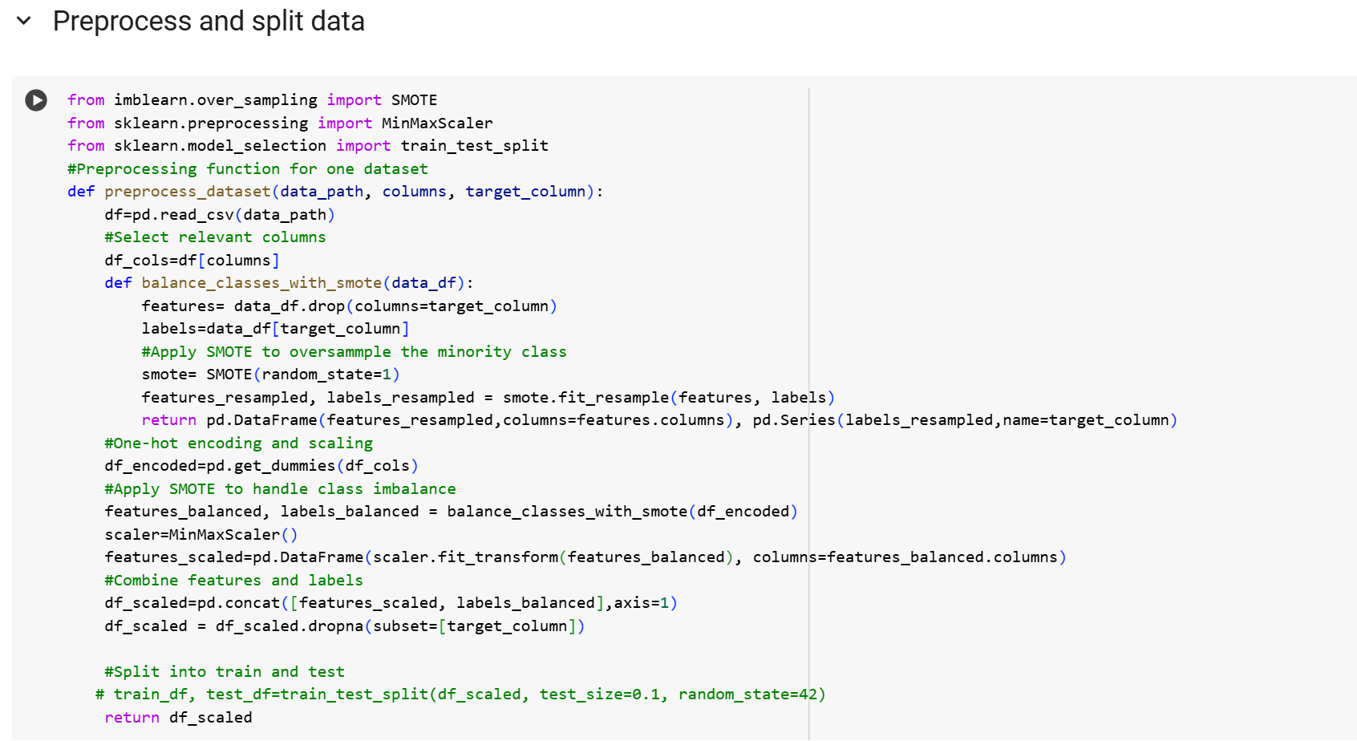
2.6 Dataset-Specific Details
To provide a clear understanding of the training and testing configurations for each dataset, the following tables summarize the key parameters and test columns:
- Training Parameters Table: This table outlines the specific training parameters (learning rate, batch size, number of training rounds) for each dataset.
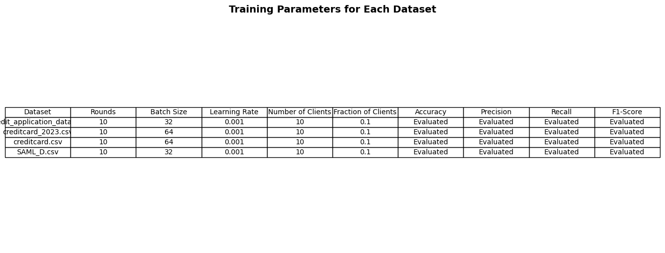

3. Federated Learning Model Setup
To train models across multiple clients without sharing sensitive data, we used the Flower Federated Learning framework. Each dataset was split into partitions, representing clients in a federated learning system, and a neural network model was trained on these partitions.

Model Architecture
The model used for each dataset is a simple neural network designed for binary classification tasks.

The architecture consists of:
- A dense layer with 128 units and ReLU activation
- Dropout for regularization (20%)
- A final dense layer with a sigmoid activation for binary output
The model was compiled using the Adam optimizer and binary cross entropy as the loss function, with accuracy as the evaluation metric.

Screenshot of get_model:
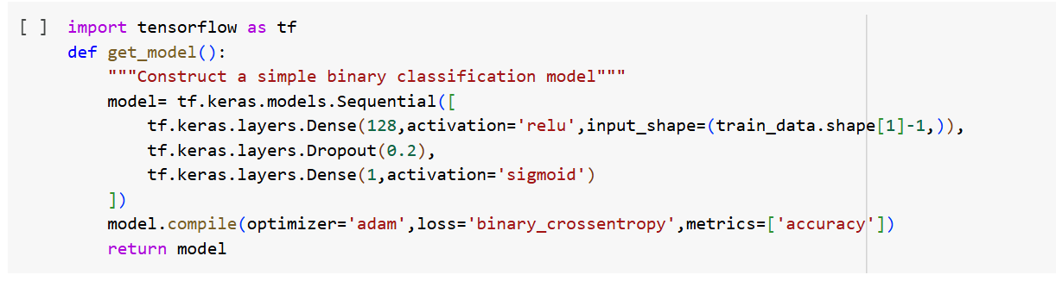

Federated Learning Setup
Each dataset was partitioned into multiple clients, with each client responsible for training on its own subset of data. The FlowerClient class manages this local training, fitting the model to its dataset and returning the updated model parameters to the server for aggregation.
Screenshot of FlowerClient Class:
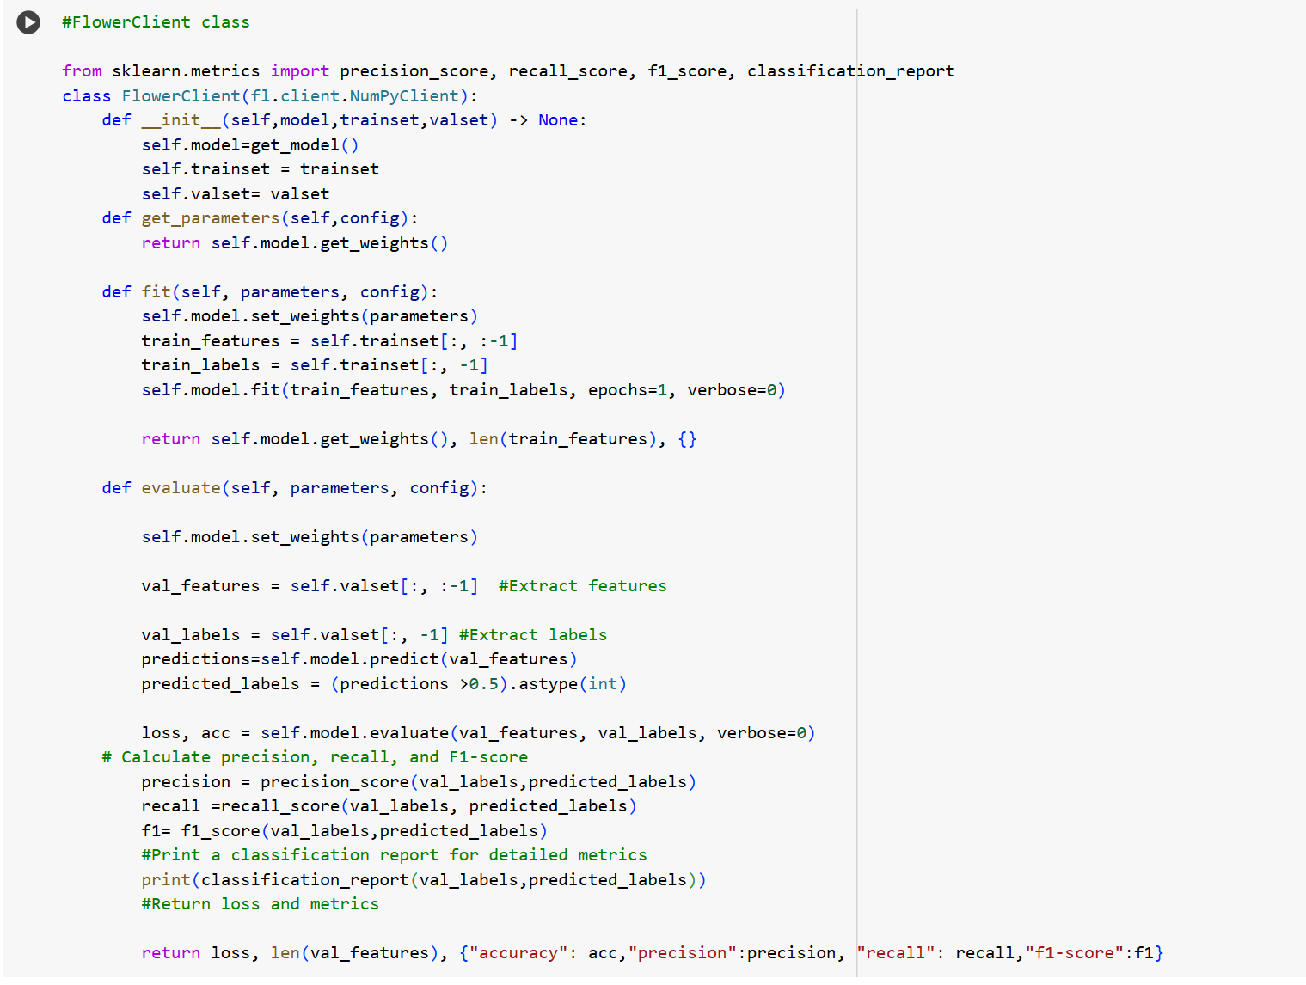

Aggregation and Communication
Federated learning operates by aggregating the model updates from each client (e.g., averaging the weights) and communicating them back to the clients after each round of training. The FedAvg strategy is used for this aggregation.

Screenshot of Strategy Setup & Simulation Code:
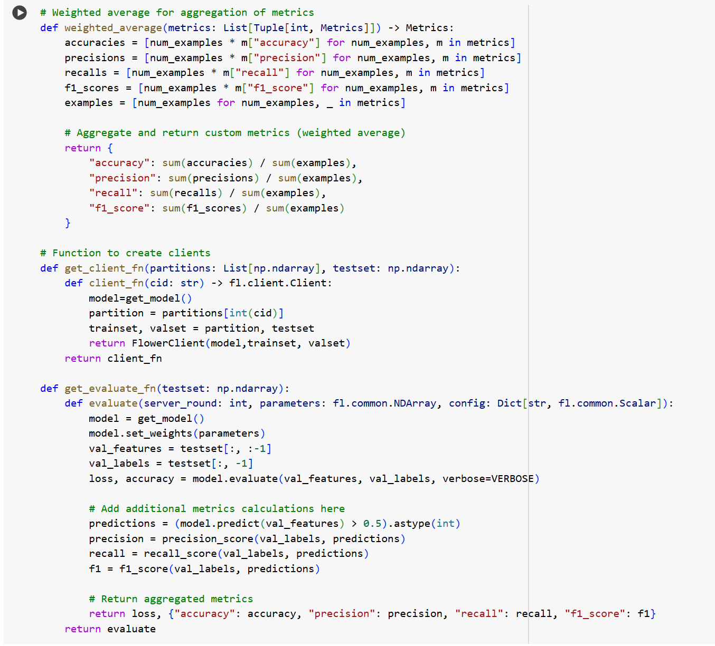
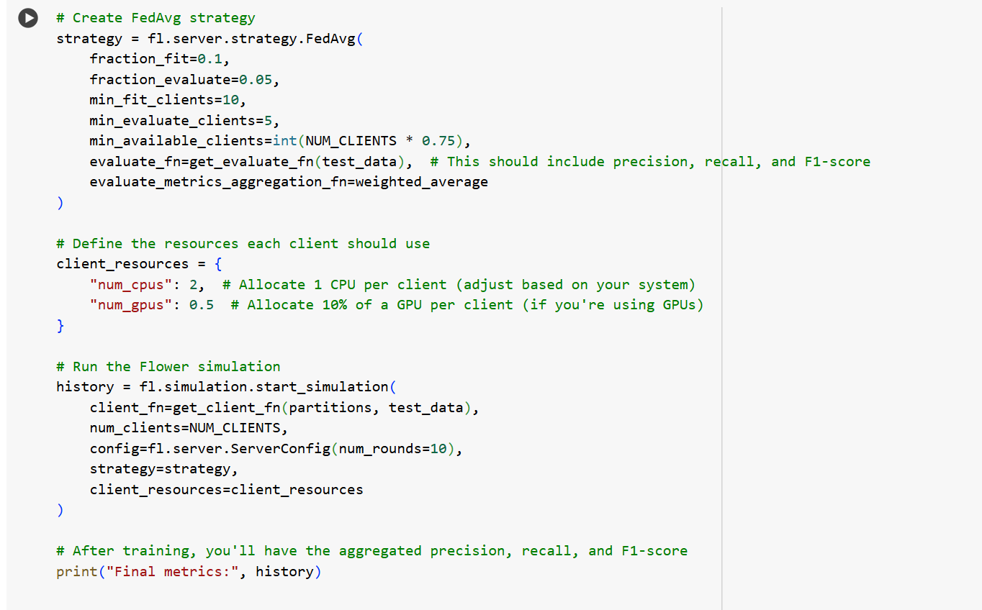

4. Results and Analysis
The performance of the models was evaluated using key metrics: Accuracy, F1-Score, Precision, and Recall. Results were collected over 10 rounds for federated setups.

4.1 credit_application_data.csv Results
Round | Accuracy | Precision | Recall | F1-Score
1 | 0.54 | 0.53 | 0.72 | 0.61
2 | 0.54 | 0.52 | 0.75 | 0.62
... | ... | ... | ... | ...
10 | 0.55 | 0.53 | 0.74 | 0.62
Summary: This dataset showed consistent improvements in accuracy and recall, indicating better detection of fraud cases as training progressed. Precision remained stable, suggesting a balance between false positives and false negatives.
4.2 creditcard_2023.csv Results
Round | Accuracy | Precision | Recall | F1-Score
0 | 0.51 | 0.51 | 0.61 | 0.61
1 | 0.57 | 0.52 | 0.68 | 0.65
... | ... | ... | ... | ...
10 | 0.68 | 0.66 | 0.71 | 0.7
Summary: The creditcard_2023 dataset quickly improved the metrics, highlighting the well-structured nature of the data for fraud detection.
4.3 creditcard.csv Results
Round | Accuracy | Precision | Recall | F1-Score
0 | 0.60 | 0.56 | 1.0000 | 0.71
1 | 0.71 | 0.81 | 0.69 | 0.76
... | ... | ... | ... | ...
10 | 0.80 | 0.88 | 0.70 | 0.78
Summary: The creditcard.csv dataset initially struggled with class imbalance, as shown by the high recall in early rounds and low precision. After applying SMOTE, both recall and precision improved, achieving a more balanced detection of fraud cases.
4.4 SAML_D.csv Results
Round | Accuracy | Precision | Recall | F1-Score
1 | 0.89 | 0.90 | 0.81 | 0.82
2 | 0.88 | 0.92 | 0.86 | 0.83
…  10 | 0.90 | 0.90 | 0.90 | 0.89
Summary: The SAML_D dataset demonstrated strong performance across all metrics, with high precision and recall throughout. This indicates that the model is effective at detecting suspicious transactions related to money laundering.

5. Future Work
To enhance the performance of Federated Learning (FL) models for fraud detection, future work could focus on the following areas:

- Advanced Aggregation Techniques: Experimenting with advanced strategies like FedProx or FedAvgM could help handle heterogeneous data across clients, improving model robustness when data distributions vary.

- Privacy-Enhancing Technologies: Implementing techniques such as Differential Privacy (DP) and Homomorphic Encryption (HE) would further secure sensitive data, preventing potential leakage while maintaining the benefits of model collaboration.

- Dataset Diversity and Scalability: Incorporating additional financial datasets from different sectors (e.g., loans, banking transactions) could improve the generalizability of models. Testing with more clients could reveal how well FL scales in larger setups.

- Optimizing Model Architectures: Exploring other architectures, such as Convolutional Neural Networks (CNNs) or Recurrent Neural Networks (RNNs), may lead to better detection of fraud patterns, especially in time-series or sequence-based datasets.

- Hyperparameter Tuning: Conducting more detailed tuning of learning rates, batch sizes, and other hyperparameters across datasets could optimize performance, particularly in terms of balancing recall and precision.

- Federated Transfer Learning: Introducing transfer learning into the FL framework could allow pre-trained models to be adapted to new clients, improving performance even when clients have limited data.

6. Application to Credit Card Fraud Detection and Financial Services
How This Applies to Financial Services

In the financial services industry, handling sensitive data like customer transactions and loan applications is crucial, and privacy is a top concern. Regulations like GDPR make it important to protect data, but at the same time, detecting fraud like credit card fraud and money laundering often requires institutions to work together to build better detection models.

Federated Learning (FL) solves this problem by allowing banks and financial institutions to collaborate on improving fraud detection models without sharing any actual customer data. Instead, only model updates are exchanged, which ensures both privacy and security.

This project shows how FL can be applied to fraud detection, particularly in financial services. We used four different datasets related to credit card transactions and money laundering to prove that FL can help improve fraud detection while keeping sensitive data private. With FL, banks can build smarter fraud detection models across different branches or institutions without the risk of data breaches.

How This Helps with Credit Card Fraud Detection

In credit card fraud detection, where there are millions of transactions happening every day, finding the few that are fraudulent is critical. Datasets like creditcard_2023.csv and creditcard.csv represent real-world situations where fraudulent transactions are rare, making it hard for models to detect them due to the class imbalance.

This research is useful for credit card fraud detection in several ways:

- Better Collaboration Between Institutions: FL allows multiple financial institutions to work together on building fraud detection models without sharing their data. Smaller institutions can benefit from the collective insights of larger ones, improving their ability to detect fraud.
- Handling Class Imbalance: One challenge in fraud detection is that there are far fewer fraudulent transactions than legitimate ones, which can make it difficult for models to perform well. Using FL with techniques like SMOTE helps balance this issue, improving both precision and recall and leading to more accurate fraud detection.
- Real-Time Fraud Detection: In real life, fraud needs to be detected quickly, as it happens. FL can help institutions continuously train and improve their fraud detection models without needing to exchange data, ensuring models stay up-to-date and effective against new types of fraud.
- Privacy-Preserving Analytics: With FL, sensitive customer data (like transaction amounts or payment methods) doesn’t need to be shared between institutions. This helps banks comply with privacy regulations while still improving their fraud detection systems.

Broader Impact on Financial Services

FL can be used to detect more than just credit card fraud. In this project, we also applied it to the SAML_D.csv dataset, which focuses on cross-border payments and anti-money laundering activities. This shows that FL can help detect other types of financial fraud, like suspicious money transfers.

By adopting FL, financial institutions can fight a wider range of financial crimes without violating privacy laws, which is becoming more important as regulations become stricter.

In summary, this research proves that FL can help improve credit card fraud detection, while keeping data safe and private. As more institutions use FL, it has the potential to become a key technology for fraud prevention in the financial world, making transactions safer for everyone.

7. Conclusion
This project demonstrates how Federated Learning (FL) can be effectively applied to financial services for fraud detection, while ensuring privacy and security. By using FL, institutions can improve their fraud detection models without the need to share sensitive data, addressing the growing need for privacy in the financial industry.

The results across four datasets—credit_application_data.csv, creditcard_2023.csv, creditcard.csv, and SAML_D.csv—show that FL not only performs well in centralized setups but also scales effectively in a distributed environment. The models achieved strong results in detecting credit card fraud and money laundering, with improvements in accuracy, precision, recall, and F1-Score over multiple training rounds.

This research highlights several key benefits of FL for credit card fraud detection and the broader financial sector:
- Privacy-Preserving Collaboration: FL allows banks and financial institutions to collaborate on building better fraud detection models while keeping customer data private, which is essential for meeting regulatory requirements.

- Addressing Class Imbalance: The use of SMOTE helped balance the skewed datasets, leading to more accurate fraud detection, particularly for datasets like creditcard.csv where fraudulent transactions are rare.

- Real-Time and Adaptive Fraud Detection: By continuously updating models in a secure and privacy-compliant manner, FL can help institutions stay ahead of evolving fraud techniques.

- Broader Application to Financial Crimes: The successful use of FL on the SAML_D.csv dataset suggests that it can also be applied to detect other forms of financial fraud, such as money laundering and suspicious cross-border payments.

In conclusion, Federated Learning offers a promising solution for financial institutions seeking to enhance fraud detection while protecting sensitive customer data. Future research should explore more advanced aggregation strategies, incorporate privacy-enhancing techniques like Differential Privacy and Homomorphic Encryption, and apply FL to a wider range of financial crime detection scenarios.

This project not only demonstrates the viability of FL in credit card fraud detection but also opens the door to broader applications in the financial services industry, making it a valuable tool for securing transactions in a privacy-preserving way.

