# Name Ideas

The names need to evoke the ideas of at least two of these keywords:

* Nature
* Wildlife
* Sound
* Location
* Australia
* Technology

1. WildSound Tracker
2. Outback Audio Explorer
3. Aussie Wildlife Listener
4. Bush Sound Scout
5. EcoSound Mapper
6. Down Under Critter Call
7. AustraliaSound Discovery
8. Wildlife Whisperer
9. NatureNest Explorer
10. Oz Animal Acoustics
11. BioSonic Trailblazer
12. Aussie Fauna Finder
13. WildVoice Recon
14. FaunaSoundscape Pro
15. Outback Sound Safari
16. EcoVoice Explorer
17. WildSense Australia
18. AnimalSpeak Mapper
19. NatureSonic Navigator
20. WildlifeWatch Pro
21. AussieBioVoice Scout
22. Outback Animal Detect
23. EcoWild Tracker
24. Down Under Audio Atlas
25. AustraliaSound Seeker
26. WildWhisper Explorer
27. BioVoice Reconnaissance
28. Aussie Fauna Sonic
29. WildSoundVenture
30. NatureSound Trekker
31. Oz Animal Audio Guide
32. BioSonic Outback Scout
33. FaunaTrack Pro
34. Outback Voice Explorer
35. EcoSonic Safari
36. WildVoice Australia
37. AnimalSound Expedition
38. NatureVoice Mapper
39. WildlifeWave Pro
40. AussieBio Acoustics
41. SoundSafari Scout
42. EcoWild Sound Discover
43. Down Under Fauna Finder
44. AustraliaSonic Explorer
45. WildWhisper Seeker
46. BioVoice Nature Scout
47. WildSound Discovery
48. Outback Wildlife Listener
49. EcoSense Tracker
50. FaunaSpeak Atlas
51. NatureNest Adventurer
52. Oz Animal Sound Survey
53. BioSonic Expedition
54. Aussie Critter Call Scout
55. WildVoice Tracker
56. AnimalSound Safari Pro
57. EcoSound Australia
58. SoundScape Explorer
59. WildlifeWhisper Mapper
60. AustraliaBioVoice Scout
61. NatureSonic Surveyor
62. EcoFauna Finder
63. Outback BioSound Scout
64. Down Under Audio Adventure
65. WildSound Seeker
66. BioVoice Recon Trail
67. Aussie Fauna Sound Mapper
68. SoundSafari Discovery
69. EcoWildlife Explorer
70. Oz Animal Voice Atlas
71. FaunaSound Adventurer
72. NatureNest Audio Guide
73. WildlifeVoice Pro
74. BioSonic Safari Scout
75. WildSense Australia
76. Outback Animal Audio Explorer
77. AustraliaSound Trekker
78. WildWhisper Tracker
79. EcoVoice Reconnaissance
80. AnimalSpeak Surveyor
81. NatureSound Expedition
82. AussieBioWave Pro
83. SoundSafari Seeker
84. EcoWildVoice Discover
85. Down Under Fauna Finder
86. WildSoundVenture
87. BioVoice Atlas
88. WildlifeWave Scout
89. FaunaTrack Australia
90. NatureVoice Mapper
91. Oz Animal Sound Seeker
92. BioSonic Outback Discovery
93. Aussie Critter Call Explorer
94. WildVoice Australia
95. SoundScape Expedition
96. EcoFauna Whisperer
97. Outback BioVoice Scout
98. AustraliaSound Adventure
99. WildWhisper

# Logo Concepts

*See Github for source xcf files*

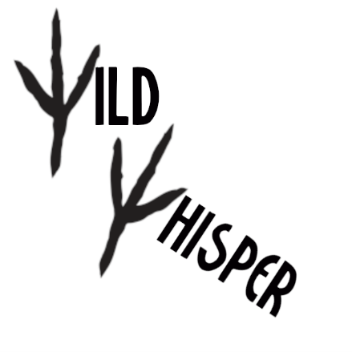

Figure : Concept for bird tracks acting as letters within the logo



Figure : Concept for a 'ripple' effect of sound waves emanating from the letter O

# Visual Identity

Green represents nature

Blue represents technology

# Slogans

1. Secrets of the Wild.
2. Nature's Symphony.
3. Where Wildlife Speaks, We Listen.
4. Scouting Sounds, Unearthing Wildlife.
5. Mapping the Echoes of Nature.
6. Connecting You to Australia's Wildlife.
7. Explore Australia's Soundscapes.
8. Whispers of the Wild.
9. Explore Nature's Hidden Calls.
10. Australia's Animal Orchestra.
11. Find Fauna in Every Sound.
12. Explore, Listen, Protect.
13. Sense the Wild, Sense Australia.
14. Watch, Learn, Protect.
15. Atlas of Australia's Acoustics.
16. Seek and You Shall Find Australia's Sounds.
17. Venture into the Wild Soundscape.
18. Trekking the Trails of Nature's Sound.
19. Finding Fauna with Eco Sound.
20. Seeking the Sounds of the Wild.
21. Discovery through Sound Safari.
22. Atlas of Australia's Animal Voice.
23. Trekking Australia's Sonic Terrain.
24. Expedition into Nature's Sound.
25. Finding Fauna Down Under.
26. Mapping Nature's Voice.
27. Australia's Voice of the Wild.
28. Expedition into the SoundScape.
29. Adventure in Australia's Sound.