Name Ideas

The names need to evoke the ideas of at least two of these keywords:
- Nature
- Wildlife
- Sound
- Location
- Australia
- Technology
- WildSound Tracker
- Outback Audio Explorer
- Aussie Wildlife Listener
- Bush Sound Scout
- EcoSound Mapper
- Down Under Critter Call
- AustraliaSound Discovery
- Wildlife Whisperer
- NatureNest Explorer
- Oz Animal Acoustics
- BioSonic Trailblazer
- Aussie Fauna Finder
- WildVoice Recon
- FaunaSoundscape Pro
- Outback Sound Safari
- EcoVoice Explorer
- WildSense Australia
- AnimalSpeak Mapper
- NatureSonic Navigator
- WildlifeWatch Pro
- AussieBioVoice Scout
- Outback Animal Detect
- EcoWild Tracker
- Down Under Audio Atlas
- AustraliaSound Seeker
- WildWhisper Explorer
- BioVoice Reconnaissance
- Aussie Fauna Sonic
- WildSoundVenture
- NatureSound Trekker
- Oz Animal Audio Guide
- BioSonic Outback Scout
- FaunaTrack Pro
- Outback Voice Explorer
- EcoSonic Safari
- WildVoice Australia
- AnimalSound Expedition
- NatureVoice Mapper
- WildlifeWave Pro
- AussieBio Acoustics
- SoundSafari Scout
- EcoWild Sound Discover
- Down Under Fauna Finder
- AustraliaSonic Explorer
- WildWhisper Seeker
- BioVoice Nature Scout
- WildSound Discovery
- Outback Wildlife Listener
- EcoSense Tracker
- FaunaSpeak Atlas
- NatureNest Adventurer
- Oz Animal Sound Survey
- BioSonic Expedition
- Aussie Critter Call Scout
- WildVoice Tracker
- AnimalSound Safari Pro
- EcoSound Australia
- SoundScape Explorer
- WildlifeWhisper Mapper
- AustraliaBioVoice Scout
- NatureSonic Surveyor
- EcoFauna Finder
- Outback BioSound Scout
- Down Under Audio Adventure
- WildSound Seeker
- BioVoice Recon Trail
- Aussie Fauna Sound Mapper
- SoundSafari Discovery
- EcoWildlife Explorer
- Oz Animal Voice Atlas
- FaunaSound Adventurer
- NatureNest Audio Guide
- WildlifeVoice Pro
- BioSonic Safari Scout
- WildSense Australia
- Outback Animal Audio Explorer
- AustraliaSound Trekker
- WildWhisper Tracker
- EcoVoice Reconnaissance
- AnimalSpeak Surveyor
- NatureSound Expedition
- AussieBioWave Pro
- SoundSafari Seeker
- EcoWildVoice Discover
- Down Under Fauna Finder
- WildSoundVenture
- BioVoice Atlas
- WildlifeWave Scout
- FaunaTrack Australia
- NatureVoice Mapper
- Oz Animal Sound Seeker
- BioSonic Outback Discovery
- Aussie Critter Call Explorer
- WildVoice Australia
- SoundScape Expedition
- EcoFauna Whisperer
- Outback BioVoice Scout
- AustraliaSound Adventure
- WildWhisper

Logo Concepts
See Github for source xcf files
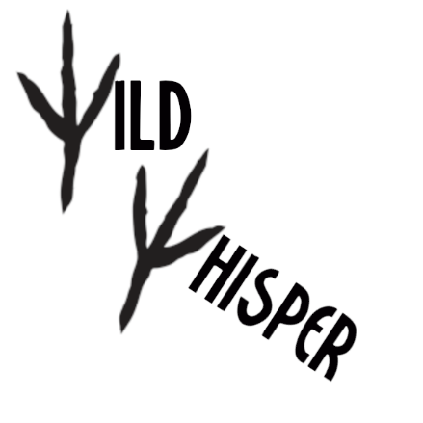
Figure 1: Concept for bird tracks acting as letters within the logo
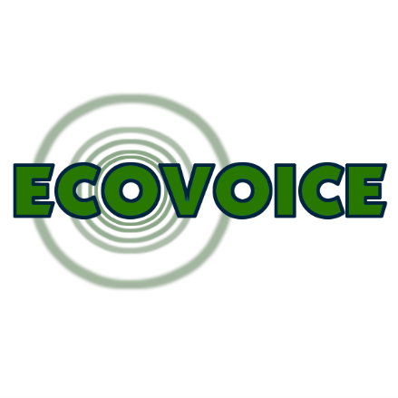
Figure 2: Concept for a 'ripple' effect of sound waves emanating from the letter O

Visual Identity
Green represents nature
Blue represents technology

Slogans
- Secrets of the Wild.
- Nature's Symphony.
- Where Wildlife Speaks, We Listen.
- Scouting Sounds, Unearthing Wildlife.
- Mapping the Echoes of Nature.
- Connecting You to Australia's Wildlife.
- Explore Australia's Soundscapes.
- Whispers of the Wild.
- Explore Nature's Hidden Calls.
- Australia's Animal Orchestra.
- Find Fauna in Every Sound.
- Explore, Listen, Protect.
- Sense the Wild, Sense Australia.
- Watch, Learn, Protect.
- Atlas of Australia's Acoustics.
- Seek and You Shall Find Australia's Sounds.
- Venture into the Wild Soundscape.
- Trekking the Trails of Nature's Sound.
- Finding Fauna with Eco Sound.
- Seeking the Sounds of the Wild.
- Discovery through Sound Safari.
- Atlas of Australia's Animal Voice.
- Trekking Australia's Sonic Terrain.
- Expedition into Nature's Sound.
- Finding Fauna Down Under.
- Mapping Nature's Voice.
- Australia's Voice of the Wild.
- Expedition into the SoundScape.
- Adventure in Australia's Sound.

