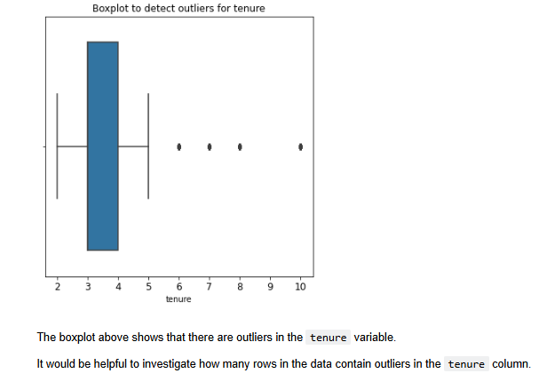

The visualizations from the Python lab in Jupyter Notebook provide a comprehensive overview of the dataset, highlighting key insights into employee turnover at Salifort Motors.

1. **Correlation Heatmap**: Displays relationships between numerical features, identifying satisfaction level and average monthly hours as significant predictors of turnover.
2. **Department Analysis**: Bar plots showcasing turnover rates across departments reveal that specific teams, such as "Technical" and "Support," experience higher turnover.
3. **Satisfaction Levels**: Histograms illustrate the distribution of satisfaction scores, revealing that employees with lower satisfaction are more likely to leave.
4. **Workload Distribution**: Scatter plots of average monthly hours and number of projects indicate that employees with excessive workloads exhibit higher turnover rates.
5. **Salary Insights**: Stacked bar charts show turnover trends by salary tiers, suggesting that employees with "low" salaries are disproportionately affected.
6. **Tenure Analysis**: Line graphs charting time spent at the company highlight tenure thresholds where dissatisfaction peaks.



