Model Development Document (MDD)

1. Title of the Project
Cryptocurrency Daily Price Forecasting

2. Brief on the Project

Project Idea:
This project focuses on developing a forecasting model that predicts the daily closing prices of cryptocurrencies based on historical data. The model utilizes statistics learning and deep learning techniques to capture market trends, volatility, and temporal dependencies within the data. The goal is to provide an intelligent system that aids traders and analysts in making data-driven investment decisions.

Project Type:
This is a Deep learning-based Time Series Forecasting based project focusing on predictive analytics. It employs statistics-based algorithms and deep learning architectures to model and forecast daily cryptocurrency prices.

Problem Statement:
Cryptocurrency prices exhibit extreme volatility influenced by multiple factors such as trading volume, market sentiment, and global economic events. Traditional statistical methods often fail to capture these non-linear dependencies. Hence, a robust predictive model capable of learning temporal trends and market patterns is essential for accurate forecasting of cryptocurrency prices.

Motivation:
With the rapid growth of digital currencies and blockchain technology, cryptocurrencies like Bitcoin and Ethereum have become major players in the global financial system. Accurate price prediction can assist traders in risk management and decision-making. This project bridges the gap between financial analysis and machine learning by applying predictive modeling techniques to the dynamic crypto market.

Previous Work / Background Study:
Previous studies have explored ARIMA, LSTM, and GRU-based models for cryptocurrency forecasting. ARIMA models capture linear trends but fail under high volatility. Deep learning models like LSTM are more effective in modeling temporal dependencies, while hybrid models combining statistical and neural network approaches have demonstrated improved performance. This project builds on these approaches by implementing preprocessing, feature engineering, and model evaluation to enhance accuracy.

Tentative Approach:
1. Data Acquisition: Download daily cryptocurrency market data from CoinMarketCap via Kaggle.
2. Preprocessing: Handle missing values, normalize features, and create derived indicators such as moving averages.
3. Model Design: Implement statistical models (ARIMA, SARIMA etc.) and deep learning models (e.g., GRU, LSTM) for forecasting.
4. Evaluation: Assess model performance using MAE, RMSE, and R² metrics.
5. Deployment: Build a Streamlit web app for real-time forecasting and visualization.

3. Deliverables of the Project

General Approach
The Cryptocurrency Forecasting System is based on a data-driven predictive modeling approach. It leverages historical cryptocurrency data and deep learning algorithms to produce daily price forecasts. The project workflow includes data collection, preprocessing, model building, evaluation, and deployment.

Evaluation and Evidence Collection
Both quantitative and qualitative evaluations were performed to assess the model's predictive performance, stability, and generalization. The model was trained on historical data and tested on unseen data to evaluate accuracy.
- ARIMA Modeling:
- Parameter selection: I will iteratively explore different combinations of ARIMA parameters. For each combination, I’ll fit a new model using the ARIMA() function from statsmodels and evaluate its overall performance. To compare models, I’ll use the Akaike Information Criterion (AIC) — a metric that balances model fit and complexity. The AIC rewards models that fit the data well but penalizes those that are unnecessarily complex. Therefore, the goal is to identify the model with the lowest AIC value, as it represents the best trade-off between goodness of fit and simplicity.
Index | Parameters | AIC
14 | (3, 1, 2) | -5140.727998
12 | (3, 1, 0) | -5140.293681
10 | (2, 1, 2) | -5139.737160
3 | (0, 1, 3) | -5139.599015
8 | (2, 1, 0) | -5139.573120
Key point:
(3,1,2) is the best ARIMA model for the log 1-differenced series. d=1 because differencing was applied by the model. We can now use this model to forecast, then reconstruct the original prices by cumulative sum + last log value, and finally exponentiate to invert the log.
Plot diagnostics:
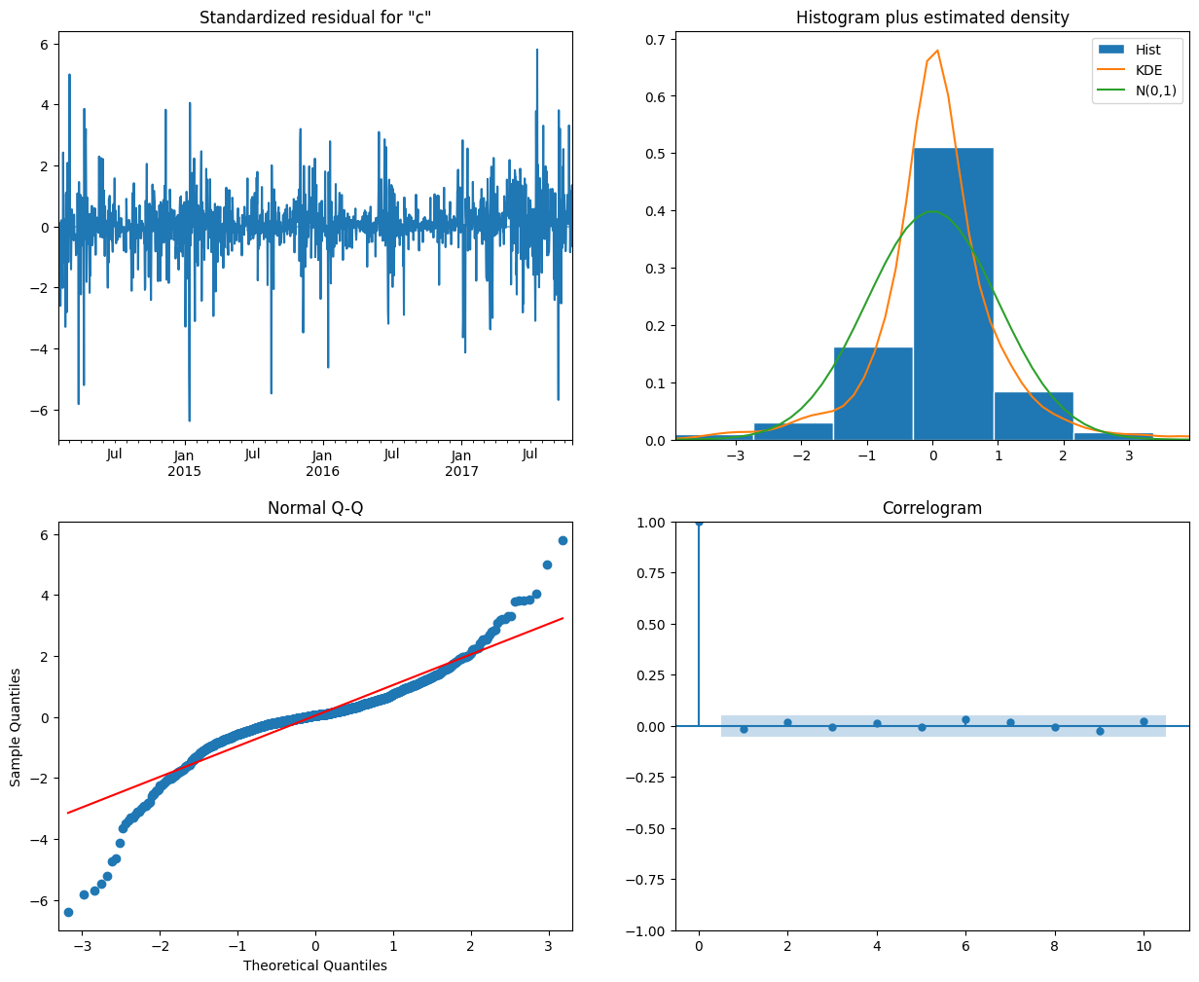

Overall:
Residuals appear roughly normal, uncorrelated, and homoscedastic — indicating a well-fitted model with no major violations of assumptions.

Plot | What It Shows | Good Sign | Red Flags
Standardized Residuals (Top Left) | Residuals over time (mean ≈ 0, variance ≈ 1) | Random scatter around zero; constant variance | Trend, cycles, or changing variance (heteroskedasticity)
Histogram + KDE (Top Right) | Distribution of residuals vs. Normal(0,1) | Symmetric, bell-shaped, KDE ≈ normal curve | Skewness, heavy tails, or multi-modal shape
Normal Q–Q Plot (Bottom Left) | Residual quantiles vs. theoretical normal quantiles | Points near 45° line | Curved/S-shaped pattern or outliers (non-normality)
ACF / Correlogram (Bottom Right) | Autocorrelation of residuals | Spikes within blue band (white noise) | Spikes outside band (autocorrelation → model misspecification)

Bitcoin Daily Forecasting

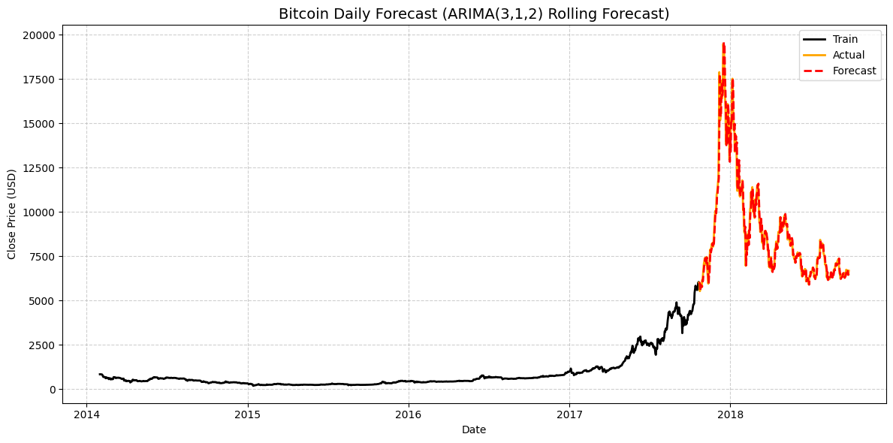
- Single LSTM Modeling:
Model Architecture:
model = Sequential()
model.add(LSTM(
units=128,
return_sequences=False,
input_shape=(x_train.shape[1], 1),
))
model.add(Dense(1))

Bitcoin Daily Forecasting
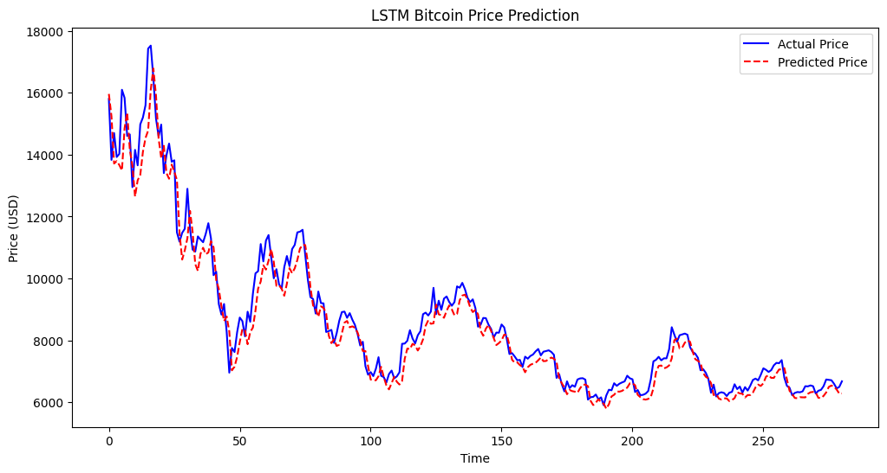
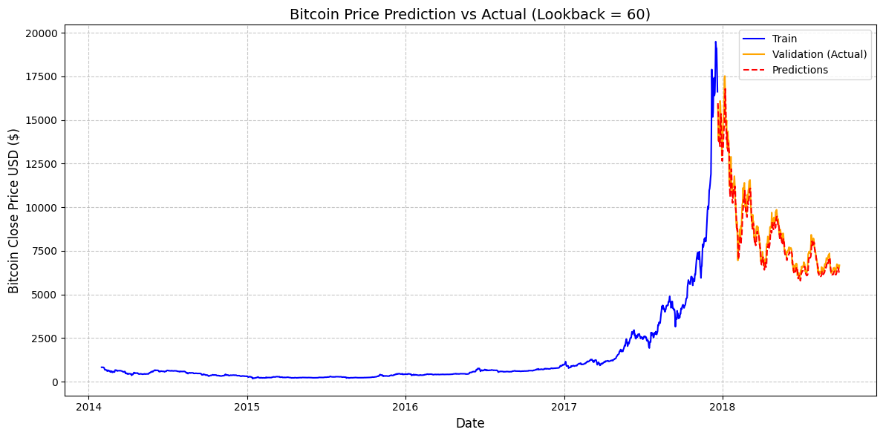

Quantitative Evidence
• Model performance metrics: MAE, RMSE, R²
• Training vs. validation error comparison
• Forecast plots comparing actual vs. predicted prices

Model Evaluation Summary
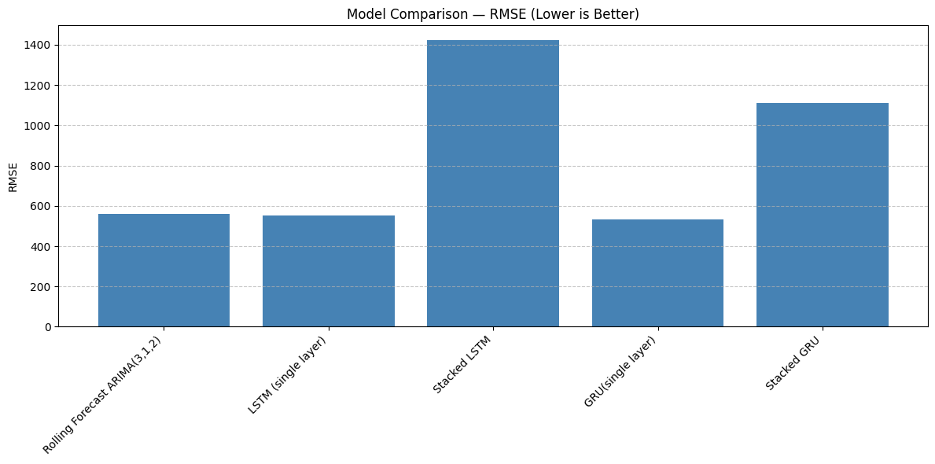
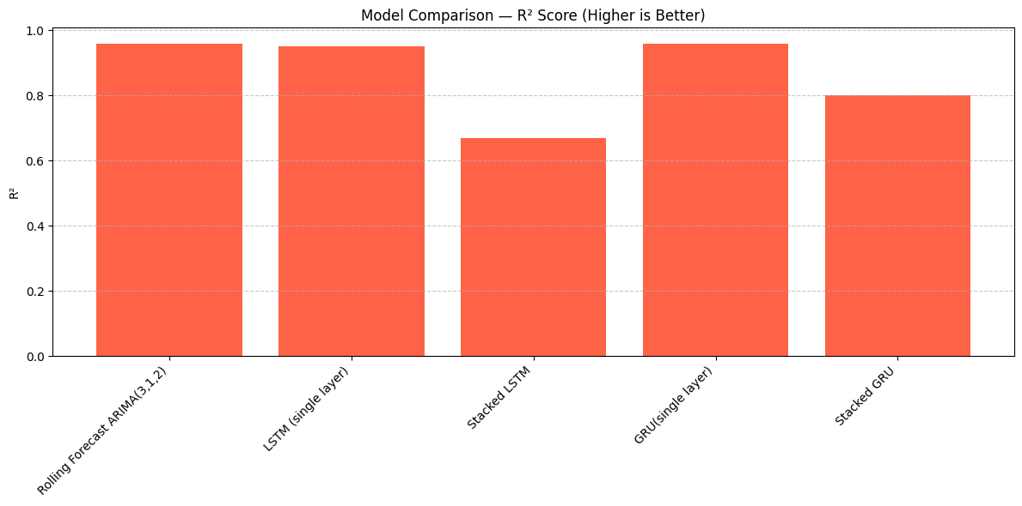

Streamlit deployment and forecasting:
The LSTM model’s predictions on the recent data demonstrate a strong alignment with the observed values.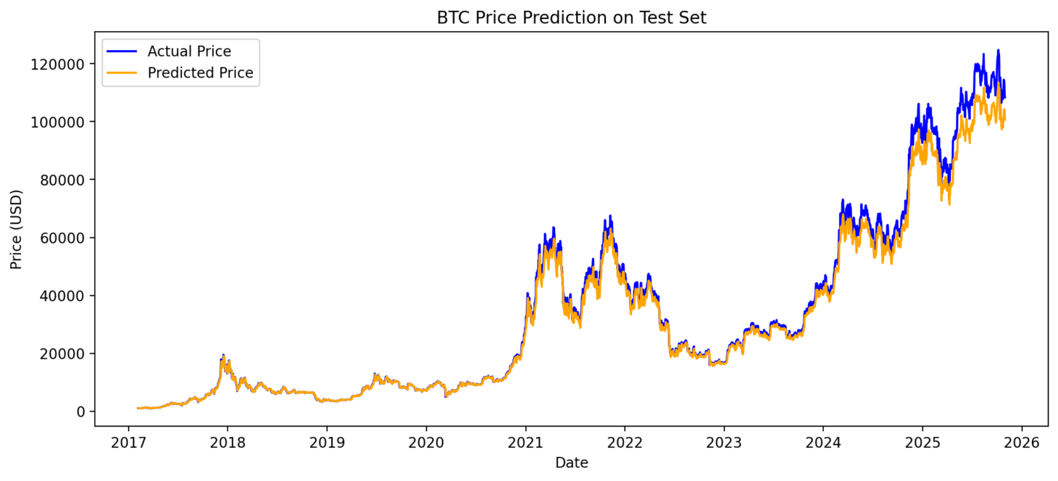
Link streamlit io cloud: Streamlit

Key Insights
• ARIMA (3,1,2) and LSTM models outperform.
• Deep learning models capture temporal dependencies better.
• Data scaling and feature engineering significantly improve performance.
• Predictive accuracy decreases during periods of extreme volatility.

Conclusion
The ARIMA-based model produced the most accurate results, capturing both trend and short-term fluctuations in cryptocurrency prices. The project successfully demonstrates how stats model-based learning can assist in financial forecasting. Future work may include incorporating sentiment analysis from news or social media to improve performance.

Qualitative Evidence
• Visualization of actual vs. predicted prices confirmed the model's reliability.
• Testing on unseen cryptocurrency data validated generalization.
• The forecasting application produced consistent results under varying conditions.

List of Research/Model Questions
1. Can deep learning models accurately predict daily cryptocurrency closing prices?
2. Which model architecture performs best for volatile financial time series?
3. How do feature engineering and normalization affect model accuracy?
4. Can the model be deployed for real-time price forecasting?

Details of the Model
• Model Type: Time Series Forecasting
• Base Models: ARIMA, SARIMA, GRU, LSTM
• Optimizer: Adam (for deep learning)
• Loss Function: Mean Squared Error
• Metrics: MAE, RMSE, R²
• Input Features: Open, High, Low, Close, Volume, Moving Averages
• Output: Predicted daily closing price

Expected Findings and Observations
• LSTM models expected to outperform traditional models.
• Data normalization reduces bias and improves convergence.
• Market volatility influences short-term forecasting accuracy.
• Predictive stability increases with more training data.

Expected Outcome
• A predictive model capable of forecasting cryptocurrency closing prices with R² > 0.9.
• Visual dashboards displaying trends and model predictions.
• Deployable forecasting application for user interaction.
• Comprehensive evaluation report with visual insights.

4. Resources

4.1 Hardware Resources
Processor: Intel Core i5/i7 or higher
GPU: NVIDIA GPU (e.g., Tesla T4, RTX 3060) for faster training
RAM: Minimum 8 GB (Recommended: 16 GB+)
Storage: 20 GB free space
System: Windows/Linux/MacOS
Internet: Required for dataset access and model training

4.2 Software Resources
Python (3.5+): Core programming language
TensorFlow/Keras: Deep learning model development
Pandas & NumPy: Data preprocessing and analysis
Matplotlib & Seaborn: Visualization
Scikit-learn: Machine learning algorithms
Streamlit/Flask: Deployment interface
Jupyter Notebook / Google Colab: Development environment

4.3 Dataset Resources
Dataset Name: Cryptocurrency Market History (CoinMarketCap)
Description: Contains daily price data (Open, High, Low, Close, Volume, Market Cap) for multiple cryptocurrencies.
Source: Kaggle (https://www.kaggle.com/datasets/taniaj/cryptocurrency-market-history-coinmarketcap)

4.4 Human Resources
Role: Project Developer / Data Scientist – Responsible for data preprocessing, model training, and evaluation.
Project Mentor / Guide – Provides technical supervision and evaluation feedback.
Test Users – Validate results and test model deployment interface.

4.5 Online and Research Resources
Learning Platforms: Kaggle, Coursera, TensorFlow Documentation
Research Papers: IEEE, Springer, and arXiv on cryptocurrency forecasting
Community Support: Stack Overflow, GitHub Discussions, TensorFlow Forum

5. Project Member Detail
Name: - Akanksha Rawat
Email id: - meetakansharawat@gmail.com

6. Milestones
1. Define the Problem – Identify objectives of cryptocurrency forecasting.
2. Data Collection – Acquire dataset from CoinMarketCap.
3. Data Preprocessing – Clean, normalize, and create new features.
4. Model Building – Implement stats-based model and LSTM-based models.
5. Model Evaluation – Evaluate using MAE, RMSE, R².
6. Visualization – Plot forecast trends and residuals.
7. Report Writing – Document findings and conclusions.
8. Deployment – Build and test a web app for predictions.
9. Final Submission – Submit complete project package.

