ADF Assignment

Mentor – NAGA LAKSHMI KRISHNA PODILA

  - Name: Raushan Kumar Singh
  - Email id: Raushan.singh4@wipro.com

- Create a pipeline that will read data stored in CSV files located in an Azure Blob Storage container & Write the data to an Azure SQL Database table.

Source:
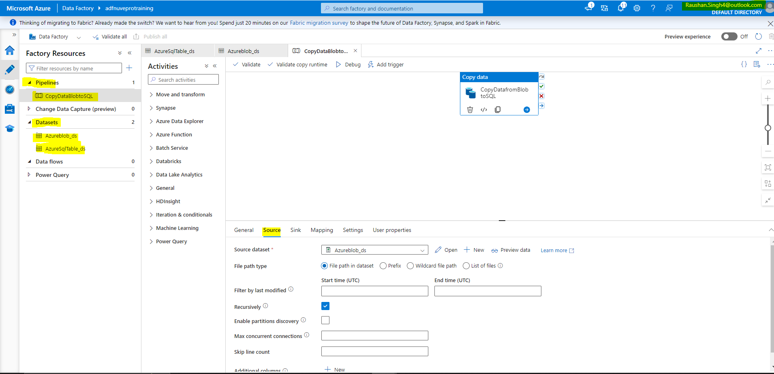

SINK:
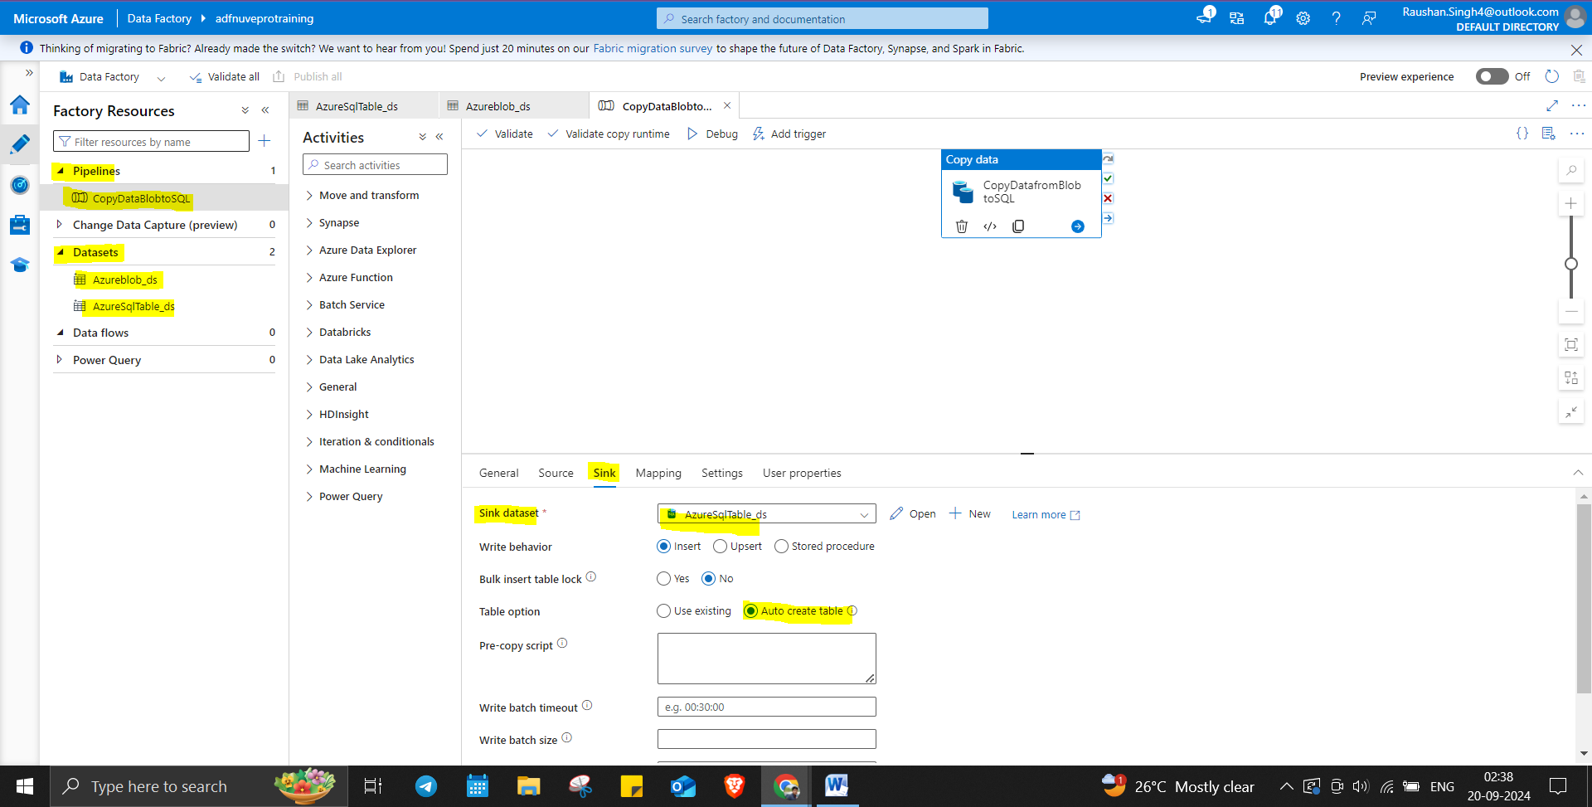

Reading from: Azure Blob Storage > Container > EMPcsv.txt
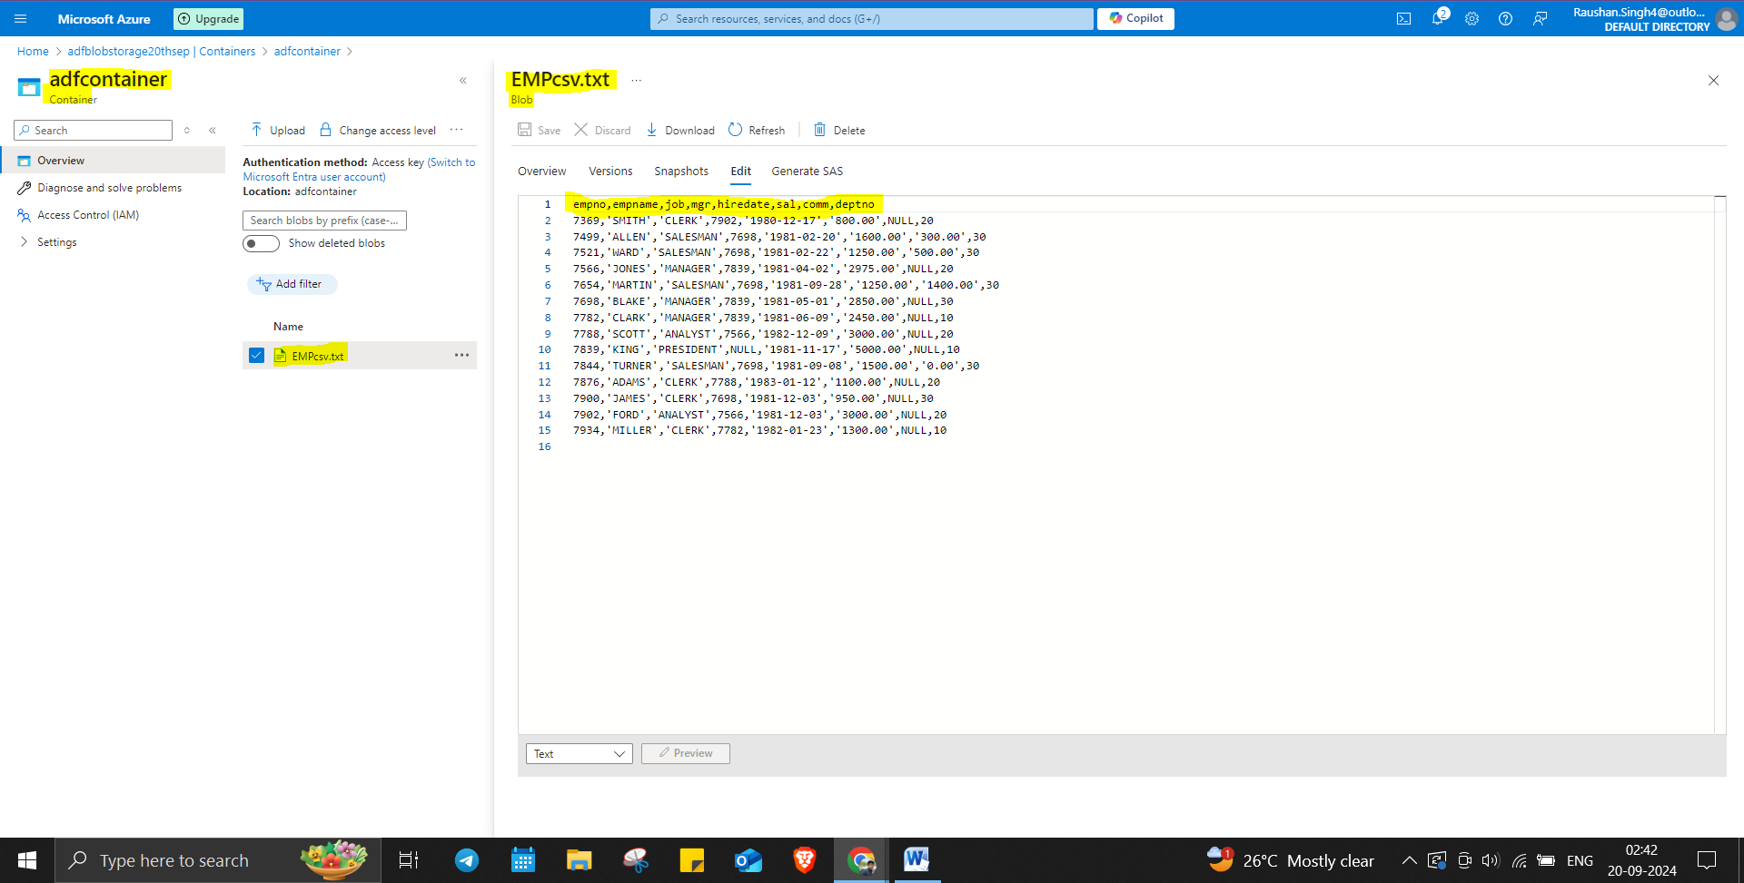

Writing to : Azure SQL Database
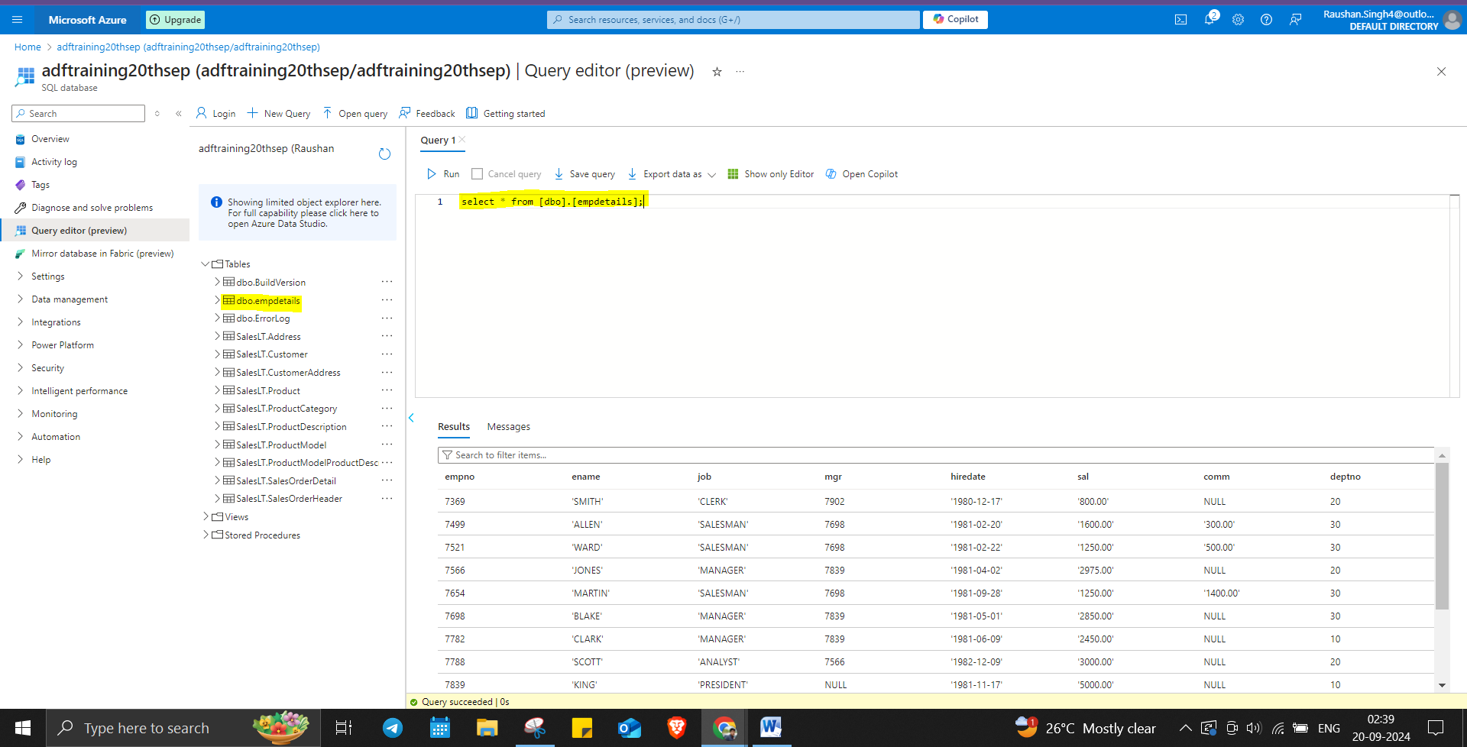

- In this exercise you will use Data factory flow activity in ADF. Which will read data from an Azure SQL Database table called "Student" and Calculate the average value of the student age then save the result to another Azure SQL database table.

Student Table in Azure SQL DB.
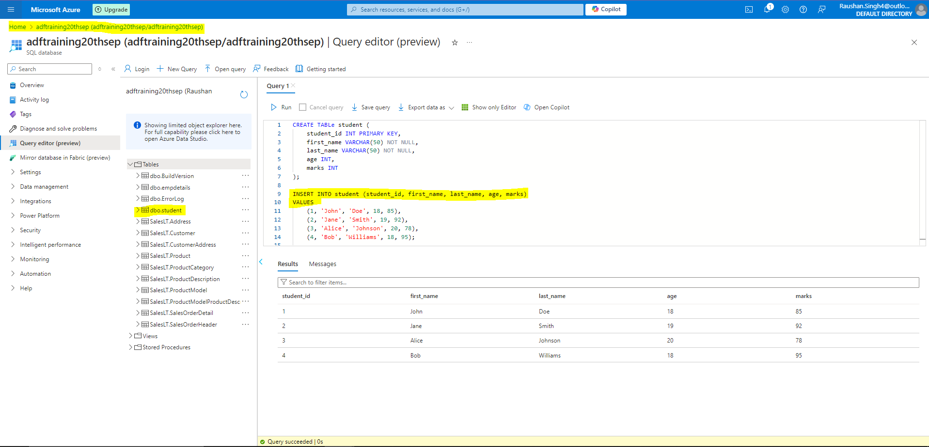

Dataflow:
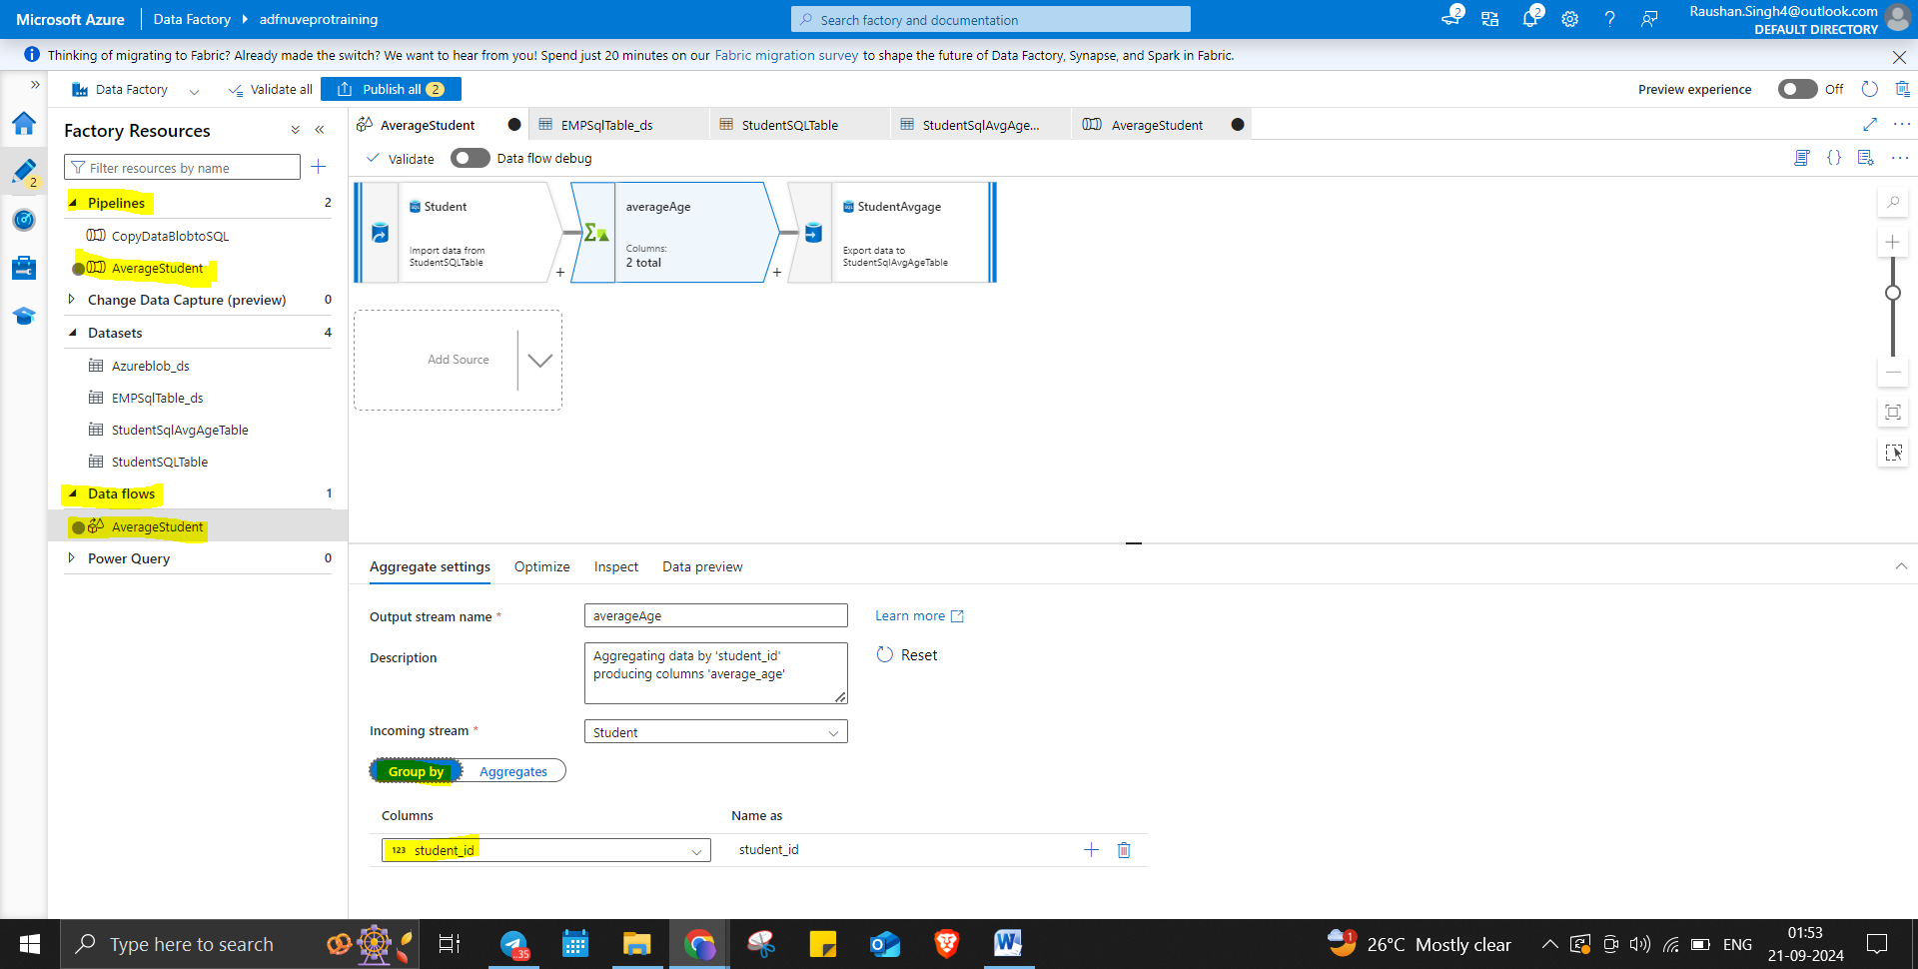

Average Age Table:
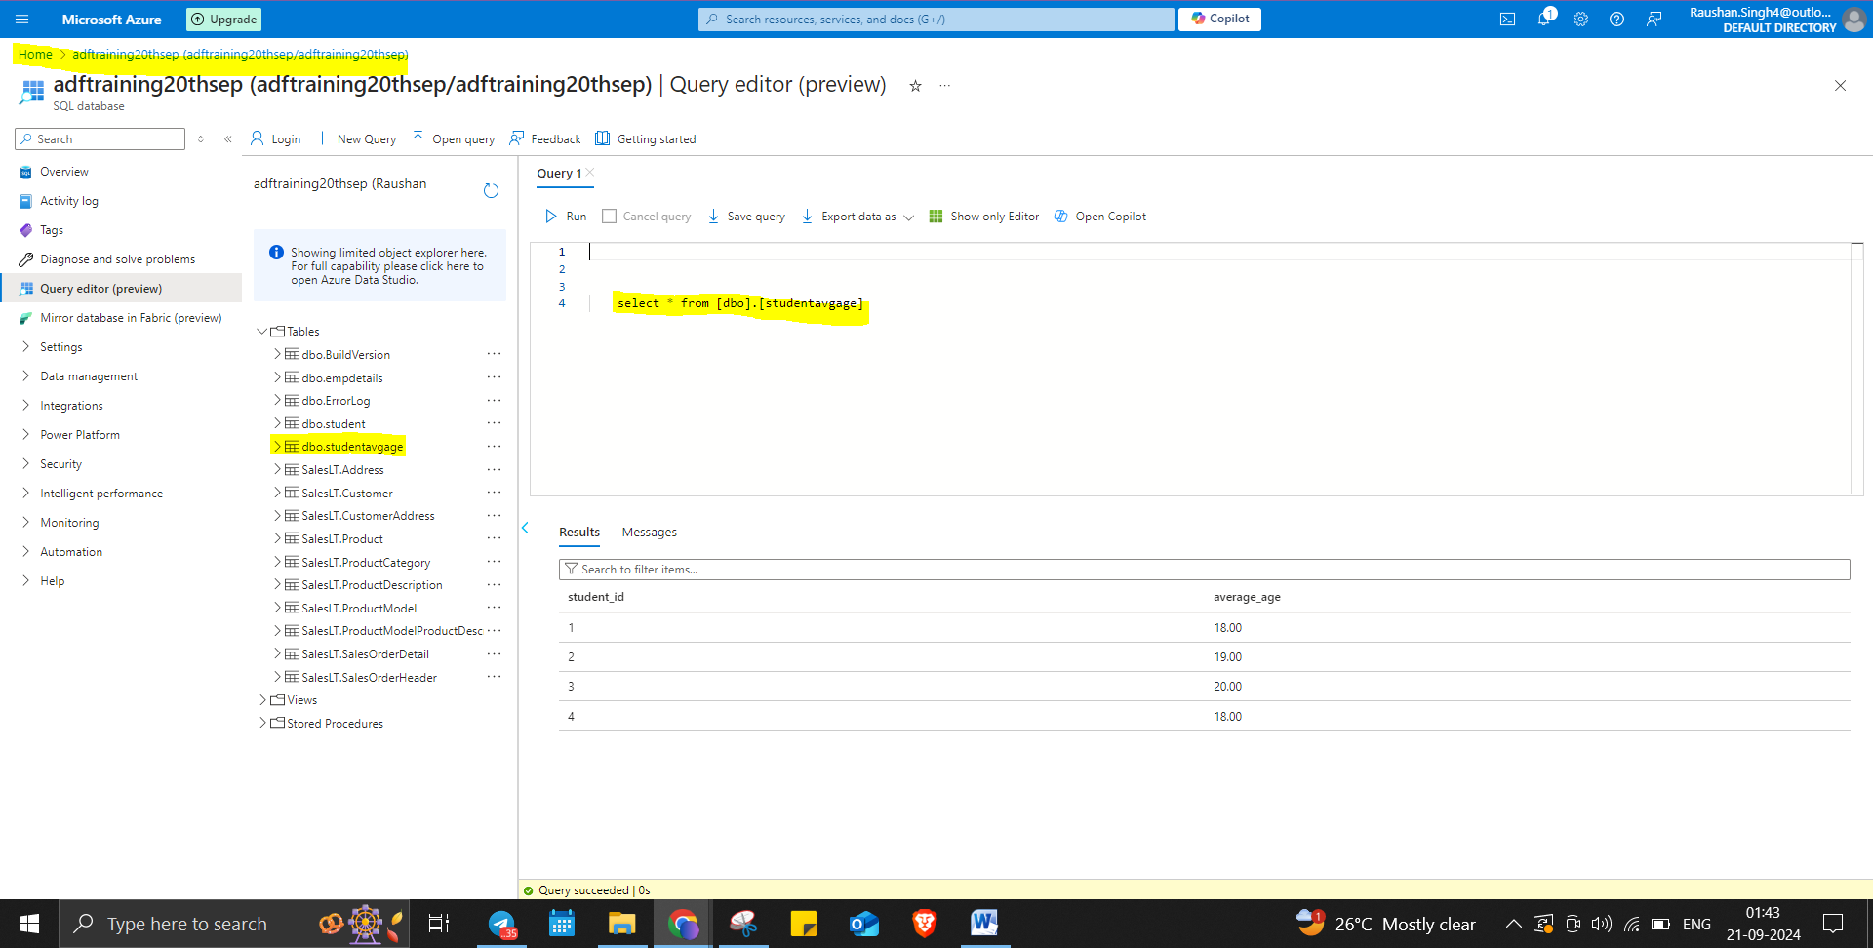

- In this exercise you will use data low activity in ADF. Which will Read data from Azure SQL Database table “Department" and “Employees”. By using ADF copy data from Department & Employee table using qui-join and load the data to “Employee_Details” table.

EMP Table:
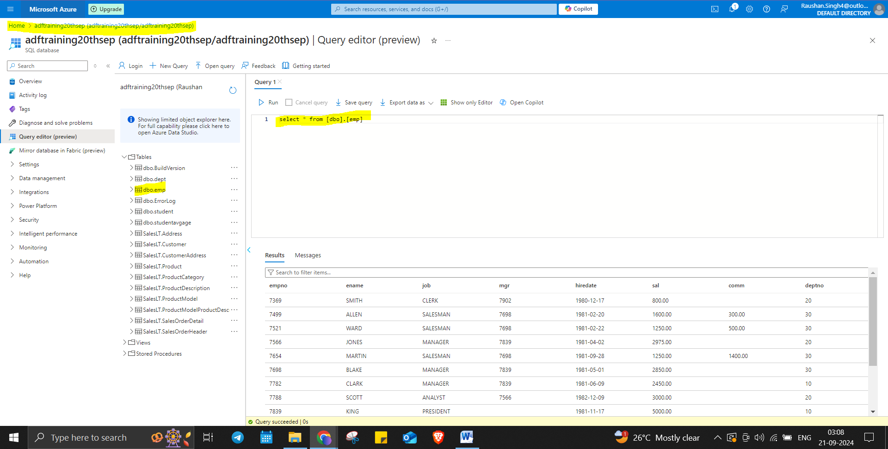

Dept Table:
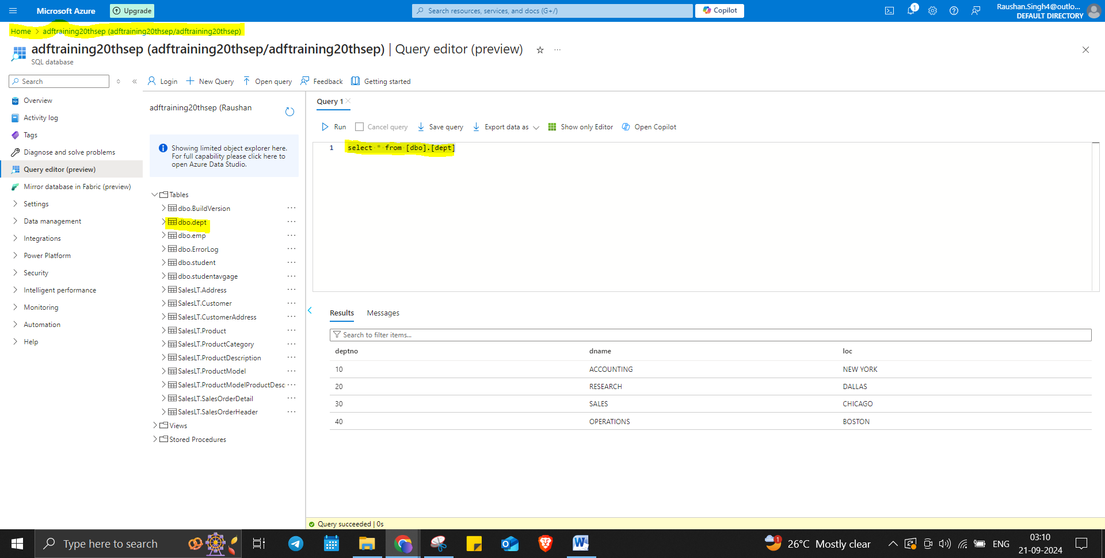

Data Flow:
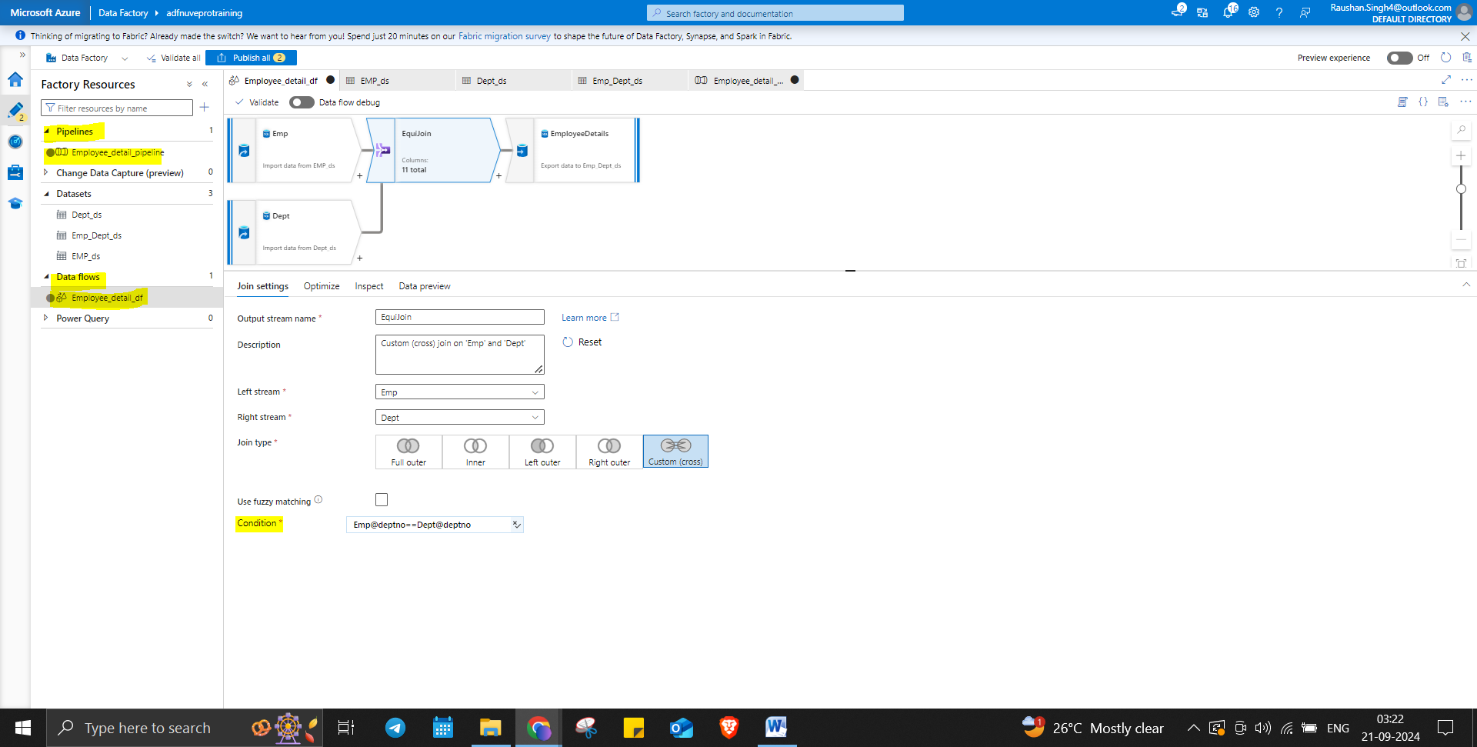

EmpDetails Table:
