**Appendix**

**Emergent properties of organic matter decomposition by soil enzymes**

Bin Wang 1, Steven D. Allison 1,2

1 Department of Ecology and Evolutionary Biology, University of California, Irvine, CA

2 Department of Earth System Science, University of California, Irvine, CA



|  |  |  |  |
| --- | --- | --- | --- |
| **Table A2** Substrate concentrations initialized in DEMENT simulations (mg cm-3). | | | |
| **Substrate** | **C** | **N** | **P** |
| DeadMic | 0 | 0 | 0 |
| DeadEnz | 0 | 0 | 0 |
| Cellulose | 146.89 | 0 | 0 |
| Hemicellulose | 85.855 | 0 | 0 |
| Starch | 12.21 | 0 | 0 |
| Chitin | 4.9952 | 0.83254 | 0 |
| Lignin | 48.51 | 0.40425 | 0 |
| Protein1 | 10.6 | 2.09704 | 0 |
| Protein2 | 10.6 | 2.09704 | 0 |
| Protein3 | 10.6 | 2.09704 | 0 |
| OrgP1 | 12.48 | 0 | 0.478469 |
| OrgP2 | 1.8182 | 0.79745 | 0.478469 |

|  |  |  |  |  |
| --- | --- | --- | --- | --- |
| **Table A3** Manipulated enzyme production rate scenarios and ECA parameter values. Bold values indicate simulations used in further analyses. | | | | |
| **Run** | **EnzProdConstit** | **EnzProdInduce** | **k2** | **km** |
| 1 | 2 | 2 | 17.830 | 28.603 |
| 2 | 3 | 3 | 22.353 | 73.208 |
| 3 | 4 | 4 | 21.473 | 65.600 |
| 4 | **5** | **5** | **22.506** | **75.040** |
| 5 | 6 | 6 | 22.929 | 80.467 |
| 6 | 7 | 7 | 24.091 | 90.833 |
| 7 | 8 | 8 | 22.766 | 81.393 |
| 8 | 9 | 9 | 23.244 | 86.231 |
| 9 | **10** | **10** | **24.976** | **102.192** |
| 10 | 11 | 11 | 26.746 | 119.165 |
| 11 | 12 | 12 | 26.132 | 114.029 |
| 12 | **15** | **15** | **30.561** | **158.196** |
| 13 | 17 | 17 | 32.961 | 180.897 |
| 14 | 18 | 18 | 32.575 | 177.935 |
| 15 | **20** | **20** | **33.243** | **189.403** |
| 16 | 22 | 22 | 37.327 | 227.398 |
| 17 | 25 | 25 | 41.945 | 273.338 |
| 18 | **30** | **30** | **51.635** | **379.492** |
| EnzProdConstit, EnzProdInduce: 10-5 mg C mg-1 day -1 | | | | |
| k2: mg substrate mg-1 enzyme d-1 | | | | |
| km: mg cm-3 | | | | |

|  |  |  |
| --- | --- | --- |
| **Table A4** Cellulose enzyme kinetic parameter values for the Michaelis-Menten equation. | | |
| **Enzyme** | **Vmax(mg substrate mg-1 enzyme day-1)** | **Km (mg cm-3)** |
| 1 | 11.68 | 13.09 |
| 2 | 19.13 | 21.44 |
| 3 | 36.72 | 41.16 |

|  |  |  |  |
| --- | --- | --- | --- |
| **Table A5** ECA parameter values of different substrates based on the simulation with enzyme production rates of 15.0×10-5 mg C mg-1 day-1 (both constitutive and inducible). | | | |
| **Substrate** | **k2** | **km** | **RMSE** |
| Cellulose | 30.561 | 158.196 | 0.029 |
| Chitin | 31.578 | 51.798 | 0.002 |
| DeadEnz | 10.027 | 7.717 | 0.004 |
| Hemicellulose | 48.030 | 90.618 | 0.019 |
| Lignin | 14.826 | 27.247 | 0.009 |
| OrgP1 | 43.331 | 100.000 | 0.012 |
| OrgP2 | 73.453 | 100.000 | 0.003 |
| Protein1 | 35.204 | 100.000 | 0.021 |
| Protein2 | 26.128 | 100.000 | 0.029 |
| Protein3 | 48.722 | 100.000 | 0.011 |
| Starch | 34.229 | 100.000 | 0.016 |
| Total | 17.806 | 1177.599 | 0.178 |
| Note: parameter values of substrates from OrgP1 through Starch are derived from fits with an upper bound of 100.0 for each parameter to avoid overfitting and should be interpreted with caution. | | | |
| k2: mg substrate mg-1 enzyme d-1 | |  |  |
| km: mg cm-3 |  |  |  |
| RMSE: mg cm-3 d-1 | |  |  |

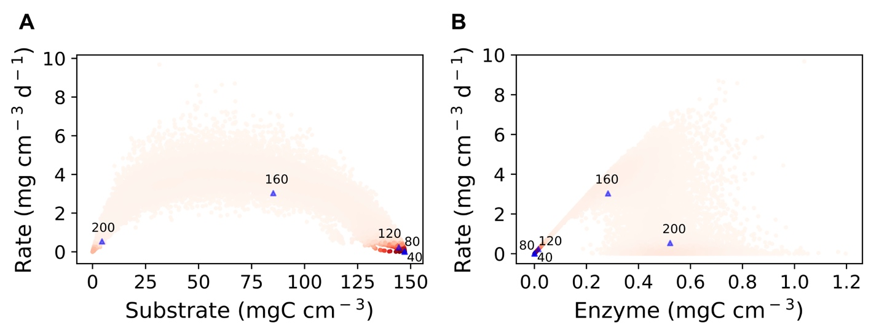

**Fig.A1 Degradation rate versus substrate and enzyme concentration over the 100**×**100 spatial grid** **with data from specific dates plotted together.** Points represent grid box data on days 40, 80, 120, 160, and 200 from the simulation with enzyme production rates of 15.0×10-5 mg C mg-1 day-1 (both constitutive and inducible). High intensity of red denotes high density of points based on kernel density distribution. Blue points denote the means for each day.

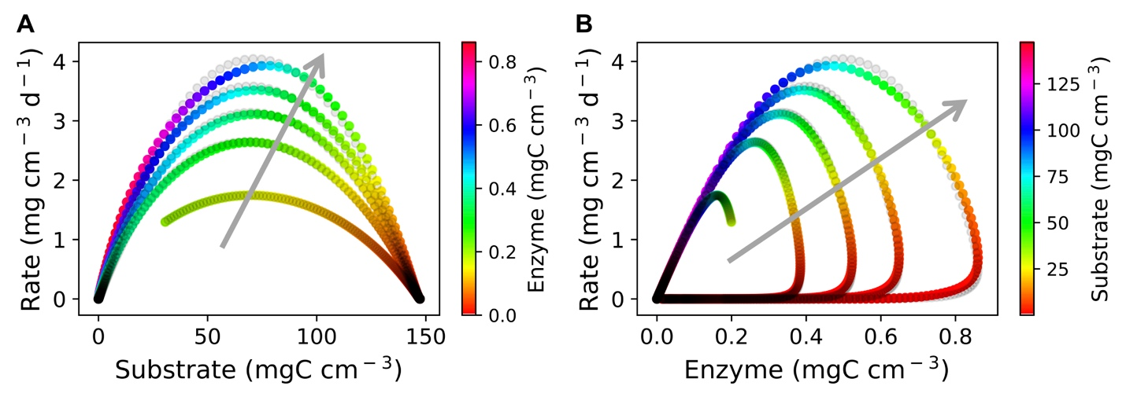

**Fig.A2** **Cellulose degradation rate as a function of both substrate and enzyme concentration.** Similar to **Fig.4**, grey points follow the best fit ECA equation (see **Table A3** for the parameter values). Points in color represent averages over the grid of each day with colors denoting enzyme (**A**) or substrate concentration (**B**). In contrast to **Fig.4,** the ECA equation is fitted with data from five simulations with different enzyme production rates (5×10-5, 10×10-5, 15×10-5, 20×10-5, and 30×10-5 mg C mg-1 day-1, which are selected from scenarios in **Table A3**). The arrow in grey points toward increasing enzyme production rates across the simulations.

**Fig.A3 Same as Fig.4 but for different substrates. A,B)** Lignin (RMSE= 0.009 mg cm-3 d-1); **C,D)** hemicellulose (RMSE= 0.019 mg cm-3 d-1); and **E,F)** all substrates in the system (RMSE= 0.178 mg cm-3 d-1). See **Table A5** for ECA parameter values and all other substrates.