Lending Club Loan Data Analysis

**Springboard Capstone Project**

**Aug - 2017**

Prepared by-Prerna Saxena

**Index**

Introduction

Obtaining Data

[About Lending Club Data](#AboutLCdata" \o "About Lending Club Data)

Tech Stack

Process Flow

Problem Formulation

Exploratory Analysis

* Exploring “Loan Status”
* Exploring “Emp_length” (Number of year lender is employed)
* Exploring “Term”
* Exploring “Grade”
* Exploring “Home Ownership”

Logistic Regression

Algorithms

Conclusion & Future Direction

Learning & Credits

References

**Introduction**

Lending Club is no new name in the lending industry. It has shifted the lending paradigm with the use of technology devising efficient, convenient and the smartest way of investing and borrowing.

It has revolutionized peer to peer loan lending platform by operating a credit marketplace which is overpowering the loan programs offered by traditional banking institutions. With their lending model, borrowers can take advantage of lower interest rate where as investors can also be benefitted with better returns on their investment.

With [Lending Club](http://lendingclub.com/), an investor can invest in a portfolio of loans.  But how will those loan perform, and which loans to pick?  In order to say anything meaningful about what loans to choose, we must first estimate how loans will do over time.  What percentage of loans will default?  What percentage of loans will get paid off in full?

Through this project we are interested in making a guess at the probability of default, which is intended to support company’s decision in approving/not approving the loans given the features that are collected from the lenders through loan application.

**Obtaining data**

We obtained data which is publicly available from the Lending Club website. We also referred to the data dictionary provided by the company on the site while exploring features.

Link to data: - (<https://www.lendingclub.com/info/download-data.action>).

We are going to explore, visualize and analyze 2014-2015 data set and build models for loan predictions. We downloaded two separate csv files each for 2014 and 2015 from the above link and combined them together into one dataset and called it ‘custdata’

**Process Flow**

* Exploratory Analysis
* Dealing with nulls / missing values
* Feature Cleaning
* Preparing Training/Test data set
* Applying Modelling techniques

**Tech Stack**

Our code is written in Panda framework. And we used a number of libraries, to handle numerical calculations, we used the Python libraries NumPy, SciPy. We used ggplot, matplotlib for exploratory analysis and visualization. To benchmark our results against robust machine learning code, we took advantage of the scikit-learn library, which offers out of the box functionality for the Logistic regression, KNN random forest and Naïve Bayes algorithms we are implementing. After we get results using the code that we’ve written, we use the scikit implementations to verify that these results are accurate. We’ve written our code to be modular making use of ipython notebook so that we can easily plug in different implementations to test our code.

**About Lending Club dataset**

Original data came with 656732 rows and 122 columns. We noticed there are a number of columns which are listed in the data dictionary yet missing from the data set. Also, not all of the fields are intuitively effective for the learning algorithms, like ID, Member_ID, URL, month the last payment was received etc. and thus we removed such fields. We also dropped all those rows which had “nan” values and removed columns with greater than 50% of rows having missing values.

To label the dataset, we classified any loan that defaulted or were charged off as negative examples (0), while we classified any loan that was fully paid as positive examples (1). We eliminated loans which were late and in-grace period or current from the dataset.

We would explore a subset of features and test their predictive strength against lenders paying off their loan or defaulting on their loan.

**Problem formulation**

We decided to tackle the loan quality problem by approaching the simple problem of whether a loan will be fully paid or charged off at completion, simplifying our initial approach to **a binary classification problem**.

**Exploratory Analysis**

**Exploring Loan Status (Target variable)**

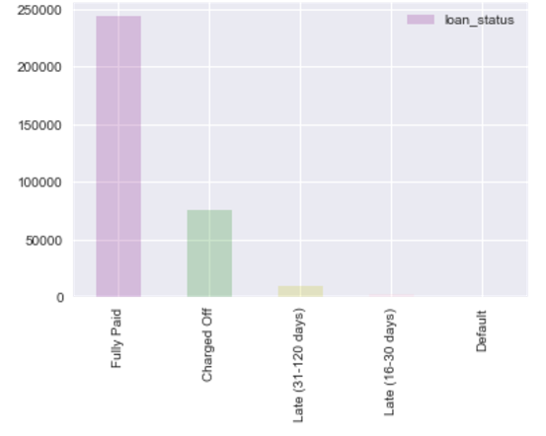Loans can transition through the following states over time.

* Current,
* In Grace Period,
* Late (16-30 days),
* Late (31-120 days),
* Default,
* Charged Off,
* Fully Paid

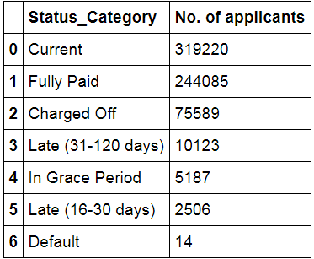From one month to the next, a loan could move, for example, from Current -> In Grace Period, or Current -> Fully Paid, or Late -> Current.

Here, we are interested in the final and irreversible stage of a loan activity. We consider a loan being a “good loan” if it is Fully Paid off and a loan being defaulted or under the Charged-Off categories making it “bad loan”. Any loan falling under the Late or in-grace period could turn up or down so we would filter them from the dataset along with “Current”. So, here is our new groups:

‘1 ’= ‘Fully Paid' and

'0’= ‘Charged Off' + ‘Default’

‘2’ = ‘Current’, ‘Late (31-120 days)’ + ‘In Grace Period’ + ‘Late (16-30 days)’

Cleaning “loan_status”

|  |  |
| --- | --- |
| **Action** | **loan_status_category** |
| 1 | ‘Fully Paid' |
| 0 | 'Charged Off' and Default |
| Remove | 'Current’,‘In-GracePeriod’, ‘Late(16-30days)','Late (31-120 days)' or blank |

That reduces our dataset to **332317** rows now out of which there are **256,714** “Fully paid”rows & “**75,603”** bad loans. Hence, 29 % of the loans turns out to be bad loans in our dataset.

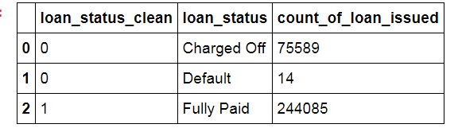

**Exploring “verification status” (Input variable)**

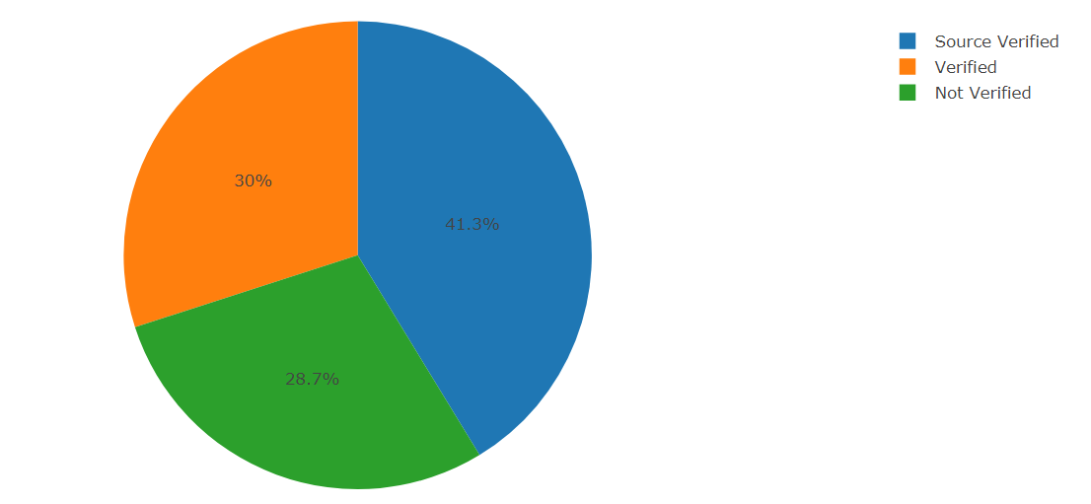**“verification_status”** indicates if income was verified by LC. There are three distinct values in the column. There is no clear explanation in the data dictionary about what is the difference between ‘Source Verified’ and just ‘verified’. We are going to make an assumption that Source Verified could be a third party confirming the verification of income or it could have been obtained from the credit report. Based on the assumption we could merge them into one and classify the values into two groups.

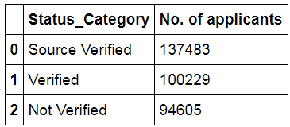

**Cleaning “verification_status”**

We cleaned up the column by assigning “Source Verified” and “Verified” as 1 and “Not Verified” as 0. ***21% (16202/75603) of the bad loans were not verified in our dataset.***

|  |  |
| --- | --- |
| **Action** | **Verification_status** |
| 1 | 'Verified', 'Source Verified' |
| 0 | 'Not Verified' |
| Remove | All other keywords or blank |

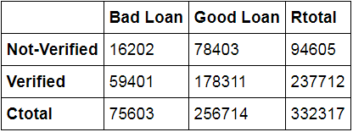

#### Exploring “Emp_length” (Number of year lender is employed)

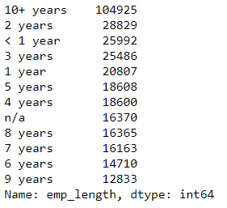

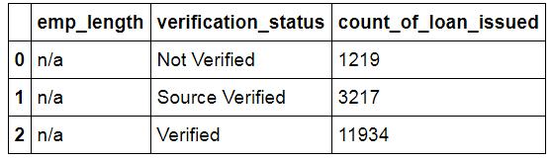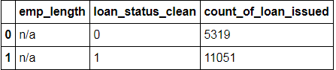It indicates employment length in years. Possible values are between <1, 1...9 and 10+ where <1 means less than one year and 10 + means ten or more years. We see good number of loan application counts are coming from individuals less the 3 years of employment length. We also identified rows with “n/a” which is interesting. To my understanding, this could be because the individual are unemployed or they just didn’t fill that column. When we analyzed n/a records alone, we identified half of the applications have a history of defaulting the payments. I further pulled corresponding verification status just to find out whether these records had their employment verified. And I could see only 1219 records with “n/a” that are not verified which is quite low. That makes me assume that these individuals might not be bound by any employment. They might be doing business or their source of income must be something which does not qualify as employment.

For now, I just wanted to retain these records and study them further to determine the impact on loan status, however I still wanted to give it a suitable name like not_specified instead of n/a that will be tackled in the cleaning section.

Cleaning Emp_length

We cleaned up the column by replacing “<” embedded in the values with space. We also see many applications having “n/a” against emp_length.

|  |  |
| --- | --- |
| **Action** | **Verification_status** |
| < , +, Years | Replace with ‘ ‘ |
| n/a | 'Not Verified' |
| Remove | Nothing |
|  |  |

Below table displays the % contribution of the emp_length towards loan_status.

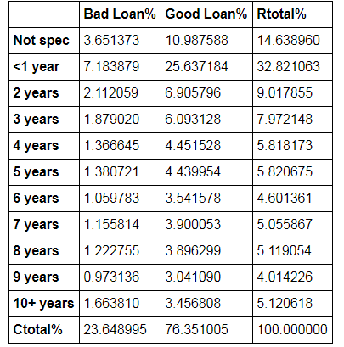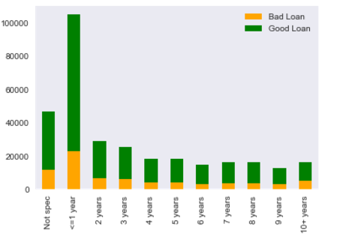

It's intuitive enough to assume that the loan payments would continue as long as individual continues to work but I would like to explore if number of years have anything to do with the loan defaults emphasizing more on the lower range (1-3 years) of emp_length.

**Exploring “home_ownership”**

This indicates home ownership status provided by the borrower while furnishing the loan application. Values are: RENT, OWN, MORTGAGE, OTHER.

Here is the loan number distribution:-

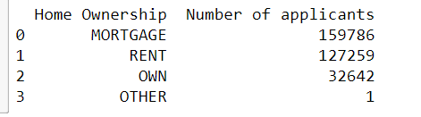

It’s interesting to see only 1 record against “OTHER”. We verified the loan status for this record. Since we found it Fully paid (loan_status_clean = ‘1’), we eliminated this row from our data-set.

Cleaning “home_ownership”

|  |  |
| --- | --- |
| Action | loan_status_category |
| 1 | ‘OWN |
| 2 | 'MORTGAGE’ |
| 3 | ‘RENT’ |
| REMOVE | ‘OTHER’ |
|  |  |

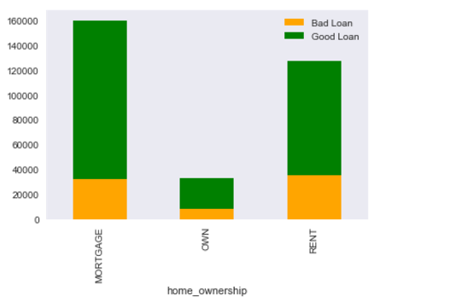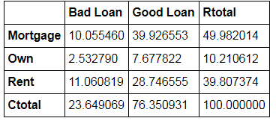

"Rent" status seems to have the biggest contribution to the bad loans as compared to "Mortgage” and “Own" categories.

**Exploring “grade”**

This is LC assigned loan grade: There are 7 loan grades ranging from A: F, A being the finest and F being the lowest grade. Let’s look at distribution of loan_amnt against grades.

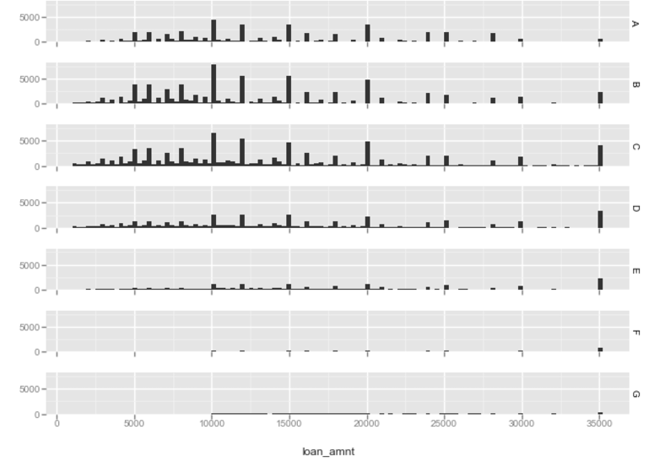

More loans have been allotted to the loan grade A, B, C, D compared to the lower grades.

Cleaning loan_grade

We will assign numeric values to the grades: Since G being the finest we assign 1 for it. And 7 to the lowest grade A.

|  |  |
| --- | --- |
| **Action /Assignment** | **grade_value** |
| **1** | **“G”** |
| 2 | “F” |
| 3 | “E” |
| 4 | “D” |
| 5 | “C” |
| 6 | “B” |
| 7 | “A” |

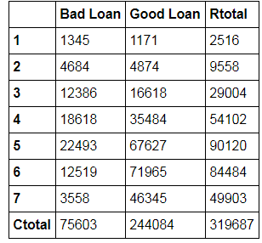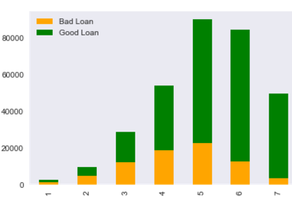

Loan grade 1, 2 & 3 appear to have equally distributed good and bad loans.

**Exploring “term”**

Term indicates number of payments on the loan. Values are in months and can be either 36 or 60. We will see if term has any impact in a loan getting paid defaulted. Below is the distribution of applications by “term”. Most of the loans are issued for 36 months timeframe.

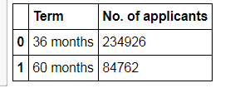

Later, I found out the grade for “36 month” and looks like many low grade loans have been allotted against 36 months.

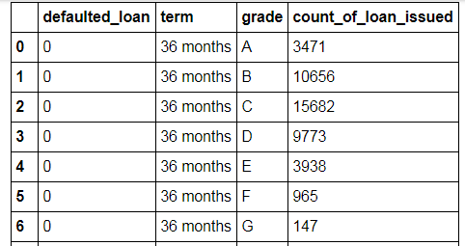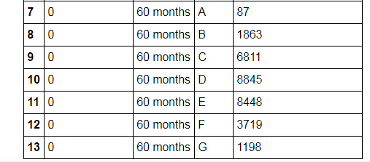

When we look at the grade and number of application defaulted for 60 months, we see there are good number riskier loans allotted against 60 months term which got defaulted.

Cleaning “term”

We will assign numeric values to the term values:

|  |  |
| --- | --- |
| Action | term_clean |
| 1 | “36 months” |
| 0 | “60 months” |

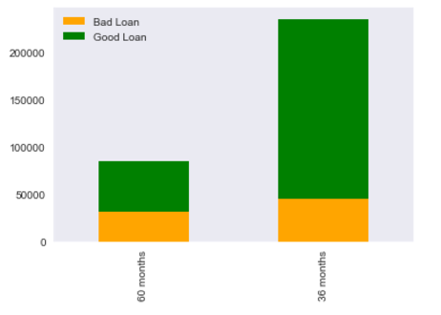

18 % of the 36 months term loans have turned bad vs 36 % of loan with 60 months term. We will check its predictive power in the modeling section.

**Logistic Regression**

Logistic Regression becomes an obvious choice as it encodes a binary outcome.

**Logistic regression with “home_ownership”**

Before running unique list of values for home ownership using logistic regression against loan status, we have to create individual columns for each value, referred to as dummy variables. Each column will have a True(1) or a False(0) value associated with the individual loan that has either "Rent", "Mortgage", "Own". We eliminated "Other" as there was only one record and that was fully paid. And here is our co-efficient values.

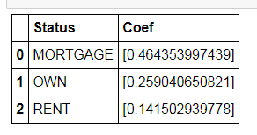**Inference:** Home ownership status marked as "Rent" has

the lowest chance of 0.14 paying back the loan. An additional study of other related features could have shed more light to determine its predictive strength. It will be interesting to see the corresponding “dti” (debt to income ratio) values for those individuals.

**Logistic regression with “emp_length”**

Using our column of years employed, we create dummies so that we could easily run the logistic regression. We're trying to see which length of employment is best predictive of someone paying back their loan.

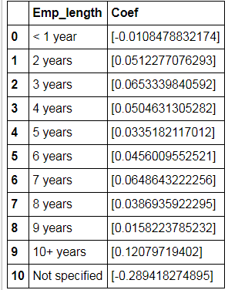**Inference:** There does not seem to be striking variation in the coefficient values for the number of employment years between 2 to 9 years. They are hovering over the range of .01 to .05. However, applications with emp_length <= 1 year and also those which dint have the employment length specified” Not-specified” have negative coefficients. They are more likely to be defaulting. To my understanding, anybody not specifying the employment could be because they might not be bound with employment at the time loan was funded or could be in some other business. Their annual_inc and verification status could be analyzed further to draw any co-relation yet this feature does have predictive power to a certain extent as much intuitive it appears to begin with.(a person would be continuing to pay off loans as long as he/she is employed.)

#### Logistic regression with “verification status” and “term”

#### Okay so both the features have been converted into numeric values: 0 and 1. We will apply LR to both and see the results:-

#### Inference: -> Any application which does not have the source of income verified is more likely to fall in the default category. This could be a good predictor. And about the term for the loan is funded there is .84 chance of individuals paying off the loan if they are granted loan for 36 months.

**Algorithms**

Here we split the dataset into train: test in the ratio 7:3. We are going to apply below techniques and record model performances.

* **Logistic Regression**
* **Random forest**
* **KNN**
* **Decision Tree**

Target Variable = [loan_status_clean]

Input Variables= [emp_length_clean, verification_status_clean, term_clean, home_ownership_clean, grade_clean

**Logistic Regression Results**

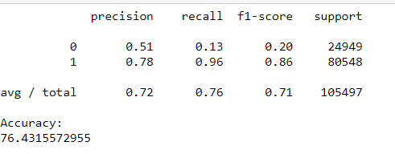

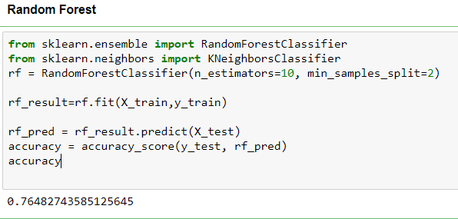

**kNN**

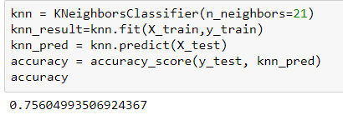

Logistic Regression gave us an overall accuracy of about 0.764

Random forest gave us an overall accuracy of about .764

Logistic Regression gave us an overall accuracy of about .756

**Decision Tree**

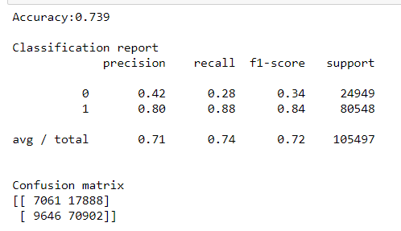

**C**onfusion matrix is often used to describe the performance of a classification model on a set of test data for which the true values are known. As much as this model provides us the decent accuracy value of .73, yet it gives us terrible specificity value. We see out of 24949 class 0 loans in our test dataset, our model could predict only 7061 defaulted loans correctly. Predictions for Class ‘1’ is better with high precision and high recall values. So, overall our model made correct prediction for about 77,963 (7061+70902) applications and incorrect prediction for about 27534 (9646+17888) loans. So, now the question is why is the model bad in predicting Charged Off loans when it gives out a decent accuracy?

Possible causes could be the imbalance in the data. We have 76 % of the 319688 records classified as “Fully Paid” which hints us towards imbalance distribution of data in our dataset due to which minority classes (0) are not able to make a big impact making accuracy almost meaningless and a poor metric for inferring model quality. AUC curve could be way to go!

ROC and AUC

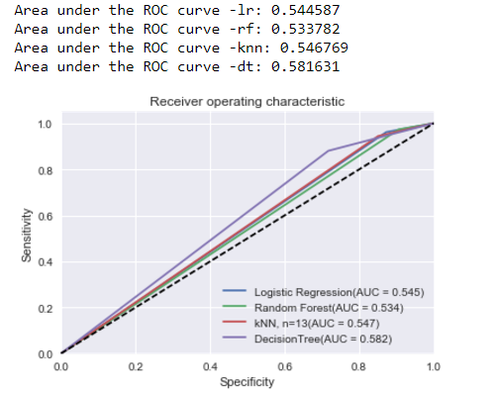

We tested our dataset through four modelling techniques and Naive Bayes seems to have performed better that the other three techniques giving an AUC of .582..I speculate that Naive Bayes with Gaussian is slightly better than the other models as this model works well with independent feature which might have evenly distributed dependencies. Some of the key features that we used, like emp_length, home_ownership, verification_status might be distributed in Gaussian, which would have possibly allowed the model to perform better.

kNN yields a comparable result to Logistic Regression whereas Random Forest has the lowest AUC.

Looking at the ROC graphs, we find not a single model standing out to be significantly different than the others all of them having comparable AUCs, There is a need to eliminate data imbalance by adopting oversampling/under sampling techniques which could serve as the future direction of this project. For now, if we go by the AUC, Naïve Bayes should be our choice and if we go by simplicity of the model implementation Logistic Regression should be the model of choice in predicting Loan Defaults in the Lending Club dataset (2014-15)

**Conclusion & Future Direction**

Determining the loan outcome is clearly not an easy task. Going through various techniques, we found out that some of the intrinsic characteristics of a loan by itself have a major role to play in determining the loan results. Like grade, term in our case. On the borrower side, verification status (source of income verified) was an important factor. Length of lender’s employment was certainly a good predictor. Homeownership status gave us an insights about how the defaults predictability improved with the individuals who are renting than the individuals who own a house or have a mortgage. Borrower’s Information collected from the loan application is equally important as we saw “n/a” for employment length yielded greater chances of loan defaults.

No model can guarantee 100 percent accuracy. But there will always be value in a model that can help discern future outcomes. Likewise, this model by no means guarantee best results to drive any investment/financial decisions, but it certainly will be a great source to gain insight into potential lending outcomes at the time of loan’s origin making us all smarter investors!

**Future Direction**:

Some possible reasons and ways to improve the results:

It will be interesting to see how our model performs against relatively larger dataset. We can combine all the 2007-15 data tables and perform the prediction again.

Not all default cases are the same, and some late payments could still be recovered later on, we could include late and in-grace status in our model so instead of a binary classification, multinomial predictions could be employed to take into account the different types of statuses so as to make a more granular prediction.

We played with limited features to make the predictions. A further analysis may incorporate some of the discarded features, such as emp_title, debt to income ratio, annual inc or external information like relevant economic status into the model to produce more meaningful results. Also, some of the variables, which probably are known to offer the strongest predictive power, are removed from the public data-set, such as fico/credit scores. That information would have been helpful as well.

Future work would also include looking into each of the various methods for fixing up imbalanced data by oversampling, undersampling, or synthetic data generation and then generating AUC for better results.

**Learnings and Credits**

In this project I was able to make use of a range of skills learned through Springboard’s Data Science career track. The capstone project gave me a platform to apply the fundamental concepts in the real world scenario. Lending Club publicly available data set was very streamlined and clean to work with. I gained experience in exploratory analysis, data-munging, and data-analysis and was able to touch upon the basics of several modelling techniques. Code and the synopsis can be located in the following github link.

GitHub repo: <https://github.com/DataGalore/Capstone>

Special credit goes to my mentor **Kenneth Kihara** for the valuable suggestions, feedback and discussions.

**References**

<http://www.dataschool.io/simple-guide-to-confusion-matrix-terminology/>

<http://kevinyuan.ca/2016/08/01/Interpreting-Logistic-Regression/>

<https://www.youtube.com/watch?v=yLsKZTWyEDg>

<http://rpubs.com/jfdarre/119147>

<https://www.analyticsvidhya.com/blog/2015/09/naive-bayes-explained/>

<https://www.kaggle.com/amanemisa/want-to-get-low-interest-rates>

<http://blog.yhat.com/posts/machine-learning-for-predicting-bad-loans.html>

<http://cs229.stanford.edu/proj2015/199_report.pdf>

<https://kevinzakka.github.io/2016/07/13/k-nearest-neighbor/>

<https://www.lendingclub.com/info/download-data.action>