**Cross selling and Upselling**

Cross selling and Upselling is one of the most widely discussed concept in marketing analytics. Every other day when you visit a supermarket, restaurant to purchase something, this concept comes into live action. This concept is being taught in every marketing class across the world, thereby students are expected to know of it.

You may be curiously wondering why we have selected this topic of “Cross-Sell”? Well, the answer to this is very obvious. In our experience (spawning several decades) of setting up and training teams, we have conducted hundreds of interviews. And guess what? For our standard interview question of “Elaborate on a project you have worked on from start to end”, the most frequent response has been a Cross-Sell Model! However, when a lot of people were quizzed around the basic concepts of cross-sell / up-sell, they were unable to provide satisfactory answers. They would know the code used, but were unable to explain this simple concept.

## Benefits of Cross Selling

Cross Selling offers benefit to both the ends of marketing cycle i.e. customer and firm.

For the Firm

* Builds customer equity
* Differentiates from competition, enhances market position
* Promotes diversification and innovation
* Stimulates universe expansion and entry into new markets
* Balances growth between new and existing customers, low and high margin products and segments
* Enhance customer profitability
* Discourages customer attrition, improves customer loyalty

For the Customer

* Patronizes the brand
* Broadens choices of product and services
* Offers convenience through one-stop shopping, flexibility, consolidated bill and others
* Increases customer satisfaction
* Lowers price
* Encourages better customer service from relationship marketing

## Bank Case Study: Next Best Product Recommendation Model

**1.** **Objective**: The objective for the Bank is to improve the efficiency of “Investment to Credit Card” cross-sell program based on focused targeting. Investment is also called a liability product in the banking industry.

**2. Segmentation**: For customized one- to- one marketing programs as each segment may have different needs and preferences. The Response Model will be developed for the Segment “Affluent Income Low Risk”

3. **Data Preparation**: Data Preparation for Response Model using Credit Card Customer Information and Historical Campaign Files

4. **Response Model**: The following table shows the variables description and relationship to cross-sell response / propensity in descending order of importance using Logistic Regression

5. **Model Performance**: The model rank orders based on a decile distribution split. It also demonstrates good performance throughout the score range based on cumulative lift ratio.

6. **Implementation**[: Based on the response model, a cut-off of the score can be decided. Customers exceeding the cut-off should be considered for marketing.](https://www.analyticsvidhya.com/wp-content/uploads/2015/08/t3.png)

**Dataset description**

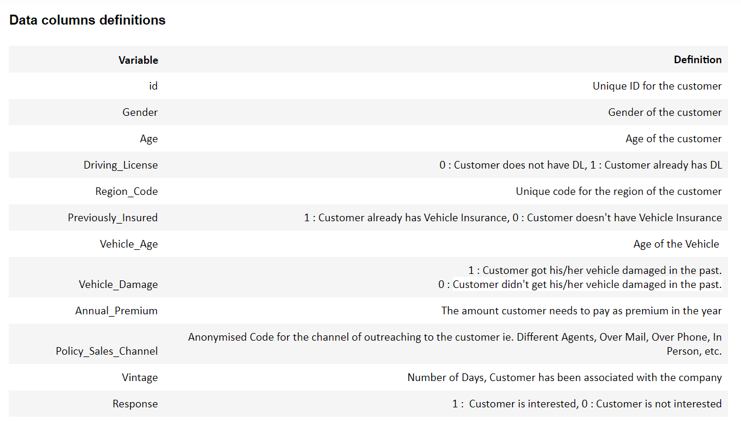

**Team Members:**

Fatemeh Bagheri , France, Université Jean Monnet St Etienne - Université de Lyon, Email: f.bagheri13@gmail.com

|  |  |
| --- | --- |
|  | |