Team Name: Solution Team
Team Members: Bashir Farida, Senjong Dawuleng, Mary Omerekpe
Challenge Name: Female Digital Inclusion in Africa
Date of submission: 23 Nov 2025

Summary :
Our project focuses on understanding the barriers that limit women’s participation in tech across Africa. Using open datasets, we examine how many women have internet access, how many take digital courses, how many work in tech, and overall digital literacy levels in different communities. We explore patterns such as whether women with better internet access are more likely to enter tech careers, which regions have the lowest digital access for women, and which skills are missing.
We start by cleaning and exploring the datasets to ensure accurate analysis. We then use simple analysis methods, including line charts, distribution checks, and country rankings, to visualize female internet usage and trends over time. Our approach highlights key barriers, such as the high cost of data, lack of devices, and skills gaps, that prevent women from fully participating in digital opportunities.
Based on the data, we suggest practical, data-driven solutions to improve digital inclusion. These include community Wi-Fi programs, digital skills training, educational programs, and mentorship opportunities targeted at women and girls. By providing evidence-based recommendations, our work aims to inform policymakers, educators, and NGOs on how to address these barriers effectively.
Our analysis has direct impact: it helps identify countries and communities where women are most disadvantaged, supports the development of targeted interventions, and contributes to building a more inclusive and diverse tech ecosystem across Africa. Through monitoring female internet usage and digital literacy, we can measure progress and ensure that women have equal opportunities to thrive in tech.

Datasets Used
Dataset Name | Source | Description | Limitations
Female Internet Usage | PDPublin / World Bank | % of women using the internet by country and year | Some missing years; data aggregated by region for some countries
Male Internet Usage (optional) | PDPublin / World Bank | % of men using the internet by country and year | Only for correlation/gender gap analysis

KEY VISUALS
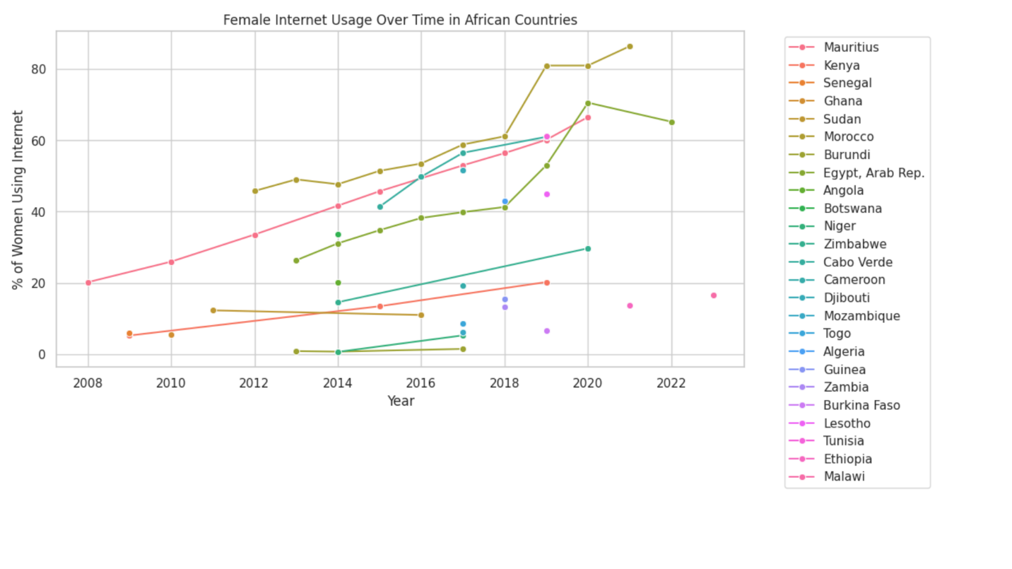
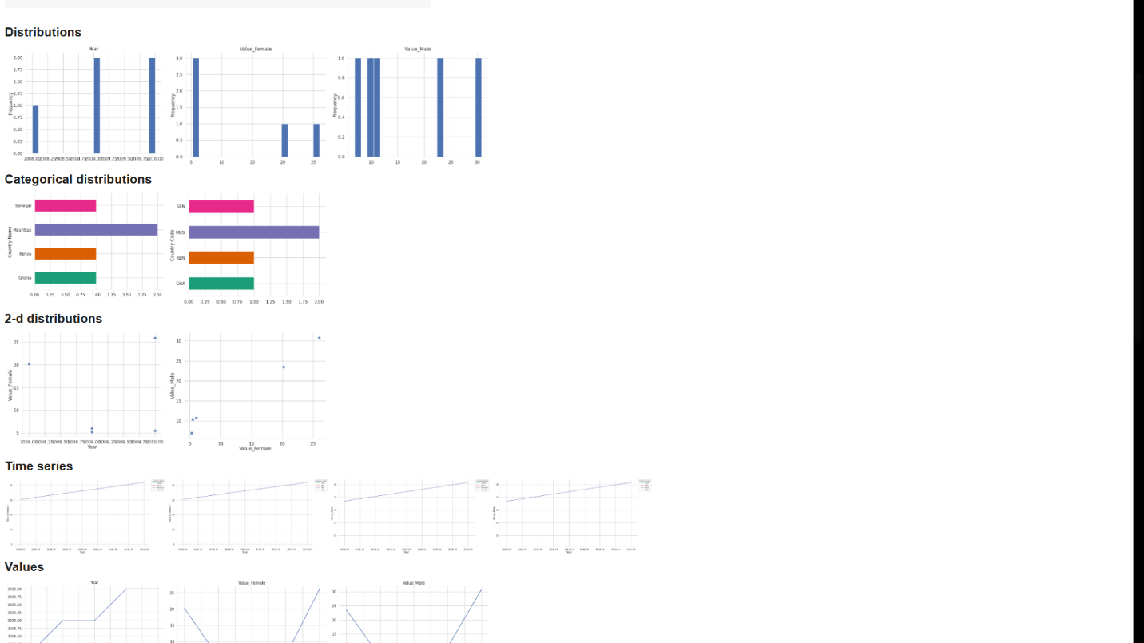

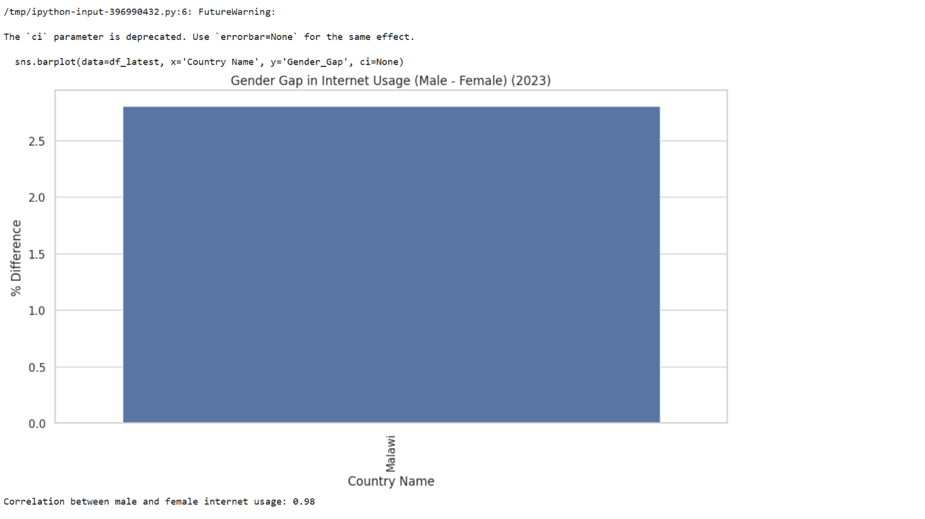
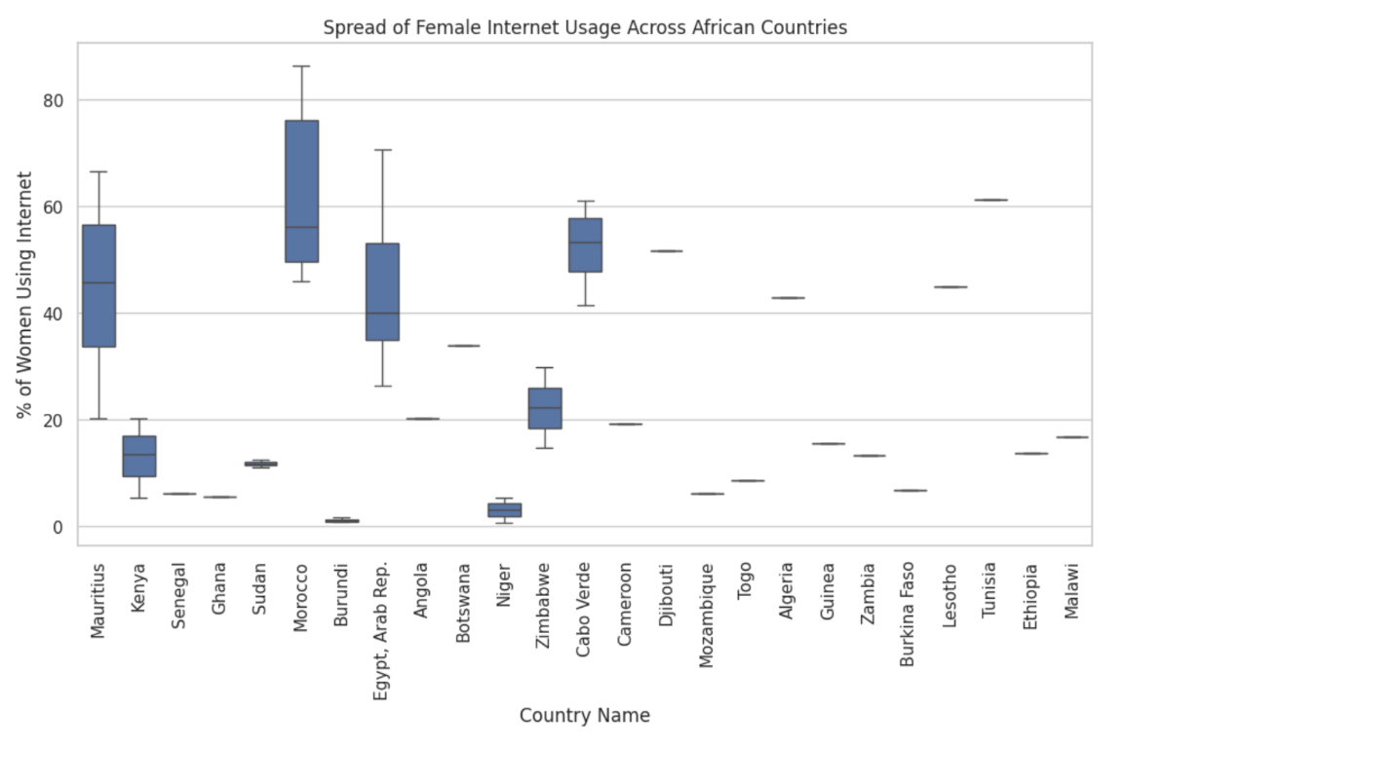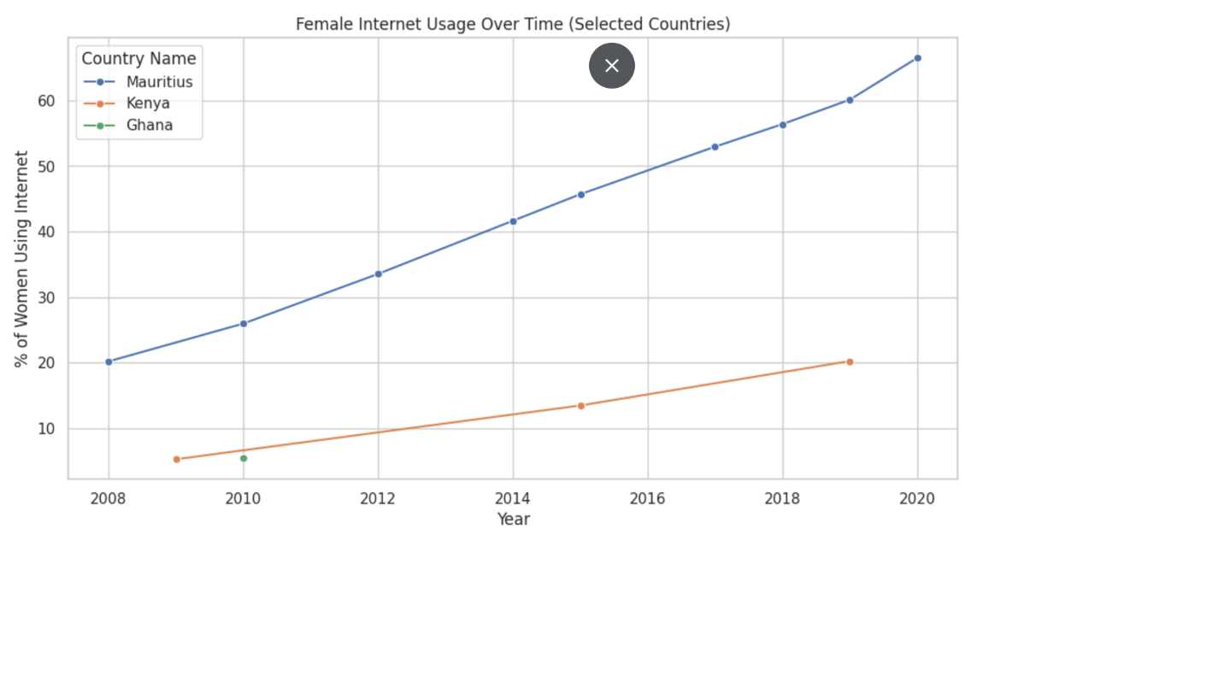

Key Findings
- Correlation between male and female internet usage = 0.98 (strong positive relationship)
- Malawi female internet usage = 16.70%, one of the lowest in Africa
- Countries with high female usage: South Africa, Kenya, Egypt
- Wide variation across countries → some need targeted interventions
RECOMMENDATION
- Subsidize internet in underserved areas
- Provide community Wi-Fi and digital devices
- Launch digital literacy and coding programs for women and girls
- Support mentorship programs and tech communities for women
CONCLUSION
- Female internet usage is improving but uneven across Africa
- Data-driven interventions can help reduce gender gaps and empower women in tech

