## Import the Medak Cases file into R data frame

MC <- read.csv("Medak_Case1.csv", header = T , as.is = T)

## Import the Medak hearings file into R data frame

MH <- read.csv("Medak_Hearing1.csv", header = T , as.is = T)

## Extracted month in numerical form in to new field Case_Filed_Mon from the date_filed field

MC$Case_Filed_Mon <- format(as.Date(MC$date_filed),"%m")

## aggregated the filed case_types for each month using table command

MC_TS <- table(MC$Case_Filed_Mon,MC$case_type)

## changed structure of table to data frame

MC_TS_DF <- as.data.frame(MC_TS)

## Converted the month field from factor to numeric

MC_TS_DF$Var1 <- as.numeric(MC_TS_DF$Var1)

## plot the graph

ggplot(data = MC_TS_DF, aes(x=MC_TS_DF$Var1, y=Freq)) + geom_line(aes(colour=MC_TS_DF$Var2))

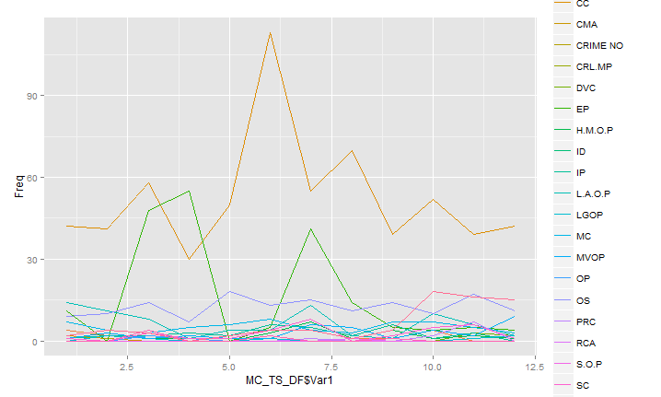

Data file :



## using sqldf package collected the court name , case type , combined case id and number of hearings and hearings first date and hearings last date

case_details <- sqldf("select a.court_name , a.case_type , a.combined_case_number , substr(a.date_filed,1,10) as date_filed, substr(a.registration_date,1,10) as Reg_date , count(b.combined_case_number) as No_of_Hearings , substr(min(b.hearing_date),1,10) as First_Hearing , substr(max(b.hearing_date),1,10) as Last_hearing from MC a , MH b where a.combined_case_number=b.combined_case_number and b.hearing_date <> \"\" group by a.combined_case_number", row.names = T, drv="SQLite")

## Get the last record of every case hearing list

combined_case_wise_hearing_last_record <- MH %>% group_by(combined_case_number) %>% arrange(id) %>% filter(row_number()==n())

## Combined both above files and generated on final file with all the required details about the case

case_details_final <- sqldf("select a.*,substr(b.hearing_date,1,10) as Last_hearing_Dt ,b.purpose_of_hearing from case_details a , combined_case_wise_hearing_last_record b where a.combined_case_number = b.combined_case_number ")

## calculated hearing frequency

case_details_final$hearing_frq <- difftime(case_details_final$Last_hearing,case_details_final$First_Hearing,units = "days")/case_details_final$No_of_Hearings

## Caluclated pendency duration as below :

ifelse(case_details_final$purpose_of_hearing=="Disposed",difftime(case_details_final$Last_hearing,ifelse(case_details_final$date_filed=="",case_details_final$Reg_date,case_details_final$date_filed) ,units = "days"),difftime(case_details_final$Last_hearing_Dt,ifelse(case_details_final$date_filed=="",case_details_final$Reg_date,case_details_final$date_filed) ,units = "days"))

**Output :**

