CivicAssociations Report

DataKind: TeamTree

4/12/2021

## All Civic ASsociations

This generates reports for each civic association

## By civic association

Each civic association- return map

## Reading layer `Modified_Civic_Associations' from data source `C:\Users\cle9a\Documents\Trees\GitHub_02-07-2021\EcoAction\data\shape_files\Modified_Civic_Associations' using driver `ESRI Shapefile'  
## Simple feature collection with 63 features and 14 fields  
## Geometry type: POLYGON  
## Dimension: XY  
## Bounding box: xmin: -77.17232 ymin: 38.82747 xmax: -77.04704 ymax: 38.9343  
## Geodetic CRS: WGS 84

## [1] "Chain Bridge Forest"

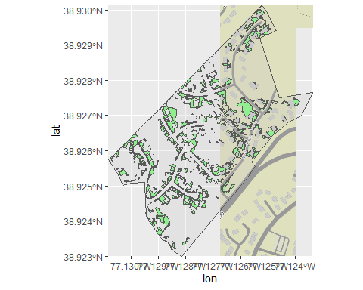

## a flextable object.  
## col_keys: `Stat`, `Value`, `Unit`, `Rank (out of 63)`   
## header has 1 row(s)   
## body has 6 row(s)   
## original dataset sample:   
## Stat Value Unit Rank (out of 63)  
## 1 % In Poverty 0.0 % of population 63  
## 2 % Non-White 1.5 % of population 63  
## 3 Canopy per person 6324.9 ft^2/person 3  
## 4 Population Density 2.8 1k ppl/mi^2 62  
## 5 % canopy 64.1 % of land area 8  
## [1] "Gulf Branch"

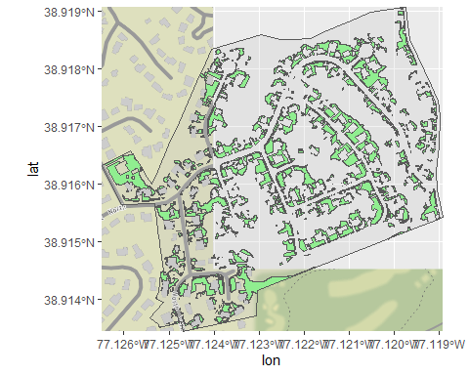

## a flextable object.  
## col_keys: `Stat`, `Value`, `Unit`, `Rank (out of 63)`   
## header has 1 row(s)   
## body has 6 row(s)   
## original dataset sample:   
## Stat Value Unit Rank (out of 63)  
## 1 % In Poverty 0.6 % of population 58  
## 2 % Non-White 15.1 % of population 43  
## 3 Canopy per person 4391.1 ft^2/person 11  
## 4 Population Density 3.7 1k ppl/mi^2 54  
## 5 % canopy 57.5 % of land area 11  
## [1] "Williamsburg"

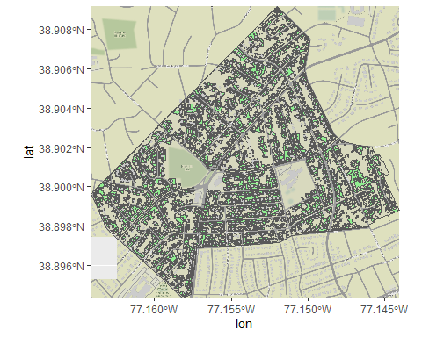

## a flextable object.  
## col_keys: `Stat`, `Value`, `Unit`, `Rank (out of 63)`   
## header has 1 row(s)   
## body has 6 row(s)   
## original dataset sample:   
## Stat Value Unit Rank (out of 63)  
## 1 % In Poverty 1.0 % of population 53  
## 2 % Non-White 16.5 % of population 41  
## 3 Canopy per person 1811.2 ft^2/person 24  
## 4 Population Density 6.3 1k ppl/mi^2 45  
## 5 % canopy 40.9 % of land area 32