Figure 3 registration sheet
Registration overlay — no findings
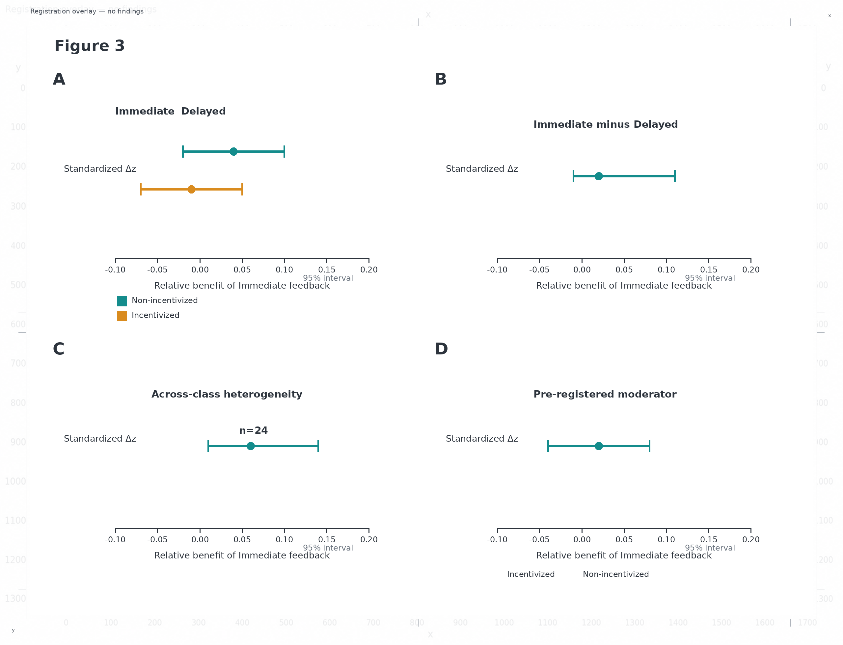
Source proof | PRF-02 | Source locator | page[6].image[0]
Extraction file | figure3_current_proof_extracted.png | Native size | 2400 × 1800 px
Canvas offset | x=80; y=80 | Overlay size | 2560 × 1960 px
Panel bounds source | proof_component_inventory.json | Scale | 1.000 native
Purpose | Coordinate registration only | Interpretation | No findings recorded

