**Faculty Rights and Responsibilities Committee (FRRC)**

**Annual Report 2020-2021**

Respectfully submitted by Alireza Ebrahimi, Chair

**Members:**

FRRC consists of seven members with four continuing members: Mervyn Keizer, Blidi Stemn, Sheyi Oladipo, Katarzyna (Kasia) Platt and three new members: Jillian Nissen, Deepa Jani, and Alireza Ebrahimi

**MEETINGS (2020-2021)**

The first meeting of FRRC was held on **September 24, 2020:**

* The meeting opened with an introduction of committee members, followed by an explanation of the role of the FRRC, discussion of the Annual Report 2019-2020, and identification of work to be completed and presented to the faculty senate.
* The committee elected Alireza Ebrahimi as the chair and Jillian Nissen as the new secretary.
* Mervyn Keizer was absent, and the committee was informed he was retired. Alireza Ebrahimi praised Mervyn for his years of dedication to College committees, and the FRRC thanks him for his service.
* Alireza Ebrahimi was selected to present the FRRC to the Full Faculty meeting on September 25th.
* The role of the FRRC in the student and faculty grievance process was discussed.
* A workshop topic was proposed to focus on the ongoing bylaws revision, to be held in the Spring 2021 semester.
* The impact of COVID on classroom policies and faculty autonomy in the choice of course administration was discussed.

The next meeting was held on **November 23rd, 2020:**

* Preparations of the 2019-2020 Annual Report were discussed.
* Requests to the Faculty Senate Executive Committee to replace Mervyn Keizer were discussed.
* Changes to the FRRC and FUAC Bylaws were evaluated and discussed.
* In the Fall 2020 semester, there were three unofficial faculty grievances, one delivered orally and two submitted in written form with no follow up. No official grievances were submitted this semester.
* The topic of the Spring FRRC workshop was chosen to focus on challenges facing the Faculty during the COVID-19 pandemic. Areas of concern included changes to ARPT evaluation procedures in response to remote learning, Faculty rights and provision of instructional support, and the logistics of the tenure-clock extension and Faculty autonomy in deciding when to take this extension.
* Faculty rights in being able to install software on College-issued laptops without ITS intervention was discussed.

The next meeting was held on **December 18, 2020:**

* Student evaluations were discussed, in particular issues regarding evaluations remaining open during the final exam period. Questions were raised regarding whether evaluations from this Fall could be excluded from ARPT review as in the Spring 2020 semester.
* An academic grievance from a student was raised, and policies and procedures surrounding this process were discussed. Sheyi Oladipo volunteered to serve as the FRRC representative on the Academic Grievance Committee along with Alireza Ebrahimi.
* Alireza Ebrahimi met with Michael Kavic, Faculty Senate Chair, regarding membership on the Bylaws Subcommittee, with the suggestion that new members be added including some from the Faculty Senate Executive Committee.
* The FRRC discussed revisions to its bylaws, in particular focusing on specific requirements such as required numbers of meetings.
* As Mervyn Keizer was unable to serve on the FRRC, a replacement member was discussed. Sara Williamson was the runner-up in the previous election and was suggested as a replacement.

The next meeting was held on **February 18, 2021:**

* New procedures were put into place regarding data management of FRRC meeting minutes and documents.
* Discussions focused on the email outage from January 29 – February 3 that significantly impacted the ability of students and faculty to communicate during the Add-Drop period.
* Questions regarding the membership of the Bylaws Committee were raised. Deepa Jani and Jillian Nissen expressed interest in participation in this committee.
* In lieu of a Spring Workshop the FRRC developed a survey to assess faculty concerns and quality of life during the COVID crisis. The results of this survey will be used to design a workshop in the Fall 2021 semester. This survey was announced in the final Full Faculty meeting of the semester.
* The AGC meeting from December 28, 2020 was discussed. The departmental decision was upheld.
* Concerns regarding some of the requirements for Faculty training were raised. In particular, certification for remote teaching through mandatory Innovation Lab participation was discussed. The FRRC agreed that the Innovation Lab workshops were important and valuable, but the training requirement was an undue burden on faculty who had been teaching remotely for three semesters.

The final meeting was held on **April 22, 2021:**

* Kasia Platt gave a report of the AGC meeting, in which the grievance was decided in favor of the student.
* The Workshop Questionnaire was developed in this meeting, and was prepared for distribution at the final Full Faculty meeting on April 30th.
* The FRRC agreed that further clarification was needed on the training requirements for the Remote teaching modality.

**WORKSHOP**

* The FRRC workshop was instead changed into an FRRC questionnaire to gauge areas of Faculty concern.
* This questionnaire was announced in the final Full Faculty meeting on April 30, 2021
* On May 21, 2021 the questionnaire was emailed to all faculty and the form administered by Deepa Jani, the questionnaire circulated by email during the special session of Faculty Senate/ Full Faculty Meeting on May 28, 2021.

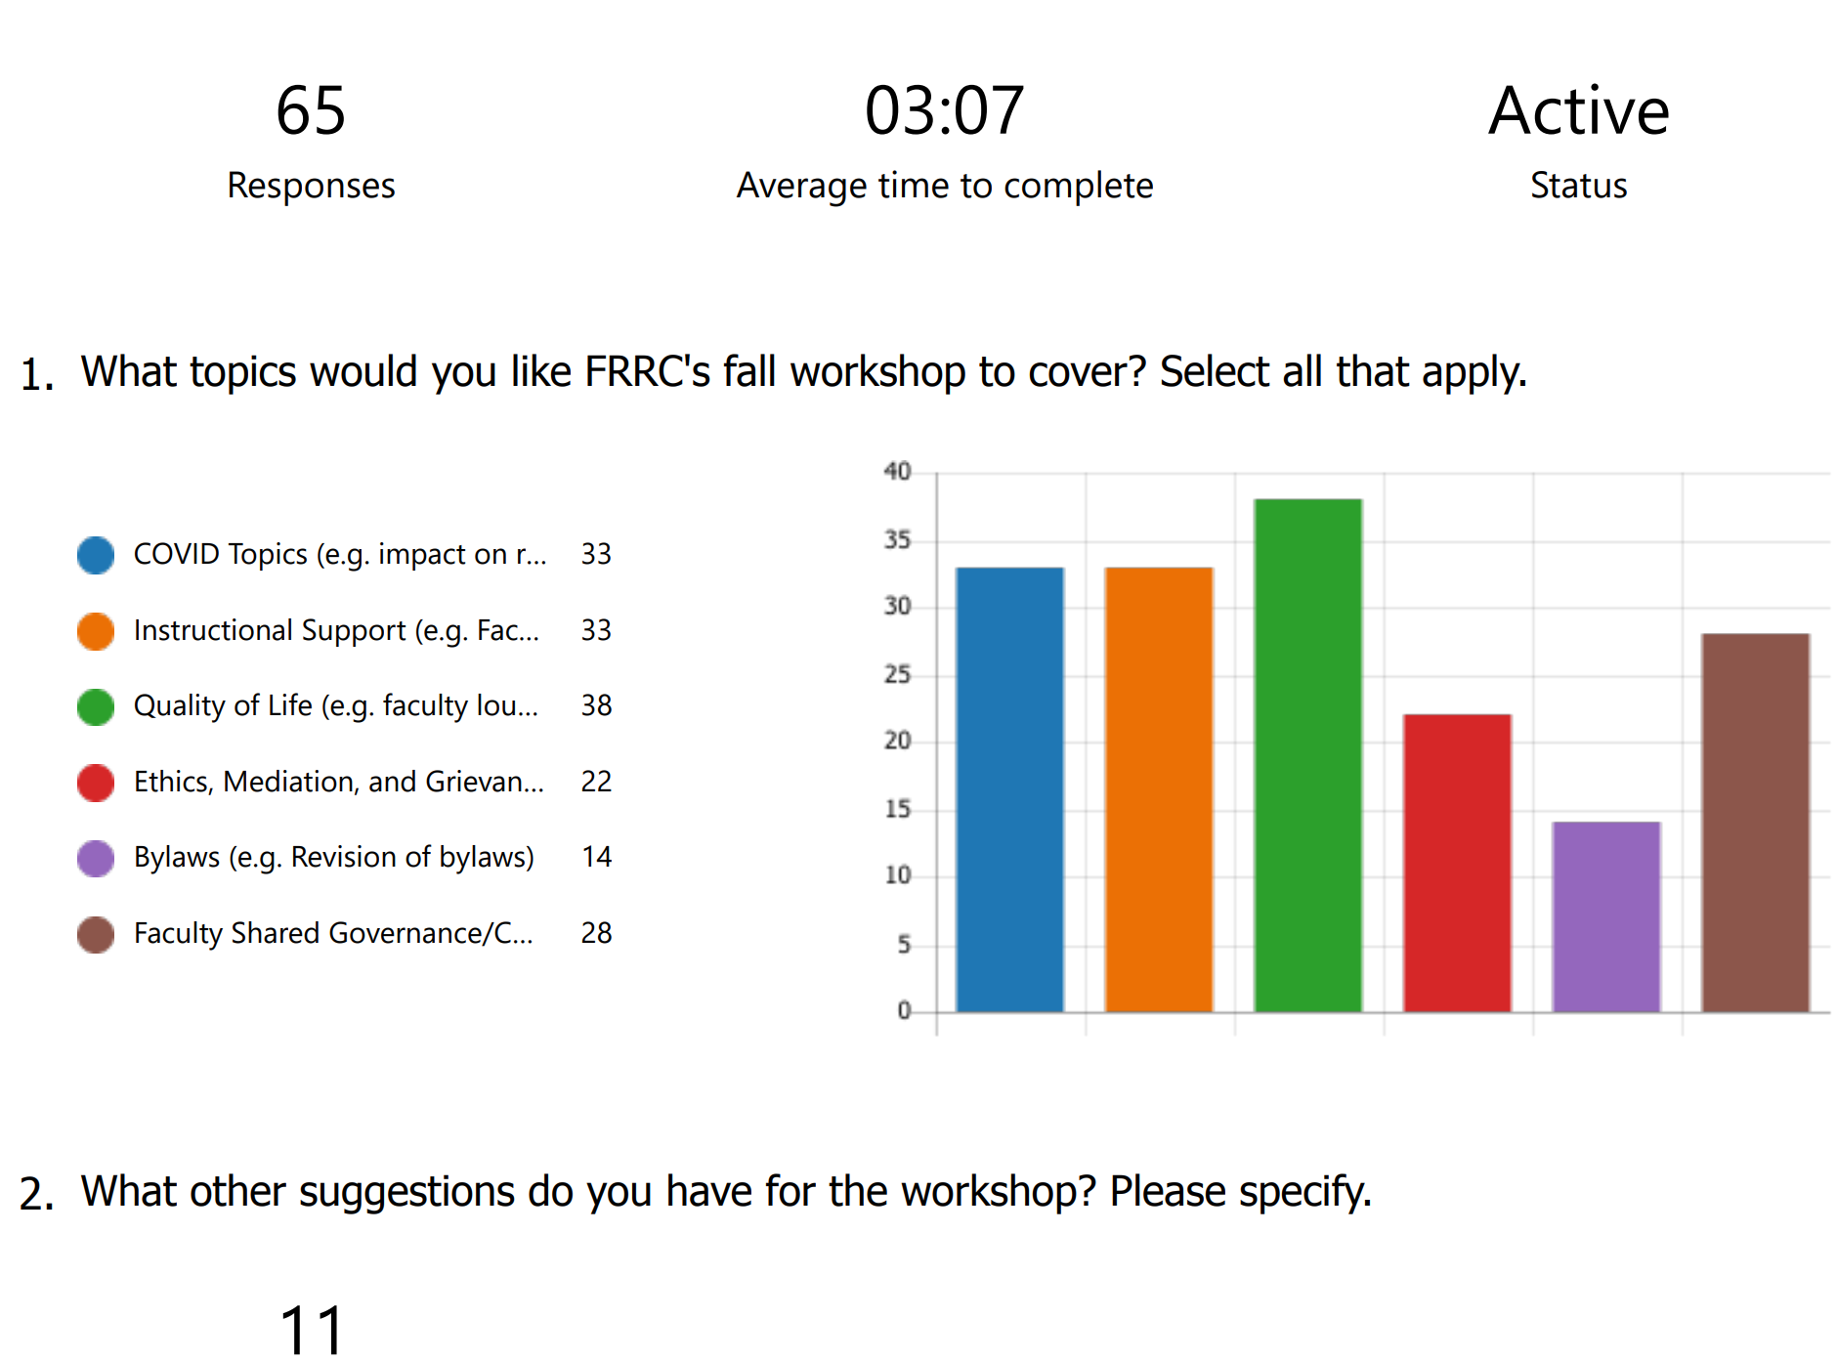

**STUDENT GRIEVANCE**

* The Academic Grievance Committee met on December 28, 2020 to discuss a student grievance. The departmental decision was upheld after review of the relevant documents.
* The Academic Grievance Committee met for a second time on April 12, 2021. This grievance was decided in the favor of the student, in which the student met the threshold for an A based on the syllabus but the grade was rounded down to an A-.

**FACULTY GRIEVANCE**

* There were three Faculty grievances with two continuing and one adjunct concern about losing the job and health insurance after teaching decades.

**FUTURE PLANNING**

* Examine Quality of Life issues on campus.
* Determine Faculty needs regarding instructional and institutional support to address issues due to the COVID pandemic.
* Discuss final grade submission deadline, currently 48 hours after giving the final exam—automated system.
* Instructional and technological support. Extended hours, at nights and weekends.
* Bylaws Revisions.