

Office of the President

P.O. Box 210

Old Westbury, NY 11568

Phone: 516-876-3160

Dear Dr. Jennie D’Ambroise

Thank you and the Faculty Senate for creating and sending this resolution regarding the renovation of the Natural Science Building. After reviewing the document, I fully embrace the call for a strategic approach and advocacy to ensure that the College has a renovation plan that supports our mission, values, and causes the least disruption to academic activities. This I plan to do in the true spirit of the resolution, with special attention to the specific asks.

I truly appreciate the time and thoughtfulness I have witnessed around this matter. This is truly a top college priority and I hope to make headway on the matter in coming days and weeks. I will be certain to keep Faculty Senate informed and updated on the progress.

Best,

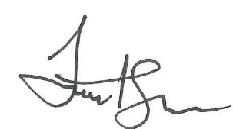

Timothy E. Sams

SUNY Old Westbury President