Database Report

7/25/18

## Completed this week

* Designed the database tables, requirements, and relationships
* Set up MySQL instance on Google Cloud (subject to change based on what we find to be the best host; Google Cloud does allow for easy communication between the frontend and backend teams)
* Created a python module with functions for various queries
  + Mostly for testing right now, limited query and update functionality until we get feedback from the backend team
* Uploaded files to github for backend testing including the dbmodule.py, dbroutes.py (for url testing), and requirements. We also uploaded an sql file for anyone to create a sample database locally for their own testing.
* Database design (see image below)

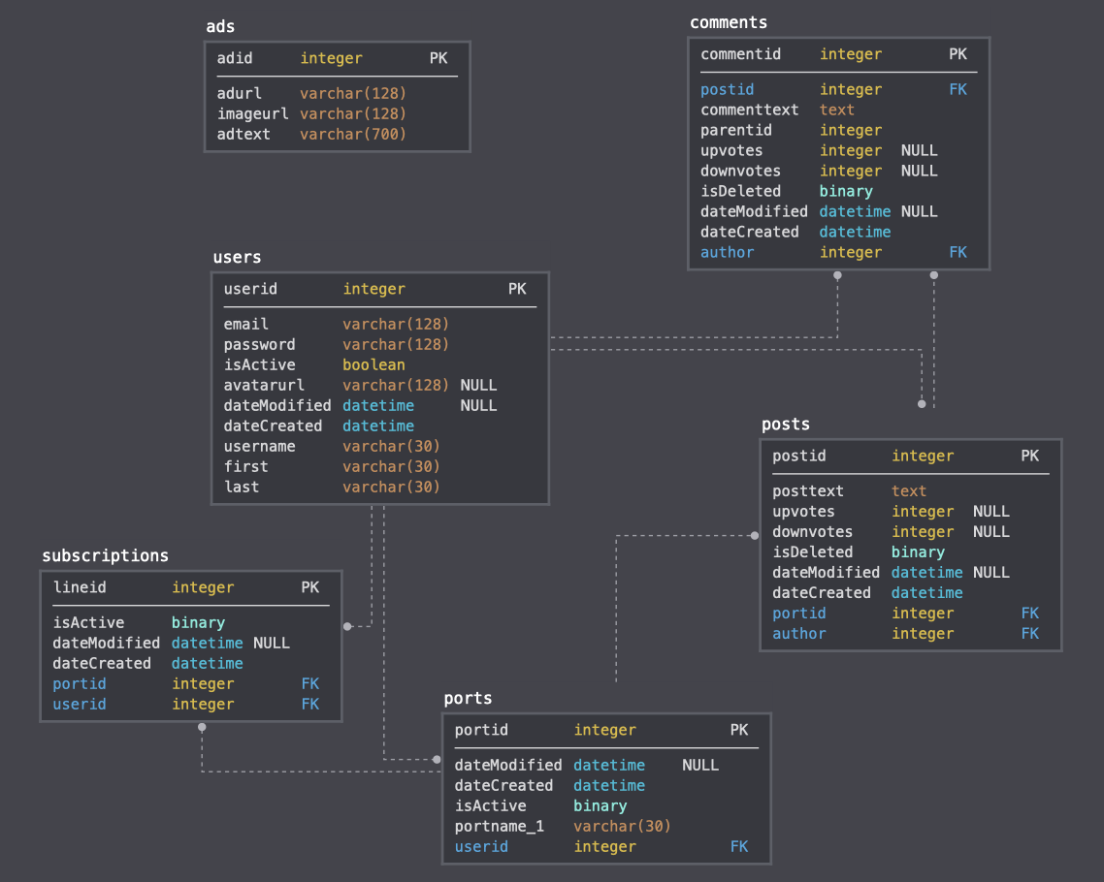

## Coming Up...

* Adding further function to the database module, including more queries and inserts, etc allowing the backend team to access the data through queries
* Creating sample/dummy data to put in the database for testing and later production
* Working further with the backend team to make sure all the necessary queries, updates, and inserts are going into the code
* Working with backend and QC teams to assure data integrity and reduce errors