**# Project Theme: Human Resources Analytics**

A data mining project about why employees leave their work

We used a dataset from kaggle.com with the website: https://www.kaggle.com/ludobenistant/hr-analytics  
And our result in the github:   
About this Dataset  
This dataset is simulated.Fields in the dataset include:

|  |  |  |
| --- | --- | --- |
| satisfaction_level | Level of satisfaction (0-1) | Numeric |
| last_evaluation | Time since last performance evaluation (in Years) | Numeric |
| number_project | Number of projects completed while at work | Numeric |
| average_montly_hours | Average monthly hours at workplace | Numeric |
| time_spend_company | Number of years spent in the company | Numeric |
| Work_accident | Whether the employee left the workplace or not (1 or 0) Factor | Numeric |
| left | Whether the employee was promoted in the last five years | Numeric |
| promotion_last_5years | Whether the employee was promoted in the last five years | Numeric |
| sales | Department in which they work for | String |
| salary | Relative level of salary (high) | String |

Table 1 fields in the dataset

|  |  |  |  |  |  |  |
| --- | --- | --- | --- | --- | --- | --- |
|  | Min | Max | Std | Mean | Mode | Median |
| satisfaction_level | 0.09 | 1 | 0.249 | 0.613 | 0.1 | 0.64 |
| last_evaluation | 0.36 | 1 | 0.171 | 0.716 | 0.55 | 0.72 |
| number_project | 2 | 7 | 1.233 | 3.803 | 4 | 4 |
| average_montly_hours | 96 | 310 | 49.943 | 201.037 | 0 135/ 1 156 | 200 |
| time_spend_company | 2 | 10 | 1.46 | 3.498 | 3 | 3 |
| Work_accident | 0 | 1 | 0.352 | 0.145 | 0 | 0 |
| left | 0 | 1 | 0.426 | 0.238 | 0 | 0 |
| promotion_last_5years | 0 | 1 | 0.144 | 0.021 | 0 | 0 |

Table 2 statistics of fields

|  |  |  |
| --- | --- | --- |
| sales | label | Count |
| 1 | sales | 4140 |
| 2 | accounting | 767 |
| 3 | hr | 739 |
| 4 | technical | 2720 |
| 5 | support | 2229 |
| 6 | management | 630 |
| 7 | IT | 1227 |
| 8 | product_mng | 902 |
| 9 | marketing | 858 |

Table 3 sales count

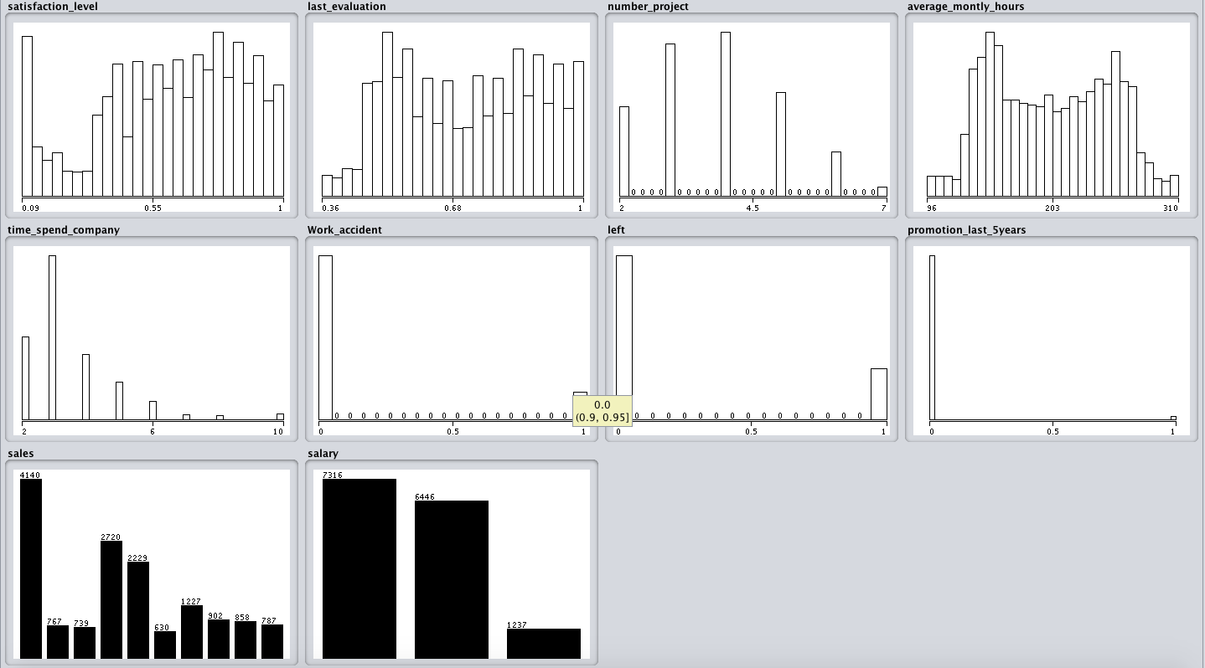

Figure 1

