Proposal and Dataset Exploration
Florida Residential Market Intelligence
Project 1
Diana Gómez
Prof. Martin Idahosa
CAI 4510C: Machine Intelligence
EnTec - Miami Dade College

Proposal
For the project I chose the Florida residential real estate market to study how prices vary between counties and property types and eventually build a tool to compare markets when deciding where and when a property may be interesting to buy, renovate, and resell. This is a useful ML problem because price is affected by inventory, homes sold, days on market, supply, location, and property type. For Part 1 the task is supervised regression because the value we want to predict, median sale price, is numeric. Later parts can extend the same problem into classification, neural models, and time-based models.
The dataset comes from Redfin's Housing Market Tracker. I downloaded monthly county-level data from January 2023 through August 2026 and filtered it to Florida. The Florida subset has 9,788 rows covering all 67 counties and four property types: Condo/Co-op, Townhouse, Single Family Residential, and Multi-Family (2-4 Units). Each row represents one county, one property type, and one month, so the data describes market conditions rather than individual home sales.
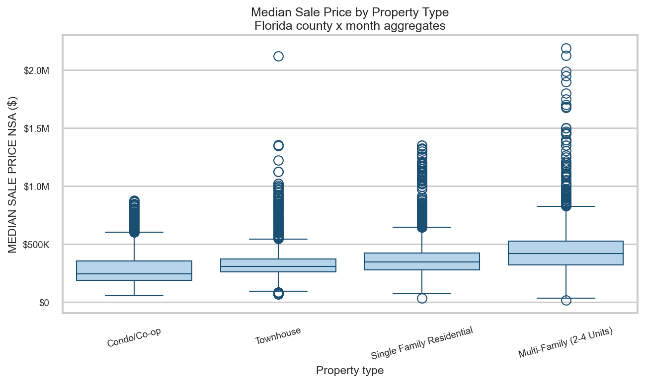
Figure 1. Median sale price by property type in Florida.
Exploratory Data Analysis
A brief data set description:
- 346,099 rows × 24 columns in the full file
- Florida contains 9,788 rows
- The dataset includes all 67 Florida counties
- Time period: January 2023 through August 2026
- If we focus only on Single Family Residential, there are 2,948 rows
- The dataset covers 44 monthly periods
- I found no duplicate records for the combination of county + property type + period
Some points after EDA:
- Median sale price: about $327,500
- Average sale price: about $363,231
- A few very expensive markets pull the average up
- Condo/Co-op had the lowest typical price: about $245,000
- Multi-Family (2–4 Units) had the highest typical price: about $418,125
- Different property types showed different price patterns over time
- Higher-priced counties included Monroe, Walton, Collier, Miami-Dade, Broward, and Palm Beach
- The dataset was generally clean and usable
- There were no duplicate county + property type + month records
- About 14.7% of sale-price values were missing
- Most missing prices came from months with no recorded home sales
- Some small markets had very few sales, so a few values were extreme kept those extreme values and simply noted them instead of deleting them automatically
- 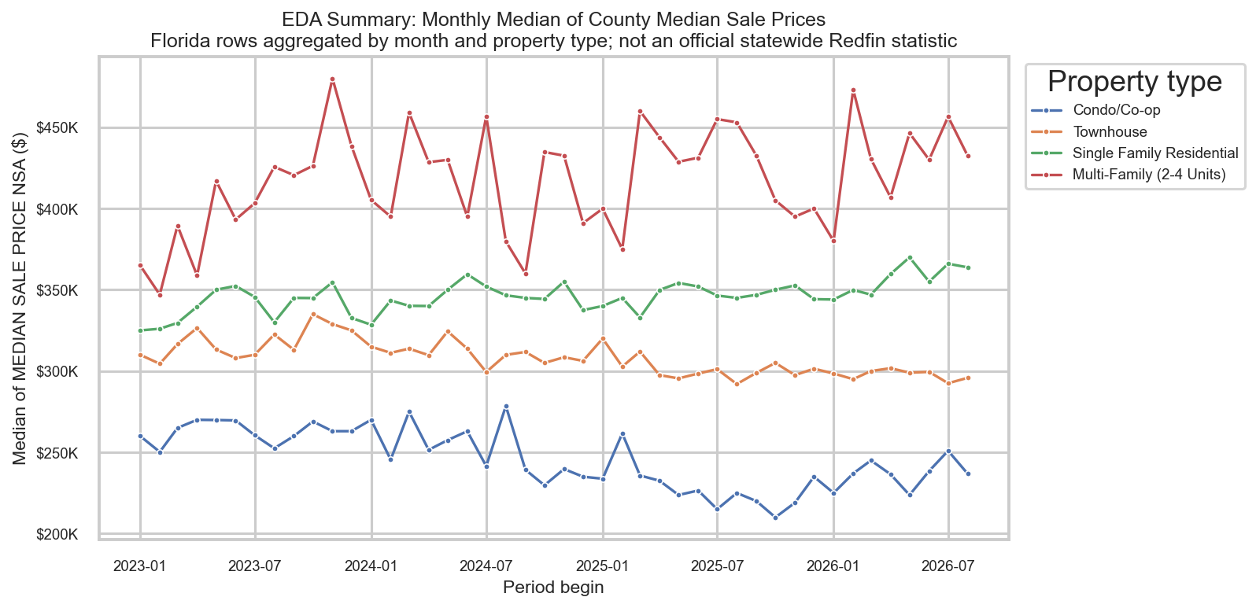
Figure 2. Monthly sale-price trends by property type, January 2023-August 2026.
Baseline Regression Notes
We use a Linear Regression model to predict MEDIAN SALE PRICE which is going to be our target. The predictors were property type, homes sold, inventory, median days on market, months of supply, average sale-to-list ratio, year, month, and metro area. Missing metro values were labeled with Non Metro. I excluded the rows with a missing target or incomplete predictors. The final modeling sample had 8253 rows and used an 80/20 train-test split.Some of the initial metrics for the baseline were MAE = $80,468, and RMSE = $129,071, and an R² of 0.514. It explained about half of the variation in median sale price, but prediction error was still large. The model works better in the middle of the market and the model still underestimates several very expensive observations. There is still a lot to cover but I think it is a good starting point and we will continue working on improvements.
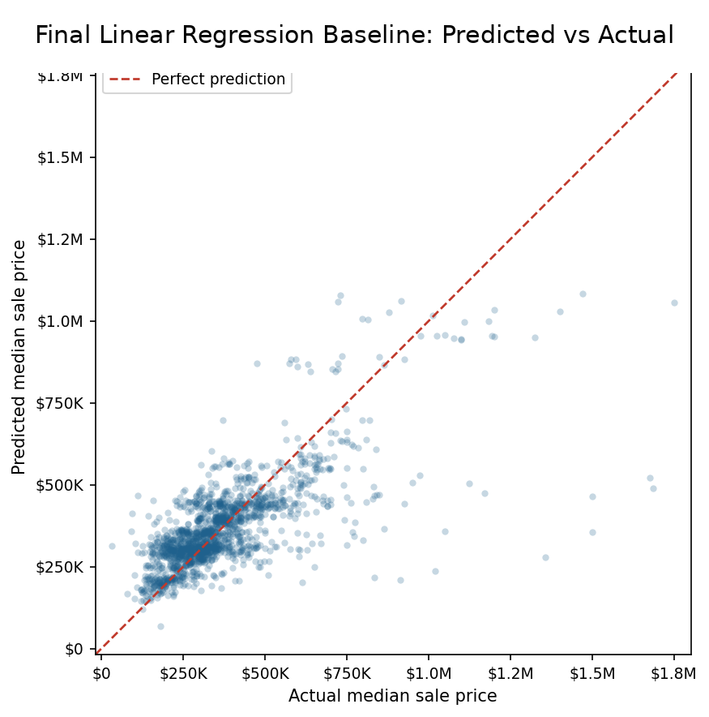
Figure 3. Predicted versus actual median sale price for the Linear Regression baseline.

