Section | Title
1 | Introduction
1.1 | Business Understanding using the BACCM Framework
1.2 | Project Context and Objectives
2 | Insights from Exploratory Data Analysis (EDA)
2.1 | Responses to the Client’s Six Key Questions
2.2 | Additional Insights and Observations
2.3 | Data Quality Review
2.4 | Insights from Clustering Analytics
3 | Proposed Machine Learning Solution
3.1 | Selected Machine Learning Models
3.2 | Model Performance Evaluation
3.3 | Discussion of Pros and Cons
4 | Recommendations and Conclusions
4.1 | Business Application Recommendations
4.2 | Benefits to Stakeholders and Value Proposition
4.3 | Implications for Business Processes and Decision Making
4.4 | Recommendations for Model Improvements
5 | References

Executive Summary
This aims to identify Australian students at risk of numeracy difficulties by analysing Year 1 and 2 literacy and numeracy data from 2,000 students across 40 schools (2016–2020), using Year 3 NAPLAN outcomes to define risk (ACARA, 2020). Logistic regression was selected for its interpretability, achieving 81% accuracy and 70% precision, though recall remained low at 36% (Müller & Guido, 2017). To address this, K-Nearest Neighbours was tested, improving recall to 77% at the cost of reduced precision. Clustering techniques were used to group students by literacy levels to support tailored interventions (Strickland, Woods, & Pavlovic, 2016). Exploratory analysis highlighted key gaps in skills such as Place Value and Addition & Subtraction. We recommend targeted, skill-specific support strategies in schools. Future improvements include incorporating broader data sources, retraining models, testing advanced methods like Random Forest, and refining clusters based on educator input (Wiliam, 2011)
BACCM
Need:
Australian primary schools need effective, early identification of students at risk of numeracy underperformance. Foundational skills built in Years 1 and 2 are critical to later academic success, employability, and wellbeing. Early intervention requires data-driven approaches to detect risk before gaps widen (DESE, 2021).
Solution:
We analysed data from 2,000 students across 40 schools (2016–2020) using exploratory data analysis and predictive models (logistic regression, KNN, clustering). The models assess how Year 1 and 2 literacy and numeracy skills, along with demographic and disability data, relate to Year 3 NAPLAN outcomes (Azodi, Tang, & Shiu, 2020).
Value:
This solution supports early, targeted interventions, enabling schools and policymakers to allocate resources efficiently, improve outcomes for at-risk students, and promote educational equity (Slade, Prinsloo, & Khalil, 2019).
Change:
Stakeholders can shift from reactive to proactive strategies by using predictive insights to guide skill-specific support, refine interventions with feedback, and continuously improve the model.
Stakeholders:
• Data2Intel – Develops and refines analytics tools
• Primary Schools & Teachers – Use model outputs to support students
• Policymakers – Inform funding and programs
Context:
The project uses five years of clean, formative assessment data, aligned with Year 3 NAPLAN results, supporting national goals for early learning intervention (ACARA, 2020).
.

Insights from Exploratory Data Analysis (EDA):
1. Student Demographics:
The group of students is almost evenly split between boys and girls. Most kids started Kindergarten between the ages of 5 and 5 and a half. Around two-thirds of the students have some kind of disability, with about one in four having a cognitive disability. Almost half of the students are either the first or second child in families of small to medium size.
2. Year 1 Numeracy Skills:
In Year 1, students were tested on basic math skills like counting, place value, addition, subtraction, and multiplication. Most students scored in the middle range, but those with very low scores were more likely to be at risk for numeracy difficulties by Year 3.
3. Year 1 Reading Skills:
Reading skills in Year 1 mostly fall between scores of 5 and 15. Interestingly, some students with strong reading skills still struggled with numeracy later on.
4. Literacy and Numeracy Relationship:
There’s a moderate connection between literacy and numeracy skills in Year 1 when it comes to predicting who might be at risk later. But by Year 2, this link becomes weaker as students’ literacy and numeracy abilities start to develop more independently.
5. Disability Conditions:
About 23% of the students have a cognitive disability, and this group is more likely to be at risk for numeracy challenges. Other types of disabilities didn’t show as strong a connection to numeracy risk.

Additional Insights
1.Socio-Economic Status (SES)
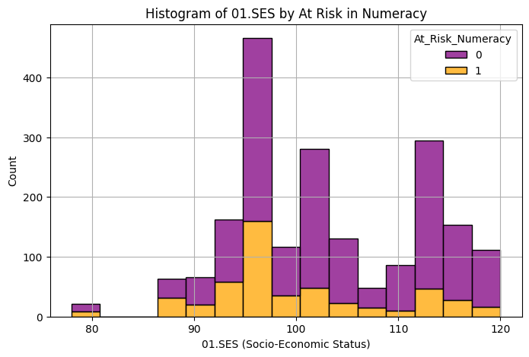
Figure 1
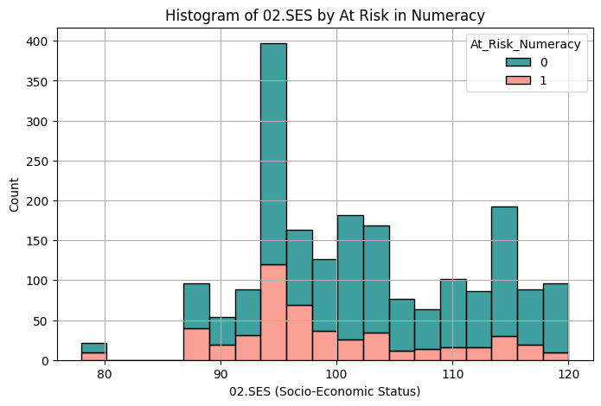
Figure 2

- SES ranges from 90–115, with higher SES linked to lower risk (r ≈ -0.18). However, at-risk students are found at all SES levels..

2. Parent Education & Occupation
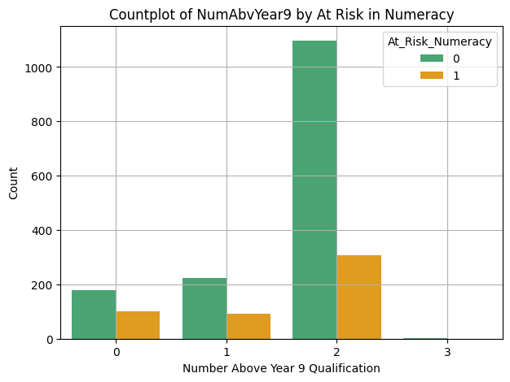
Figure 3
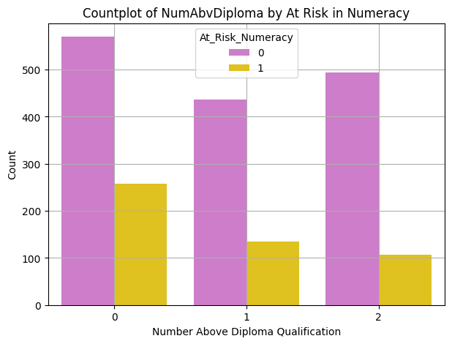
Figure 4
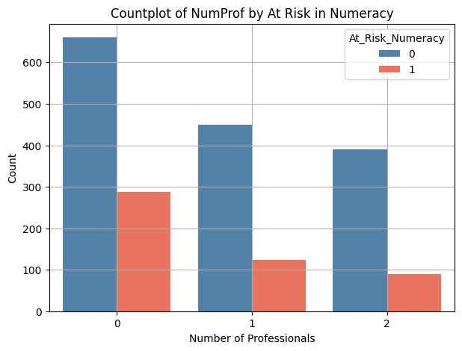
Figure 5
- Most students have parents educated beyond Year 9, but many lack diploma-holding or professional parents. Lower parental education and occupation levels correlate with higher student risk..

3. Family Size & Sibling Order
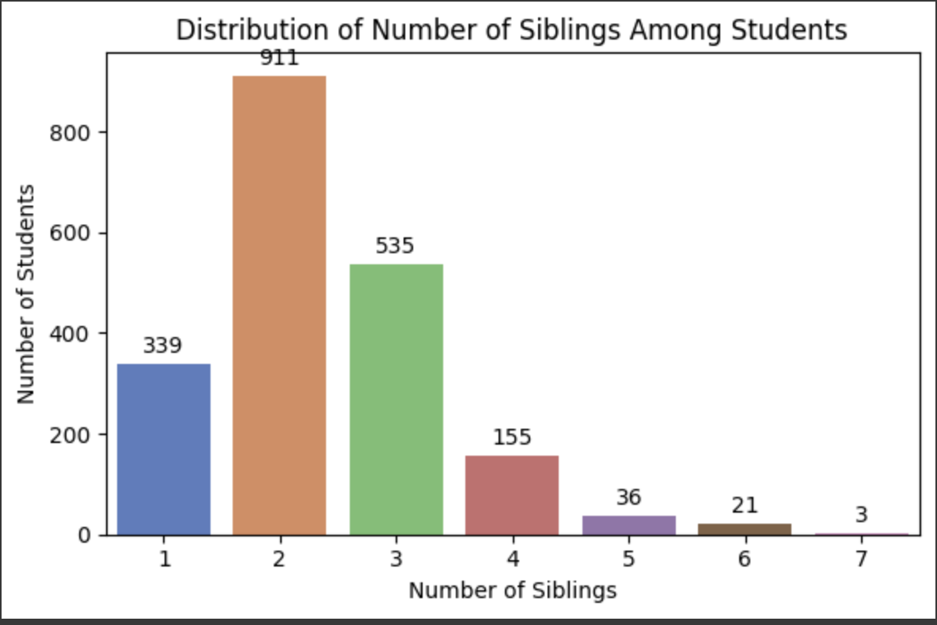
Figure 6
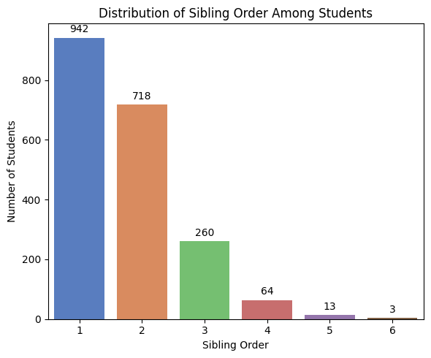
Figure 7
- Most students have 1–3 siblings and are first or second born. Later-born students and large families are less common.

4. NCCD Funding
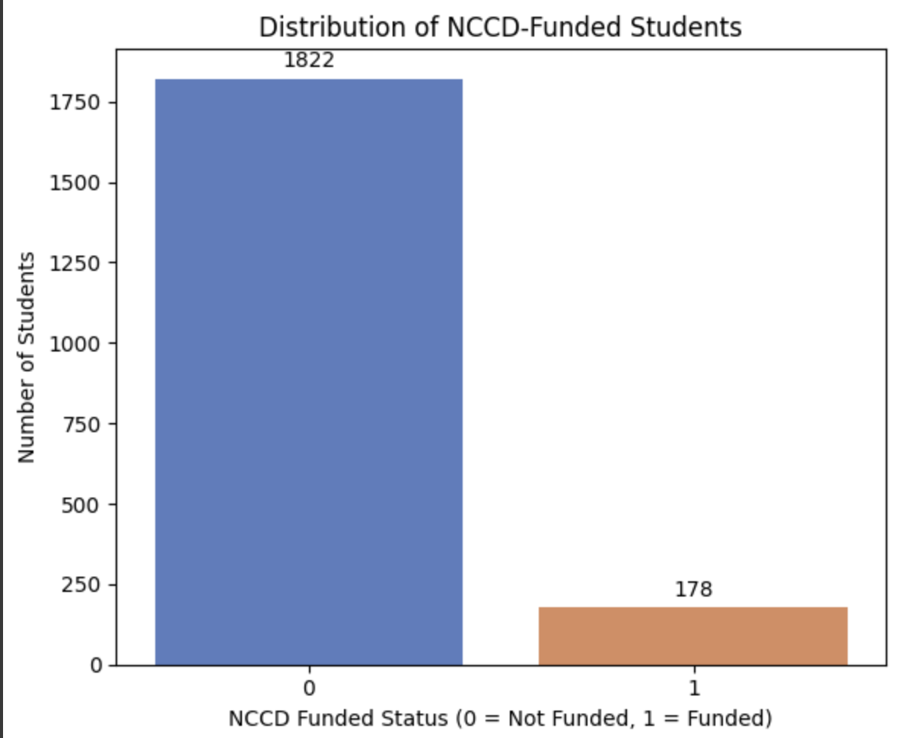
Figure 8
- About 9% of students receive disability funding, with slightly more at-risk students in this group.

5.. Gender
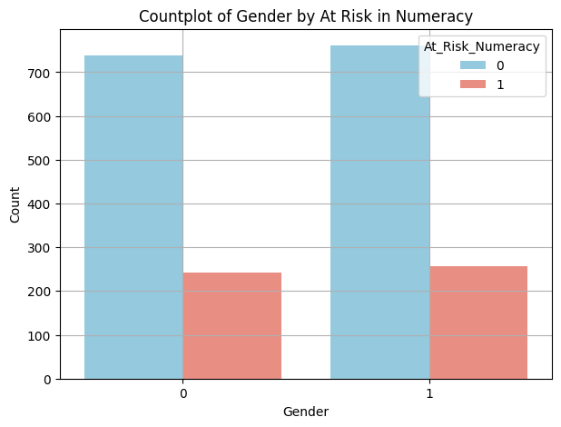
Figure 9
- Male and female students are nearly equal in number and show similar numeracy risk rates..

Proposed Machine Learning Solution
This project used two machine learning methods to identify students at risk of underperforming in numeracy: logistic regression as the main predictive model and clustering as a supportive strategy for targeted intervention planning.

Selected Machine Learning Models
Logistic Regression (Supervised Model):
Chosen for its ability to handle binary classification, logistic regression predicted whether a student is at risk based on their Year 1 and 2 literacy and numeracy assessments.
- Accuracy: 81%
- Precision: 70%
- Recall: 36%
Clustering (Unsupervised Model):
Clustering grouped students based on similar literacy levels and risk indicators, helping identify student segments for more tailored support, even without outcome labels.

Model Interpretation and Discussion
The logistic regression model performed well with 81% accuracy and 70% precision, meaning it’s good at correctly identifying students at risk with few false alarms. However, it missed about 64% of the students who actually needed help, showing room for improvement.
The clustering model grouped students by similar literacy levels, creating clear clusters that help understand different learning needs. Although it doesn’t directly predict risk, it’s useful for tailoring support to different student groups.
Together, these models give a clearer picture: logistic regression predicts who is at risk, and clustering helps customize interventions based on student profiles.
Logistic Regression
Pros:
- Easy to interpret- educators can see which skills drive risk (e.g., Place Value).
- Good precision-reduces false alarms.
- Simple to implement and explain.
Cons:
- Lower recall-misses some at-risk students.
- Assumes straight-line relationships, which may miss complexity.
Clustering
Pros:
- Uncovers learning patterns across students.
- Helps design targeted programs and optimize resource use.
Cons:
- Doesn’t directly predict risk.
- Depends on clustering parameters and interpretation.

Conclusion
Logistic regression offered clear and accurate predictions, while clustering helped interventions by grouping similar students.

Recommendations

- Helping schools focus on key numeracy skills like Place Value and Addition & Subtraction
This means teachers can give extra support exactly where students struggle most, helping more kids succeed early on.
- Using and improving predictive models to spot at-risk students sooner
Data2Intel and schools get smarter tools that catch students who need help earlier, so support can be more personalized and effective.
- Adding more information like family background and attendance to the models
This gives Data2Intel and policymakers a clearer picture, helping them plan better support and funding where it’s really needed.
- Regularly updating the models and getting feedback from teachers
This keeps the tools fresh and reliable, so schools can adapt and improve how they help students over time.
- Helping policymakers make smarter funding decisions based on data
This means resources go to the students and programs that need them most, making education fairer and more efficient.
- Making sure support includes students with cognitive disabilities
Everyone deserves a fair chance, so schools and policymakers can focus on helping vulnerable students get the extra support they need.
Implications for Business
This approach helps schools, Data2Intel, and policymakers move from fixing problems after they happen to spotting students who might struggle early on. Schools will need to collect better data and use it to focus support where it’s needed most, making the best use of their resources.
Data2Intel can improve their models over time by working closely with teachers and updating strategies based on real feedback. Policymakers might change how they fund programs, putting more emphasis on early help.
Process and Decision Changes
Schools may need to improve how they collect and use student data. Decision-making will shift from reacting late to acting early based on data. Funding models might also change to support those most in need.
Model Improvements
- Keep training with new data: Helps improve overall accuracy by capturing recent learning patterns.
- Add more student information (e.g., behaviour, background): Can increase recall and F1 score by better identifying students truly at risk.
- Try advanced algorithms like Random Forest: May boost precision and F1 score by reducing false positives and balancing detection.
- Involve teachers for feedback on groupings and support: Enhances recall and precision by refining clusters and interventions based on real-world insights.
.
References

• ACARA. (2020). National Assessment Program – Literacy and Numeracy (NAPLAN). https://www.nap.edu.au
• Azodi, C. B., Tang, J., & Shiu, S. H. (2020). Opening the black box: Interpretable machine learning for geneticists. Trends in Genetics, 36(6), 442–455. https://www.cell.com/trends/genetics/abstract/S0168-9525(20)30069-X
• DESE. (2021). Australian Early Development Census (AEDC): National Report 2021. https://www.aedc.gov.au/resources/detail/2021-aedc-national-report
• Slade, S., Prinsloo, P., & Khalil, M. (2019). Learning analytics: Ethical issues and dilemmas. American Behavioral Scientist, 64(11), 1510–1529. https://www.researchgate.net/publication/258122968_Learning_Analytics_Ethical_Issues_and_Dilemmas

