**2014 DataONE User Interface Testing: Metadata and Search Views**

**Participants**

* 8 participants
  + Recruited through Member Node Forum, USGS, and Oak Ridge National Laboratory
  + Completed November 11-14 2014
  + 2 participants had no prior knowledge of DataONE, 4 had some/little knowledge of DataONE, and 2 were very familiar with DataONE.
  + The participants were shown a series of mock-ups and asked for first impressions. The proctor then pointed out certain features of the pages.
    - Participants were asked for input on what they liked, what they didn’t like, what they thought was missing, and what they found confusing.

**Metadata View Page**

**Overall Impressions:**

* Participants liked the colors, layout, and design of the metadata page.
* Participants familiar with DataONE really liked how the DataONE member repository was displayed. They thought the dataset was clearly attributed to the correct repository.
* They did not know what the provenance circles were at first, but were able to guess.
  + The left to right alignment helped clarify what the circles represented.
  + The participants thought they would get the hang of the provenance circles after 1-2 visits, and they liked how the provenance was displayed.
  + They thought they looked “hover-able”, and the pop-up was easy to understand and use.
* There was some concern that the provenance circles would get too busy if there were a lot of sources (e.g., census data).
* This is probably a problem with the mock-up but in one place it says two derivations but there are three circles. Want to make sure that the number of circles always matches the wording.
* Overall, participants had no complaints about the variable attributes.
  + They liked the provided definitions, the ability for users to add comments and tags, and they liked the quality control with the flagged incorrect attribute.
* They liked that you could still see the incorrect tags, but they hoped that the incorrect tags would be at the end of the list.

There were some issues which are addressed below.

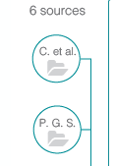

**Issue:** Participants were confused by the letters in the circles. When the circle contained “et al.” it was more obvious that the letters referred to author, but otherwise, participants were confused rather than aided by the letters.

**Recommend:** Remove the authors’ initials from the provenance circles**.**

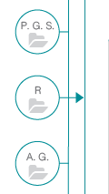

**Issue:** Some participants thought the direct arrow from the “R” circle to the source implied a special association.

**Recommend:** Design the PROV circles so that no circle is directly linked to the displayed data set.

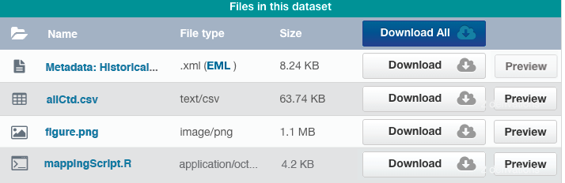

**Issue**: Participants wanted to see the entire name of the file in the dataset.

**Recommend**: Decrease the size of the download and preview buttons to allow for more room to display the file name.

**Search View Page**

**Overall impressions:**

* Participants first thought the page looked busy with the large map, the various color blocks, and the filter and search results. The participants were split on whether they liked the map taking up the entire page.
* Participants thought there were a lot of icons on the page, many of which they were not familiar with; however, they were okay with them if they could be hovered over to provide a description.
  + The crossed-out eye in the left-hand corner was especially confusing to participants.
  + Are icons cross-cultural?
* They liked how the provenance was displayed in the search results.
* They liked how the title was bolded with a different color in the search results.

There were some issues which are addressed below.



**Issue:** The text in the search bar is dark. Participants thought the bar looked more clickable rather than fill-in-the-blank.

**Recommend:** Use the same gray color in the search bar as used in the filter.

**Issue:** The search results page does not show the initial search query.

**Recommend**: Keep the search query shown in the search bar. This may just be the case in the mock-up.

**Issue:** Participants were not sure what the numbers and colors on the maps referred to. Many were able to guess what they did, but they wanted some sort of guide.

**Recommend:** Provide a legend on the map or provide a help menu to aid in participants’ searches.

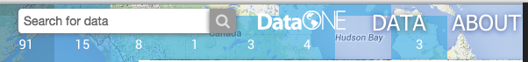

**Issue:** Participants thought the “Data” and “About” links and DataONE logo were hidden/lost on the map.

**Recommend**: Consider redesigning the colors, font, and/or size of the links and DataONE logo to be more prominent on the site.

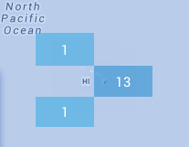

**Issue:** Participants noticed that the colors used to show search results on the map covered parts of the map. For example, the 13 hides Hawaii from view.

**Recommend**: Reconsider how the colors on the map are shown. Decide if the color blocks are more important than what is under the map.

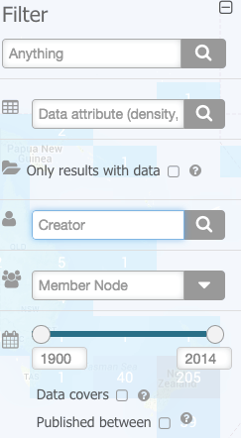

**Issue:** Participants did not like the transparency of the filter. They thought it added to the “busy-ness” of the page.

**Recommend:** Make the filter a solid background.

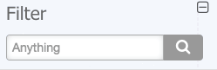

**Issue:** One participant pointed out that in her library they use “anything” to mean the user can search for any field not as a full text search.

**Recommend**: Consider if a different term should be used in the main filter box.

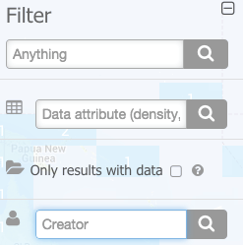 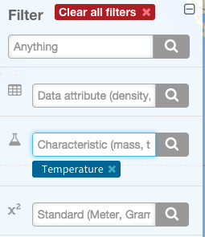

**Issue:** The filter options change after a filter is selected. It is unclear why there is a change. This also causes the selected filter to be displayed below a different filter option than the one used.

**Recommend**: Make sure this is how you wanted to filter to work.



**Issue:** Participants who were not familiar with DataONE did not know what a Member Node was.

**Recommend:** Provide a definition of a Member Node (as a hover-over) on the filter option.

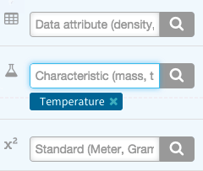

**Issue:** Participants were not familiar with the filter options (standard and characteristic). They thought different disciplines might have different terms. The description in the search fields did not clarify their concerns because the description ran out of space (e.g., Characteristic (mass, t…).

**Recommend:** Add a hover-over to the filter symbol that provides a definition. Change the definition/description in the box so that the entire word is shown.

**Issue/Question**: Participants wanted to know if the filter and search results could be moved around the page. They liked the minimize function, but they also liked the ability to move them around the page to uncover different sections of the map.

**Issue/Question**: Participants wanted to know if they could move the map around by clicking and dragging.