­­



Submitted to

:

Sir.Hasnain

***BS***

***-***

***Software Engineering***

***3***

***rd***

***-***

***E***

Title: Assignment 2

SRE

Hamza Mehmood

Roll# SP-21-110

NUML

-

S21

-

2352

9



**National University of Modern Languages**

Q1.  What is Use Case, Activity Diagram and Sequence Diagram. Explain it with Example, Also Draw their Notations.

* USE CASE:

A use case could be a methodology employed in system analysis to spot, clarify and organize system necessities. the employment case is formed from a collection of potential sequences of interactions between systems and users during a specific surroundings and associated with a specific goal. the strategy creates a document that describes all the steps taken by a user to complete associate activity.

* Activity Diagram:

An activity diagram visually presents a series of actions or flow of management in an exceedingly system just like a multidimensional language or an information flow chart. Activity diagrams are usually utilized in business method modeling. they will additionally describe the steps in an exceedingly use case diagram. Activities sculptural is successive and co-occurring.

* Sequence Diagram:

Sequence Diagrams are interaction diagrams that detail however operations are disbursed. They capture the interaction between objects within the context of a collaboration. Sequence Diagrams are time focus and that they show the order of the interaction visually by victimization the vertical axis of the diagram to represent time what messages are sent and once.

* Example:

We are taking ATM MACHINE as an example, and making its Use Case, Activity Diagram and Sequence Diagram.

USE CASE Notations:

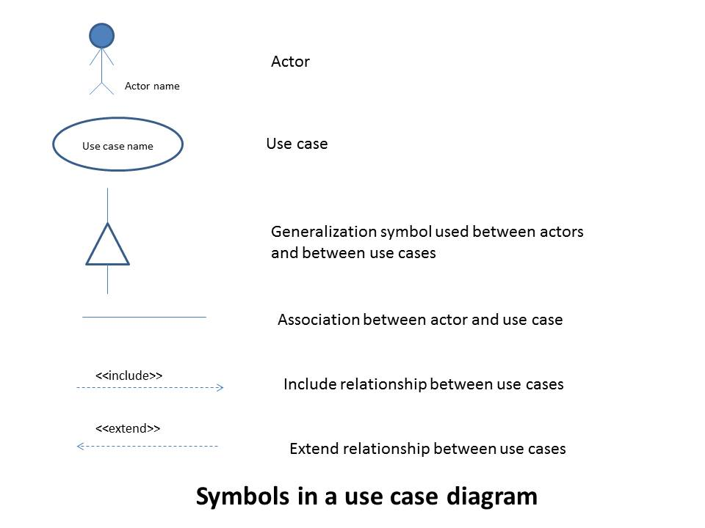

USE CASE DIAGRAM:

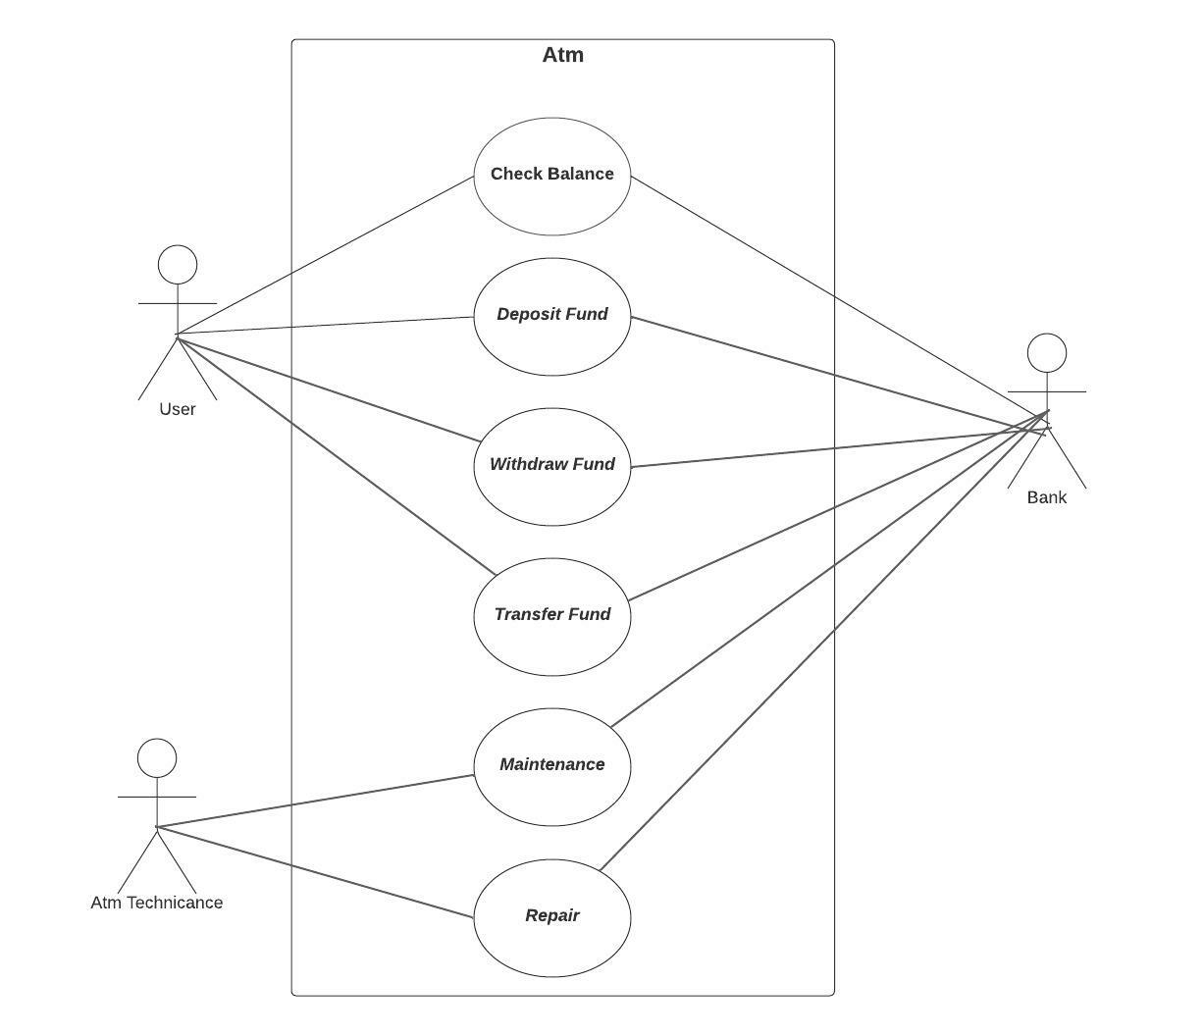

Activity Diagram Notations:

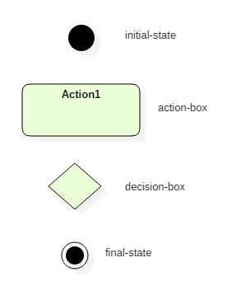

Activity Diagram:

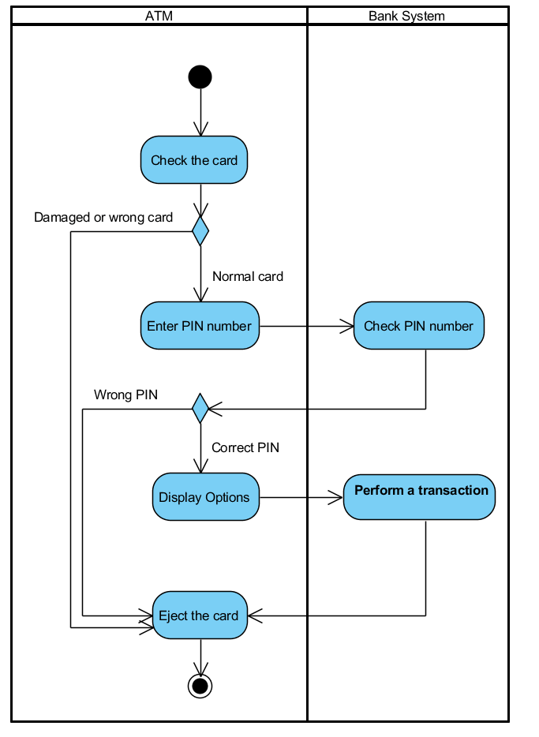

Sequence Diagram Notations:

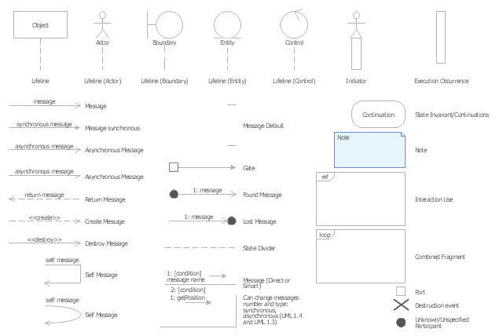

Sequence Diagram:

