

Submitted to

:

Sir Naveed Ahmed

***BS***

***-***

***Software Engineering***

***4***

***th***

***-***

***E***

Title: ASSIGNMENT

OPERATIG SYSTEM

Jibran Naeem

Roll# SP-21-111

NUML

-

S21

-

2539

6



1. **Multiprocessing :**

Multiprocessing is a system that has two or more than one processors. In this, CPUs are added for increasing computing speed of the system. Because of Multiprocessing, there are many processes that are executed simultaneously. Multiprocessing are further classified into two categories: Symmetric Multiprocessing, Asymmetric Multiprocessing.

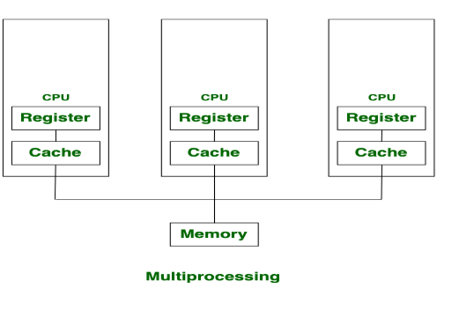

1. **Multi-programming :**

Multi-programming is more than one process running at a time, it increases CPU utilization by organizing jobs (code and data) so that the CPU always has one to execute. The motive is to keep multiple jobs in main memory. If one job gets occupied with Input/output, CPU can be assigned to other job.

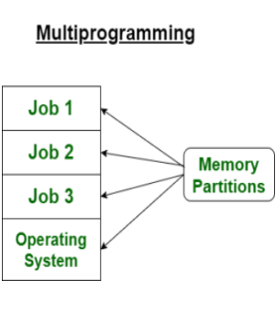

**Difference between Multiprocessing and Multiprogramming :**

|  |  |  |
| --- | --- | --- |
|  | Multiprocessing | Multiprogramming |
| 1. | The availability of more than one processor per system, that can execute several set of instructions in parallel is known as multiprocessing. | The concurrent application of more than one program in the main memory is known as multiprogramming. |
| 2. | The number of CPU is more than one. | The number of CPU is one. |
| 3. | It takes less time for job processing. | It takes more time to process the jobs. |
| 4. | In this, more than one process can be executed at a time. | In this, one process can be executed at a time. |
| 5. | It is economical. | It is economical. |
| 6. | The number of users is can be one or more than one. | The number of users is one at a time. |
| 7. | Throughput is maximum. | Throughput is less. |
| 8. | Its efficiency is maximum. | Its efficiency is Less. |