­­



Submitted to

:

Sir. Naveed Ahmed

***BS-Software Engineering 4th-E***

Title: Assignment 2

OS (Linux)

Hamza Mehmood

Roll# SP-21-110

NUML-S21-23530



National University of Modern Languages

“Differentiate between Multi-Programmed &

Multi-Processor OPERATING SYSTEMS”

1. **Multiprocessing:**

In a uni-processor system, only one process executes at a time. Multiprocessing makes use of two or more CPUs (processors) within a single computer system. The term also refers to the ability of a system to support more than one processor within a single computer system. Since there are multiple processors available, multiple processes can be executed at a time. These multiprocessors share the computer bus, sometimes the clock, memory and peripheral devices also.

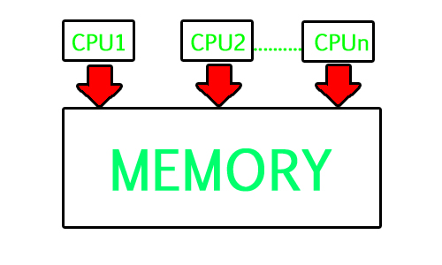

**2.Multiprograming:**

A Multiprogramming Operating System **runs multiple programs on a single processor**. If a program has to wait for an I/O operation, other programs utilize the CPU in the meantime. These operating systems form an important and popular class of operating systems. Some examples are Linux distributions, Windows, IOS, etc.

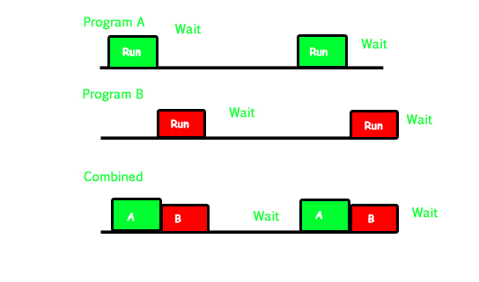

**Difference:**

|  |  |
| --- | --- |
| **Multiprocessing** | **Multiprogramming** |
| Multiprocessing refers to the availability of more than one processor per system that may execute multiple sets of instructions simultaneously. | Multiprogramming is the process of running multiple programs in the main memory at the same time. |
| The processing of jobs takes less time. | The processing of the jobs takes longer. |
| This allows for the simultaneous execution of many processes. | One process can be run at a time in this method. |
| It has several processors to do the work. | Batch OS is used. During execution, the CPU is fully utilized. |
| The efficiency of multiprocessing is maximum. | The efficiency of multiprogramming is minimum. |
| More than one CPU is required. | Only one CPU is required in multiprogramming. |