­­



Submitted to:

Mam Iqra Shahzad

***BS-Software Engineering 5th-E***

Title: Assignment 1

HCI

Hamza Mehmood

Roll# SP-21-110

NUML-S21-23530



National University of Modern Languages

**Question # 01:**

Take any web or mobile application of your choice. Consider two scenarios for storyboarding. Choose an appropriate tool for story boarding. Your response assignment should consist of both scenarios and storyboards that you have created for those scenarios.

**Scenario 1:**

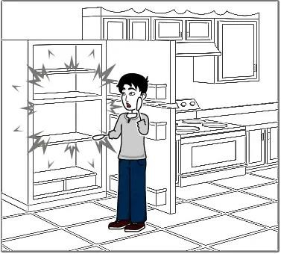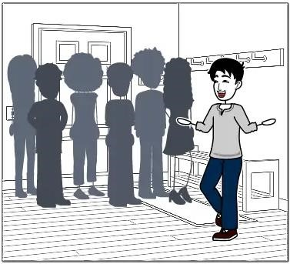

|  |  |  |  |  |
| --- | --- | --- | --- | --- |
| Sara invited her friends and colleagues for a small gathering at his home. |  | | However, as dinner time approaches, Sara realizes that has no food for her guests because she is too busy. | |
|  | | |  | |
| |  | | --- | | Fortunately, Sara remembers that a nearby pizza restaurant offers food delivery services in her area. She also discovered that it has a mobile app with group order feature. | | | |

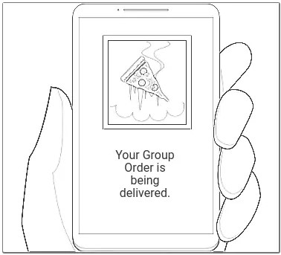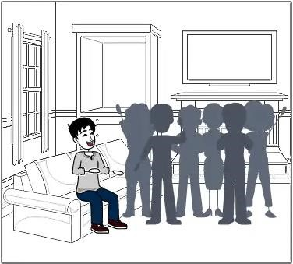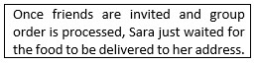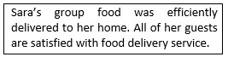

**Scenario 2:**

