­­



Submitted to:

Mam Iqra Shahzad

***BS-Software Engineering 5th-E***

Title: Assignment 2

HCI

Hamza Mehmood

Roll# SP-21-110

NUML-S21-23530



National University of Modern Languages

**Question # 01:**

1. Draw an interface for any social media app or website with at least five screens.

2. Interface for the app should not be already used by that app. these should be new and innovative and according to your perception.

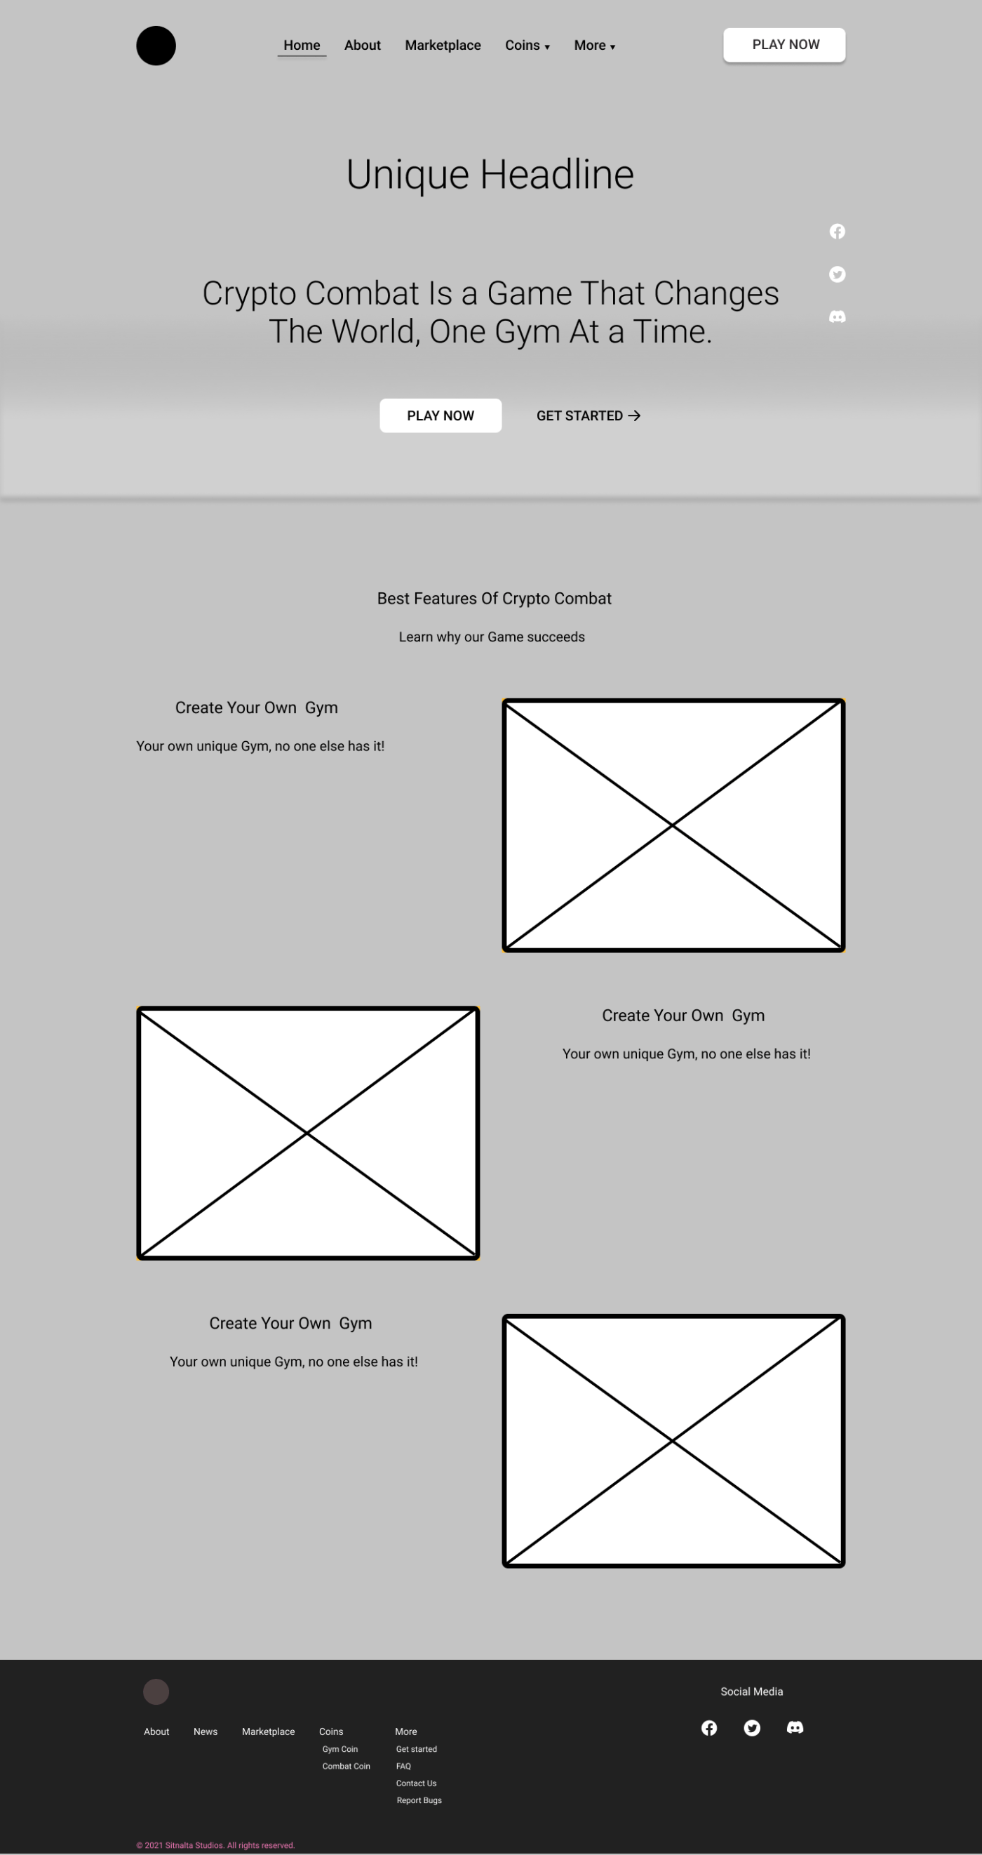

Home Screen



Main Content Container

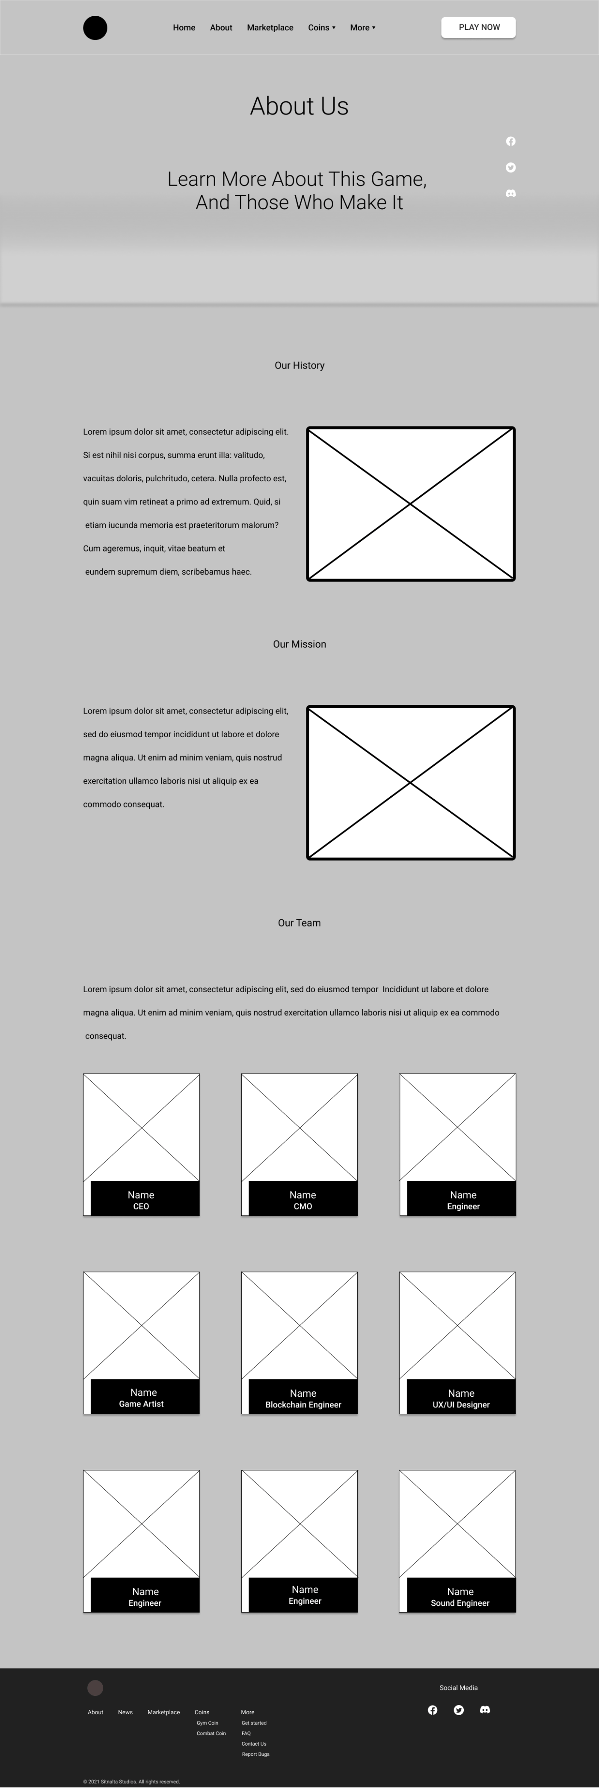

About us



Different Products

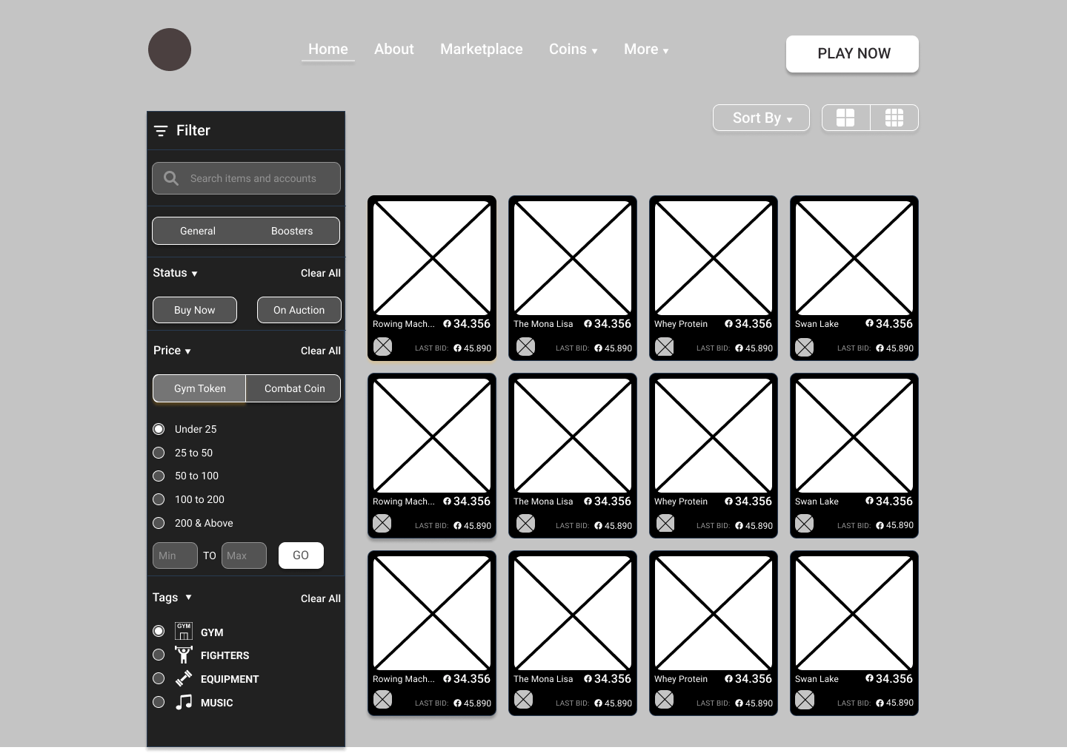

Analytical Dashboard

**Question # 02:**

**Overview:** For this part of assignment, you will be choosing and describing two

products that require human interaction. The goal is to practice describing and

analyzing a product& interface as well as develop an awareness to different kinds of users and to what constitutes good or poor design.

**Choosing your products:**

To complete this assignment, you will need to choose two products: one that you find particularly easy to use and one you find difficult to use. Simple software applications (e.g. calculators, image viewers, text editors or Web sites)

**Describing your products:**

For the product you find easy to use, describe or answer the following (each in a 3 sentences maximum):

1. What is the product?

Ans: **Spotify**

1. What task does the product perform?

Ans: **Music streaming and discovery**

1. Present one way in which this product is easy for you to use

Ans: **Spotify's search functionality allows me to quickly find and play any song or artist I want, with relevant recommendations based on my listening history and playlists.**

1. How would someone else find this product difficult to use?

Ans: **A new user may find it difficult to navigate the app's many features and menus, and may struggle to understand the purpose and function of certain buttons and icons.**

1. How could this difficulty be resolved?

Ans: **Spotify could implement more guided tutorials or onboarding processes to help new users familiarize themselves with the app's features and functions.**

For the product you find difficult to use, describe or answer the following (each in a 3 sentences maximum):

1. What is the product?

Ans: **Adobe Photoshop**

1. What task does the product perform?

Ans: **Image editing and manipulation**

1. Present one way in which this product is difficult for you to use

Ans: **The sheer number of tools and options in Photoshop can be overwhelming and confusing, and it can be difficult to remember the location and function of each tool. The interface can also be cluttered and difficult to navigate, making it hard to find specific functions quickly.**

1. How could this difficulty be resolved?

Ans: **Adobe could streamline the interface and make it more intuitive, grouping related tools and functions together and providing more guidance on their purpose and usage.**

1. How would someone else find this product easy to use?

Ans: **An experienced user may find Photoshop's interface and tools easy to use due to their familiarity with the software, and may appreciate the advanced level of control and customization it offers.**

**With a few sentences, summarize an important difference between the two products that affected your answers.**

One important difference between the two products is the level of complexity in their interfaces and the learning curve required to become proficient in using them. While Spotify's interface is relatively straightforward and easy to navigate, Adobe Photoshop's interface is much more complex and requires a significant investment of time and effort to master.