­­



Submitted to:

Mam Iqra Shahzad

***BS-Software Engineering 5th-E***

Title: Assignment 3

HCI

Hamza Mehmood

Roll# SP-21-110

NUML-S21-23530



National University of Modern Languages

**Question # 01:**

1. What is difference between Fitts Law, KLMs and GOMS Models

**Answer:**

Fitts Law, KLMs, and GOMS models are all frameworks used in human-computer interaction (HCI) to understand and analyze user interactions. Here's a concise overview of the differences between these models:

**1. Fitts Law:** Fitts Law is a mathematical model that predicts the time required for a user to move a pointing device (such as a mouse) to a target on a computer screen. It is based on the size and distance of the target, and the speed and accuracy of the user's movements. Fitts Law helps designers optimize the placement and size of interactive elements for improved user performance.

**2. KLMs (Keystroke-Level Model):** KLMs are a set of predictive models that estimate the time required to perform specific tasks using a keyboard or other input devices. KLMs break down tasks into fundamental operations, such as pressing keys, pointing and clicking, and mental operations. By assigning time values to these operations, KLMs provide designers with a quantitative method to compare and evaluate different interaction techniques.

**3. GOMS (Goals, Operators, Methods, and Selection rules):** GOMS is a cognitive model used to analyze and predict the performance of users in complex tasks. It decomposes tasks into subtasks, and further breaks them down into goals, operators, methods, and selection rules. GOMS models help designers identify potential bottlenecks, streamline user interfaces, and optimize user workflows by understanding the cognitive processes involved in task execution.

**In summary,** Fitts Law focuses on pointing device movement and target selection, KLMs estimate task completion time using keyboard or input device operations, and GOMS models delve into cognitive processes to analyze task performance and inform interface design decisions. Each model serves a distinct purpose in understanding and improving human-computer interaction.

**Question # 02:**

1. Perform a KLM Analysis for the Replacing a “Word” from document. Assuming performer as a good user.

**Answer:**

KLM analysis typically estimates task completion time in seconds.

Here are some of the Operators used for KLM Operations:

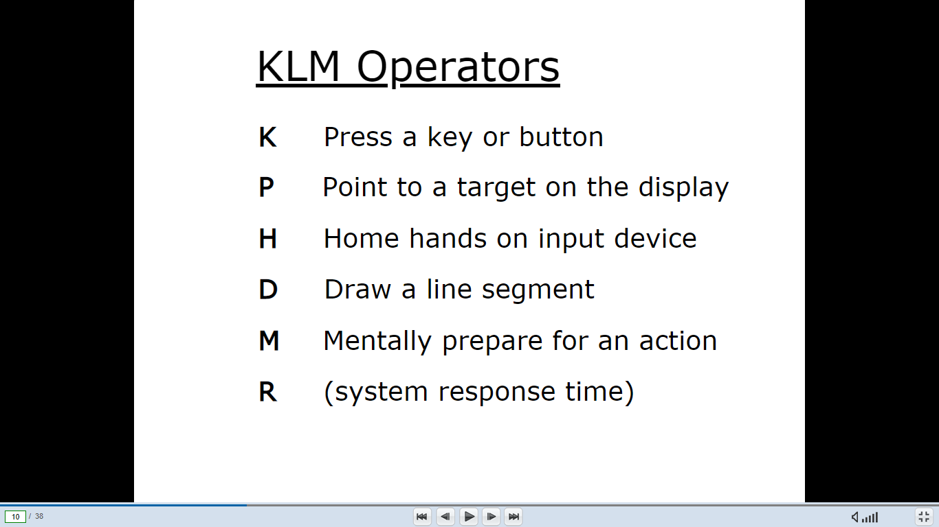

**1. Hitting the "Find" shortcut: (K) - 0.28 seconds:**

This involves pressing the keyboard shortcut (e.g. Ctrl+F) to activate the find functionality in the document editor.

**2. Typing the word to find: (K) - 2.00 seconds:**

The user inputs the word they want to find in the document using the keyboard.

**3. Activating the "Replace" functionality: (K) - 0.28 seconds:**

After finding the word, the user presses the keyboard shortcut (e.g. Ctrl+H) to activate the replace functionality.

**4. Typing the replacement word: (K) - 2.00 seconds:**

The user enters the replacement word using the keyboard.

**5. Initiating the replacement: (P) - 0.10 seconds:**

The user triggers the replacement process by clicking a button (e.g., "Replace" or "Replace All") using the mouse.

**6. Confirming replacement prompts: (P) - 0.10 seconds:**

If prompted, the user clicks on a confirmation button (e.g., "Yes" or "OK") using the mouse.

**7. Completing the task: (P) - 0.10 seconds:**

The user clicks outside the find/replace dialog box or performs any necessary action to close it using the mouse.

**Total Estimated Time:**

**3P+4K** = (3*0.10) + (2*2) + (2*0.28) = **4.86 seconds**