­­



Submitted to:

Mam Iqra Shahzad

***BS-Software Engineering 5th-E***

Title: Assignment 4

HCI

Hamza Mehmood

Roll# SP-21-110

NUML-S21-23530



National University of Modern Languages

**Question # 01:**

What do you think are the future domain of HCI? Write some of Application of HCI in Software Engineering, where HCI can grow its roots.

**Answer:**

The future of HCI is very bright. As technology continues to advance, so too will the ways in which humans interact with computers. Some of the most promising areas for HCI research in the future include:

* **Natural language processing (NLP):**

NLP is the ability of computers to understand and process human language. This technology has the potential to revolutionize the way we interact with computers, making it possible to control devices with our voices and have conversations with them in a natural way.

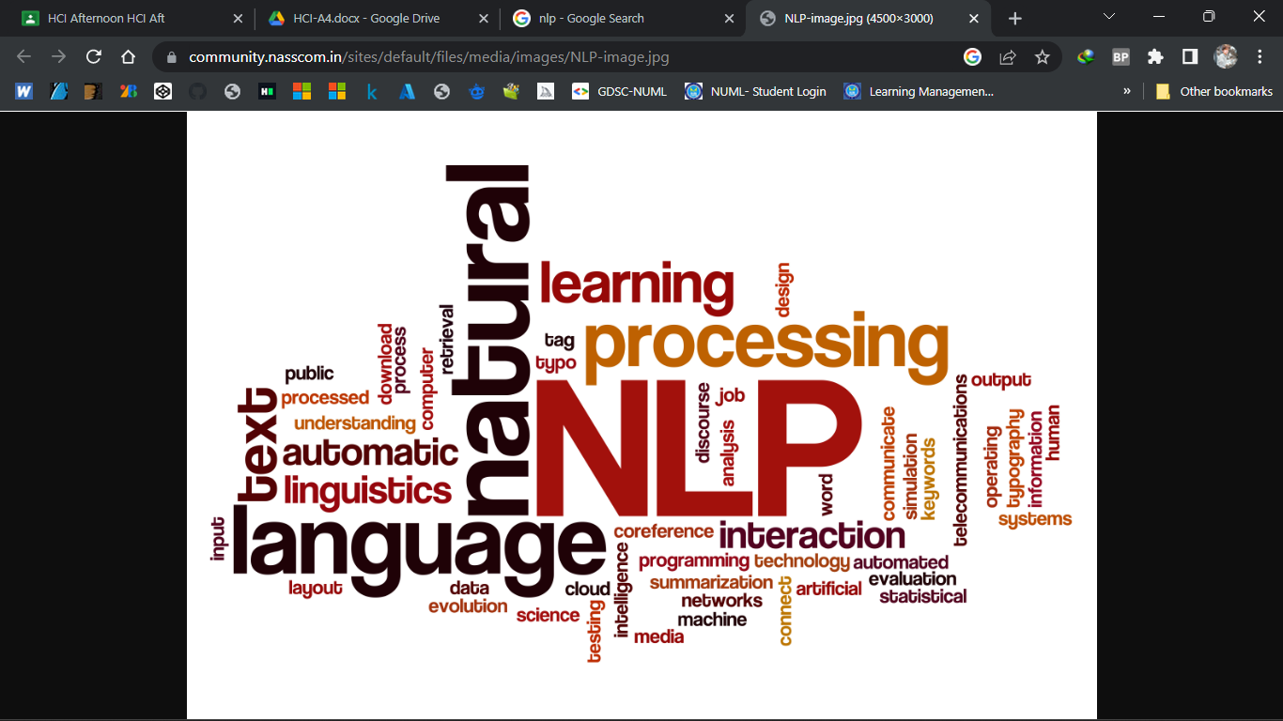

* **Augmented reality (AR):**

AR is a technology that superimposes a computer-generated image on a user's view of the real world. This technology has the potential to make computers more immersive and engaging, and to provide users with information about their surroundings in real time.

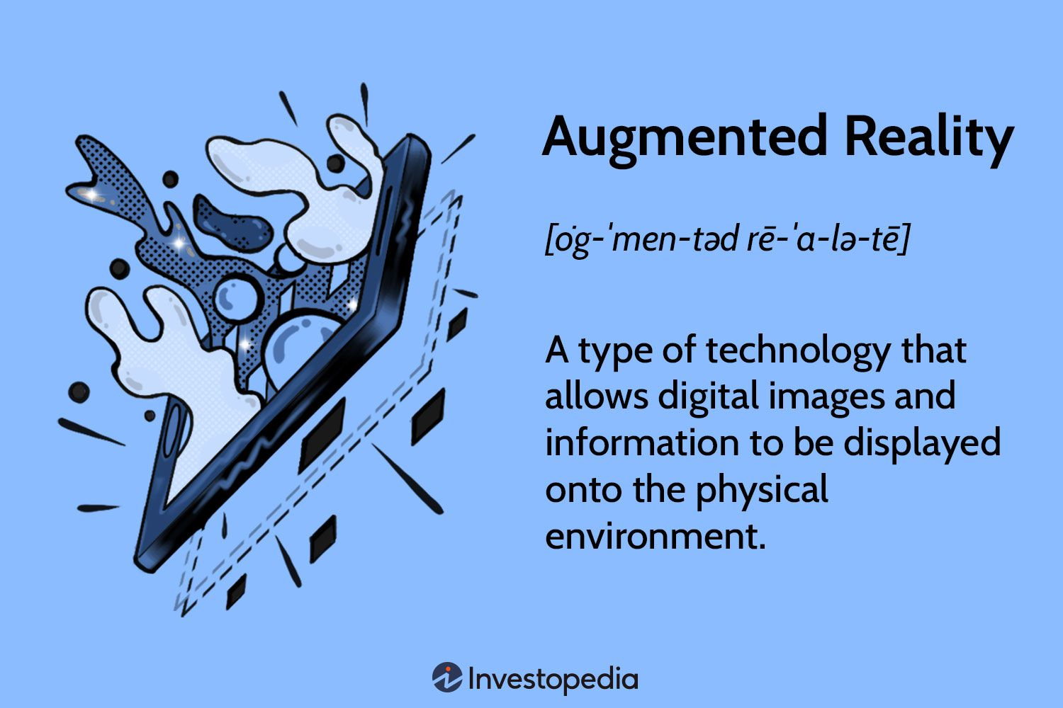

* **Virtual reality (VR):**

VR is a technology that creates a simulated environment that users can interact with. This technology has the potential to provide users with new and exciting experiences, and to train them for real-world tasks.

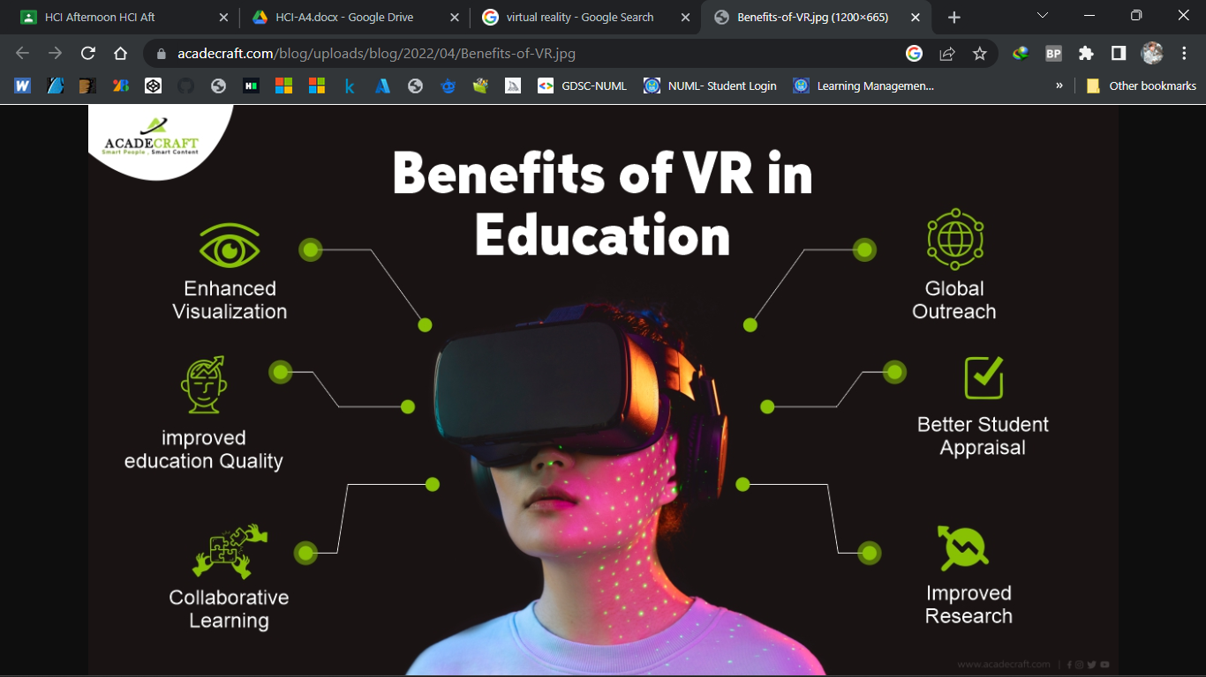

Here are some specific examples of how HCI can be applied in software engineering:

* **User interface design:** HCI experts can help to design user interfaces that are easy to use and understand. They can also help to ensure that user interfaces are accessible to people with disabilities.
* **Usability testing:** HCI experts can help to evaluate the usability of software applications. They can do this by observing users as they interact with the application, and by collecting feedback from users.
* **Accessibility testing:** HCI experts can help to ensure that software applications are accessible to people with disabilities. They can do this by testing the application with users who have a variety of disabilities.