|  |
| --- |
| **National University of Modern Languages Islamabad**  **DEPARTMENT OF SOFTWARE ENGINEERING**  **FACULTY OF ENGINEERING & CS**        **UI/UX Design**  **Final Project**      Name: **Hamza Mehmood**  Roll No: **SP-21-110**  Submitted to: **Mam Sana**  Section: **BSSE-VI (Evening)** |

## **Abstract:**

This Figma design of the Car Rental Mobile Application, likely for “**Hamza Motors**”, is a comprehensive and user-friendly interface that aims to streamline the car rental process. The design is **clean and modern,** with a focus on user **convenience and efficiency.**

The application offers a range of features, including an **ongoing promotion display,** **car filter options by categories, and a list of available cars with images and rental prices**. It also provides a detailed breakdown of costs for selected rentals, **multiple payment options,** and **real-time car tracking.**

The settings menu is **intuitive,** with options for **profile settings,** **location, account details,** and information about the company. The application also prioritizes user security with features like a secure **log out button.**

The design also includes a detailed “**About Us**” section that provides information about the business and its services, as well as a “**Reach Us**” section with contact icons and a map showing the business location.

Overall, the design prioritizes user **convenience, transparency, and security,** making the car rental process straightforward and enjoyable for users. It’s a testament to the potential of well-thought-out UI/UX design in enhancing user experience and satisfaction.

The Car Rental Mobile Application uses a combination of **dark and light themes** for different sections, creating a visually appealing contrast.

The application seems to use a **sans-serif font**, which is known for its modern and clean appearance.

## **Screen 1: Getting Started:**

The following image is a mobile application interface for a car rental service named “**HAMZA MOTORS**”. The design is **sleek and modern**, with a **dark color scheme** accented by **white and red elements**.

The top half of the image features a stylish photo of the front end of a car with its headlights on, casting a blue illumination. This gives the app a premium feel, suggesting that high-end cars might be available for rent.

The company’s name, “**HAMZA MOTORS**”, is prominently displayed in **white and red** text against the dark background, ensuring brand visibility.

A tagline in white text reads: “**Rent your dream car from the Best Company**” indicating the service’s aim to provide high-quality car rental options to its users.

Finally, there’s a red “**Get Started**” button at the bottom. This likely leads users to begin their booking process or learn more about the available cars for rent.

**Screenshot:**

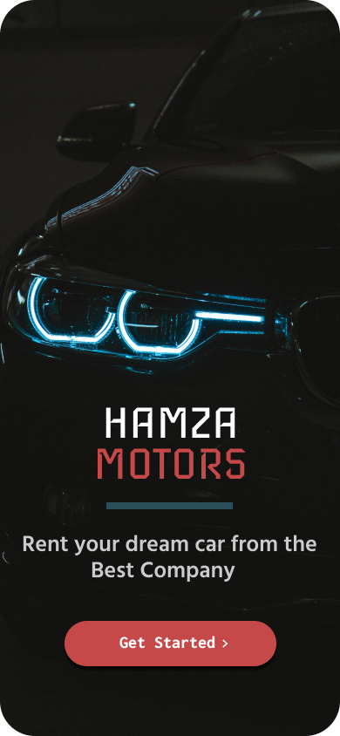

## **Screen 2: Login Screen:**

1. **Sign-In Page**: The main feature of this image is the “Sign In” page of the mobile application. It’s designed to be user-friendly and intuitive.
2. **Email or Phone Input Field**: There’s an input field labeled “EMAIL OR PHONE”. An example email address is already filled in, indicating where users should enter their email or phone number.
3. **Password Input Field**: Below the email or phone field, there’s another input field for the password. An eye icon on the right side of this field allows users to toggle the visibility of their password.
4. **Login Button**: A dark blue “Log In” button is present for users to proceed after entering their credentials.
5. **Alternative Login Options**: The design also includes buttons labeled “Continue with Google” and “Continue with Facebook”. These buttons, each accompanied by the respective company’s logo, offer alternative login options.
6. **Sign-Up Option**: At the bottom of the screen, there’s a text that reads “Don’t Have an account yet?” followed by a yellow “SIGN UP” button. This is for users who are new to the application and need to create an account.

The design is clean and straightforward, making it easy for users to navigate and use the application. It also offers **multiple sign-in options**, catering to the preferences of different users. Overall, it’s a well-designed and user-friendly interface for a Car Rental mobile application.

**Screenshot:**

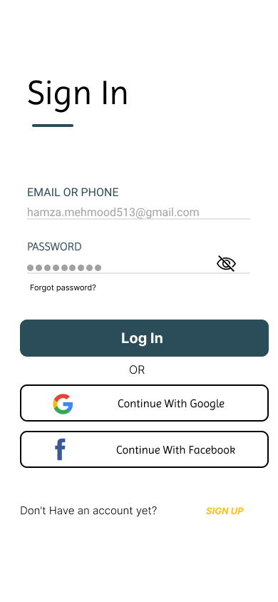

## **Screen 2: Signup Screen:**

1. **Sign-Up Page**: The main feature of this image is the “Sign Up” page of the mobile application. It’s designed to be user-friendly and intuitive.
2. **Full Name Input Field**: There’s an input field labeled “FULL NAME”. An example name, “Hamza Mehmood”, is already filled in, indicating where users should enter their full name.
3. **Email or Phone Input Field**: Below the full name field, there’s another input field labeled “EMAIL OR PHONE”. An example email address is already filled in, indicating where users should enter their email or phone number.
4. **Password Input Field**: There’s a third input field for the password. An eye icon on the right side of this field allows users to toggle the visibility of their password.
5. **Login Button**: A dark blue “Log In” button is present below the input fields. This button is for users who have filled in all the necessary information and are ready to create their account.
6. **Alternative Login Options**: The design also includes buttons labeled “Continue With Google” and “Continue With Facebook”. These buttons, each accompanied by the respective company’s logo, offer alternative login options.
7. **Sign-In Option**: At the bottom of the screen, there’s a text that reads “Have an account already?” followed by a blue text button labeled “SIGN IN”. This is for users who already have an account and need to sign in.

**Screenshot:**

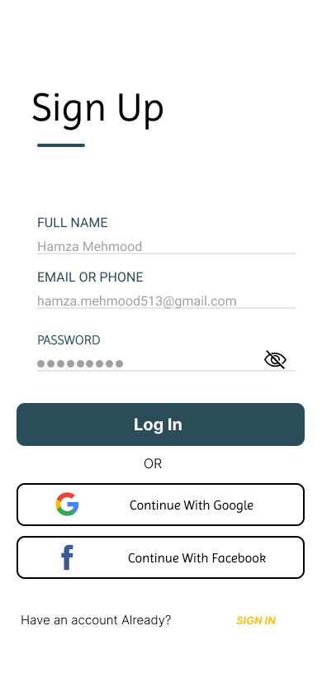

## **Screen 4: Main Dashboard:**

The following image a mobile application interface for car rentals. The design is clean and user-friendly, with various elements that enhance the user experience.

**At the top,** there’s a promotional banner with a black background and white text announcing “**30% Off THIS JULY**”. This is followed by an advertisement that reads “**Travel to the end of the world this whole month cause we care when you are happy.”** with a “**Try Now**” button, suggesting a special offer for the month of July.

Below the banner, there are three category tabs: “**Family Cars**”, “**Cheap Cars**”, and “**Luxury Cars**”. This categorization likely helps users to quickly navigate and find the type of car they’re looking for.

The main section of the interface, titled “**Cars Available near You**”, displays four different car models available for rent, each with an **image, model name, and rental price per day**. The cars listed are a Toyota priced at $300/day, a Lamborghini priced at $550/day, a Range Rover and a Tesla, both priced at $150/day. Each car listing also has a heart icon, indicating that users can like or favorite them.

Finally, there’s a “**View more**” option at the bottom of the car listings, allowing users to explore additional available cars.

**Screenshot:**

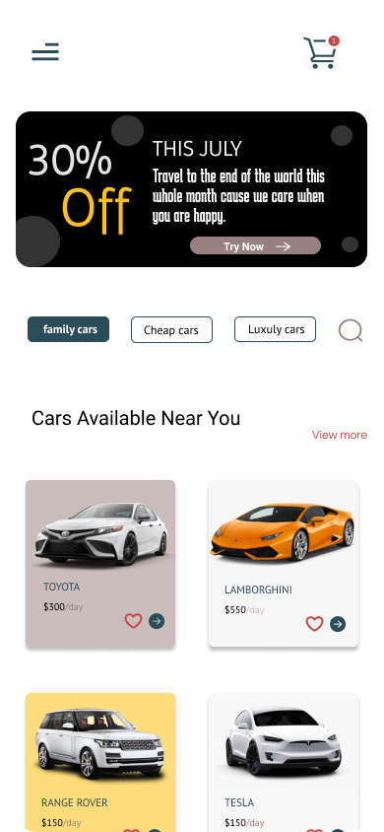

## **Screen 5: My Cart:**

1. **My Cart Page**: The main feature of this design is the “My Cart” page of the mobile application. It’s designed to be user-friendly and intuitive.
2. **Car Listings**: The page lists four different cars: RANGE ROVER, two different models of TOYOTA, and AUDI Red A6. Each car listing includes:
   * **A clear image of the car**
   * **The model name in capital letters**
   * **The rental price per day**
   * **Star ratings indicating customer reviews**
   * **Buttons to increase or decrease quantity**
   * **A ‘Delete’ option to remove it from the cart**
3. **Navigation Option**: At the top, there’s a back arrow on the left corner indicating a navigation option to return to the previous page.
4. **Next Button**: At the bottom right corner, there’s a ‘Next’ button presumably leading to the next step in the rental process.

**Screenshot:**

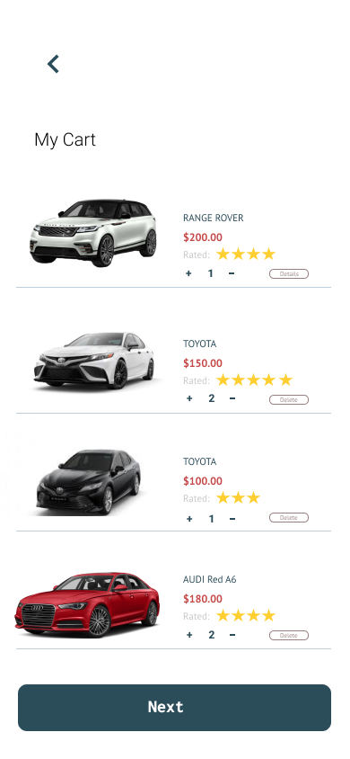

## **Screen 6: Rent Details:**

The following image is a interface for car rental. It displays the **selection and booking process** for a Rental Car.

At the **top** of the screen, there are **navigation icons**; an arrow pointing left and a shopping cart. Below that, there’s text indicating that a vehicle has been “**Selected**” and “**Needs a driver**”, with a toggle switch next to this text.

The selected vehicle, a white Range Rover, is **prominently displayed** along with its rental price ($200.00) and a 5-star rating.

Below the car’s image, details about the selection are listed:

* **Selected: 1**
* **Days: 3**
* **Price: $600**
* **Drivers Fee: $50**
* **Total: $650**

This indicates that the user has selected the Range Rover for 3 days, and the total cost, including the driver’s fee, amounts to $650.

The location for pick-up or drop-off is specified as “**1-14/3 Islamabad**”. At the bottom, there’s a “**Confirm**” button, allowing users to finalize their booking.

**Screenshot:**

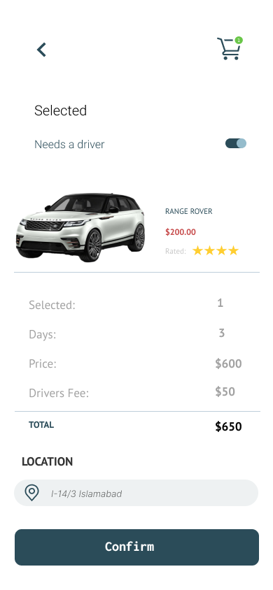

## **Screen 7: Payment Method:**

The following image is a design of a mobile application’s “**Payment Methods**” interface for a Car Rental service.

1. **Payment Methods Page**: The main feature of this image is the “**Payment Methods**” page of the mobile application. It’s designed to be user-friendly and intuitive.
2. **Payment Options**: The page displays three payment method icons: MTN Mobile Money, MasterCard, and PayPal. These options provide users with a variety of ways to make payments.
3. **Input Fields**: Below the payment methods, there are fields for entering the “**OUR CODE**”, “Sim Name”, and “Phone Number”. Example entries are shown in these fields, indicating where users should enter their information.
4. **Remember Info Toggle**: There’s a toggle switch labeled “**Remember This Info**” that is turned on. This feature allows the application to remember the user’s information for future transactions.
5. **Pay Button**: At the bottom of the screen, there’s a prominent “**Pay” button**. This button is for users who have filled in all the necessary information and are ready to proceed with the payment.

**Screenshot:**

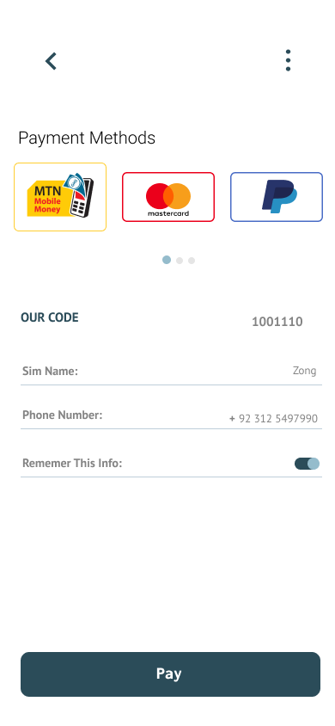

## **Screen 8: Payment Details:**

The following image is a design of a mobile application’s “**Credit Card Payment**” interface for a Car Rental service.

1. **Credit Card Payment Page**: The main feature of this image is the “Credit Card Payment” page of the mobile application. It’s designed to be user-friendly and intuitive.
2. **Credit Card Visual Representation**: At the top half of the interface, there’s a visual representation of a credit card with placeholders for card numbers, expiration date, and cardholder name. This visual aid helps users understand where to input their information.
3. **Input Fields**: Below the visual representation, there are fields for entering the “Card Number,” “Expiration Date,” and “CCV”. Example entries are shown in these fields, indicating where users should enter their information.
4. **Remember Info Toggle**: There’s a toggle switch labeled “Remember This Info” that is turned on. This feature allows the application to remember the user’s information for future transactions.
5. **Pay Button**: At the bottom of the screen, there’s a prominent “Pay” button. This button is for users who have filled in all the necessary information and are ready to proceed with the payment.

**Screenshot:**

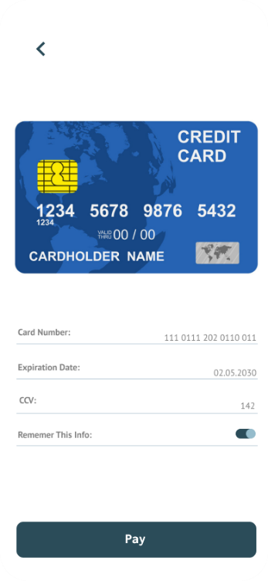

## **Screen 9: Final Review:**

The following image is a design of a **payment confirmation interface** for a Car Rental Mobile Application. It displays the final step of the car rental process, where the user is prompted to confirm the payment.

At the top left corner, there’s an arrow pointing to the left, indicating a back button. In the center top part of the screen, there is an icon representing a shopping cart, likely indicating the user’s selected items or services.

Below this icon, there’s text informing that “You are going to pay the rental fee for Range Rover 0v”. This suggests that the user has chosen to rent a Range Rover model.

A breakdown of costs is provided next:

* **Price: $600**
* **Driver’s Fee: $50**
* **Total: $650**

This indicates that the rental price for the Range Rover is $600, and with the addition of the driver’s fee of $50, the total payment due is $650.

Finally, at the bottom of the screen, there are two buttons: “**Cancel**” and “**Confirm**”. The “**Cancel**” button is outlined, while the “**Confirm**” button is solid, drawing the user’s attention and prompting them to finalize the transaction.

**Screenshot:**

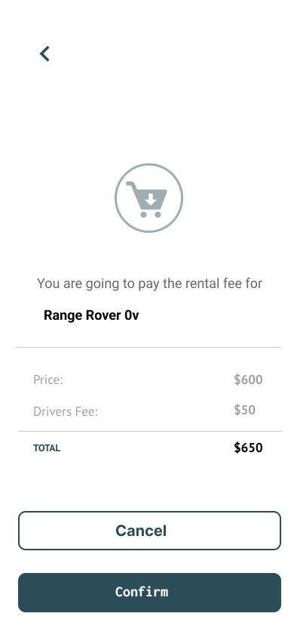

## **Screen 10: Payment Done:**

The following image is a design of a mobile application’s “**Payment Confirmation**” interface for a Car Rental service.

1. **Payment Confirmation Page**: The main feature of this image is the “Payment Confirmation” page of the mobile application. It’s designed to be user-friendly and intuitive.
2. **Successful Payment Icon**: Centrally positioned on the screen is a green circle containing an icon of a shopping cart with a check mark, symbolizing successful payment.
3. **Thank You Message**: Below this icon, “Thank You” is written in bold letters, acknowledging receipt of payment.
4. **Payment Information**: Further below, “PAYMENT MADE $650” indicates that a transaction of 650 dollars has occurred.
5. **Confirmation Message**: A message “Well done your payment is Successfully done and your car is on its way.” informs users that their transaction was successful and updates them on the status of their rented car.
6. **Track and Go Back Buttons**: There are two buttons at the bottom; “Track”, which likely allows users to track their rented car’s location in real-time, and “Go Back”, allowing navigation back to previous app pages.

**Screenshot:**

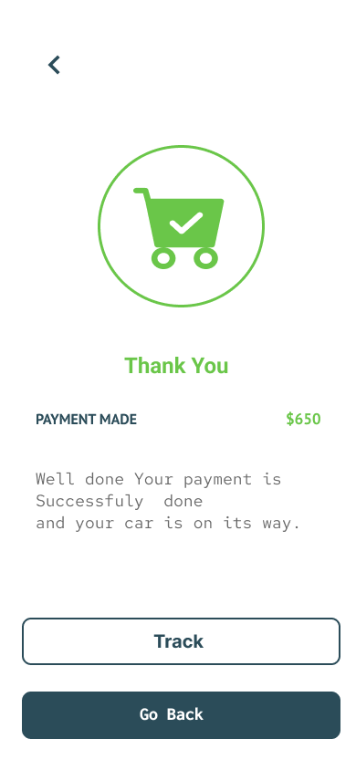

## **Screen 11: Payment Done:**

The following image is a design of a mobile application’s “**Car Tracking**” interface for a Car Rental service.

1. **Car Tracking Page**: The main feature of this image is the “Car Tracking” page of the mobile application. It’s designed to be user-friendly and intuitive.
2. **Map and Route**: The main focus is on a map that shows roads and green spaces. A red line indicates the path from a starting point, marked with a green dot labeled “Driver”, to an ending point marked with a red pin.
3. **Driver Information**: On the bottom left, there’s information about the driver named “**Ahad Ali”** with a call icon next to it for direct communication.
4. **Remaining Time**: Next to the driver’s information, there’s an indicator showing “Remaining Minutes” as 12 minutes and 42 seconds for arrival or completion of the journey.
5. **Location Details**: Below these details, there’s an address “Kurri Road, Rawalpindi” indicating either pick up or drop off location.

**Screenshot:**

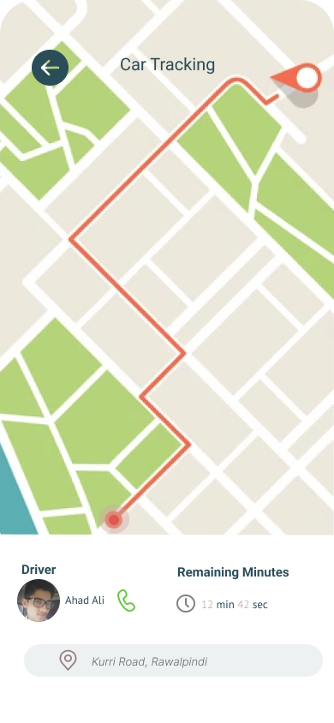

## **Screen 12: My Profile:**

The following image is a design of a user interface design for a Car Rental Mobile Application.

At the top of the screen, there’s a back arrow on the left corner for navigation. A circular profile picture is displayed at the top center; however, the face is pixelated to maintain privacy.

Below the profile picture, “Hamza Mehmood” is written in white text, indicating the username. This suggests that the application provides a personalized experience for the user.

There are five menu options listed vertically: “My Profile,” “Settings,” “Notification,” “My Cart,” and “Track Car.” Each option has an associated icon to its left and an arrow to its right, indicating that these are clickable and will lead the user to different sections of the application.

Finally, at the bottom of the interface, there’s a “Log Out” button in blue text against a lighter background for visibility. This allows users to securely log out of their account when needed.

**Screenshot:**

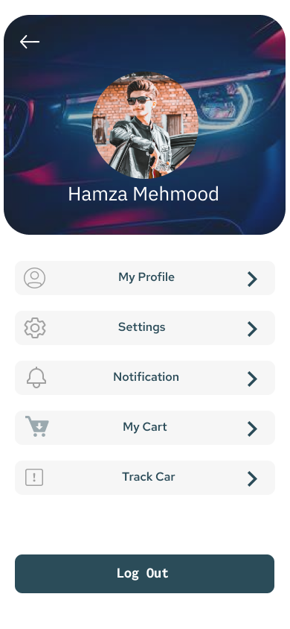

## **Screen 13: Edit Profile:**

The following image is design of a mobile application’s “**Edit Profile**” interface for a Car Rental service.

1. **Edit Profile Page**: The main feature of this image is the “Edit Profile” page of the mobile application. It’s designed to be user-friendly and intuitive.
2. **User Information Fields**: The page displays various fields for entering personal information, including “Full Name,” “Email,” “Phone number,” “Birth Day,” and an unlabeled field likely for gender selection. Each field is accompanied by an edit icon to allow users to make changes.
3. **Sample Data**: Each field contains sample data: a name, an email address, a phone number, a birth date, and the word “Male.” This indicates where users should enter their information.
4. **Save Changes Button**: At the bottom of all these fields is a “Save Changes” button in bold letters. This button is for users who have made changes to their information and are ready to save them.
5. **Navigation Option**: The top left corner has a back arrow for navigation, indicating that users can return to the previous page.

**Screenshot:**

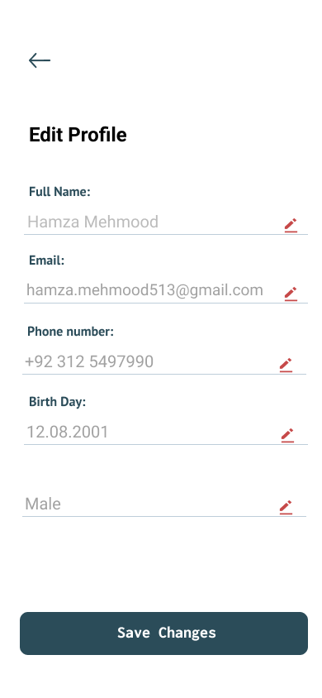

## **Screen 14: Settings:**

The following image of the **settings menu** from a Car Rental Mobile Application. The design is clean and minimalist, with a white background that enhances readability.

At the top of the screen, there’s a back arrow on the left corner, indicating that users can return to the previous screen. The word “Settings” is prominently displayed at the top, indicating the page’s purpose.

Below “Settings,” there are four options listed: “Profile Settings,” “Location,” “Account,” and “About Us.” Each option is written in black text with an arrow on the right side, suggesting that users can tap on these options to access more information or make changes.

**Screenshot:**

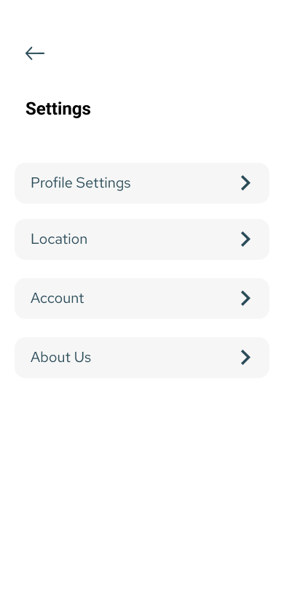

## **Screen 15: Notifications:**

The following image is a design of a mobile application’s “**Notifications**” interface for a Car Rental service. Here’s a detailed description:

1. **Notifications Page**: The main feature of this image is the “Notifications” page of the mobile application. It’s designed to be user-friendly and intuitive.
2. **Notification Messages**: The page displays seven notification messages in individual white boxes against a grey background. Each notification has an associated icon on the left side indicating the type or category of the message.
3. **Star Symbol**: A star symbol appears next to each message indicating that it can be marked as important or highlighted.
4. **Types of Notifications**: The notifications include messages about payment confirmation, promotions, and alerts about downtown areas, Independence Day wishes, and discount offers. Each message includes a brief description and timestamp showing when it was received.
5. **Navigation Icons**: The top bar contains navigation icons for going back and accessing settings or options.

**Screenshot:**

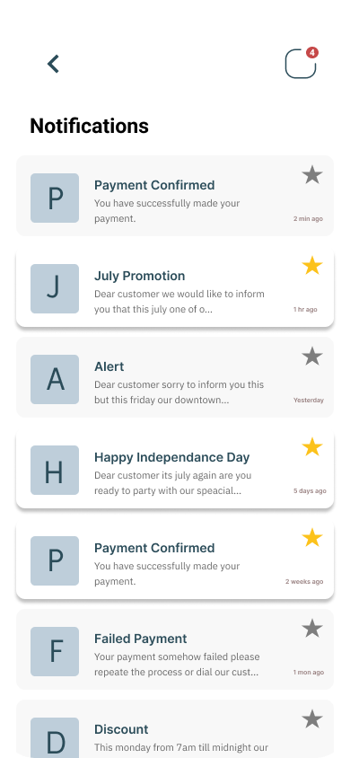

## **Screen 16: About Us:**

The following image is a design of the “**About Us**” and “**Reach Us**” sections of a Car Rental Mobile Application, likely for “Hamza Motors” based in Punjab, Pakistan.

In the “About Us” section at the top, there’s a brief description of the business and its services. It mentions that Hamza Motors is a locally owned and operated business that prides itself on delivering top-notch car rental services to its customers. A “Read More” option is available for users to expand and read more about the company.

Below this section, there’s a “Reach Us” header followed by three contact icons for phone call, mail, and WhatsApp respectively. This suggests that the application provides multiple ways for users to get in touch with the business.

A detailed map is displayed under these icons showing streets named Jans Marg and Canyon Islamabad with various colored blocks representing different areas or buildings. This could be indicating the location of the business or the areas it serves.

**Screenshot:**

