****

**National University of Modern Languages**

Department of Management Science

**Subject:** Management information system **Instructor:** Mam Sobia

**Final project :** CRM, ERP **Due Date:** 12-05-2022

**Class:** BSAF 4B (MOR)

**Students Roll No:AF-1410,AF-1359** **Students Name: MAAZ MEHMOOD,TAHIR MEHMOOD**

**INTRODUCTION**

so we will discuss in this report our project that is about the survey the any organization which they are use what kind of software and take information in the following (CRM,ERP,SCM.KMS)

CRM=Customer Relation Management System

ERP=Enterprise Resource planning

SCM=Supply Chain Management

KMS=Knowledge Management System

**VISITING SITUATION**

Our group visit many organization but nobody give us a proper data and information so at the last we have one last option that **TCS warehouse** that is situated in the Islamabad and meet the manager **(SHAHRUKH AFTAB)** such a

Nice person he was tell and guide us properly and give data which we needed

He told us **(CRM,ERP)** how we engage customer how customer login portal how we satisfied our customer also telling the competitors steps

So we will discuss in detail in next page about the introduction of TCS about their software and also discuss their input and output

**INTRODUCTION OF TCS**

**Tata Consultancy Services** (**TCS**) is an Indian [multinational](https://en.wikipedia.org/wiki/Multinational_corporation) [information technology](https://en.wikipedia.org/wiki/Information_technology) (IT) services and [consulting](https://en.wikipedia.org/wiki/Consulting) company headquartered in [Mumbai](https://en.wikipedia.org/wiki/Mumbai). It is a part of the [Tata Group](https://en.wikipedia.org/wiki/Tata_Group) and operates in 149 locations across 46 countries. TCS is the second largest [Indian company](https://en.wikipedia.org/wiki/List_of_companies_of_India) by market capitalisation and is among the most valuable IT services brands worldwide

 In 2015

KEY AA ACHIEVMENTS :

• Won Best practice Award under ‘Employability’ at the Tata Affirmative Action Programme 2011

• TCS BPO annexed Asian Leadership Award in CSR category in Dubai 2011

• Recognized as Benchmark AA Process in the Employability sector amongst TATA companies in 2011

• Social Change Agent Award at the National Awards in IT Excellence 2012, & BPO Excellence Awards 2012 hosted by the Stars of the Industry Group

• Received special commendation in the 2012 Asian Human Capital Award from the Singapore Ministry of Manpower and Human Capital Leadership Institute (HCLI).

• Selected by Govt of India as Partner for Project UDAAN to train youth of J&K

• Selected as Best Practice from India to be showcased in World Business Capability Congress in Auckland in Dec 2012.

**Enterprise Resource planning**

**ERP:** Enterprise resource planning (ERP) is a process used by companies to manage and integrate the important parts of their businesses. Many ERP software applications are important to companies because they help them implement resource planning by integrating all of the processes needed to run their companies with a single system. An ERP software system can also integrate planning, purchasing inventory, sales, marketing, finance, human resources, and more.

TCS use many software throughout the world but in Pakistan its most probably use **ENVIO**

What is envio, how use it and how they work we will discuss

**ENVIO:** Tata Consultancy Services (TCS) ERP on ENVIO Platform is a pre-built, hosted enterprise application powered by Tier 1 ERP systems to help fill functional gaps, improve business processes, and enable efficient global business services. The platform is offered through Software-as-a-Service (SaaS) and Business-Process-as-a-Service (BPaaS) models,

HOW TO LOGIN:

* **Step 1.**Go to page via official link below.
* **Step 2.**Login using your username and password. Login screen appears upon successful login.
* **Step 3.**If you still can't access then see [Troublshooting options here](https://trustsu.com/troubleshoot).

**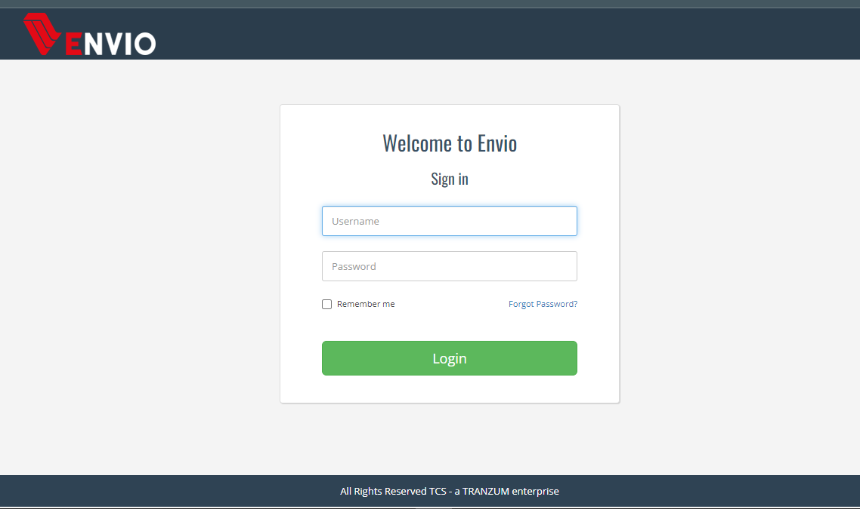**

**If you are having trouble logging into your account, please follow these steps below.**

* **Step 1 –**To login to your Tcs cod login account, open this guide in a new window. You'll be able to follow along with the steps while seeing them!
* **Step 2 –**Log in by entering your login details for Tcs cod login. This information will be given to you either upon sign up or from an authorized representative of the website.
* **Step 3 –**After receiving a "successfully logged in" message, you are officially connected with Tcs cod login!
* **Step 4 –**[Tcs cod login](http://webapp.tcscourier.com/COD/" \t "_blank) may have trouble accepting your login credentials. We recommend following these step-by-step instructions to help solve this issue.

**Customer Relation Management System**

**CRM:** CRM stands for [Customer Relationship Management](https://www.salesforce.com/crm/what-is-crm/), and it’s a technology for managing and supporting customer relationships.

A CRM system allows businesses to manage customer and prospect relationships with data. You can store, track, and analyze customer and prospect information in one central location, including:

* Contact info
* Accounts
* Leads
* Sales opportunities
* Service inquiries
* Marketing campaigns