­­



Submitted to

:

Sir Mohsin

***BS***

***-***

***Software Engineering***

***3***

***rd***

***-***

***E***

Title: Assignment 3

DSA

Hamza Mehmood

Roll# SP-21-110

NUML

-

S21

-

2352

9



**National University of Modern Languages**

DATA STRUCTURES & ALGORITHMS

**Note: You are going to make a system to store data of students for DSA course. Implement a linked list that should have the ability to save the data of N number of students.**

**1. Store the data according to your choice. (Insert at Head/ Tail etc)**

**2. Your System should provide additional features like Display the Name of Student having Minimum and Maximum score in DSA course.**

**3. Display the linked List in reverse order.**

#include<iostream>

using namespace std;

class Node

{

    public:

    string Name;

    double Score;

    int Roll;

    Node* next;

    Node(string nam, double s, int r, Node* n=0)

    {

        Name=nam;

        Score=s;

        Roll=r;

        next=n;

    }

};

class LinkedList{

    public:

    Node* Head,* Current,* temp, *index=NULL;

        LinkedList()

        {

            Head=NULL;

        };

void SortedRoll(string name,double score,int roll)

    {

        Current = Head;

        if(Head == NULL || Head->Roll > roll)

        {

            Current = new Node(name,score,roll);

            Current->next = Head;

            Head = Current;

            return;

        }

        while( Current->next != NULL && Current->next->Roll < roll )

        {

            Current = Current->next;

        }

        temp = new Node(name,score,roll);

        temp->next =  Current->next;

        Current->next = temp;

    }

void minScore()

    {

        Current=Head;

        double min = Current->Score;

        string name = Current->Name;

        while(Current!=NULL)

        {

            if(min>Current->Score)

            {

                min=Current->Score;

                name=Current->Name;

            }

            Current=Current->next;

        }

            cout<<"\n"<<name<<" Have Minimum Score "<<min<<" in DSA Course "<<endl;

    }

void maxScore()

    {

        Current=Head;

        double max = Current->Score;

        string name = Current->Name;

        while(Current!=NULL)

        {

            if(max<Current->Score)

            {

                max=Current->Score;

                name=Current->Name;

            }

            Current=Current->next;

        }

            cout<<"\n"<<name<<" Have Maximum Score "<<max<< " in DSA Course "<<endl;

    }

void SortedScore()

{

    Current = Head;

    string Name;

    double Score;

    int Roll;

    temp= new Node(Name,Score,Roll);

    if(Head == NULL)

    {

        return;

    }

    else

    {

        while(Current != NULL)

        {

            index = Current->next;

            while(index != NULL)

            {

                if(Current->Score > index->Score)

                {

                    temp->Name=Current->Name;

                    temp->Score=Current->Score;

                    temp->Roll=Current->Roll;

                    Current->Name=index->Name;

                    Current->Score=index->Score;

                    Current->Roll=index->Roll;

                    index->Name=temp->Name;

                    index->Score=temp->Score;

                    index->Roll=temp->Roll;

                }

                index = index->next;

            }

            Current = Current->next;

        }

    }

}

void display()

    {

    Current = Head;

        while(Current != 0)

        {

            cout<<endl;

            cout<<"Name :"<<Current->Name<<endl;

            cout<<"Score :"<<Current->Score<<endl;

            cout<<"Roll No :"<<Current->Roll<<endl;

            Current = Current->next;

            cout<<endl;

        }

    }

};

int main()

{

    LinkedList list1;

    int option;

    do

    {

        cout<<"\nWelcome To Student Registration System"<<endl;

        cout<<"\nPRESS 1 TO Enter Student Data";

        cout<<"\nPRESS 2 TO Check Minimum Student Score Of The Student";

        cout<<"\nPRESS 3 TO Check Maximum Student Score Of The Student";

        cout<<"\nPRESS 4 TO Display Students Score Minimum To Maximum";

        cout<<"\nPRESS 5 TO Display Data Of The Students";

        cout<<"\nPRESS 6 TO Exit The Program";

        cout<<"\nEnter your Choice: ";

        cin>>option;

        system("CLS");

        if(option == 1)

        {

            string name;

            int roll,score;

            cout<<"\nEnter Name of Student :";

            cin>>name;

            cout<<"Enter Score of Student :";

            cin>>score;

            cout<<"Enter Roll No of Student :";

            cin>>roll;

            list1.SortedRoll(name,score,roll);

        }

        else if(option == 2)

        {

            list1.minScore();

        }

        else if(option == 3)

        {

            list1.maxScore();

        }

        else if(option == 4)

        {

            list1.SortedScore();

            list1.display();

        }

        else if(option == 5)

        {

            list1.display();

        }

    } while(option != 6);

    cout<<"\nPROGRAM END";

    return 0;

}

# Screenshots

## MAIN MENU

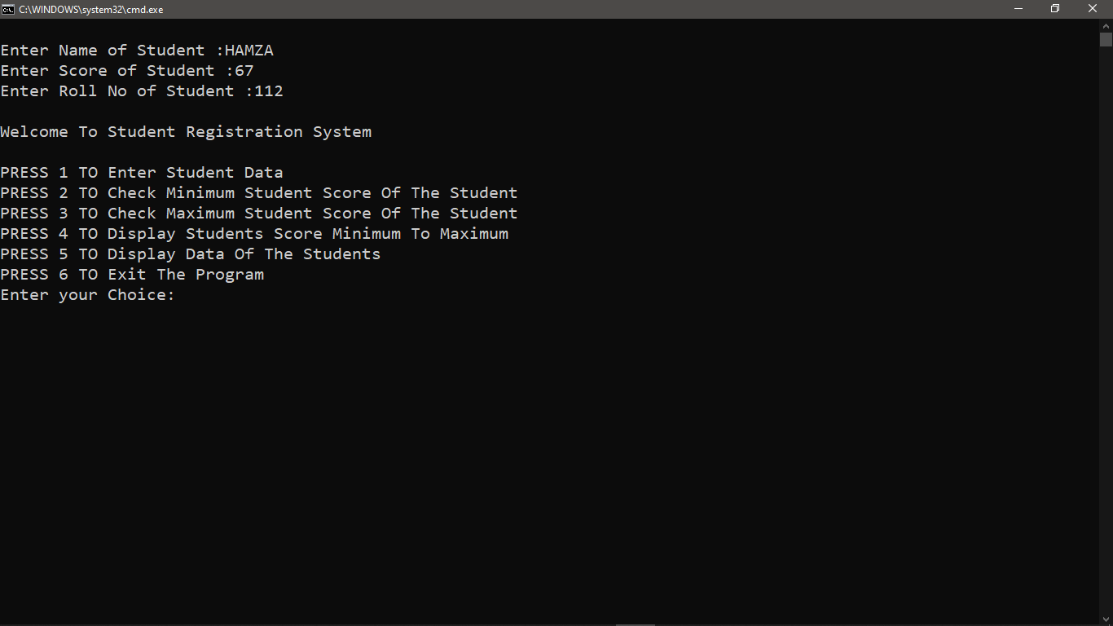

## ADDING DATA

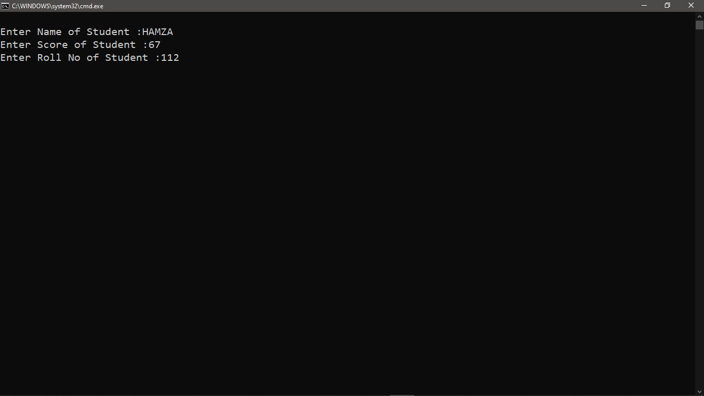

## Displaying Min Score

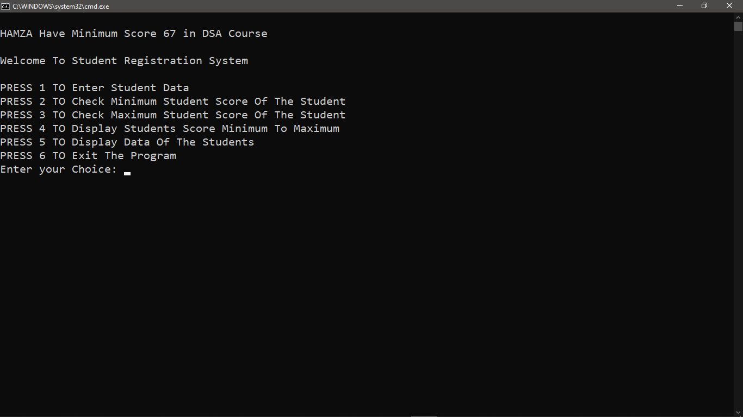

## Displaying Max Score

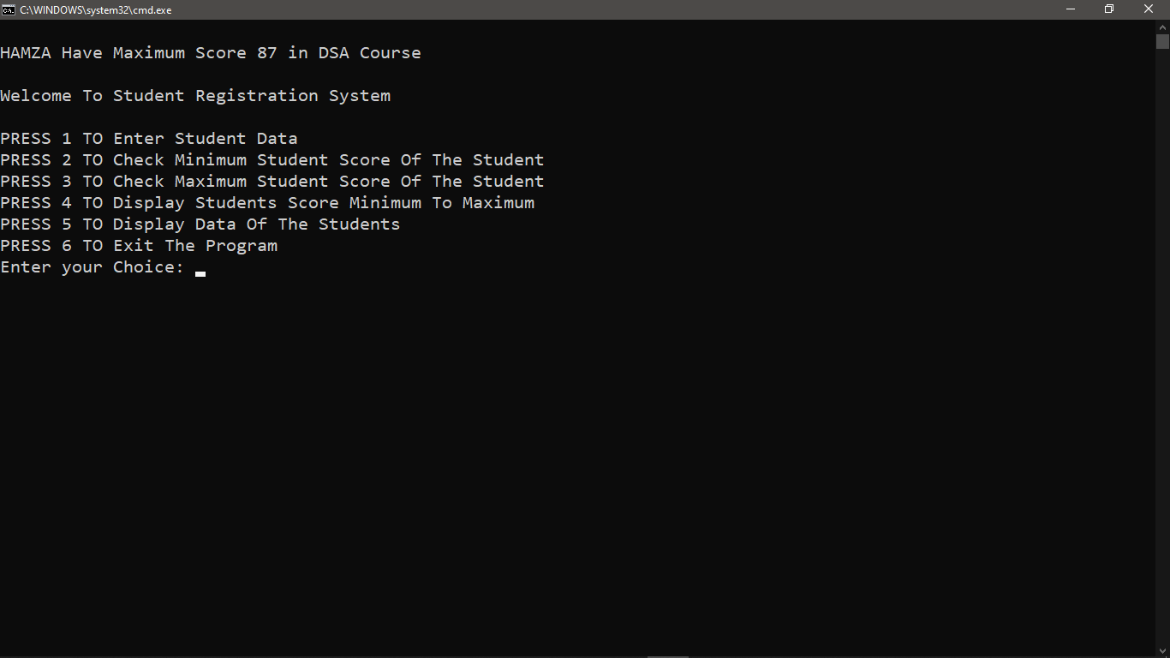

## Displaying Data

