# FD Name : Customer Onboarding

Author Name: Developer Guide

Date Of Assignment: 28-11-2021

Date Of Submission: 28-11-2021

Document detail

|  |  |  |  |  |
| --- | --- | --- | --- | --- |
| Name | Description | Version | Comment | Date |
| Developer Guide | Initial Draft | 1.0 |  | 28-11-2021 |
|  |  |  |  |  |
|  |  |  |  |  |

Document Future Scope

|  |
| --- |
|  |
|  |
|  |
|  |
|  |

# FUNCTIONAL REQUIREMENT

## Business Scenario

Investment banking Customer onboarding system will allow customers create account , to check and update the member details ,member login and reset member credentials. First customer will go to company portal and using signup option will create account by providing basic details. Once customers complete successful member registration, they can login using the login username and password details. If in case, customers forget the login details, they can utilize forgot password and forgot username options.

During customers login, they will receive an OTP on their mobile which is needed as part of login process. After successful login, customer can view member details, update member details, reset password.

## Flow diagram

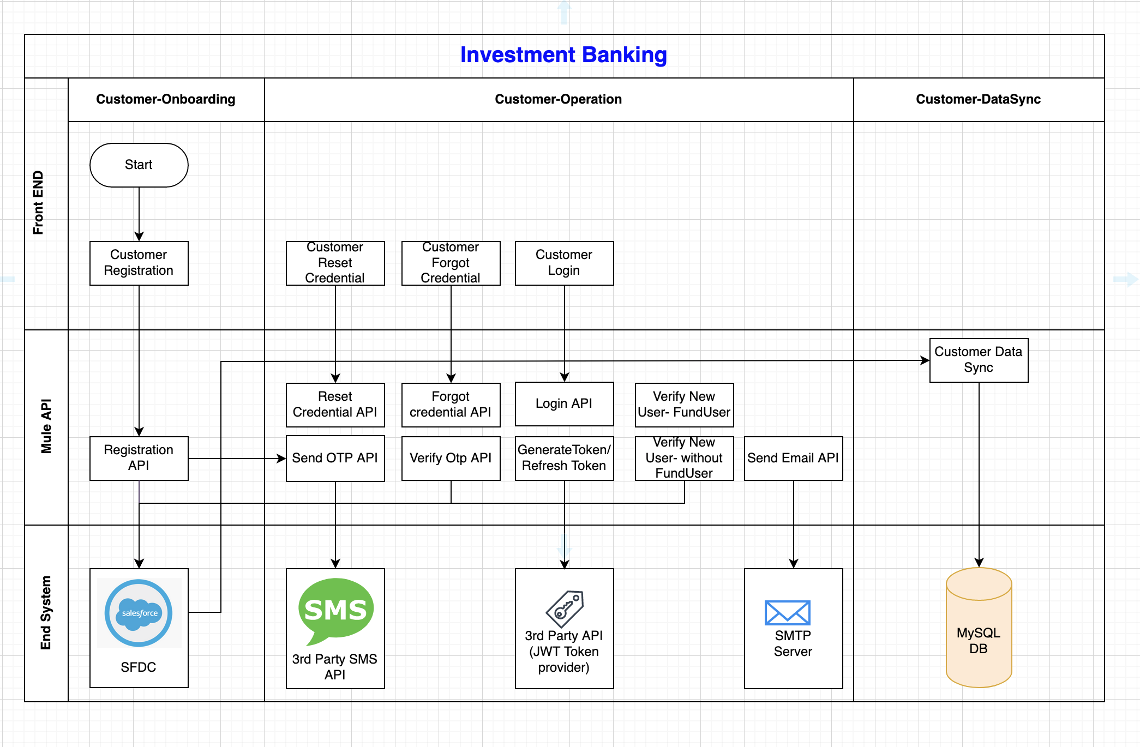

# API Details

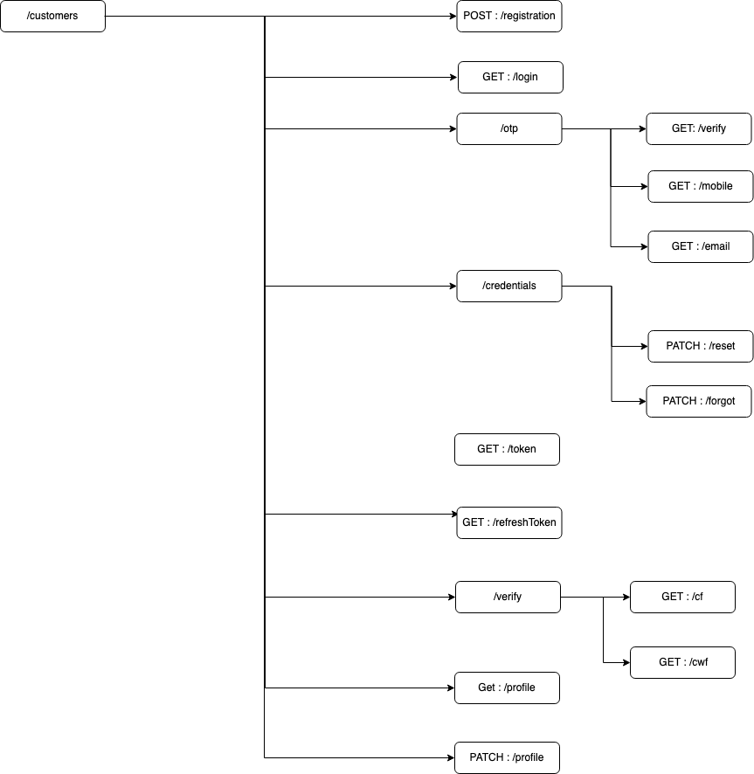

## Registration API

### Registration XAPI

#### API Resource Details

|  |  |
| --- | --- |
| **Version** | v1 |
| **Resource URI** | /customers/registration |
| **Method** | POST |
| **Objective** | This API will create new customer. |

#### Request

##### Headers

|  |  |  |  |
| --- | --- | --- | --- |
| **Field Name** | **Field Rule** | **Mandatory** | **Type** |
| x-cms-transactionId | Use for logging and tracking purposes. Example: hdsfhjdh-jxbv859-sjdf7643-3746bbd  MinLength = 36  MaxLength = 36 | Y | String |
| Authorization | JWT token | Y | String |
| ClientId | Ex: hsdfgysdhfcdshf37er6twgsdhfjcd | Y | String |
| ClientSecret | Ex: dsgfhaegur457r6ewsewegrfjesh | Y | String |

##### Query Parameter

|  |  |  |  |
| --- | --- | --- | --- |
| **Field Name** | **Field Rule** | **Mandatory** | **Type** |
| featureName | Enum : cwf/cf | Y | String |

##### Body.

##### (MIME-Type= application/json)

|  |  |  |  |
| --- | --- | --- | --- |
| **Field Name** | **Field Rule** | **Mandatory** | **Type** |
| registrationRequest | Indentation : 1 | Y | object |
| contactType | Indentation : 2  Eunm : mobile / email | Y | String |
| countryCode | Indentation : 2  Enum : +91 / +1  Ex: “+91” | Y | String |
| mobile | Indentation : 2  Ex: “5676456354” | N | String |
| email | Indentation : 2  Ex: “kumar@gmail.com” | N | String |
| password | Indentation : 2  Ex: “dsfhdshxf” | Y | String |
| acceptDataPolicy | Indentation : 2  Boolean : true/false | Y | String |
| recieveNews | Indentation : 2  Boolean : true/false | Y | String |
| acceptPIC | Indentation : 2  Boolean : true/false | Y | String |
| locale | Indentation : 2  Enum : en/zh  Ex” “en” | Y | String |
| captchatoken | Indentation : 2  Ex: “sbmhasvdfhdsfhsdfjvjhsfbvsfdvvdhgv” | Y | String |
| recieveClaimsettle | Indentation : 2  Boolean : true/false | Y | String |

Example :

{

“registrationRequest” : {

“contactType” : “mobile”,

“countryCode” : “+91”,

“mobile” : “7647678765”,

“password” : “sdkhjfd”,

“acceptDataPolicy” : true,

“recieveNews” : true,

“acceptPIC” : true,

“locale” : “en”,

“captchatoken” : “weu8iuehfew8fyiushdfsiuehfd8sed”,

“recieveClaimsettle” : true

}

}

#### Response

##### Body

##### (MIME-Type= application/json)

|  |  |  |  |
| --- | --- | --- | --- |
| **Field Name** | **Field Rule** | **Mandatory** | **Type** |
| registrationResponse | Indentation : 1 | Y | object |
| eventInstanceId | Indentation : 2  Ex: “dsfhsdfvjhdfew87yr4r8e4r” | Y | String |
| status | Indentation : 2  Enum : success / failure | Y | String |

Example :

{

“registrationResponse” : {

“eventInstanceId” : “dsfhdbfhsbdfhjsb3784t2wfsd”,

“status” : success

}

}

#### Error Details Registration PAPI

### Registration PAPI

### Registration SAPI

## Common Error

### 400:

Body: MIME-Type= application/json

Output message for MemberLogin

|  |  |  |  |
| --- | --- | --- | --- |
| **Field Name** | **Field Rule** | **Mandatory** | **Type** |
| msg | 1 | Y | String |
| code | 1 | Y | Integer |
| success | 1 | Y | Boolean |
| eventId | 1 | Y | string |
| error | 1 | Y | Object |
| type | 2 | Y | String |
| title | 2 | Y | String |
| details | 2 | Y | String |

example:

{

msg: "failed operation",

code: 400,

success: false,

eventId: "dbfhjsdbhfbdo8ryt876t75ty"

error:

{

type: "BAD_REQUEST",

title: "Invalid Request",

details: "The input contains invalid data"

}

}

### 401:

Body: MIME-Type= application/json

Output message for MemberLogin

|  |  |  |  |
| --- | --- | --- | --- |
| **Field Name** | **Field Rule** | **Mandatory** | **Type** |
| msg | 1 | Y | String |
| code | 1 | Y | Integer |
| success | 1 | Y | Boolean |
| eventId | 1 | Y | string |
| error | 1 | Y | Object |
| type | 2 | Y | String |
| title | 2 | Y | String |
| details | 2 | Y | String |

example:

{

msg: "failed operation",

code: 401,

success: false,

eventId: "dbfhjsdbhfbdo8ryt876t75ty"

error:

{

type: "UNAUTHORIZED",

title: "Unauthorized",

details: "This endpoint requires all requests to be authenticated"

}

}

### 404:

Body: MIME-Type= application/json

Output message for MemberLogin

|  |  |  |  |
| --- | --- | --- | --- |
| **Field Name** | **Field Rule** | **Mandatory** | **Type** |
| msg | 1 | Y | String |
| code | 1 | Y | Integer |
| success | 1 | Y | Boolean |
| eventId | 1 | Y | string |
| error | 1 | Y | Object |
| type | 2 | Y | String |
| title | 2 | Y | String |
| details | 2 | Y | String |

example:

{

msg: "failed operation",

code: 404,

success: false,

eventId: "dbfhjsdbhfbdo8ryt876t75ty"

error:

{

type: "NOT_FOUND",

title: "Resource not found",

details: "The URI requested is invalid or the resource requested does not exists"

}

}

### 500:

Body: MIME-Type= application/json

Output message for MemberLogin

|  |  |  |  |
| --- | --- | --- | --- |
| **Field Name** | **Field Rule** | **Mandatory** | **Type** |
| msg | 1 | Y | String |
| code | 1 | Y | Integer |
| success | 1 | Y | Boolean |
| eventId | 1 | Y | string |
| error | 1 | Y | Object |
| type | 2 | Y | String |
| title | 2 | Y | String |
| details | 2 | Y | String |

example:

{

msg: "failed operation",

code: 500,

success: false,

eventId: "dbfhjsdbhfbdo8ryt876t75ty"

error:

{

type: "SERVER_ERROR",

title: "Internal server error",

details: "The server encountered an unexpected condition which prevented it from fulfilling the request"

}

}