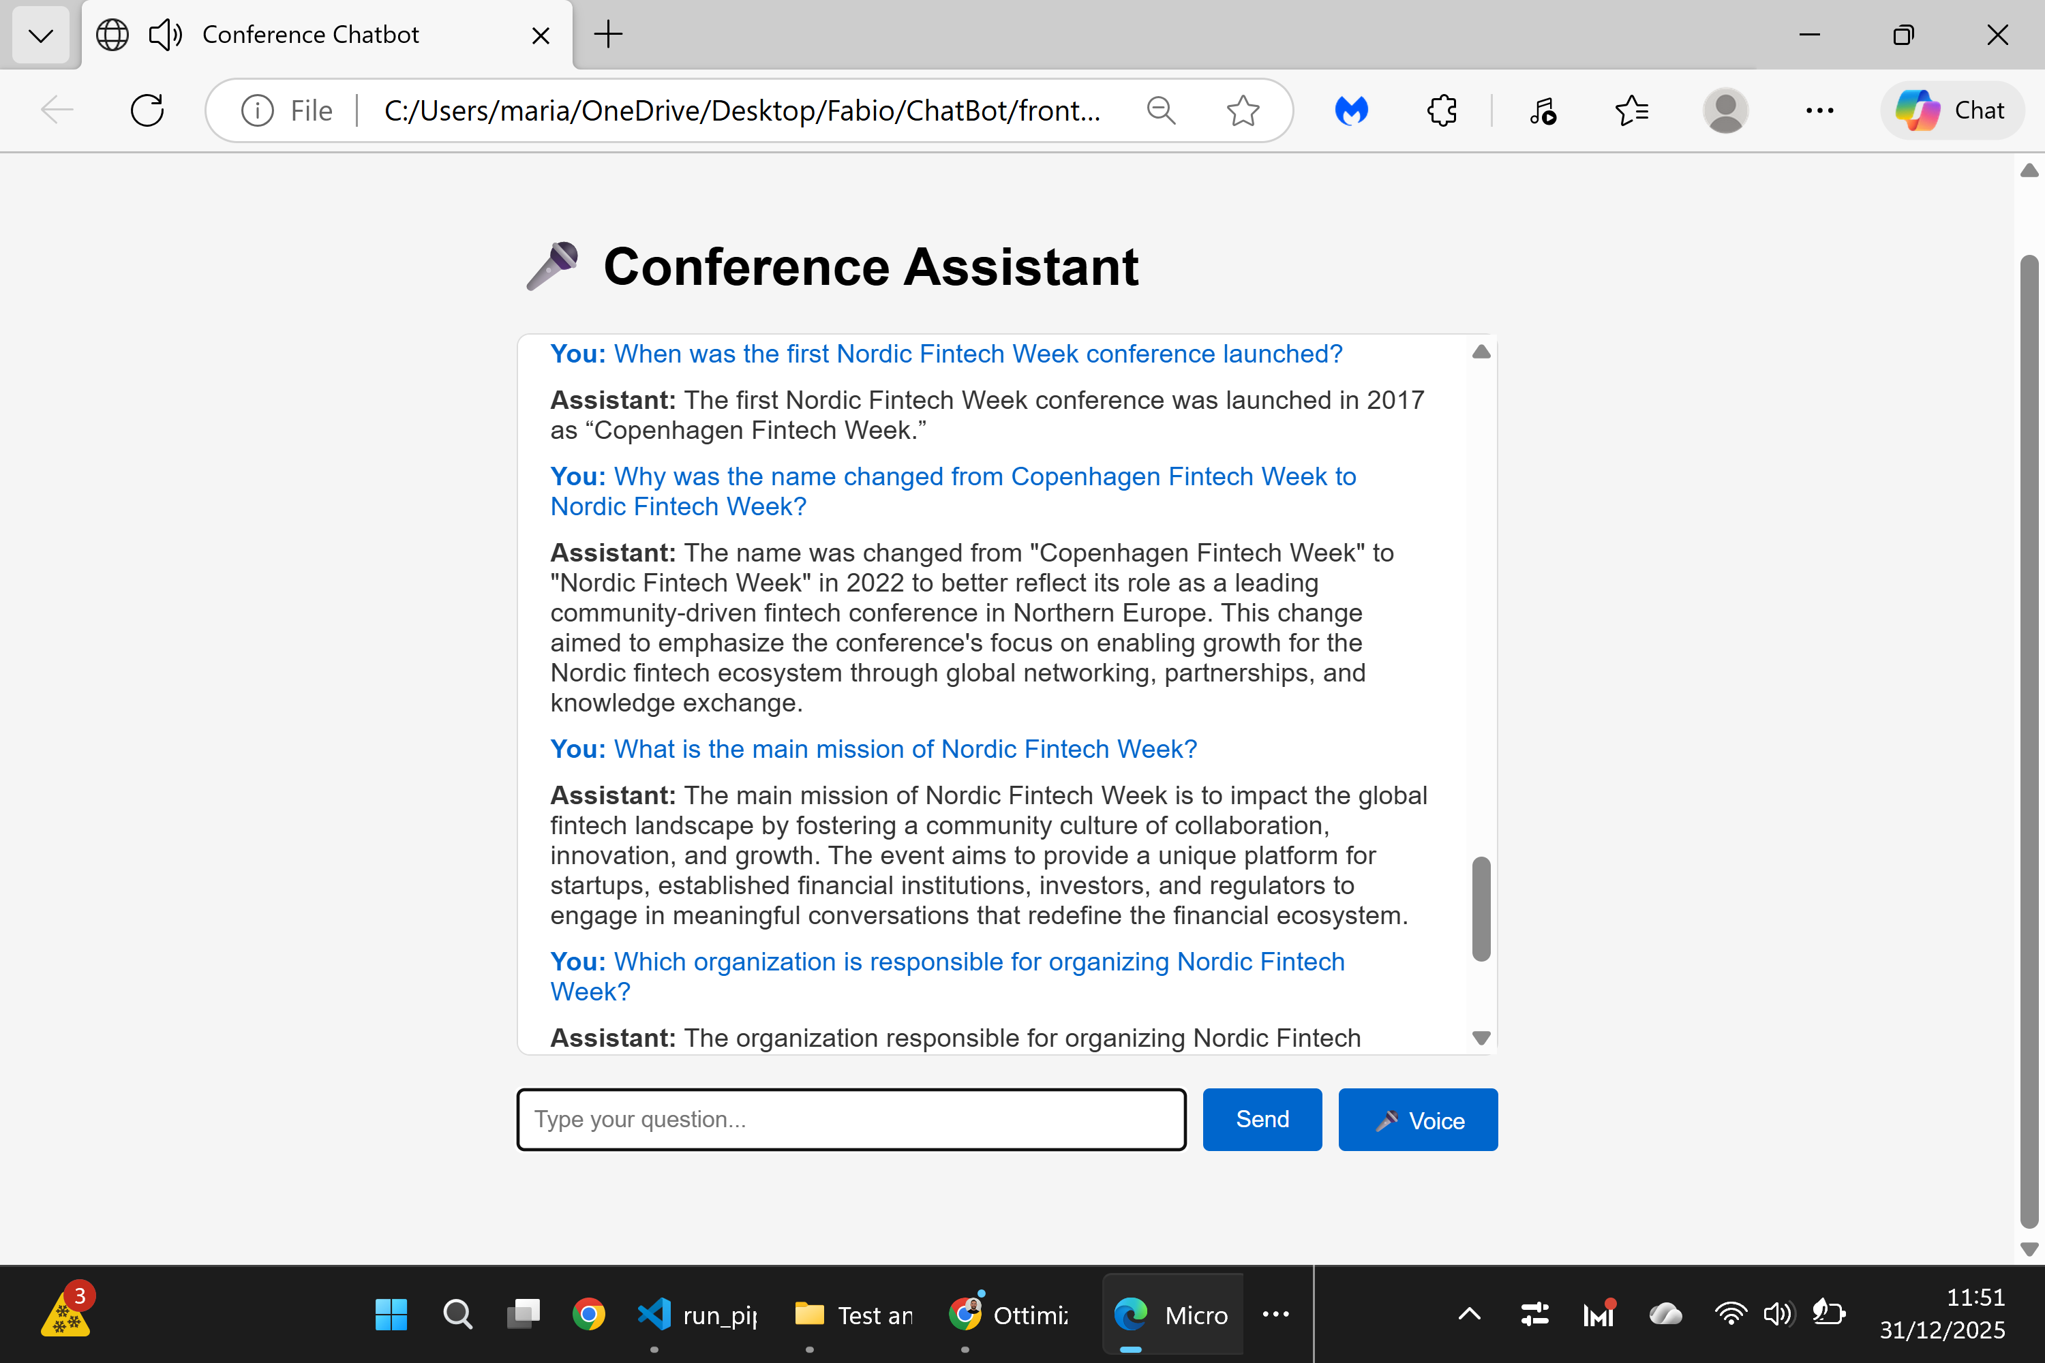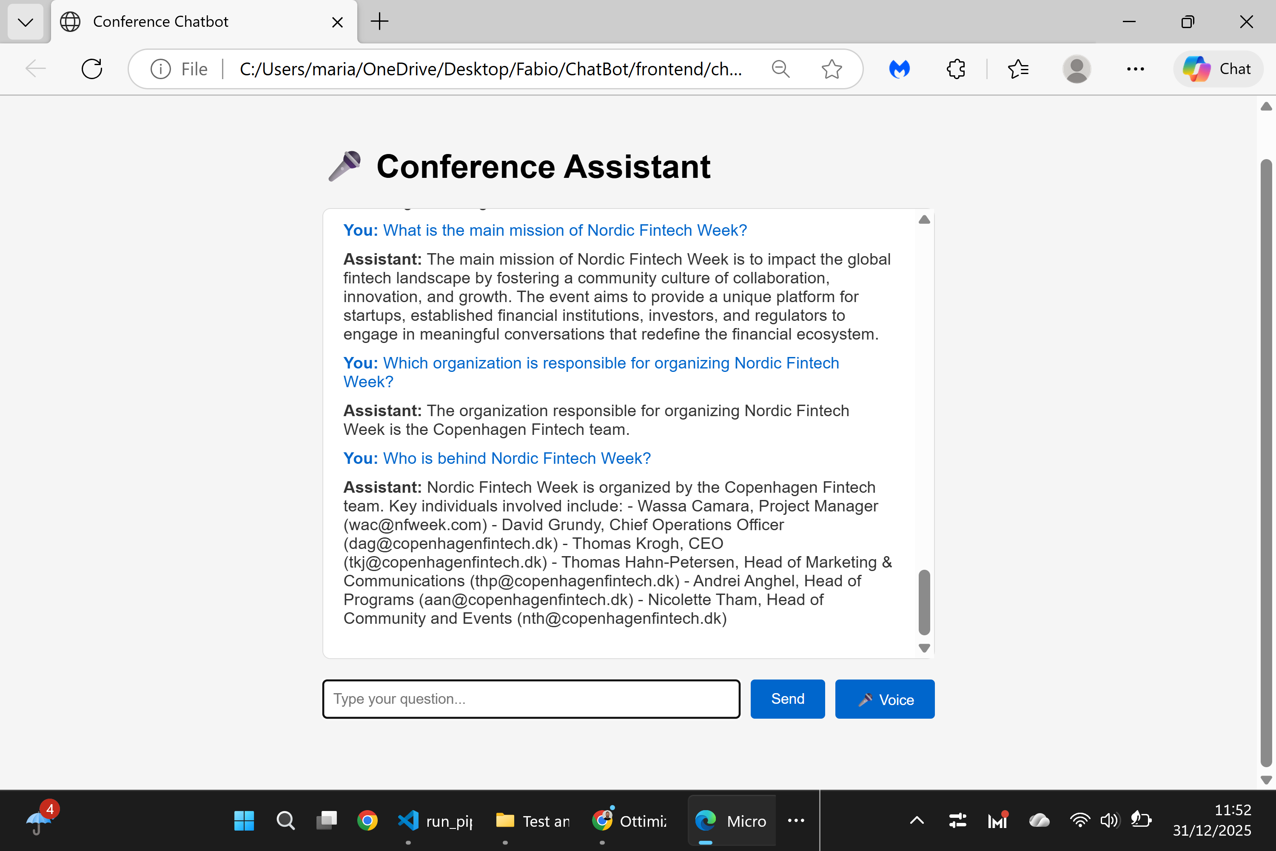

Page Tested: About Us
URL: https://nfweek.com/about-us/
Tested Questions:
- Who is behind Nordic Fintech Week?
- When was the first Nordic Fintech Week conference launched?
- Why was the name changed from Copenhagen Fintech Week to Nordic Fintech Week?
- What is the main mission of Nordic Fintech Week?
- Which organization is responsible for organizing Nordic Fintech Week?
Result:
✅ All tested questions returned accurate and relevant answers based on the page content.
Status:
Successful

